**Use this protocol for the analysis of mean cortical thickness and surface area data within FreeSurfer ROI's for the ENIGMA Bipolar, Schizophrenia, Major Depressive Disorder, ADHD, Addiction and Anxiety working groups.**

**These protocols are offered with an unlimited license and without warranty. However, if you find these protocols useful in your research, please provide a link to the ENIGMA website in your work: www.enigma.ini.usc.edu**

**Step 2: Quality Checking Cortical Measures (FreeSurfer)**

Highlighted portions of the instructions may require you to make changes so that the commands work on your system and data.

Sections highlighted in green probably do not need to be changed, but if you run the script and have problems, check the green portions to see if they match the storage structure of your FS output.

**There are three major steps for quality checking the cortical surface segmentations outputted from FreeSurfer:**

1. **Outlier Detection (page 2 of this manual):** This is a simple R script that will identify subjects with cortical thickness and surface area values that deviate from the rest of your subjects. Be aware that this script is quite rude and its outcomes do not relate high to visual QC (step 2 and 3).
2. **Internal Surface Method (page 3 of this manual):** This method uses a Matlab function to plot cortical surface segmentations directly on a subject’s scan and collates snapshots from internal slices of the brain into a webpage for easy checking. This method will be particularly useful to check Cortical Thickness segmentations.
3. **External Surface Method (page 6 of this manual):** This is loosely based on the QA-Tools for FreeSurfer. This creates a webpage with external views of the segmentations from different angles**.** Use this method for checking the Cortical Surface segmentations.
4. **Visual quality checking using the output from step 2 and 3 (page 8 of this manual and attached pdf: *Cortical_QC_2.0_ENIGMA_ANX.pdf*)**
5. **Adjust output files (.csv) based on QC**

**1. Outlier Detection**

This step requires that you have R installed and that you have downloaded the outlier detection script found [here](http://enigma.ini.usc.edu/wp-content/uploads/CORTEX/outliers.R).

Change directories to the location of your **CorticalMeasuresENIGMA_ThickAvg.csv and CorticalMeasuresENIGMA_SurfAvg.csv** generated in Step 1 of the protocols. Make sure the outliers.R script is also in that directory and run:

R --no-save --slave < outliers.R > outliers.log

This will generate a log file that will tell you which subjects are outliers and for which structures they are outliers for. **Make sure you look at these subjects closely as you proceed with the quality check protocol to make sure they are segmented properly.**

**NB:** Just because a subject is an outlier for a particular region does not necessarily mean they should be excluded from the analysis. If a subject is segmented properly in FreeSurfer (which you will visually verify at later steps in this protocol) then please do keep them in the analysis.

**2. The Internal Surface Method**

Needed:

* Matlab
* Download the QC_ENIGMA_Cortex scripts package: <http://enigma.ini.usc.edu/protocols/imaging-protocols/>

(see ENIGMA Cortical Quality Control Protocol 2.0 (April 2017), Step 2: QC_ENIGMA_Cortex scripts package)

Download the collection of Matlab scripts called QC_ENIGMA_Cortex.tar.gz (see above), unzip the directory (folder name: ENIGMA_QC 2), and change directories to that folder with the required Matlab *.m scripts. For simplicity, we assume you are working on a Linux machine with the base directory /enigma/QC_ENIGMA/.

Start Matlab: /usr/local/matlab/bin/matlab

Add the current folder containing all of the required scripts to Matlab’s path.

Select: File -> Set Path -> Add Folder -> {OK} -> {Save} -> {Close}

In the Matlab console window change directories to the folder with all of your FreeSurfer subject folders.

cd /enigma/subjects/

Make a directory to store all of the QC output.

mkdir /enigma/subjects/QC_cortical/

The script we want to run is called func_make_corticalpngs_ENIGMA_QC.m with the following parameters:

func_make_corticalpngs_ENIGMA_QC(output_QC_directory, subject_name, select_MRI_image, select_Segmented_image)

We want to set ‘subject_name’ such that ‘subject_name’ + ‘select_Segmented_image’ will form the full name of the segmentation label files (e.g. subj1/mri/aparc+aseg.mgz) and similarly for ‘select_MRI_image’ we want it to give the full name of the registered MRI scan outputted by FreeSurfer (e.g. subj1/mri/orig.mgz).

In the Matlab command window we can do:

QC_output_directory='/enigma/subjects/QC_cortical/';

FS_directory='/enigma/subjects/';

a=dir(char(strcat(FS_directory,'/*')));

%Choose this so that it selects only your

%subject folders that contain FS output

for x = 3:size(a,1)

[c,b,d]=fileparts(a(x,1).name); %b becomes the subject_name

try

func_make_corticalpngs_ENIGMA_QC(QC_output_directory, b, [FS_directory, '/', b, '/mri/orig.mgz'], [FS_directory,'/', b, '/mri/aparc+aseg.mgz']);

end

display(['Done with subject: ', b, ': ', num2str(x-2), ' of ', num2str(size(a,1)-2)]);

end

The func_make_corticalpngs_ENIGMA_QC script should take approximately several seconds/subject and will output a series of *.png image files separated by individual subject folders.

**NB:** if you run into problems with this Matlab loop try removing the last “/” in the QC_output_directory variable. So, QC_output_directory='/enigma/subjects/QC_cortical/'; would become QC_output_directory='/enigma/subjects/QC_cortical';

**Making the QC Webpage:**

To create a webpage for easy viewing of the QC output you just generated in Matlab. Within the /QC_ENIGMA/ directory is a script called ***make_ENIGMA_QC_webpage.sh.*** Make sure it is executable:

chmod 777 make_ENIGMA_QC_webpage.sh

Now to run the script, just give the script the full path to the directory where you stored the Matlab QC output files:

./make_ENIGMA_QC_webpage.sh /enigma/subjects/QC_cortical/

**NB:** If you have trouble running this script, it’s possible that you need to fix the line endings in the script before running. You can do this by running this command: sed -i -e 's/\r$//' make_ENIGMA_QC_webpage.sh

This script will create a webpage called **ENIGMA_Cortical_QC.html** in the same folder as your QC output. To open the webpage in a browser in a Linux environment you can probably just type (feel free to use a different browser):

firefox /enigma/subjects/QC_cortical/ENIGMA_Cortical_QC.html

**Note:** if you want to check the segmentation on another computer, you can just copy over the whole /enigma/subjects/QC_cortical/ output folder to your computer and open the webpage from there. (You will need access to both the PNG images and to the webpage).

Scroll through each set of images. Note that you can click on a subject’s files to see a larger version.

**NOTE: you can use the legend.jpg file found in the ENIGMA_QC 2 folder as a colored coded reference of each FreeSurfer ROI (split by left/right). We have also added it here:**

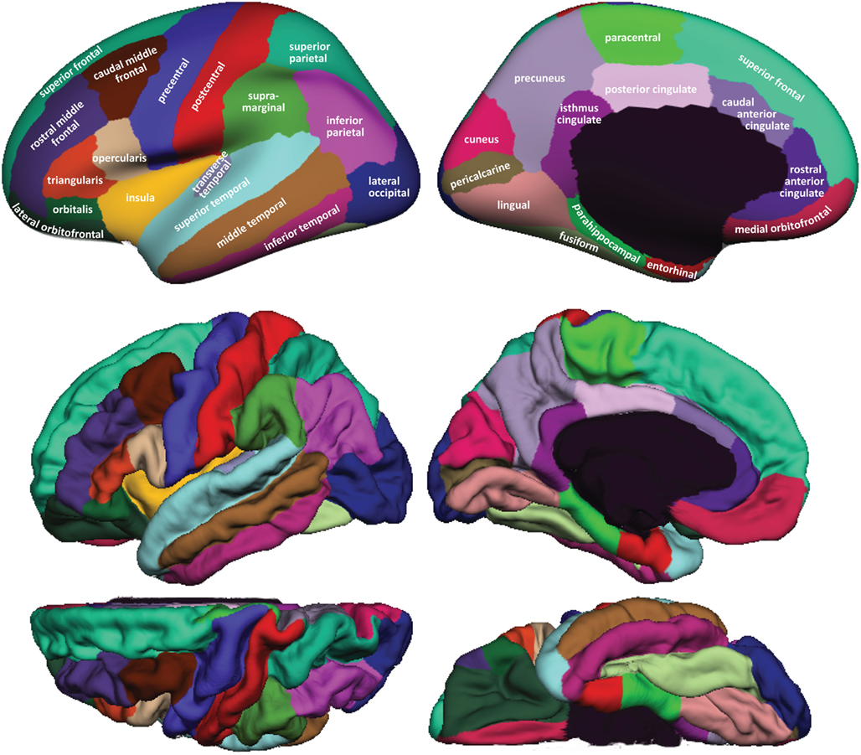

**3. The External Surface Method**

**Download the script fsqc.sh:** [**here**](http://enigma.ini.usc.edu/wp-content/uploads/CORTEX/fsqc.sh)

**NB: FreeSurfer and its utilities need to be in your path or this script will not run properly. You can type tksurfer on the command line to make sure it is available.**

The script **fsqc.sh** will create a webpage with lateral and medial snapshots of pial surface reconstructions colored with cortical labels. Clicking on the images will display a larger version. To run the script, first source FreeSurfer’s environment variable $SUBJECTS_DIR to point to your subjects directory. For example:

bash

export SUBJECTS_DIR=/enigma/Parent_Folder

Next create a directory to contain the snapshots (.tif image files), here we will call it fsqcdir/. Change the working directory to fsqcdir and run the **fsqc.sh** script from there:

cd fsqcdir

source /enigma/Parent_Folder/scripts/fsqc.sh

**NB:** If you have trouble running this script, it’s possible that you need to fix the line endings in the script before running. You can do this by running this command: sed -i -e 's/\r$//' make_ENIGMA_QC_webpage.sh

This script will call `tksurfer` in a loop for each subject and output a series of 4 images (.tif) files for each subject. It will also create a website called index.html so that you can easily view the images. You can open the index.html file in any browser, just make sure all of the .tif files are in the same folder if you decide to move the index.html file to a different location (such as a local computer). If you are in a Linux environment you should be able to just type on the command line:

#while in the output fsqcdir output folder

firefox index.html

**These are examples of successful reconstructions:**

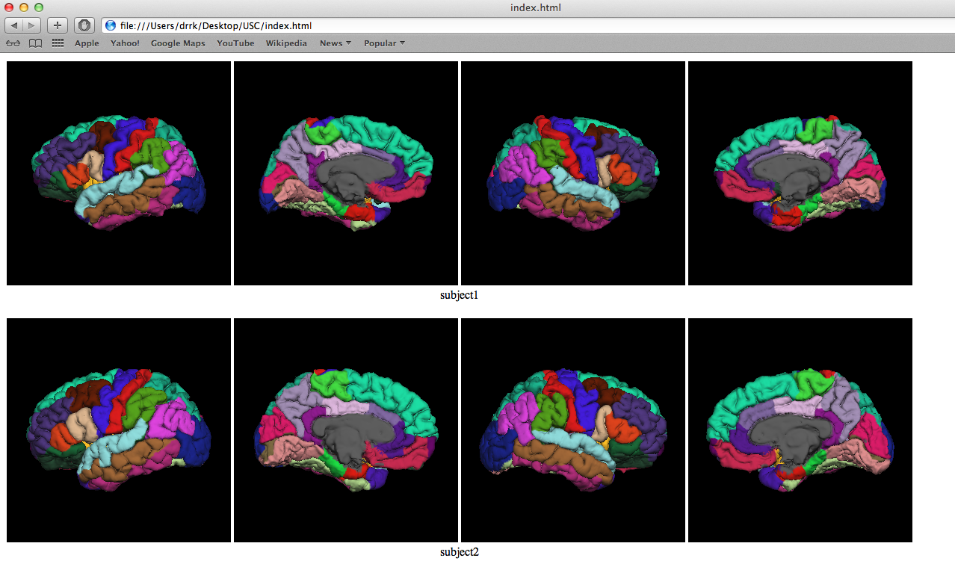

**Here is an example of a poor labeling (this would lead to full exclusion of the subject):**

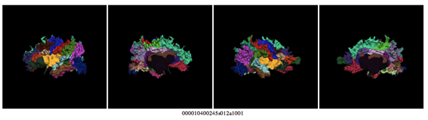

**4. Visual quality checking**

**Use ‘*Cortical_QC_2.0_ENIGMA_ANX.pdf’*, ‘*Cortical_QC_Template_ENIGMA_ANX.xlsx’* and ‘*Cortical_QC_Oneview_ENIGMA_ANX’* to conduct and record your quality ratings (attached to this protocol).**

**Focus on:**

1 General QC issues (page 9-13 pdf guide)

2 Internal QC view (page 14-18 pdf guide)

3 External QC – lateral view (page 19-25 pdf guide)

4 External QC – mid saggital view (page 26-31 pdf guide)

**5. Adjust output files (.csv) based on QC**

If QC (step 4) reveals bad segmentations, please do the following:

* Open the data files CorticalMeasuresENIGMA_ThickAvg.csv and CorticalMeasuresENIGMA_SurfAvg.csv in Excel
* Save them as CorticalMeasuresENIGMA_ThickAvg_beforeQC.csv and CorticalMeasuresENIGMA_SurfAvg_beforeQC.csv; **make sure to keep these copies of your original CSV files!**
* Mark poorly segmented cortical regions with "NA" (without the quotes) in the **CorticalMeasuresENIGMA_ThickAvg.csv** and **CorticalMeasuresENIGMA_SurfAvg.csv** files; so be aware: insert NAs in BOTH CSV FILES!
* If the whole subject is poorly segmented (like in the example) mark all of the entries in a subject's row with "NA".

**Make sure to save the files back in CSV format (so these are the files with NAs):**

* CorticalMeasuresENIGMA_ThickAvg.csv
* CorticalMeasuresENIGMA_SurfAv.csv
* Please open and inspect the csv files to verify that none of the values have converted to a scientific notation; eg 1.51708e+06. To avoid this rounding off, you can change the formatting of all metrics to “general” instead of “scientific” in excel before you convert the spreadsheet to csv.