R Notebook

#Load library.  
require('caret')

## Loading required package: caret

## Loading required package: lattice

## Loading required package: ggplot2

#Set project path so you don't have to type full path every time (this is the scripts folder).  
setwd('./')  
  
#Load data.  
subjData <- readRDS("../subjectData/n1396_T1_subjData.rds")  
  
#Pull out only variables of interest for splitting and checking demographics.  
dataToSplit <- subjData[,c('bblid','scanid','sex','race2','ageAtScan1','mood_4factor','psychosis_4factor','externalizing_4factor','phobias_4factor','overall_psychopathology_4factor')]  
  
#Remove any NA's from the variable you want to split on.  
dataNoNA <- subset(dataToSplit,is.na(dataToSplit$overall_psychopathology_4factor)==FALSE)  
  
#Count number of subjects before and after removing NAs.  
nrow(dataToSplit)

## [1] 1396

nrow(dataNoNA)

## [1] 1395

#Set a random number as the seed.  
set.seed(1234)  
  
##Split into the train and test data sets using caret.  
#p=the percentage of data that goes to training (e.g., 50%)  
#list=FALSE (gives a matrix with rows instead of list)   
#times=the number of partitions to create (number of training sets)  
trainIndex <- createDataPartition(dataNoNA$overall_psychopathology_4factor, p=0.5, list=F, times=1)  
  
#Pull the variables into the new train and test matrices.  
dataTrain <- dataNoNA[trainIndex,]  
dataTest <- dataNoNA[-trainIndex,]  
  
#Count number of subjects in the train and test sets.  
nrow(dataTrain)

## [1] 699

nrow(dataTest)

## [1] 696

#Save the train and test samples with the demographic variables.  
#write.csv(dataTrain,'../subjectData/n699_T1_train.csv',row.names=FALSE, quote=FALSE)  
#write.csv(dataTest,'../subjectData/n696_T1_test.csv',row.names=FALSE, quote=FALSE)  
  
#Save the bblids and scanids only for NMF.  
IDs <- c("bblid", "scanid")  
bblidsScanids_train <- dataTrain[IDs]  
bblidsScanids_test <- dataTest[IDs]  
  
#Remove header.  
names(bblidsScanids_train) <- NULL  
names(bblidsScanids_test) <- NULL  
  
#Save lists.  
#write.csv(bblidsScanids_train, file="../subjectData/n1396_T1_train_bblids_scanids.csv", row.names=FALSE)  
#write.csv(bblidsScanids_test, file="../subjectData/n1396_T1_test_bblids_scanids.csv", row.names=FALSE)  
  
##Make histograms to see that train and test are relatively similar.  
#Overall Psych  
hist(dataTrain$overall_psychopathology_4factor,breaks=14)

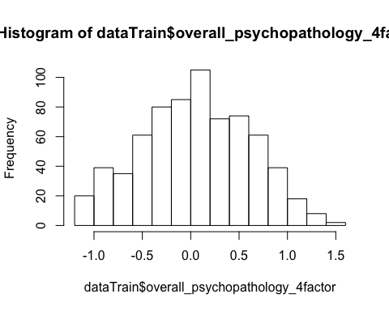

hist(dataTest$overall_psychopathology_4factor,breaks=14)

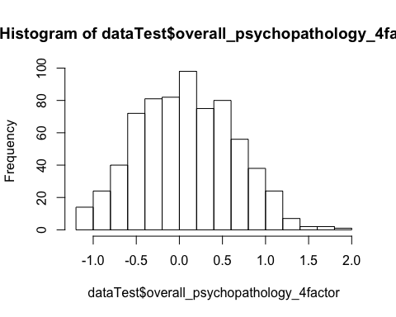

#Sex  
hist(dataTest$sex,breaks=2)

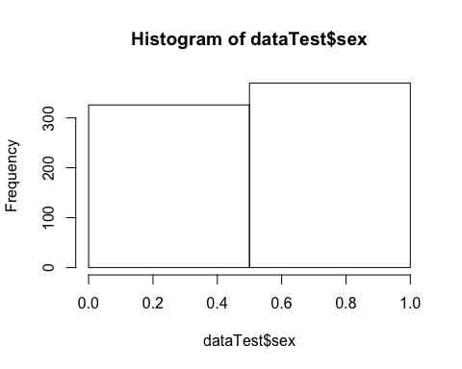

hist(dataTrain$sex,breaks=2)

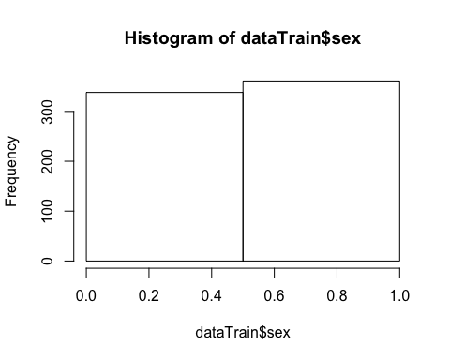

#Age  
hist(dataTrain$ageAtScan1,breaks=14)

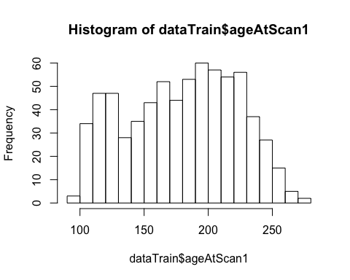

hist(dataTest$ageAtScan1,breaks=14)

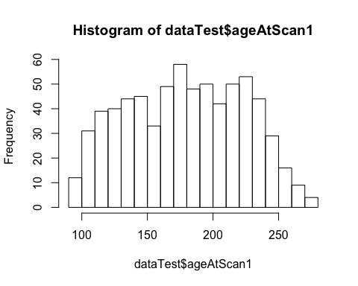

#Mood  
hist(dataTest$mood_4factor,breaks=14)

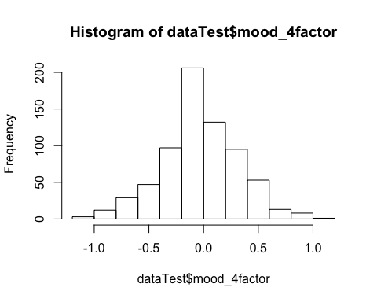

hist(dataTrain$mood_4factor,breaks=14)

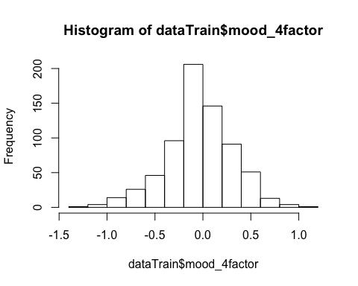

#Psychosis  
hist(dataTest$psychosis_4factor,breaks=14)

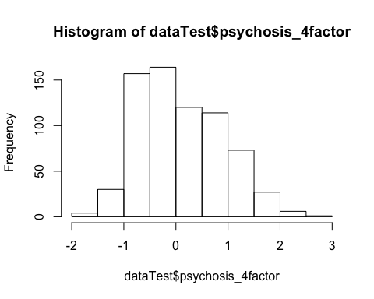

hist(dataTrain$psychosis_4factor,breaks=14)

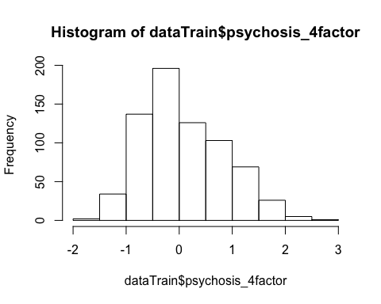

#Externalizing  
hist(dataTest$externalizing_4factor,breaks=14)

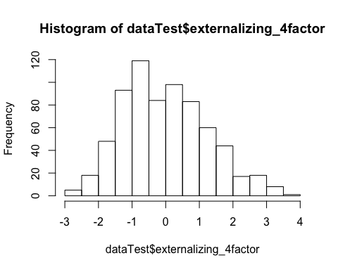

hist(dataTrain$externalizing_4factor,breaks=14)

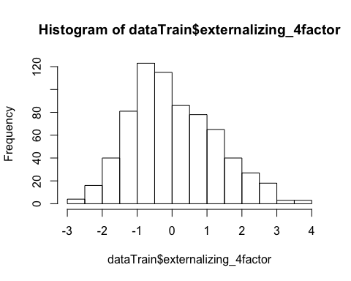

#Phobias  
hist(dataTest$phobias_4factor,breaks=14)

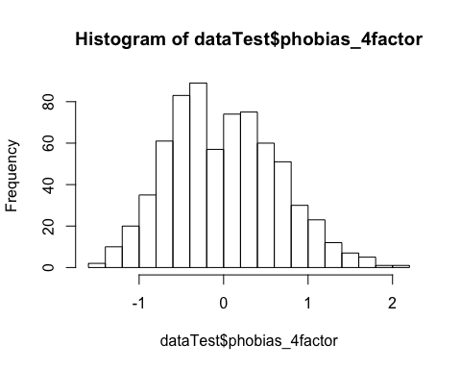

hist(dataTrain$phobias_4factor,breaks=14)

