Quick reference: Jupyter notebooks

*Launching the Jupyter notebook server*

1. Open a terminal window
2. (Optional) Navigate to a convenient directory

\* the directory where you launch Jupyter becomes the root for that session, and you will only be able to access directories within that root directory.

\* use cd <directoryName> and cd .. to move around

1. Launch the notebook with the following command:

jupyter notebook

Example:

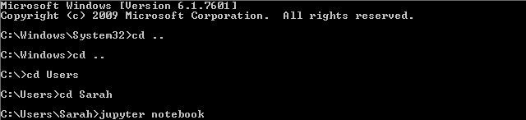

*Creating a new notebook*

1. Once the server is launched, navigate to the folder where you would like the new Jupyter notebook to be.
2. Click “New” in the upper right corner and select “Python” to create a new notebook.

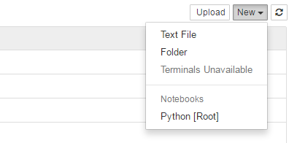

*Useful notebook shortcuts*

* Ctrl + Enter: Run the selected cell
* Shift + Enter: Run the selected cell and then move to the next cell
* Ctrl + s: Save notebook
* a: (“above”) Insert new cell above the selected cell
* b: (“below”) Insert new cell below the selected cell
* m: convert cell to text-type
* y: convert cell to code-type
* d,d: (hit d twice) Delete selected cell
* h: view all shortcut hotkeys

*Closing Jupyter*

1. Save open notebooks with Ctrl+s
2. On each open notebook, go to File > Close and Halt (closing the notebook tab will not actually close the notebook)
3. Close the Jupyter file browser (close tab)
4. Go to the terminal where you launched Jupyter, and do Ctrl+c twice.

For a more detailed overview of Jupyter notebooks, see here:

<http://nbviewer.jupyter.org/github/jupyter/notebook/blob/master/docs/source/examples/Notebook/Notebook%20Basics.ipynb>