Quick reference: Scripts

*Creating a script*

1. Open your plain text editor (Notepad++, TextWrangler, etc)
2. Type your code
3. Save the file with a .py extension

Example:

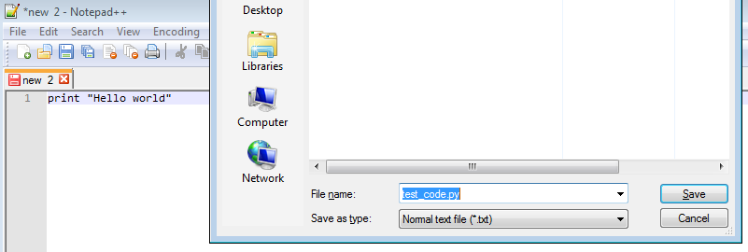

*Running a script*

1. Open a terminal window
2. Navigate to where your script is stored using cd <directory name> and cd .. to move around
3. Run your script with the following command:

python <script name>

Example:

