**Programming Bootcamp**

Checklist:

* Find instructor(s) and TAs ( I used a google spreadsheet for sign-up and posted on slack group and emailed to listserv. This past year I also held an interest meeting to discuss how the format would be as well. See below for notes from that meeting)
* Decide how many registrants you can accommodate
* Secure funding (BGSA, IBI, GCB)
* Book rooms
* Set piazza and have TAs and instructors sign up   
   TAs SIGN UP ON PIAZZA!!!!!

1. Go to https://piazza.com/

2. Click on Professors and TAs get started.

3. Search University of Pennsylvania

4. Search [NAME OF CLASS IE "**GCB WORKSHOP Programming Bootcamp"]**

5. Join as TA

* 6. Enter your upenn email address!
* Upload files to resources page and make sure to point this out on the first day (I noticed this way too late!!)
* Advertise to BGSA and Biology department for at 2-3 weeks ahead. Maybe have a date for when registration opens and advertise that. You can expect over 100 people to sign up. Flyer is attached from last year (Python_Bootcamp.docx)

-[Create google form for registration](https://docs.google.com/forms/d/1_zEum0ba-LsfwqeKssqfOjRbwl8UYhcsyTUz9XFU_k8/edit?usp=sharing) (linked to last years)

-Order food/coffee

-Order prizes ( will send you leftover bags)

-Organizing lectures (Attached). This past bootcamp we had room for one more lecture to fit 6 full sessions.

-Organize homework (Attached) and decide how to grade them/ provide feedback (this can be very time consuming)

-Optional: Set up office hours (really not necessary)

-Each class we would start off with intro, or go over common mistakes on HWK, go through the lecture, and then allow students to work on HWK with TAs around to help (introduce TAs).

- Send out survey at the end (maybe ask them to fill out survey THEN they receive a prize. We got barely any feedback last two years). Some people really liked working in groups.

**Try prioritize BGS and Biology graduate students with ZERO background. Here are links to registration responses to last two years:**

**Workshop 2018-**

[**https://docs.google.com/spreadsheets/d/1t_JyklFJiS1WGLKjxqnVHVDwnJ8PCqN7T35925S4Z3Y/edit?usp=sharing**](https://docs.google.com/spreadsheets/d/1t_JyklFJiS1WGLKjxqnVHVDwnJ8PCqN7T35925S4Z3Y/edit?usp=sharing)

**Workshop 2017-**

[**https://docs.google.com/spreadsheets/d/1uXCQo-nLDzU3GuFsH26iGMnBWKe21OrPJbleq04iFtc/edit?usp=drive_web&ouid=104034426959944358429**](https://docs.google.com/spreadsheets/d/1uXCQo-nLDzU3GuFsH26iGMnBWKe21OrPJbleq04iFtc/edit?usp=drive_web&ouid=104034426959944358429)

**Notes from the interesting meeting in May 2018**

[**https://docs.google.com/document/d/1CDah6MBTn3NoBO6UpBhYXD53sB0SCNEKTBWQceZaJJs/edit?usp=sharing**](https://docs.google.com/document/d/1CDah6MBTn3NoBO6UpBhYXD53sB0SCNEKTBWQceZaJJs/edit?usp=sharing)

**Here is the flyer from 2018!**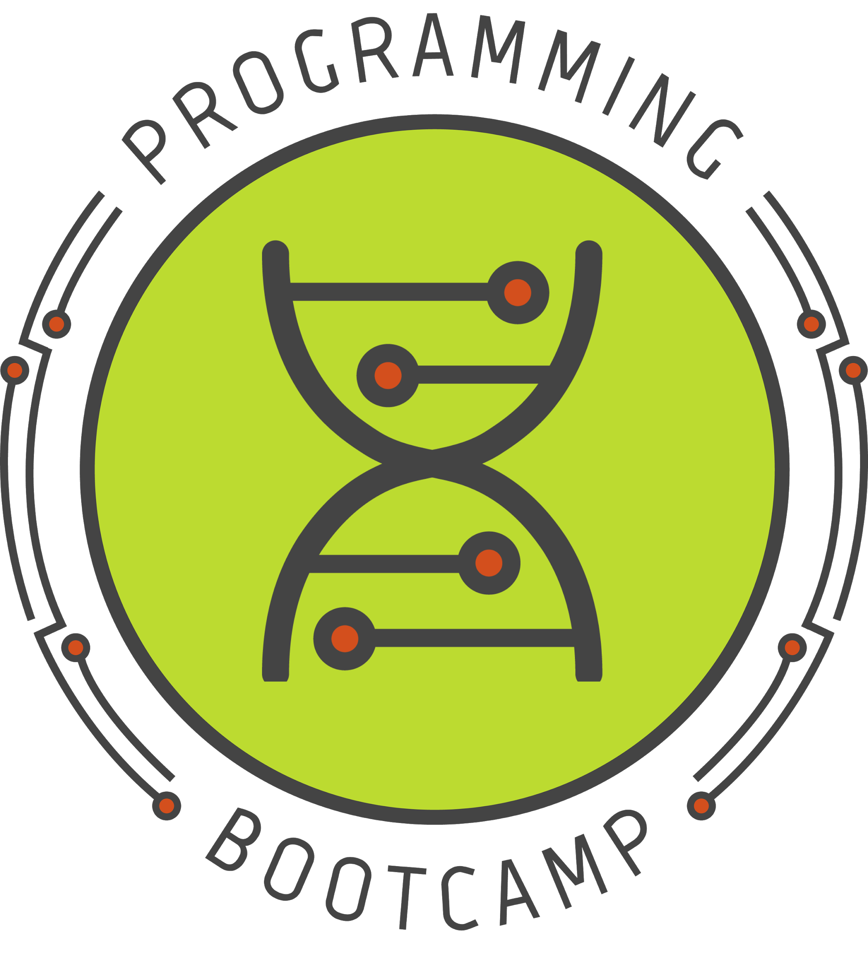

**-----------------------------------------------------------------------------**

**Come learn Python in a fun, beginner-friendly environment!**

**Dates:** Wednesdays, July 18th- August 22nd (6 sessions)

**Time:** 4:00 pm - 6:00 pm

**Location:** Smilow Center for Translational Research 11-146 (Last session will be in 9-146)

**In-person registration deadline:** July 6th, 2018(register@ <https://goo.gl/forms/ILSvm4bMq9Ztl6Rt2> )

This Programming Bootcamp is a free workshop designed to help young scientists in the biological and biomedical sciences gain programming skills.

Using Python, we will cover the core programming concepts needed to perform basic data analysis, with an emphasis on common problems in biology. Each of the 6 meetings will consist of a short lecture followed by free-form workshop time, where students will work through a set of programming exercises at their own pace. TAs will be present to answer questions/clarify the material. There will also be an active online Q&A forum where you can get help after class.

Note that if you have to miss a class or are not able to attend at all, lectures will be posted, and you can still participate with the Q&A forum.

**Register for the in-person classes using the form below (Deadline: July 6th):**

<https://goo.gl/forms/ILSvm4bMq9Ztl6Rt2>

**Register for online course:**

Piazza Sign up Instructions!  
1. Go to <https://piazza.com/>  
2. Click on enroll as a student to get started.  
3. Search University of Pennsylvania  
4. Search GCB WORKSHOP Programming Bootcamp Summer 2018  
5. Join as Student  
6. Enter your UPenn email address!

If you are interested in being a TA, or have questions, please email: misraj@pennmedicine.upenn.edu.

Programming Bootcamp is sponsored by the Genomics & Computational biology (GCB) graduate program, the [Biomedical Graduate Student Association](http://www.med.upenn.edu/bgsa/) (BGSA), and the [Institute for Biomedical Informatics](http://upibi.org/) (IBI).

