What do you do if you have one connectome/feature map extracted from a Schaefer 17 networks parcellation and another extracted from a Schaefer 7 networks parcellation? You can’t swap the labels because the ordering of the nodes actually differs between the 17 and 7 parcellations. You can see this issue by looking at the Centroid_RAS.csv files provided by Yeo’s group (https://github.com/ThomasYeoLab/CBIG/tree/master/stable_projects/brain_parcellation/Schaefer2018_LocalGlobal/Parcellations/MNI/Centroid_coordinates)

If we look at Schaefer2018_400Parcels_7Networks_order_FSLMNI152_2mm.Centroid_RAS.csv and Schaefer2018_400Parcels_17Networks_order_FSLMNI152_2mm.Centroid_RAS.csv side by side:
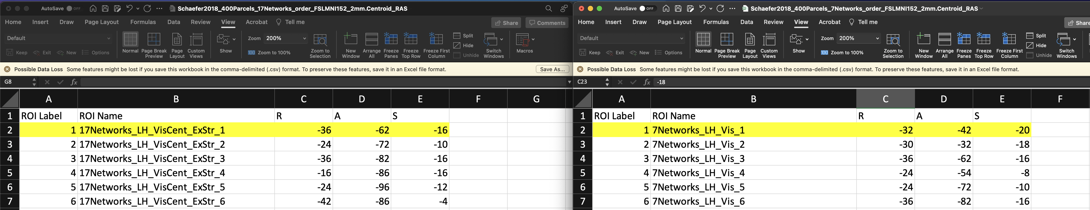
You can see that ROI 1 in the 17-network ordering is located at coordinates [-36, -62, -16], while ROI 1 in the 7-network ordering is located at [-32, -42, -20]. They aren’t the same brain regions despite both being ROI 1 in their respective parcellations.

The corresponding region in the 7-network ordering is actually ROI 3:
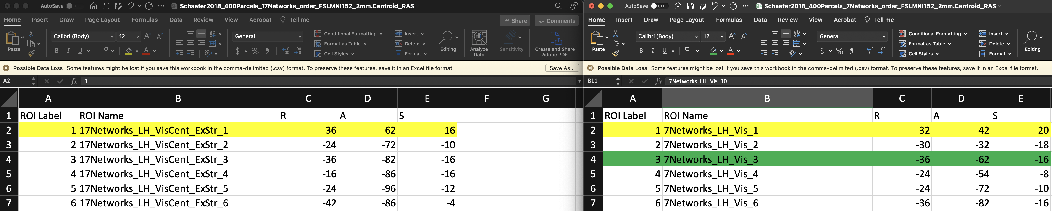

Another way to see this issue is by looking at the MNI-space parcellation files themselves:
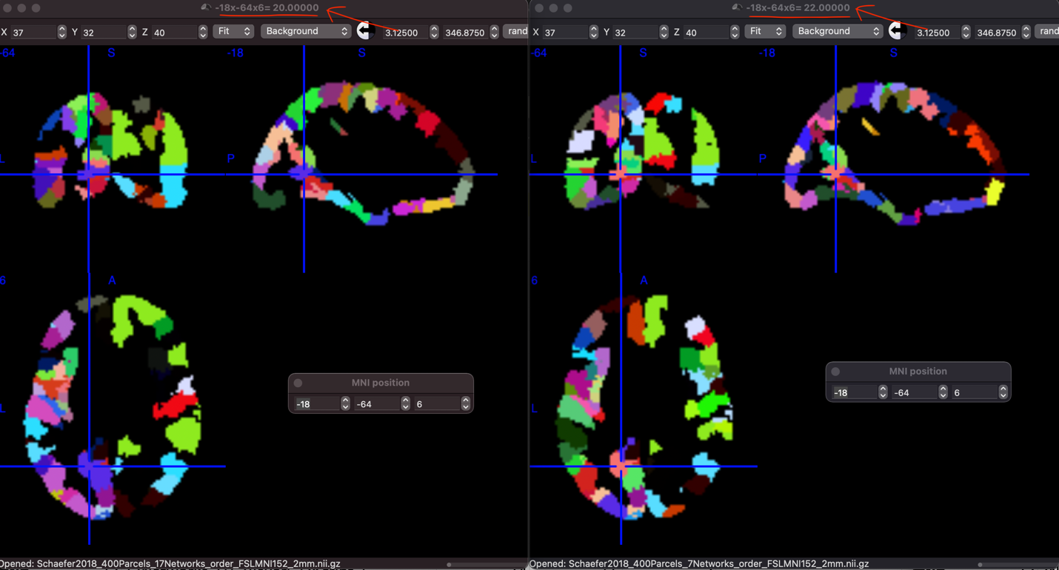
Here you can see that the same region in the brain (located at [-18, -64, 6]) is assigned the label 20 in the 17-network ordering (left), while in the 7-network ordering (right) it is assigned the label 22 (see red arrows).

So, if you want to move data from one to the other, you have to permute rows/cols/nodes. The script schaefer_ordering_mapper.py will generate this permutation for you.

If you set the params in the script to
n_parcels = 400
input_order = 17
output_order = 7

Then the script will produce a vector of indices that can be used to re-order 17-network ordering to 7-network (if you want to go the other way, set input_order = 7 and output_order = 17).

For example:
# matrix of data stored in 17-network ordering
matrix_17to7 = matrix_in_17.copy()

# matrix permuted to 7-network ordering
matrix_17to7 = matrix_17to7[mapped['mapped_indices'].values, :][:, mapped['mapped_indices'].values]

Now your data is in the 7-network ordering!

