Homework 3a data:
size | Bimodal | Gshare | Gshare n | Tour | Tour Fair
2 | 36.03% | 35.47% | 35.47% | 35.24% | 35.21%
3 | 36.56% | 35.68% | 35.68% | 35.00% | 35.25%
4 | 35.48% | 36.13% | 36.13% | 35.00% | 34.93%
5 | 34.51% | 36.44% | 36.44% | 34.20% | 34.89%
6 | 31.82% | 35.78% | 35.78% | 31.37% | 35.24%
7 | 28.19% | 34.58% | 34.58% | 27.47% | 33.83%
8 | 24.51% | 31.36% | 31.36% | 22.81% | 30.73%
9 | 20.39% | 27.15% | 27.87% | 17.74% | 26.24%
10 | 15.95% | 22.46% | 23.90% | 13.16% | 21.33%
11 | 13.62% | 17.40% | 19.12% | 10.17% | 16.44%
12 | 12.06% | 13.32% | 14.71% | 7.68% | 11.75%
13 | 10.72% | 10.34% | 11.25% | 6.03% | 8.73%
14 | 9.99% | 8.14% | 8.72% | 5.01% | 6.59%
15 | 9.82% | 7.14% | 6.92% | 4.35% | 5.27%
16 | 9.75% | 6.40% | 5.87% | 3.98% | 4.39%
17 | 9.58% | 6.04% | 5.27% | 3.73% | 4.00%
18 | 9.57% | 6.00% | 4.99% | 3.56% | 3.74%
19 | 9.57% | 5.96% | 4.89% | 3.45% | 3.56%
20 | 9.57% | 5.96% | 4.85% | 3.40% | 3.45%

 | 2^10 | 2^16
0 | 15.79% | 8.91%
1 | 15.79% | 8.91%
2 | 16.52% | 7.96%
3 | 16.64% | 7.35%
4 | 17.67% | 7.08%
5 | 18.95% | 7.12%
6 | 20.72% | 7.10%
7 | 21.43% | 6.68%
8 | 22.46% | 6.40%
9 | 22.57% | 6.02%
10 | 23.90% | 5.88%
11 | 23.90% | 5.77%
12 | 23.90% | 5.87%
13 | 23.90% | 5.94%
14 | 23.90% | 6.08%
15 | 23.90% | 5.80%
16 | 23.90% | 5.87%
17 | 23.90% | 5.87%
18 | 23.90% | 5.87%
19 | 23.90% | 5.87%

Question 1 - Static Branch Predictor
Before looking at dynamic branch prediction, we are going to look at simple "static" branch prediction policies of "always predict taken" and "always predict not taken". Modify the tracer reader to calculate the mis-prediction rate (that is, the percentage of conditional branches that were mis-predicted) for these two simple schemes.
a.What is the prediction accuracy for "always taken"?
671404 correct 810613 incorrect, 45.30%

b.What is the prediction accuracy for "always not taken"?
810613 correct 671404 incorrect, 54.70%

Question 2 - Bimodal Accuracy versus Predictor Size
(Graph shown in Question 5)
a.Given a large enough predictor, what is the best mis-prediction rate obtainable by the bimodal predictor?
The best mis-prediction rate is 9.57%

b.How large must the predictor be to reduce the number of mis-predictions by approximately half as compared to the better of "always taken" and "always not taken"? Give the predictor size both in terms of number of counters as well as bytes.
Compared to "always not taken", the size of bimodal predictor should be at least 8 bit (256 counters) to reduce the number of mis-prediction by half.

c.At what point does the performance of the predictor pretty much max out? That is, how large does the predictor need to be before it basically captures almost all of the benefit of a much larger predictor.
When the size of the predictor reaches 16 bit, the performance max out.

Question 3 - Gshare Accuracy versus Predictor Size
(Graph shown in Question 5)
a.Given a large enough predictor, what is the best mis-prediction rate obtainable by this gshare predictor with 8 history bits?
The best mis-prediction rate is 6.40%
b.At what table size is the gshare predictor generally better than the simple bimodal predictor?
When the table size reaches 13, the gShare predictor generally better than the simple bimodal predictor
c.Explain why gshare is sometimes more accurate than bimodal.
gShare has a history table to record the patterns. It has more information, it is supposed to be better than bimodal.
d.Explain why bimodal is sometimes more accurate than gshare.
gShare predictor requires more lines to train, if the loop is not long enough, the bimodal predictor can actually perform better than gShare predictor.

Question 4 - Gshare History Length vs Prediction Accuracy
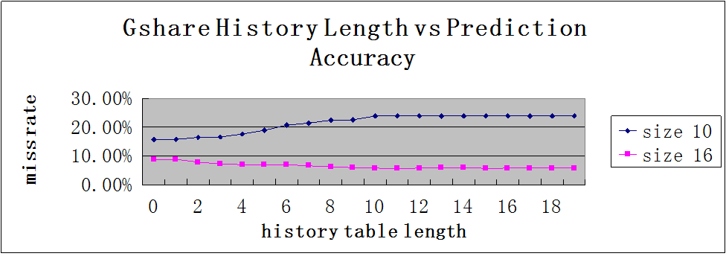
a.What is the optimal history length (the history length with the lowest mis-prediction rate) for each of these two predictor sizes?
The optimal history length for 10 bit predictor is 0
The optimal history length for 16 bit predictor is 11.
b.What do these results say about picking a history length? Generally speaking, what history lengths are the best performing?
The result says that the history length longer than the predict table length is kind of waste, it will not further decrease the miss rate.
The optima length of history table in the 2 tests are totally irrelevant, all I can draw is that the we can not make history table length as long as we want.

Question 5 - Gshare Accuracy versus Predictor Size Revisited
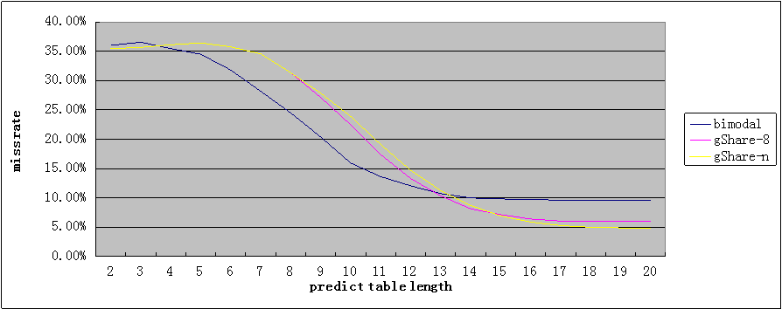
- Looking at this new data, what is new the lowest (best) mis-prediction rate for gshare?
4.85%
- When comparing the new gshare data to bimodal, where is the crossover point between then? (That is, what is the predictor size at which gshare becomes better than bimodal?) How does this crossover point compare to the crossover point of gshare with 8-bit history versus bimodal.
The gShare-N predictor outperforms the bimodal predictor when the predictor length reaches 14.
The gShare-N predictor outperforms the gShare-8 predictor when the predictor size reaches 15.
- In these experiments, we're looking at a trace of just one program. Of course, processors run many different programs. Each of these programs might have a different crossover point. What properties of a program might most significantly impact where the crossover point between bimodal and gshare occurs?
If a program contains several long loops. The crossover point will be larger.(require larger predict table for gShare to outperform bimodal)
Question 6 - Tournament Predictor Accuracy
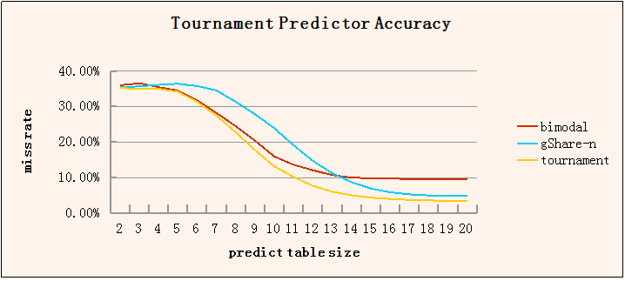
a.How does the tournament predictor's accuracy compare to bimodal and gshare? Is the tournament predictor successful in meeting its goal?
The tournament predictor outperforms both bimodal predictor and gShare-n predictor with any predict table size. Yes, the tournament predictor meets its goal

b.Does the tournament predictor improve the overall peak (best-case) accuracy? If so, why? If not, what are the benefits of the tournament predictor?
Yes, because the tournament predictor choose the best between bimodal and gShare predictor, it's supposed to be better than both bimodal and gShare predictor.

Question 7 - Tournament Predictor Accuracy -- Same Size Comparison
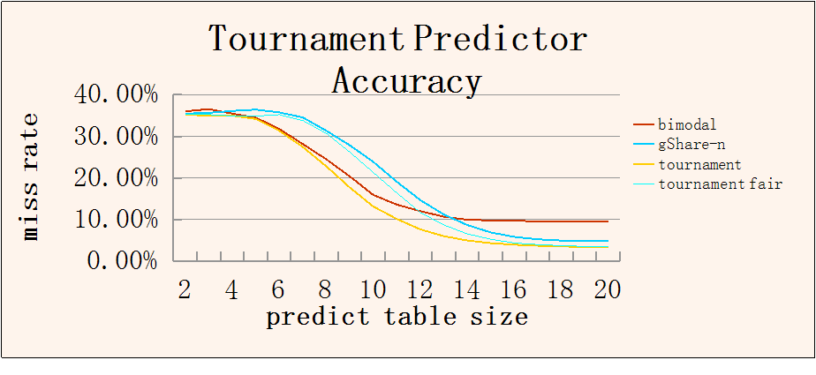
- Compare the old and new tournament predictor data. What was the impact of moving to the smaller (fairer) table sizes?
When the predict table size is small, the performance of the tournament predictor is worse than that of the unfair tournament predictor, but, when the predict table size reaches 17, the fair and unfair tournament predictors have almost the same performance.

b.Once adjusted to be a fair-size comparison, does the tournament predictor succeed in its goal of being the best of bimodal and gshare?
It depends on the size of the predict table.
No, if the predict table size is small. The fair tournament predictor can outperform the gshare-n predictor , but can not outperform the bimodal predictor.
Yes, if the predict table size reaches 13.

c.Given a fixed transistor budget for a branch predictor (say, 4KBs), what predictor approach would you use?
Give 4KB budget, we can build a 15 bit bimodal predictor or 14bit gShare-N predictor or a 13bit tournament predictor or a 15bit fair tournament predictor.
Look up the performance of these 4 predictors in the table given at the beginning, we choose the fair tournament predictor

