**UECM3033 Assignment #1 Report**

* Prepared by: Penny Chong
* Tutorial Group: T2

______________________________________________________________________________

**Task 1 -- setup a github repository**

The reports, codes and supporting documents are uploaded to Github at:

<https://github.com/PennyChong/UECM3033_assign1>

______________________________________________________________________________

**Task 2 -- setup python**

Put here the screen shot of file (python.png)

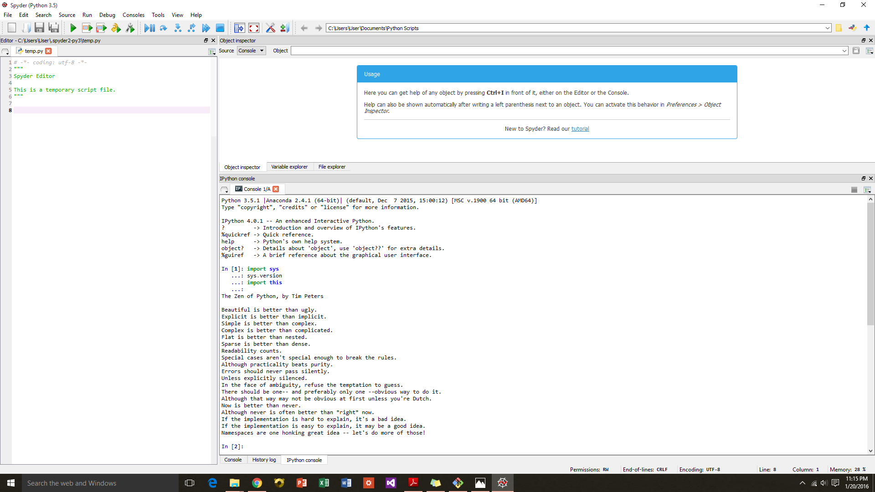

______________________________________________________________________________

**Task 3 -- modify and run Python script**

In this section, please report:

1. The hexadecimal value of your student ID.

The hexadecimal value of my student ID 1201782 is 125676.

1. Write down the definite integrals that you have chosen.
2. Write down your system of 10 linear equations.

, , , ,

, , , ,

,

______________________________________________________________________________last modified: 24/01/2016