Kennel Log Print (12.12.2014)

|  |  |  |  |
| --- | --- | --- | --- |
| Run # | Run  Type | Reservation Details | |
| 1 | Large  Front  Covered | Pet(s): Spot  Food: OWN FOOD  Services: Daily Walk  Grooming 3x  Playtime | Owner: Allan McDonald  To: **28.07.2012**  Out Today X  Medication: Pills(Extroxin)  2x Daily |
| 2 | Regular  Back Placed  Uncovered | Pet(s): Spot  Food: OWN FOOD  Services: Daily Walk | Owner: Allan McDonald  To: **28.07.2012**  Out Today Check mark symbol  Medication: |
| 3 | Regular  Back Placed  Uncovered | Pet(s):  Food:  Services: | Owner:  To:  Out Today  Medication: |
| 4 | Regular  Back Placed  Uncovered | Pet(s):  Food:  Services: | Owner:  To:  Out Today  Medication: |
| 5 | Regular  Front Placed  Uncovered | Pet(s):  Food:  Services: | Owner:  To:  Out Today  Medication: |
| 6 | Regular  Back Placed  Uncovered | Pet(s): Spot  Food: OWN FOOD  Services: Daily Walk | Owner: Allan McDonald  To: **28.07.2012**  Out Today Check mark symbol  Medication: |
| 7 | Regular  Back Placed  Uncovered | Pet(s): Spot  Food: OWN FOOD  Services: Grooming 3x  Playtime | Owner: Allan McDonald  To: **28.07.2012**  Out Today Check mark symbol  Medication: |

Example of Kennel log printout for the customer

|  |  |  |
| --- | --- | --- |
| Date | Allan McDonald  123 Thisplace  C2F 3N8 S*omeCity*  (819) 555 - 1233  Kennel Log entries for: Spot | |
| 12.3.2013 | Food: OWN FOOD  Services: Daily Walk  Grooming 3x  Playtime | Out Today X  Medication: Pills(Extroxin)  Every second day |
| Notes: Spot didn’t eat all his food today, ¼ of the portion was left. | |
| 13.3.2013 | Food: OWN FOOD  Services: Daily Walk  Playtime | Out Today Check mark symbol  Medication: |
| Notes:-- | |
| 14.3.2013 | Food:  Services: Daily Walk  Grooming 3x  Playtime | Out Today Check mark symbol  Medication: Pills(Extroxin) |
| Notes: Spot was scared during the grooming | |
| 15.3.2013 | Food:  Services: Daily Walk  Playtime | Out Today Check mark symbol  Medication: |
| Notes:-- | |
| 16.3.2013 | Food:  Services: Daily Walk  Grooming 3x  Playtime | Out Today X  Medication: Pills(Extroxin) |
| Notes:-- | |
| 17.3.2013 | Food: OWN FOOD  Services: Daily Walk  Playtime | Out Today Check mark symbol  Medication: |
| Notes: Spot is extremely shy and very timid around other dogs, he does not do well in an open playtime | |
| 18.3.2013 | Food: OWN FOOD  Services: Daily Walk  Playtime | Out Today Check mark symbol  Medication: Pills(Extroxin) |
| Notes:-- | |

# Customer pending reservation e-mail

### Pending Reservation

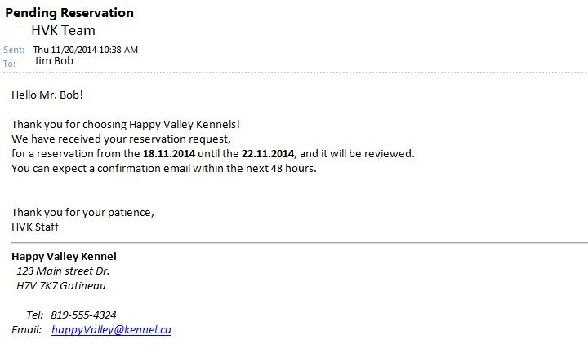

### Confirmed Reservation

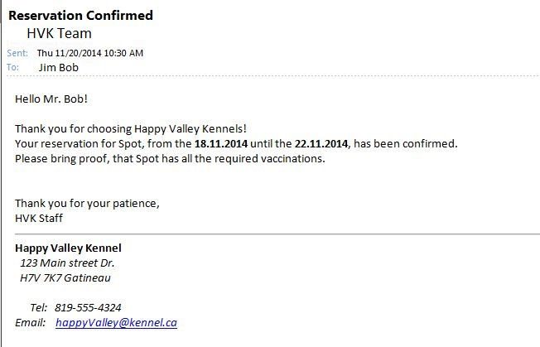

### Declined Reservation

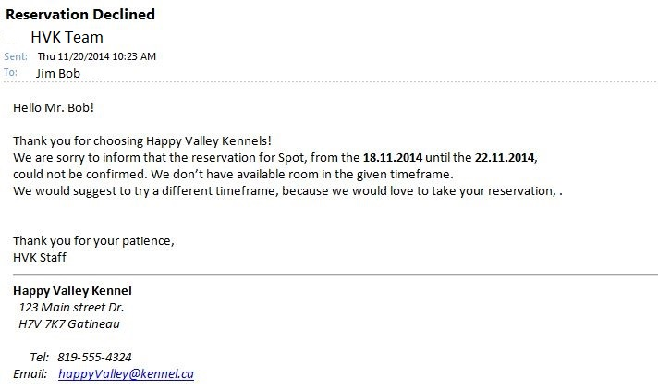

Password reset e-mail

