# AddUser

Adding a user, is a feature only available for the admin user and is a crucial use-case needed for saving a new user’s to the system.

The add user case passed unit testing successfully as seen in the figure bellow

C:\Users\Waliko\Documents\GitHub\Pentec_PIMS\Documentation\TestingDoc\Graphics\addUser.jpg

The following pre and post conditions are defined for adding a new user.

1. Pre conditions:

* User must be logged in as admin
* User to be added must not already exist in the database
* User must be a medical personnel

2. Post conditions

* New user is added and can interact with the system

The code bellow shows the testing for adding a new user with sample data

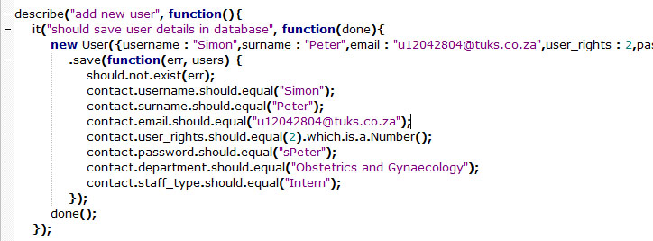

3. Remark

Add User unit test successfully passes.

# Pims Statistics

PIMS statistics is another feature for admin user only. For the statistics use case we tested for four different cases. All passed unit test and succeeded.

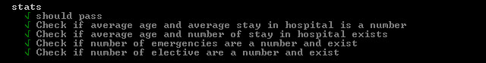

The following conditions had to be met for the statistics tests to pass.

1. Pre conditions:

* User must be logged in as admin
* Object type has to be a digit.

2. Post conditions

* Statistical results are returned

Unit test code to validate the number of elective procedures is indeed a number.

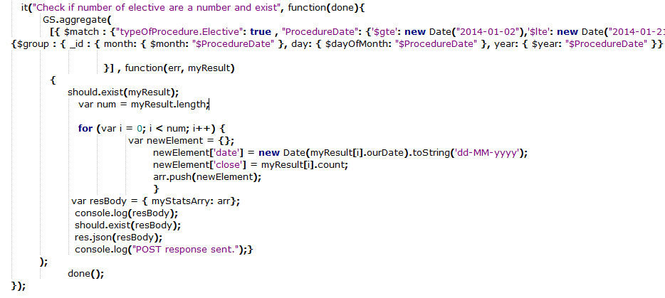

Unit test codes to validate the average age and stay in hospitals are indeed numbers.

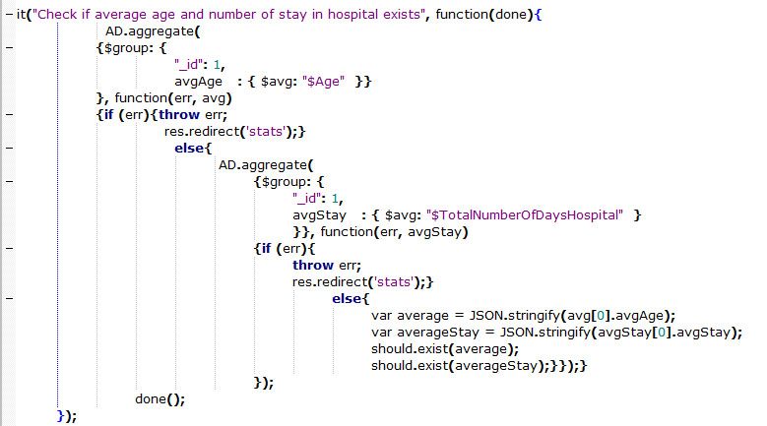

3. Remarks

Statistics is the heaviest module the PIMS. More unit testing will be done to ensure accuracy, reliability and currency. For now all tests succeeded and passed.

# User Login

It is a priority that a user logs into the system for security reasons to be able to interact with it. When testing the login use case we tested for the user’s authentication and rights. We tested weather or not he has admin or normal user rights..

The local login page

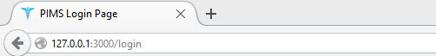

Successful login unit tests

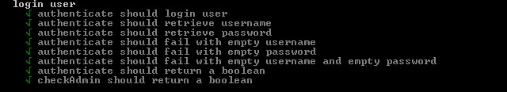

Log in and authenticating pre and post conditions that are met for a successful login

1. Pre conditions:

* User must not be logged in
* User must have valid credentials, a valid username and password
* User credentials must be found in the Mongo database

2. Post conditions

* User successfully logged in according to his user rights

Code snippets for user login use case, with test data “a” . Testing that a valid username is entered

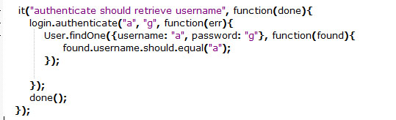

Code snippets for user login use case, with test data “g” . Testing that a valid password is entered

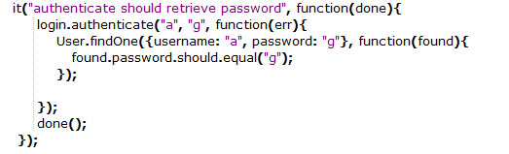

Code snippets for user login use case. Testing that the user is logged in after valid authentication

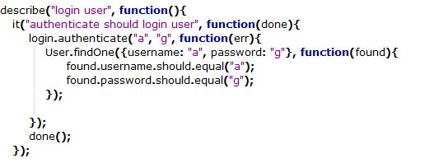

Remarks

Login ensures security and access control. Testing regarding the logging in all pass, thus the PIMS system is secure.

# Edit Profile

Edit profile, is also a feature that is only available for the admin user and is a nice to have. This use case allows him to update his basic information as he wish.

He may change his login credentials.

He may changes his username and contact details.

He may also change user icon.

Successful Edit Profile unit test.

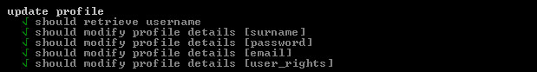

The following pre and post conditions for the edit user use case must hold

1. Pre conditions:

* User must be logged in as administrator

2. Post conditions

* User information must be updated according to modifications

Code snippets for edit profile use case. Testing that the user is logged in as administrator using test data “Leon” and that the username field updated.

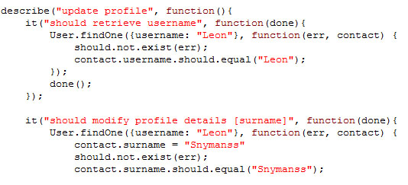

Remarks

Edit profile unit test successfully passes.

# Send Notification

Send notification is a feature that is not in the requirement documentation but was asked to be added in by our client. It allows him to send notifications to remind patience of their next follow up.

The send notification use case unit tests failed because the schema could not be found, see figure bellow.

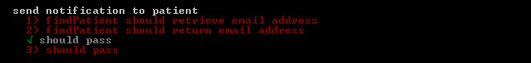

Test failure causes

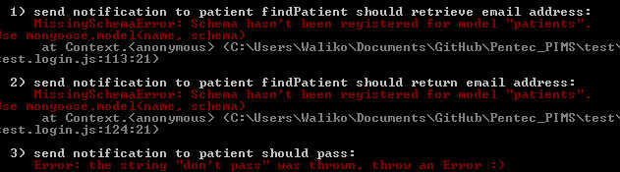

The following pre and post conditions for the send notification must hold true.

1. Pre conditions:

* User must be logged in as administrator
* Patient must exist in the system
* Patient must have an active email account

2. Post conditions

* A notification informing patient about their next appointment is sent to the users email account.

Code snippets for send notification use case that looks for a patient email address in the database to send a notification to.

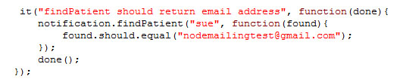

Remarks

Since Send notification fails unit testing, the module needs to be revised and tested again.