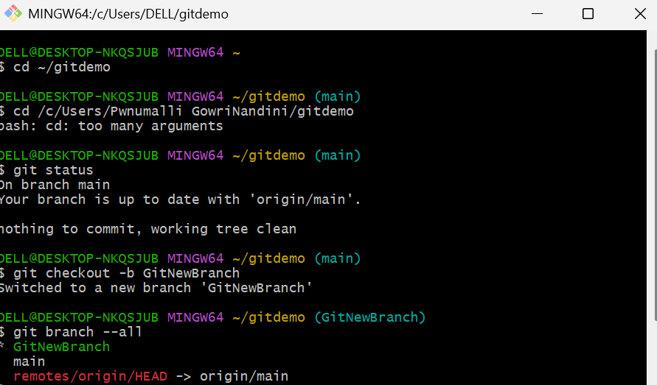Week8-Exp-3
Branching
- Create a new branch GitNewBranch:
git branch GitNewBranch

- List all local branches and verify the new branch is created:
bash
CopyEdit
git branch
- Switch to the new branch:
bash
CopyEdit
git checkout GitNewBranch
- Create a new file and add content:
bash
CopyEdit
echo "This is a file in GitNewBranch" > branchfile.txt
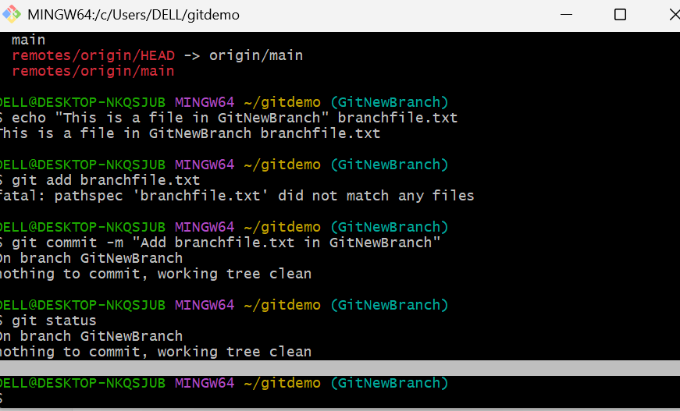

- Stage the new file:
bash
CopyEdit
git add branchfile.txt
- Commit the changes to the branch:
bash
CopyEdit
git commit -m "Add branchfile.txt in GitNewBranch"
- Check the status to confirm commit:
bash
CopyEdit
git status
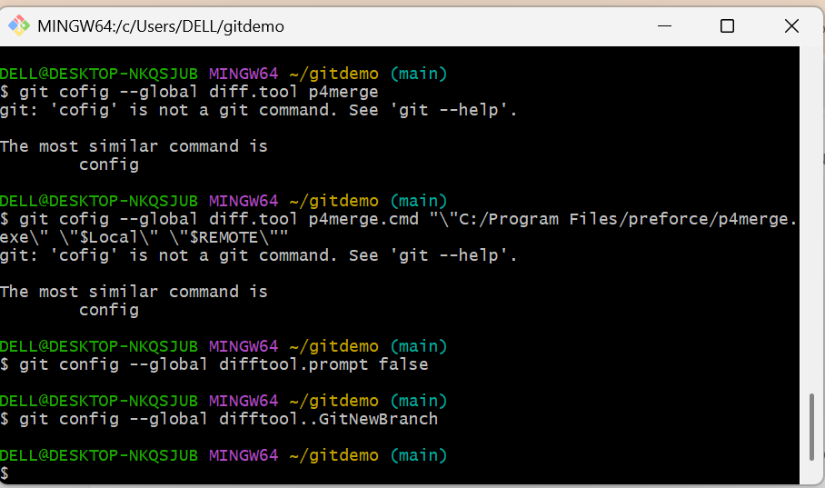

- List all branches (local and remote) to confirm:
bash
CopyEdit
git branch -a

Merging
- Switch back to the main branch:
bash
CopyEdit
git checkout main
- Check differences between main and GitNewBranch on command line:
bash
CopyEdit
git diff main..GitNewBranch
- Check visual differences using P4Merge:
bash
CopyEdit
git difftool main..GitNewBranch
- Merge GitNewBranch into main:
bash
CopyEdit
git merge GitNewBranch
- View commit history graph to confirm merge:
bash
CopyEdit
git log --oneline --graph --decorate
- Delete the merged branch GitNewBranch:
bash
CopyEdit
git branch -d GitNewBranch
- Check status after branch deletion:
bash
CopyEdit
git status
