Week-8Exp-1
Commands and steps
1) Open Git Bash and check Git
bash
CopyEdit
git --version

2) Configure your Git identity
(Replace with your actual name and email)
bash
CopyEdit
git config --global user.name "Your Full Name"
git config --global user.email "your.email@example.com"
Verify:
git config --global --list
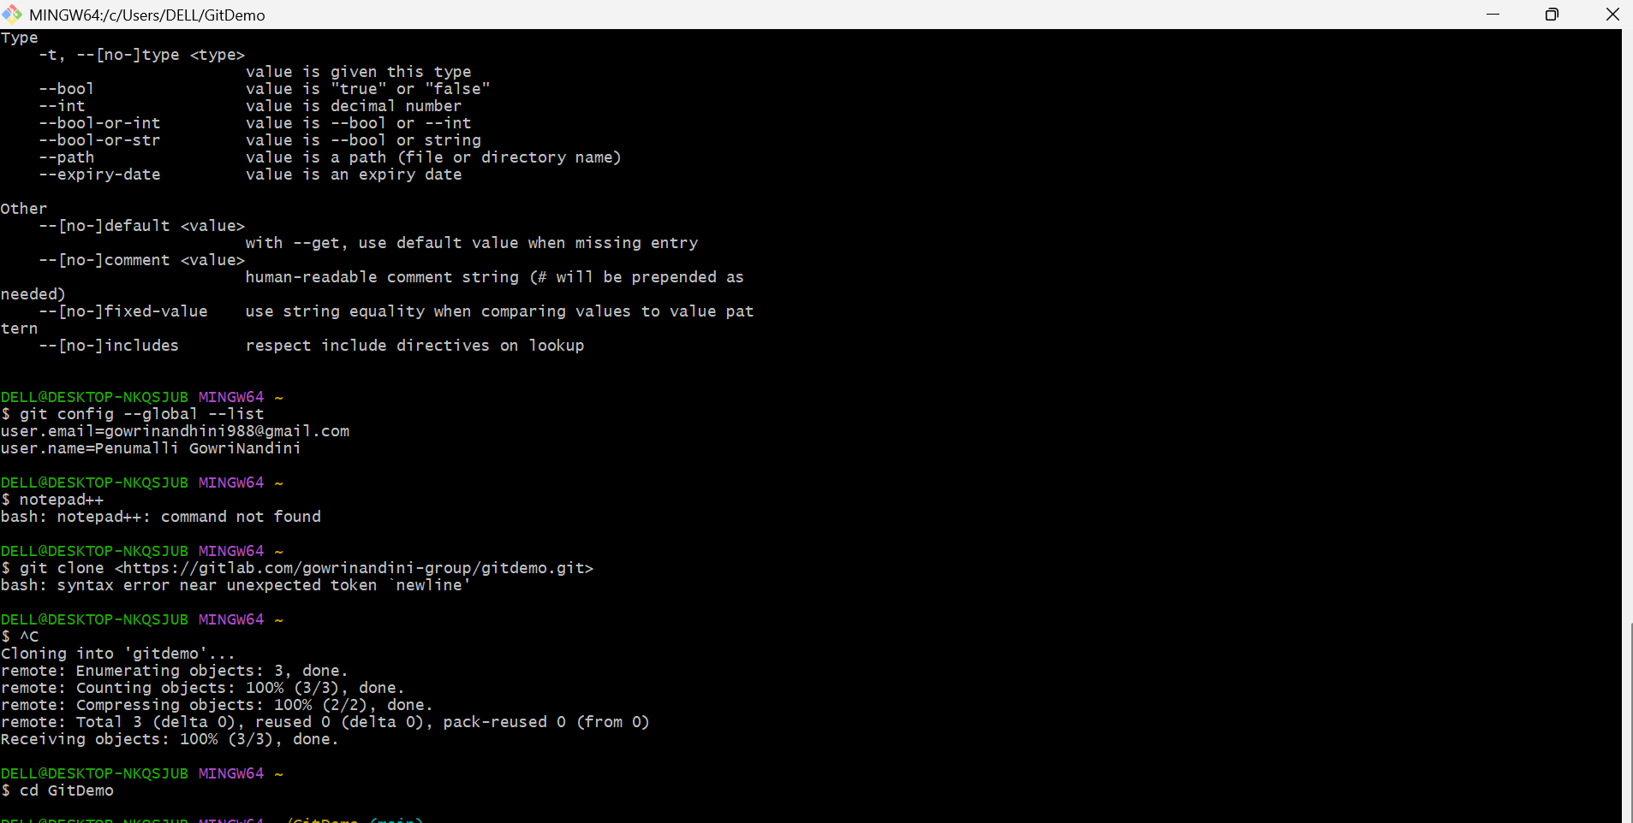

3) Test if notepad++ is recognized
Type:
bash
CopyEdit
notepad++
- If Notepad++ opens, great — skip to step 5.
- If you get bash: notepad++: command not found, try launching by full Windows path in Git Bash:
Common path (64-bit):
bash
CopyEdit
"/c/Program Files/Notepad++/notepad++.exe"
Or 32-bit:
bash
CopyEdit
"/c/Program Files (x86)/Notepad++/notepad++.exe"

4) (If notepad++ not recognized) Add Notepad++ to PATH (recommended via GUI)
GUI steps (safe):
- Open Control Panel → System → Advanced system settings → Advanced tab → Environment Variables.
- Under User variables (or System variables) select Path → Edit → New → paste:
makefile
CopyEdit
C:\Program Files\Notepad++
(or C:\Program Files (x86)\Notepad++ if that’s where it is)
- Click OK → open a new Git Bash window (changes apply only to new shells).
Alternative command-line (less recommended):
bash
CopyEdit
# Warning: setx modifies PATH persistently; use GUI if unsure.
cmd.exe /C "setx PATH \"%PATH%;C:\Program Files\Notepad++\""
After adding to PATH, open a new Git Bash and run:
.
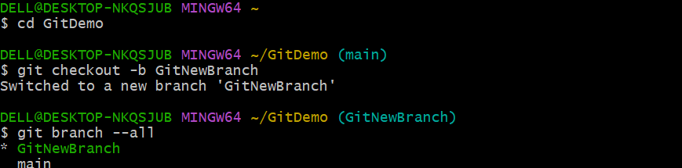

5) Configure Git to use Notepad++ as the default editor
Use the correct path for your installation. Copy one that matches your system:
Windows-style path (safe for Git on Windows):
bash
CopyEdit
git config --global core.editor "'C:/Program Files/Notepad++/notepad++.exe' -multiInst -nosession"
OR (if using Program Files (x86)):
bash
CopyEdit
git config --global core.editor "'C:/Program Files (x86)/Notepad++/notepad++.exe' -multiInst -nosession"
Verify:
bash
CopyEdit
git config --global core.editor
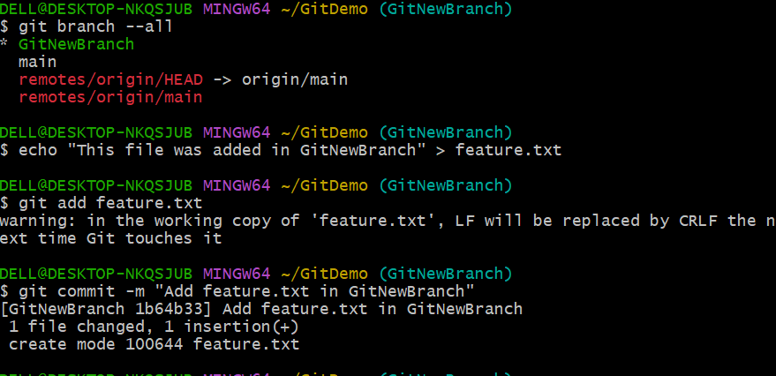

Explanation: -multiInst -nosession tells Notepad++ to open a new instance and not restore previous files — useful when Git opens it for commit messages.

6) Create a demo repo/file and commit (use Notepad++ to edit commit message)
If you already cloned your repo, cd into it. Otherwise do a quick local repo test:
bash
CopyEdit
# new local repo test (or cd to your cloned project)
mkdir git-demo-test
cd git-demo-test
git init

# create file
echo "This file was added in GitNewBranch experiment" > example.txt
git add example.txt

# commit without -m to open the editor (Notepad++ should open)
git commit
When git commit opens Notepad++:
- Type your commit message (e.g. Add example.txt for Notepad++ integration test)
- Save (Ctrl+S) and close Notepad++ → Git will finalize the commit.
Alternatively commit with message inline:
bash
CopyEdit
git commit -m "Add example.txt (Notepad++ integration test)"
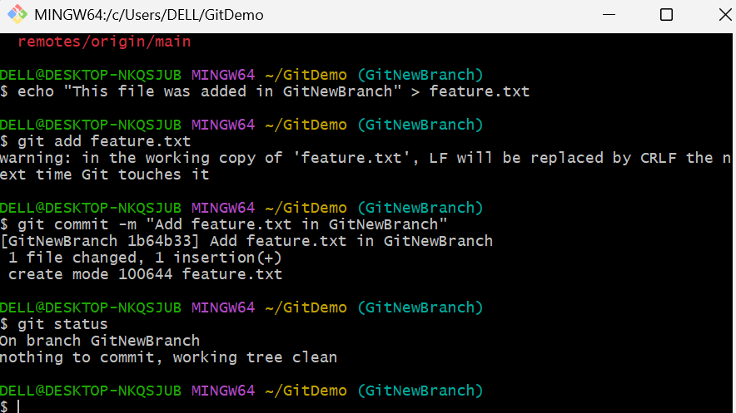

7) Final verification
bash
CopyEdit
git status
git log --oneline -1
