Blackboard Learn (9.1) is the new virtual learning environment being rolled out to replace the old BlackBoard Vista system. The VLE will continue to be known as Weblearn at London Met.

The aim of this guide is to introduce some of the new and improved Tools and features of Blackboard Learn which can be used to enhance student Collaboration and Group work. The main focus will be on using the Groups tool.

* It is recommended that you use this guide after you’ve completed the first 2 introductory sessions to Blackboard Learn created by CELT eLearning – ‘Getting your Module Ready’ and ‘Managing your Module’.

To access BB Learn: https://bblearn.londonmet.ac.uk + London Met Username & Password or through Metranet  Weblearn  Log in to New Weblearn

Table of Contents

1. Setting up groups 2
Create a Single Group 2
Making Groups Available 3
Create a Group Set 5
2. Group tools 6
3. Group Assignments 8
Test yourself 11

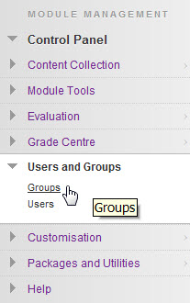
What are Groups in BB Learn?

The Groups tool in Blackboard Learn provides an online space which can be very useful when organising any kind of group work for students, such as a collaborative project, some shared research or a group presentation. It is easy for the Instructor to set up and manage groups, and students can be given access to a wide range of communication, file-sharing and reflective tools.

To access Groups, go to your Control Panel at the bottom left of the module you are in  Users and Groups  Groups.

1. Setting up groups
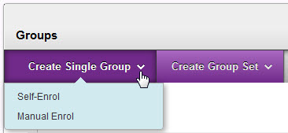
The first thing to decide is how many groups you are going to need. Do you need to create just one group (Single Group) , or a set of groups (Group Set)?

Types of Group

When you create either a Single Group or a Group Set, there are two options in common: Self-Enrol and Manual Enrol.

Self-enrol: This option allows the instructor to set up a group or groups (decide on number of members, title of group etc.) without having to choose which students to put in each group. The group/groups are made available and students can choose which one they sign up to using a Sign-up sheet. This can also be useful when you want to create a set of groups dealing with different topics or aspects of a topic, and you want to allow students to choose which one they are interested in and then sign up for the relevant group.

Manual Enrol: This option allows the instructor to set up a group or groups and select which students to put in each group from a list of all students enrolled on the module. Obviously this may not be practical if the module has a large number of students, but for smaller modules it is a useful option to have.

Create a Single Group

Self-enrol

- Group Information – Enter a Name and Description. The description should briefly describe what the group is for as it will appear to the student. The Group is made available by default. If you want to keep groups hidden until a later date, select No under the Group description box.
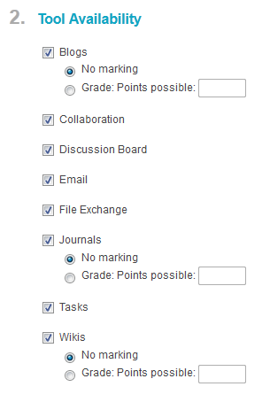
- Tool Availability - The next decision you have to make is which Tools you are going to make available to the group members. This depends on the type of work you want the group to do, how (or if) you are assessing the Group work and so on. There are 8 tools available, and the default settings make all of them available. However, it is probably not a good idea to make all of them available as you risk overwhelming your students. It is preferable to decide on perhaps 2 or 3 tools, and then encourage students to use these. You can do this by making sure you refer to the tools in face to face sessions and, if necessary, showing students how to use them. If you choose to allow Blogs, Journals or Wikis, you can also assign a grade (even if this is just a nominal number of points to encourage participation).

- Widget Personalisation Settings - this simply allows students to individually add Widgets to their own group page. For example, they might want to add a little box showing ‘My Tasks’ to help them organise their work for the group. It also allows group members to customise the appearance of the banner and group homepage.

- Sign-up Options – The Sign-up sheet is what students will use in order to enrol on a group. Every self-enrol group must have a Sign up sheet. You can write very basic instructions in this box e.g. “Sign up for your group by clicking the Sign-Up button below”. Underneath the instructions box you’ll see two options. The first allows you to choose the maximum number of members you want in your group. The second allows you to make the group available from the Groups page (see Making Groups Available).

- Submit – when you’ve created your Group, click Submit and it will be available to students.

Manual Enrol

The first 3 steps are the same as for Self-enrol. Give your Group a name and description, set its availability, decide which Tools are available to members and whether to allow personalisation.
The next step is the ‘manual’ part – you need to select from the users enrolled on the module who you want to be in the group. Select a user in the left-hand box (hold down Ctrl and select for more than one, or use the Select All option to select all the users. Then click on the arrow to the right to select them.
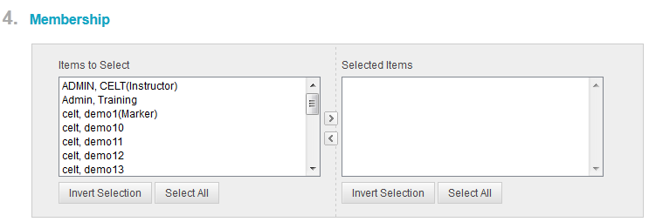

Finally, click Submit to create your group.

- You can add or remove users after you have created a group (both self-enrol and Manual groups) To do this, go to your Groups page through the Control Panel, then click on the Group you wish to change members for. Click the drop-down arrow next to the Group name at the top and select Edit.

Making Groups Available

When you create a Self-enrol group, your students will need to see it when they are in the module in order to sign-up for it. There are a number of ways to do this.

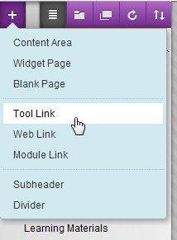
- Create a Groups link on the Module Menu.

If you use Groups regularly in a module, it’s worthwhile creating a Groups link on the menu for your students. To do this: 
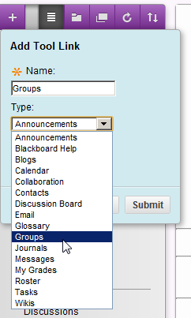

Click on the + sign at the top left of the Module Menu and select Tool link. Select Groups from the drop-down arrow and give it a name (e.g. Groups). Check the ‘Available to Users’ box, then click Submit. Use the drag and drop functionality to position the new Groups link where you want it to appear on the menu.

Alternatively, if you are just using Groups for one specific task or project, you might want to create a link to your Group in a Content area, along with the relevant information or assignment.
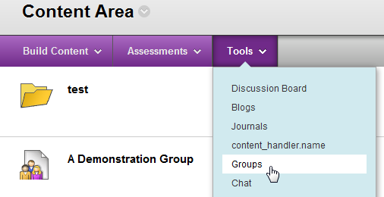

From inside a Content Area, Content Folder or Learning Module, select Tools then Groups.

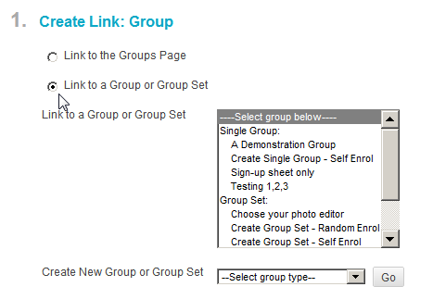

You can either link to the Groups Page where the student will be able to see all the groups they belong to.

Alternatively, you can link to a specific Group or Group Set which you can select from a list.

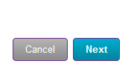
When you’ve selected the option you want, click Next, then Submit.

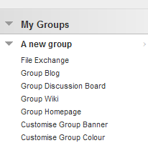
Once a student has signed up for a group, a link called ‘My Groups’ is automatically created at the bottom of the menu they see. This link gives the student quick access to all the functions of the group. 

Create a Group Set

Self-Enrol

The steps for creating a self-enrol Group Set are the same as those for creating a self-enrol single Group, except for one additional step which allows you to choose the number of groups you want to create.
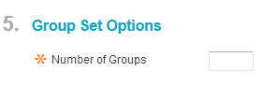

Manual

The steps for creating a set of Manual groups are also the same as for a Single group, except for the additional step of choosing the number of groups and you also need to click Submit to go to the page where you can manually add students to your groups:
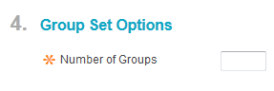

After you click Submit, you will need to complete 2 more steps..
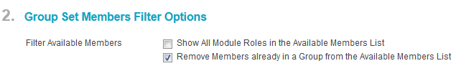

Checking the first box means that user roles will be shown in the box which you select them from. By default it is not selected.
The second box IS selected by default. This means that as you add members to groups, these members are removed from the list available to add to subsequent groups.

Group set enrolments

This is where you choose the users you want to put in each group. You can change the name of each group. If you decide at this point that you want to Add another group, you can do so by clicking Add Group. You might also decide that you don’t want to manually enrol members in groups and you want them to be automatically (randomly) enrolled. You can do this by selecting Randomise Enrolments. Finally, click Submit and your groups will be created.
(Remember: you’ll need to make sure they are available to your students.)

Random enrol

The third option for Create Group Set is Random Enrol. This is particularly useful if you have a large number of students in your module and don’t want to manually enrol all of these students in groups. Students will be randomly assigned to groups, and all you need to do is choose how many students you want per group, or the number of groups you want.

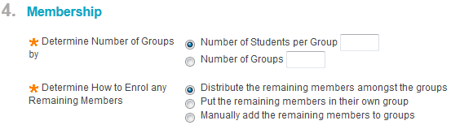

Any outstanding users can be manually added to the groups which have been randomly created, or they can be distributed amongst the groups automatically.
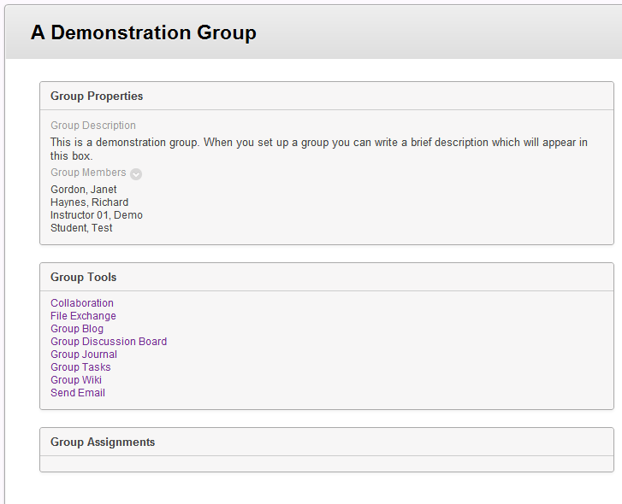
The group will appear something like this to your students.

There is a group description and list of members in the group.

The Group Tools box shows the tools available to students and allows them to access those tools (private to their group)

Any assignments which have been set for the group will be accessible in the final box.

2. Group tools

There are 8 different tools which an Instructor can choose to make available to students. Three of these tools, Blogs, Journals and Wikis allow the Instructor to assign Grades to the content.

The following descriptions of each tool are taken from Blackboard’s online Help pages:
- Group Blog: Users within the group can add entries and comments to the Group Blog to share ideas. you can grade Group Blogs, but once a Group Blog is set to be graded, it cannot be changed.
When a grade is added for a Group Blog, the grade is automatically given to all the members of the group and is populated in the corresponding column in the Grade Center for each group member. All members are assigned a grade, regardless if a member did not contribute. You can edit an individual member’s grade to assign a different grade than the group’s.
- Collaboration Tools: Users within the group can create and attend real-time chat or Virtual Classroom sessions.
- Group Discussion Board: Users within the group can communicate as a group, as well as create and manage their own forums. The Group Discussion Board is available only to group members, not to the entire course.
- Email
- File Exchange: Users within the group and instructors can use this tool to upload documents to the group area. All group members and the instructor can add files. They can also delete files, regardless of who added them. Files appear in the order they were uploaded. This tool is only available to groups.
- Group Journal: Users within the group can share their thoughts with each other and communicate with the instructor. Journal entries made in the Group Journal are visible to all group members and the instructor. You can grade Group Journals, but once a Group Journal is set to be graded, it cannot be changed. When a grade is added for a Group Journal, the grade is automatically given to all the members of the group and is populated in the corresponding column in the Grade Center for each Group member. All members are assigned a grade, regardless if a member did not contribute. You can edit an individual member’s grade to assign a different grade than the group’s.
- Group Tasks: Users within the group can define and separate the workload into tasks, while distributing the list to the entire group. Each task has a status and a due date to help keep members on track. Group members can view the group assigned tasks in the Group Tasks tool or in the Course Tasks tool. Other course members and the instructor will not see tasks for groups they are not enrolled in when viewing the Course Tasks tool.
- Group Wiki: Wikis are used to create a collaborative space for group members to view, contribute, and edit content. By default, Group Wikis can be read by all course members, but only members of the group can make a comment on a Group Wiki page. An instructor can change the default setting to allow only group members to view a Group Wiki. You can grade Group Wikis, but once a Group Wiki is set to be graded, it cannot be changed. When a grade is added for a Group Wiki, the grade is automatically given to all the members of the group and is populated in the corresponding column in the Grade Center for each group member. All members are assigned a grade, regardless if a member did not contribute. You can edit an individual member’s grade to assign a different grade than the group’s.

Tools can be enabled when you first create a Group.

The choice of tools will depend on the kind of project or work the group are doing, the learning outcomes of the work, how it fits in with the assessment objectives of the module and the role you want to take as Instructor.

You can use tools to keep track of the participation of different students in a group. You might want to take a more active role in a group, adding comments to discussion forums for example, or take more of a backseat. Either way, it’s a good idea to ensure that you make it clear to students what is expected of them in terms of the use of these tools. If you have face to face time with students, try to refer to Blackboard and the tools
you want students to use, and demonstrate if you can.

- It’s important to realise that the grade assigned by the Instructor to any of these group tools will be the same for all students. However, it is possible to change an individual student’s grades through the Grade Centre.

3. Group Assignments

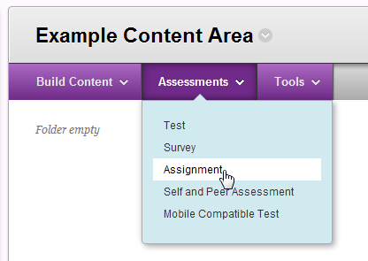
An assignment can be made available to groups, instead of everybody on a module, for example if you need to set up different assignments for different groups.

Group Assignments are created from the same place as any other Assignment – from the Action
Bar visible from inside any Content Area, Content
Folder or Learning Module.

Go through Steps 1 – 5 to create your Assignment as normal. The only difference is when you get to Step 6 where you need to select Groups of Students.

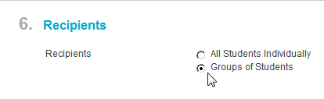
When you select this option, you’ll see a box from which you can select the group or groups to make the Assignment available to. You must have already created Groups in order to see this box.

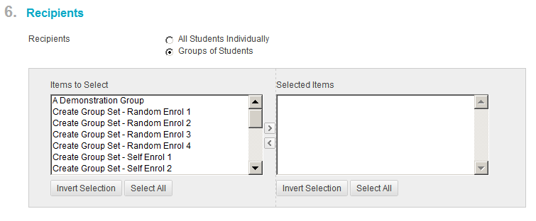

Highlight the group or groups you want the Assignment to be available to, then click the arrow to select.

Once you have created the Assignment, it will be available for the student in one of two ways. From the Content Area in which the Assignment was set up. The Assignment which shows to the students in a content area will depend on which group they are in. i.e. If there are 5 groups and the Instructor sets a different assignments for each group, then any student in Group 1 will see Group 1 assignment, in Group 2 – Group 2 assignment etc.

A Group Assignment can also be accessed by the student from the Groups Homepage available under MyGroups on their module menu. Again, this will only show the Assignments which have been set for that particular group.

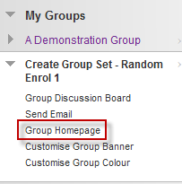

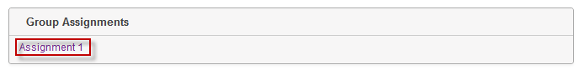


A column will automatically be created for your Group Assignments in the Grade Centre.

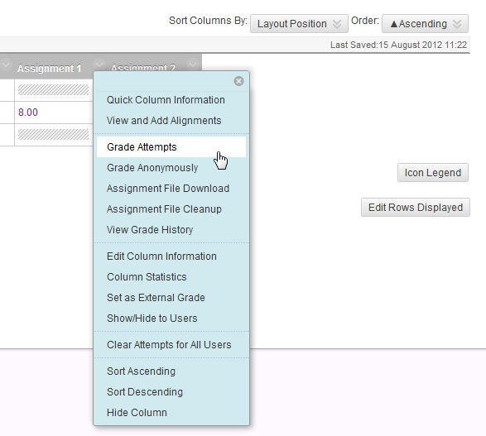
You can either click on Assignments or Full Grade Centre under Grade Centre in the Control Panel.

Find the relevant Assignment, then click on the small arrow at the top of the Assignment column and select Grade Attempts. This will allow you to give a grade for the whole group and to add a comment which will be accessible to everyone in the group.

For inputting individual Grades, just click in the column next to the student whose grade you want to change and enter their grade manually.
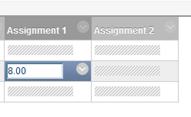

Setting up Tutor Groups
Sometimes you might want to set up a group simply to help you keep track of your own students within a module (if you are teaching on a large module with several instructors), or create separate groups for marking or giving feedback. This can help prevent the scenario of having to search through hundreds of students each time you want to find your own to give feedback, send an email etc.

To set up a ‘tutor group’ like this, simply follow the same procedure for setting up a Manual student group (or group set if you are setting up more than one group).

*You can set this type of group to be Unavailable – if you are using it to help manage students for grading/feedback – or Available, if you want to send Email to your group.

Follow the steps below to set up your tutor group(s).

- In the Control Panel, select Groups to take you
to the Groups page of your module.

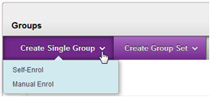
- To create a single Group, select the Create Single Group > Manual Enrol.

- On the Group Information page, fill in a name (for example Tutor Group + your initials) and add a short description.

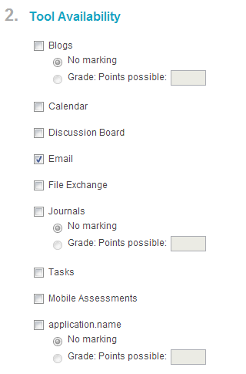
- Underneath the description you have the option to make the group Available. The default is set to Yes. If you want to use the Email tool to email your own group of students you will need to leave this as it is so the Group is available. If you don’t need to email your Tutor group then you can set the group to ‘unavailable’.



- For a Tutor Group it’s probably a good idea not to make any of the Tools available, unless you want to use the Email function. If you do then select Email in Step 2 ‘Tool Availability’, but uncheck all the other tools.

Nb: If you make your tutor group available, students WILL be able to see it as a My Groups link will automatically be created at the bottom of their menu. You need to make it clear that this group is solely for your own administrative purposes – stating this clearly in the Group Description (see above) is a good idea. If you are using other groups with students which involve them participating and collaborating with each other, make sure they’re clear which group you want them to use.

- In Section 3, uncheck Allow Personalisation in ‘Widget Personalisation setting’

- In Section 4 – Membership – select the students you wish to include in your group then click the > arrow in the middle between the two boxes:

- Click ‘Submit’ and your group is ready to use.

To create more than one Tutor Group at a time, select Create Group Set > Manual Enrol.

Give the Group Set a generic name such as Tutor Groups and fill in the same steps as for creating a Single Group. In Step 4, select the number of groups you want to create.

When you Submit, it takes you to a page where you can give each group a name (the default is just to number them Tutor Group 1, Tutor Group 2 etc.) You might want to add each tutor’s initials.

You can manually add the students to each group on this page.

*Tutor Groups can be used together with the Smart Views feature of the Grade Centre and also with Adaptive Release.

Smart Views help you filter the students in a module to show only those students assigned to your Tutor Group – very useful when it comes to grading student work or giving feedback.

For more on using Smart Views have a look at the following Youtube video:

Using Smart Views in the Grade Centre

You can also set any type of content or tool created in a Content Area to be released/shown only to certain groups by using the Adaptive Release feature.

The Blackboard On-demand Learning Centre gives the following advice about using group assignments:

Prerequisites and Cautions
- A module group must exist prior to creating any group assignments for it.
- Students who are enrolled in more than one group receiving the same assignment will be able to submit more than one attempt for this assignment. It may be necessary to provide these students with an overall grade for the assignment.
- Students who are not enrolled at the time that a group assignment has been submitted do not have access to that submission. These students can see only that the submission occurred.
- Students who are removed from the group cannot see the group assignments. They can access their submissions from My Grades.
- If the assignment is edited between creation and the due date, the entire group may lose any work already in progress.
- If a group is deleted from the assignment after they have begun the work and prior to submission, they will lose access to the assignment and lose their work.

Test yourself

- What is the difference between Self-enrol and Manual enrol?

- If you don’t want the hassle of manually enroling all your students in groups, what option can you choose?

- How can you make a group invisible to students? Why would you want to do this?

- When you are creating a Group Set, how can you determine the number of students in each group?

- If you want to send an email to students in a Tutor Group, what do you need to make sure when creating your group?

- How can using Smart View with Tutor groups help with the grading process?

