The new Journals tool in Weblearn can be used to help organise and deliver formative feedback to students on an individual basis. It has several advantages:

- A secure online space for feedback inside the university VLE
- A chronological record of feedback given
- Increased teacher-student dialogue
- Increased opportunities for student reflection and ‘deep’ learning

Journals can be seen as one useful tool in the feedback process, but may not be suitable for all types of feedback. Whether they are used, and the way they are used will depend on the particular faculty and their own assessment and feedback strategies.

NB: In order to set up Journals for individual students, it is important to use the Journal Tool and NOT the Group Journal which is available when creating groups. Any Group Journal set up can be read by all members of a group and is therefore not private.

How to set up journals for individual feedback

The steps to set up Journals for feedback are outlined below.

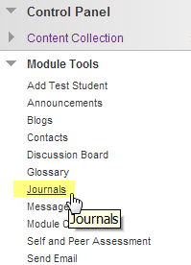
Steps:

1. Create a new Journal

Go to Module Tools in the Control Panel of your module.

Click on Journals.

From the Journals page go to Create Journal and set up a new instance of the tool for your students.


If you are working in a module with multiple Instructors and groups of students, it will be useful to agree on a name to give to these Journals. For example, they could be named numerically e.g. Tutor Group 1 feedback, Tutor Group 2 feedback etc. Alternatively, you could put the each tutor’s initials or name to help distinguish the groups e.g. JP Tutor Group journal, SG Tutor Group journal etc.

Fill in the basic information required for steps 1, 2 and 3 (Name, Instructions, Date & Time options.

Steps 4 and 5 allow you to decide how much control you give students over their own journal entries, how often the entries are archived and also whether you want to assign a grade to an individual student’s journal.

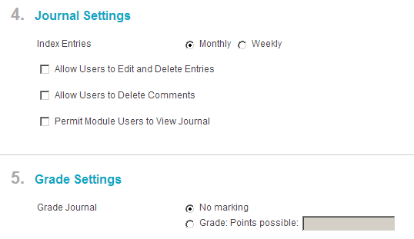
Journal entries can be indexed either on a monthly or weekly basis. After they have been indexed the entries can be accessed from the side menu on the right (rather like the way some blogs are organised).

If you want to assign a grade to the Journal (for example if you want to encourage students to reflect on their own learning through the journal) then you can assign a certain number of points.
This will create a column in the Grade Centre.

- Create a Content Area or add to an existing Content Area

From the Module Menu, click on the + sign and create a new Content Area.
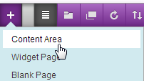
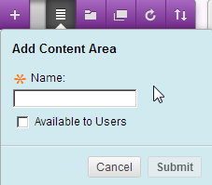

You can call this Content Area something like Student Journals, Feedback or Feedback Journal depending on how you intend to use the Journal.

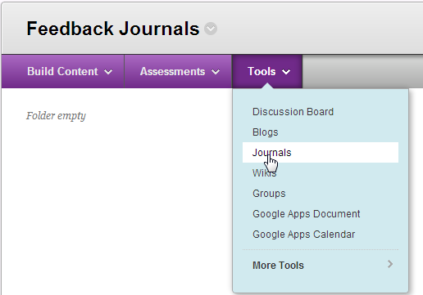
Click Submit and a new link appears at the bottom of the menu. Clicking on the link will take you to your newly created empty Content Area.

From here you need to select Tools  Journals.

This allows you to create a link to the Journal which you have just created in Step 1.

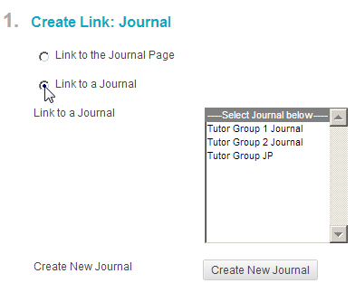

Select the Link to a Journal radio button, then highlight the relevant Journal and click Next.

If you want to give a brief description of the purpose of the journal, you can add Text in the box. Click Submit.

You now have your Journal set up in a Content Area.

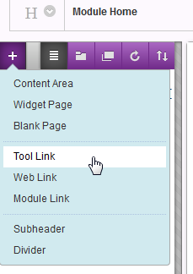
NB. It is also possible to create a Journal directly from here by clicking on Create New Journal then following steps 1 – 5 in Section 1 above.

- If you want to put a link to the Journal on your Module Menu to make it easier for your students to find, follow the steps below.

  - Click on the + sign at the top of your menu

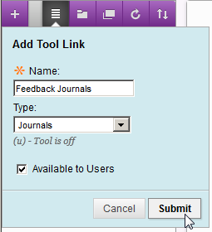
  - Give the tool a name e.g. ‘Feedback
Journals’, select the type of tool (Journals)
and select Available to Users then Submit.

3. A link is created on your menu (at the bottom)
Which you can then position where you like.


