**A quick guide to show you how to set up a basic Discussion Forum in Weblearn**

**Discussion Boards**

In Weblearn**, Discussion Board** is the name of the Tool which can be used to create **Discussion Forums** which, in turn, can contain various different **Discussion Threads**. A Discussion Board can contain as many Discussion Forums as the Instructor decides are necessary.

An online discussion **Forum** is simply a place where students (and Instructor) can discuss topics, ask questions and reply to each other. It can be divided into separate topics by creating separate ‘threads’. One common use of a Discussion Board is for FAQs (Frequently Asked Questions). The advantage of the Discussion forum for this is that Questions (and their answers) can easily be separated. The forums can also be searched to quickly locate a particular topic or question.

***Setting up a Discussion Forum***

The **Discussion Board** is the name of the page on which discussions forums can be created. Normally each module has one **Discussion Board** in which you can create as many **Forums** as you need.

It might help to think of the **Discussion Board** as simply the space in which you can create your **Forums**. (the Board itself has no other meaning / function and you don’t need to **Create** or **Edit** the Discussion Board itself)

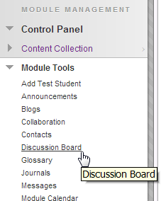The only time a new **Discussion Board** will be created is if you use **Groups** in your module, there is an option to create a space for discussion when creating each group – if this is done a separate **Discussion Board** will be created for each group.

To view the **Discussion Board** for you module, go to the **Control Panel** > **Module Tools** > **Discussion Board**.

A **Discussion Forum** can be created around a general topic or theme.

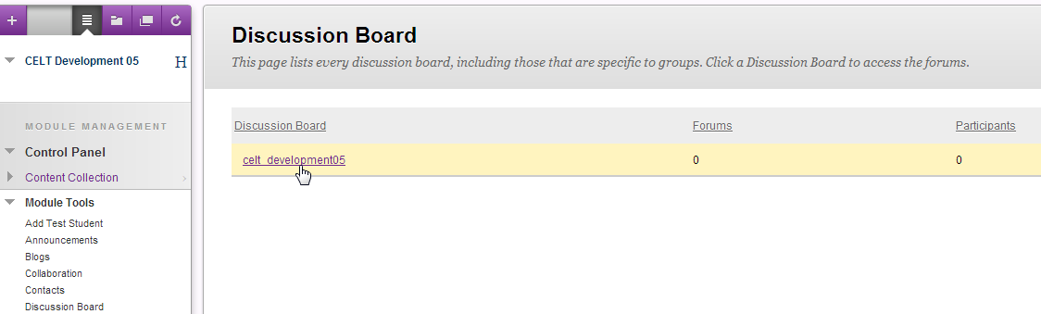In a new Module, or one in which no **Discussion Forums** have been set up, you should see something like this:

This is the link to the Discussion board for the module. Click on it to go to the board itself and start creating Forums.

In your **Discussion Board**, you can create as many **Forums** as you want.

NB. If your topic is too broad, and you have a large cohort of students, a Discussion forum can become quite difficult to manage. Think about setting up separate Forums for different topics, although you have to be careful not to end up with lots of Forums with only a few posts in each.

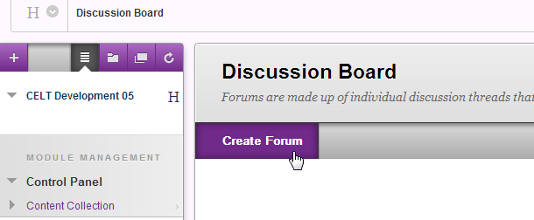**Create a Forum**

Click on **Create Forum** and you will be given a number of options:

Fill in the usual **Name**, **Description** and **Availability** options in 1 and 2.

The 3rd section gives you more options for the Settings you wish to apply to your Forum:

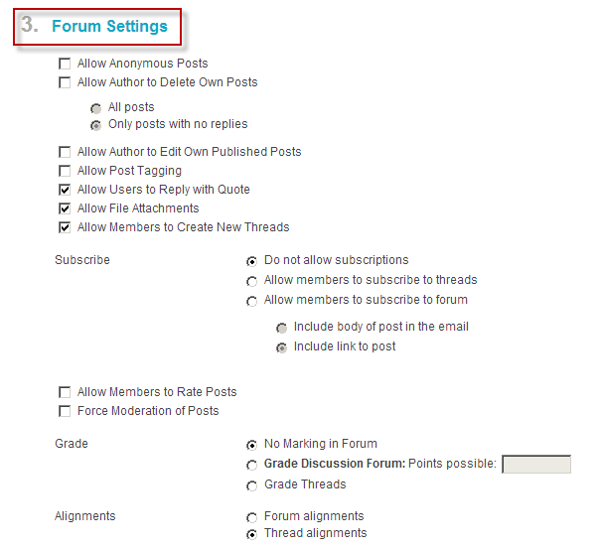

The default settings are generally OK, but you might wish to allow users to Subscribe to the forum (or even individual Threads within the Forum). You can also set a Grade for the Discussion if you think this is the best way to encourage participation.

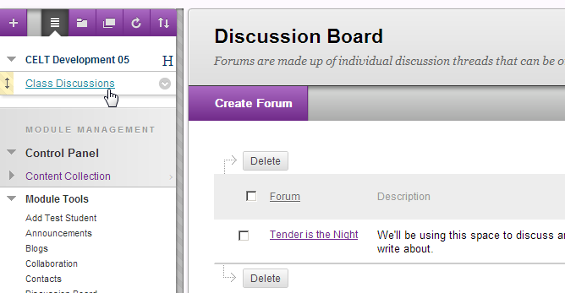

When you click **Submit**, your new **Discussion Forum** should appear on your **Discussion Board**.

**Make your Forum Available**

The next step is to make sure that your new **Forum** is available to your students (this applies to Blogs and Journals too).

In your module template, you might already have a link to the **Discussion Board** on your **Menu**. If you do, check that the forum is visible. (It’s a good idea to add yourself as a student and check from the student point of view)

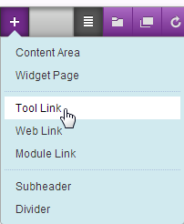

If not, follow these simple steps:

Click on the **+** at the top left of your menu and select **Tool Link**.

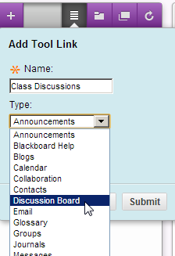

Give the link a name and select **Discussion Board** from the drop-down list.

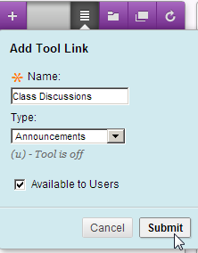

Check **Available to Users** then **Submit**.

The link should appear on the bottom of your **Module Menu**. Drag the link to the position you want it to appear. Check that the link takes you to your Discussion Board and new Forum.

You can also create a link to your **Discussion Forum** from inside a **Content Area**.

To do this, navigate to the Content Area where you want to include the Discussion forum. With Edit Mode ON, click on Tools > Discussion Board.

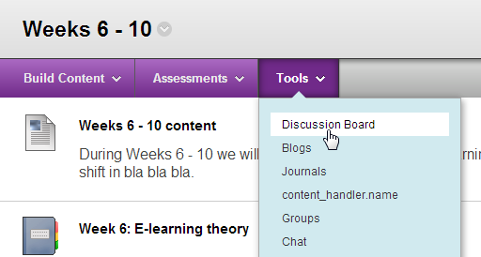

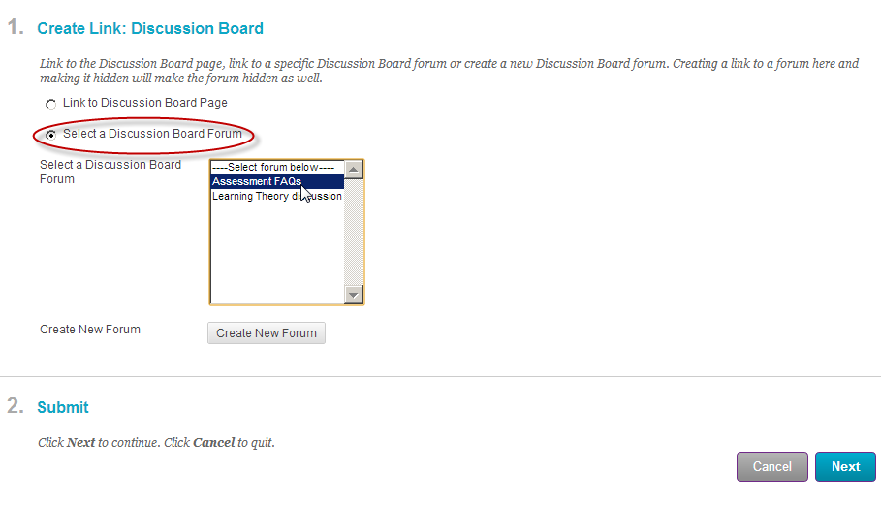After you click **Next**, you’ll have the option to include a short description of your forum which will appear with the link in your content area. Click **Submit**. Your Forum will appear at the bottom of your Content Area. Drag it to where you want it to appear. Check that you can see it by using test student.

You need to create a link to the relevant Discussion Forum. Check the option: Select a Discussion Board Forum > Click on the appropriate Forum in the box below > Click Next.

**Discussion Threads**

Within a **Discussion Forum** there are **Threads** which narrow down the focus further. A thread is a group of messages / posts all on the same topic which can be replied to by other users.

The example below is the Weblearn Staff forum (accessible from your My London Met page when you first log in). This is a fairly General Discussion Forum in which users can ask questions or post problems or issues they’re having with the system.

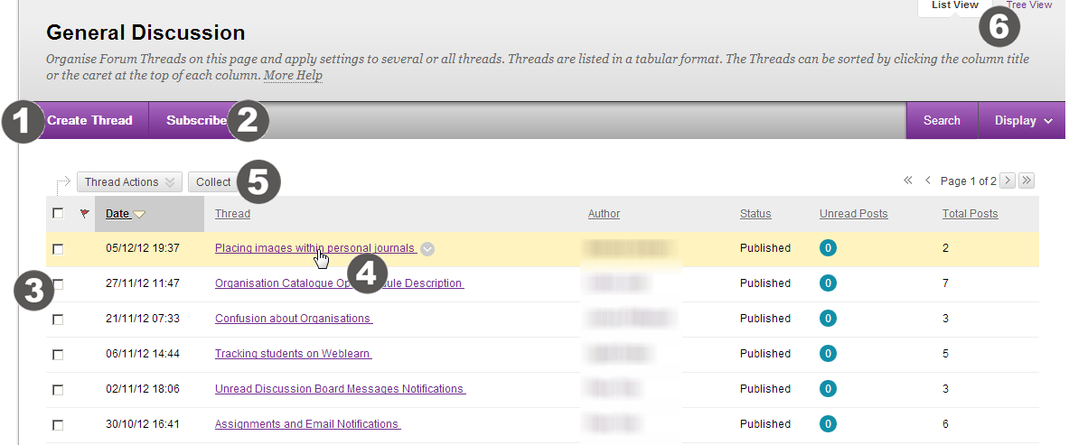

1. Any User can create a new **Thread** within the Forum.
2. Users can **Subscribe** to a Forum and they’ll get email notification when a new thread is added.
3. Check box allows for individual thread selection. Select the box in the header row to select all threads.
4. Click the thread **Title** to read the posts.
5. Select one or more threads then click **Collect** for a view of all messages in the thread.
6. View threads in either **List View** or **Tree View**. Tree View shows all messages within Threads.

You can also use the **Search** function (top right) to search for key words within a Forum.

* To avoid confusion, it’s a good idea when setting up a Forum to create an initial thread. This can simply be a short introductory sentence or two, a question or anything you want really.