Dhrityshree Goswami
Senior Associate https://www.linkedin.com/in/dhrityshree-goswami-78a6a7165

PROFILE SUMMARY

I have experience in various firms including two Big 4's where I was in the position of a Senior Associate level 3 in my last organisation for US Direct Tax Form 1065 and Form 1120 for both federal as well as states. I also have experience in using the following software like Gosystem, Onesource, TRACK (I was a specialist in using this software in my previous organisation which was used to prepare the K-1 / K-3 packages). I myself have also experience in preparation of the forms like 8825, 5472, 1120, 1120s, 4562, 4797, 1042, 1042-S, 8804 and 8805 etc. While preparing
the returns I also prepare the macro enabled work papers like 1065 RE workpaper and various other work papers.

EDUCATION

2018

2015
MBA/PGDM

don bosco institute of management

B.Com

K C Das Commerce College, Guwahati

WORK EXPERIENCE

Nov 2023 - Sep 2025

Aug 2022 - Nov 2023

Sep 2019 - Aug 2022
Senior Associate

PwC US LLP
Worked in the role of Senior Associate for the PCS for Florida market team having majorly worked for the partnership clients. Was also a TRACK software specialist which was specifically used for the preparation of the K-1 / K-3 packages.

Senior Associate

Grant Thornton
I joined as a Senior Associate for the US tax partnership team.

Advanced Analyst

EY
I worked for the US Direct Tax Non-FSO team, EY GCR team where my major role was to prepare the macro enabled workbooks as well as 1065 RE tax returns for both Federal as well as multiple State Jurisdictions.

Projects

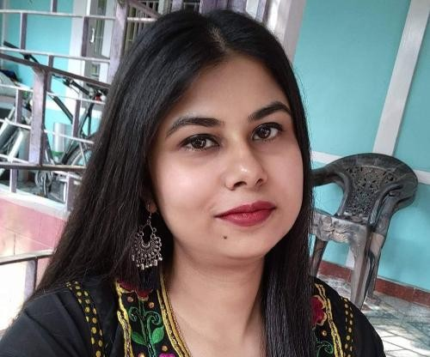
61 Days
PERSONAL INFORMATION
Email
dhrity01@gmail.com

Mobile
(+91) 7577915429

Total work experience
6 Years 0 Month

KEY SKILLS
compliance

us gaap form 1065 us tax return
journal entries balance sheet accounting finance
form 1120

us partnership tax Gosystems Onesource Advanced Excel VLOOKUP
Pivot Table
OTHER PERSONAL DETAILS
City
Guwahati

Marketing Analysis on New Product Development (Tropicana Frutz - 250ml)
We were required to conduct a retailer and consumer survey

understanding their perception regarding the newly relaunched product - Tropicana Frutz 250 ml.
Country
INDIA
LANGUAGES
English
Hindi Assamese Bengali

ROLES AND RESPONSIBILITIES

I was in the role of a Senior Associate L3 thereby supervising and supporting my 1065 OP team as well as 1120 and 1120s team during non partnership season in a ratio of 50:50 in order to deliver both Fed and State extensions and returns to our US counterpart. I were also a specialist in using the organisation specific K-1/K-3 package tool in order to prepare the K-1 packages in my previous organisation. I had two assigned buddies under me who were directly reporting under me and I also used to guide and mentor any other preparers having any 1065 related doubts even though they are not working alongwith me in my assigned client. Me being in the position equivalent to an Assistant Manage, I also got opportunity to directly work under US seniors and managers without having any Indian Manager above me and were able to deliver my work successfully. I have a total of about 3.5 years of reviewing experience.

LinkedIn:- https://www.linkedin.com/in/dhrityshree-goswami-78a6a7165

