CONTACT
+91-9944696476
kannansuriya97@gmail.com
26/15, Aandal nagar Uppulipalayam(po) Coimbatore(dt),Tamilnadu 641015
L :linkedin.com/in/kannan-m-570629125
EDUCATION

KANNAN M
Data Annotation

PROFILE SUMMARY
Experienced Data Annotation & Quality Analyst with 4+ years of hands-on work in building high-quality datasets for computer vision and AI systems. Skilled in analyzing image, video and LiDAR inputs,data annotation, and content review identifying edge cases, and maintaining consistent labeling standards across large projects. Strong record in improving workflows, fixing quality gaps, supporting team members, and delivering datasets that enhance model performance.

WORK EXPERIENCE

Objectways Technology- Quality Analyst- Annotation(4 Years) 2021 Dec - 2025 Oct | Coimbatore
2D Annotation: Annotated images and videos for object detection, image segmentation, and key point labeling (e.g. facial landmarks, vehicle recognition).
3D LiDAR Annotation: Worked with LiDAR point cloud data,annotating 3D structures, buildings and terrain for geospatial and autonomous vehicle projects.
Performed quality assurance and content validation for AI training datasets by reviewing annotations, ensuring text accuracy, formatting consistency, and adherence to labeling guidelines.

Bachelor of Engineering (B.E – ECE)
- V.S.B Engineering College
- 2014 – 2018 | 68%

Higher Secondary (HSC)
- Bharani Park Matric Hr. Sec. School
- 2013 – 2014 | 81%

SSLC
Govt Hr. Sec. School 2011 – 2012 | 76%

HARD SKILLS
- Autonomous Driving Annotation
- Quality Review
- Dataset Validation
- Annotation Guidelines

SOFT SKILLS
- Team Handling
- Adaptability & Flexibility
- Effective Communication
- Time Management
- Problem Solving Skills

ACHIEVEMENTS

Polygon & Polyline Segmentation: Created polygons and polylines for object boundaries, road lanes and other structured annotations in satellite imagery and maps.
Content Moderation: Reviewed user content for compliance with platform guidelines, ensuring safety, quality and appropriate engagement.
Lane Annotation: Focused on annotating lane markers for autonomous vehicle datasets.
Sourcing: Managed document and image sourcing for AI/ML datasets, including multi-language text and financial records, ensuring data quality and consistency.
Bounding Box Annotation: Skilled in creating accurate bounding boxes for images and videos, ensuring precise labeling and high-quality datasets.
Computer Vision AI Projects: Expert in computer vision AI projects by annotating image and video datasets using CVAT tool. (e.g. Object Detection (car, person, bike, etc.), Video Tracking, Image Classification).

Tools
AWS Sagemaker CVAT
Encord
Supervisely

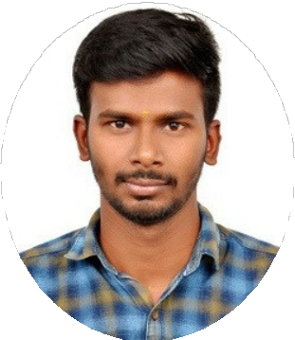
- Led quality assurance for computer vision and content moderation projects (2+ years).
- Contributed to 20+ international AI/ML projects.
- Maintained 98%+ accuracy per platform guidelines.

