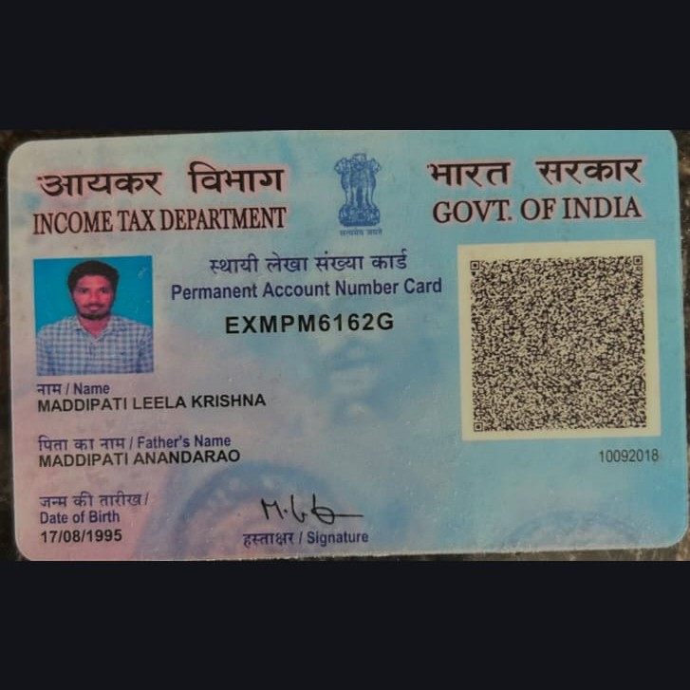
Candidate's Full Legal Name (as it appears on PAN) | Maddipati Leela Krishna
Supplier Name (Registered Name) | People-Prime Worldwide
Worked for CG previously? (IF yes share CG Employee ID/GGID required) | No
JOB Posting ID | CGEMJP00340679
Contact No (10 Digit No)8149830478 | 8179698527
Email ID | leelamkrishna591@gmail.com
Job Location (Work Location) | Telungana
Notice Period (Immediate/ Notice to Serve) | Immediate
Highest Education (Regular or Distance) | B.tech 2021
Employment Detail – Last 2 yrs Working period (Payroll Company)People GroupCAGL | Krish Technologies
College & University Full Name - | B.Tech Narayana Engineering College, Nellore
Mandatory Skills & Experience  (quick checklist – verify each skill, years of experience) | Total 7years  Ms CRM 6yrs
“Secondary” Skills & Experience | Total 7years  Ms CRM 6yrs
Key Remarks (Supplier Comment) | Candidate Good at Communication Skill.  he is with 7years of Total experience and Relevant experience in “Ms CRM”, is 6 years.

Microsoft Dynamics 365 CE Technical Leela Krishna M
leelamKrishna591@gmail.com
+91 - 8179698527
PROFESSIONAL SYNOPSYS

- Total 6.11 Years of IT experience, including 5 years of hands –on experience in Microsoft Dynamics 365 CE Technical.
- Experienced in working across all phases of the Software Development Life Cycle (SDLC) including requirement analysis, development, deployment, and support.
- Good experience on Sales, Customer Service, and Field Service modules in Dynamics 365 CE.
- Proficient in designing, customizing, configuring, and implementing Dynamics 365 CRM solutions.
- Hands-on experience with Microsoft Power Apps and Power Automate for building applications and automating business processes.
- Developed client-side customizations using JavaScript to enhance user experience and application functionality.
- Experienced in system configuration including Business Units, Security Roles, Field Security Profiles, Teams, Users, Access Teams, and Data Management (Import/Export).
- Proficient in creating, managing, and deploying Managed and Unmanaged Solutions across environments.
- Strong experience in developing and deploying Plugins and Custom Workflows to implement complex business logic.
- Hands-on exposure to Azure services for integrations, deployments, and cloud-based solutions.
- Strong analytical, problem-solving, and communication skills with the ability to collaborate effectively in team environments.
- Experienced in gathering client requirements, analysing business needs, and delivering scalable CRM solutions.
- Self-motivated professional with a continuous learning mindset and adaptability to new technologies.
TECHNICAL SKILLS
- Technology : Microsoft Dynamics 365 CE Online
- Power Platform : Power Apps, Power Automate Flows
- Database : SQL
- Server Programming Languages: C#.NET, HTML
- Tools : Visual Studio, XRM Toolbox, Plug-registration Tool, Fetch XML
EDUCATION

- Completed Diploma in the year of 2016
- Graduated B. Tech from Narayana Engineering College in the year 2021.
WORK EXPEREINCE

Organization | Designation | Time period
Krish Technology Pvt Ltd | Software Engineer | August 2023 - Present
Cyber Village Solutions Pvt Ltd | Software Engineer | July 2019 - August 2023

PROJECTS RELATED

4.Project Name | Enforcement Casework Transformation (ECT)
Role | CRM Developer
Environment | Microsoft Dynamics 365 CRM CE online, Power Apps, Power Automate Flows, Plugins, Data verse, JavaScript, XRM Toolbox.
Project Description | The client aims to make every journey safer, greener, and cleaner while keeping customers at the core of operations. The initiative focuses on delivering value to businesses through clear, accessible compliance guidance and proactive support to prevent violations. Using data-driven insights, it strengthens enforcement and decision-making. This approach reduces the regulatory burden on both the organization and industry, enabling efficient resource allocation and allowing focus on identifying and taking strict action  against seriously and repeat offenders.
Key Responsibilities | - Redesigned existing application functionalities by optimizing workflows and removing unnecessary components to improve overall system performance and usability.  - Performed extensive customizations in Dynamics 365 CE, enhancing business processes and user experience.  - Replaced legacy Plugins with Power Automate Flows where applicable to improve maintainability and reduce system complexity.  - Developed and maintained Plugins, Custom Workflows, and JavaScript for implementing complex business logic and client-side validations.  - Built Custom Pages using Power Apps and integrated them with third-party APIs for extended functionality.  - Implemented Azure Functions to automate document processing, including merging multiple documents into a single PDF.  - Performed Unit Testing for Plugins, Workflows, and JavaScript to ensure code quality and reliability.  - Integrated Sonar Qube with CI/CD pipelines and actively contributed to technical design, code reviews, and solution architecture discussions within the  team.

3.Project Name | Ardmore Construction
Role | CRM Developer
Environment | Microsoft Dynamics 365 CRM CE online, Power Apps, Power Automate Flows, Plugins, Data verse, JavaScript, XRM Toolbox.
Project Description | Ardmore Construction Ltd is a leading main contractor in the UK, handling residential, commercial, and hotel projects. A customized Dynamics CRM solution was implemented to streamline operations, manage project data, and automate workflows. The solution enhanced data accuracy, improved client-side validations, and optimized business processes using Plugins, JavaScript, Power Automate Flows, and automated document handling, providing scalable and efficient support for project management and  operational activities.

Key Responsibilities
- Developed Plugins to implement complex business logic based on client requirements.
- Created JavaScript Web Resources for client-side validations and UI enhancements.
- Designed and customized entities, fields, forms, and views in CRM.
- Built Workflows and Power Automate Flows to automate business processes.
- Developed Ribbon buttons to execute actions as per requirements.
- Implemented Business Rules to customize forms and enforce business logic.
- Participated in meetings with Project Management and Key Users to gather requirements and provide updates.
- Provided consulting, solution recommendations, and ongoing support to ensure optimal CRM implementation.

2.Project Name | Ellington
Role | CRM Developer
Environment | Microsoft Dynamics 365 CRM CE online, Power Apps, Power Automate Flows, Plugins, Data verse, JavaScript, XRM Toolbox.
Project Description | The project involved implementing a Microsoft Dynamics 365 Sales solution for Ellington, UAE, to streamline sales processes and improve customer relationship management. The system was designed to enhance lead management, opportunity tracking, and customer engagement through customized forms, dashboards, and automated workflows. It enabled efficient data handling, improved reporting, and better decision-making. The solution also incorporated document automation using Document Core Pack, ensuring standardized  communication and increased operational efficiency across sales and customer management processes.
Key Responsibilities | - Worked on Microsoft Dynamics 365 CE for developing and implementing business solutions.  - Customized entities, forms, views, dashboards, and business rules based on requirements.  - Developed JavaScript for client-side validations, form customizations, and UI enhancements.  - Designed and deployed Plugins and Custom Workflows to implement complex business logic.  - Configured and managed security roles, users, and teams to ensure proper access control.  - Involved in system design, unit testing, debugging, and performance optimization.  - Provided pre and post-deployment support, including defect analysis and resolution.  - Prepared technical documentation and collaborated in Agile teams for  requirement analysis and delivery.

1.Project Name | ShareCare
Role | CRM Developer
Environment | Microsoft Dynamics 365 CRM CE online, C#.NET, Plugins, JavaScript
Project Description | Worked on a Dynamics 365 on premise solution to manage account management, order processing, and sales operations. The system was enhanced with server-side and client-side customizations to automate key business processes and improve user experience. Custom Plugins, Workflows, and JavaScript scripts were implemented for business logic, validations, and UI enhancements. Integrated SSRS reports and PDF generation enabled automated communications and  reporting. The solution reduced manual effort, improved data accuracy, and optimized overall operations for the client.
Key Responsibilities | - Developed C# Plugins and Workflows to automate account creation, order processing, and business calculations.  - Customized CRM UI with JavaScript for client-side validations and enhanced user experience.  - Built Plugins to generate and send emails with PDF attachments, integrating SSRS reports.  - Implemented workflow-driven automation to streamline sales processes and reduce manual effort.  - Designed and configured entities, forms, views, and dashboards based on business requirements.  - Performed unit testing, debugging, and optimization of Plugins, Workflows, and JavaScript.  - Collaborated with stakeholders to gather requirements and provide effective CRM solutions.  - Prepared technical documentation and supported pre- and post-deployment  activities.

