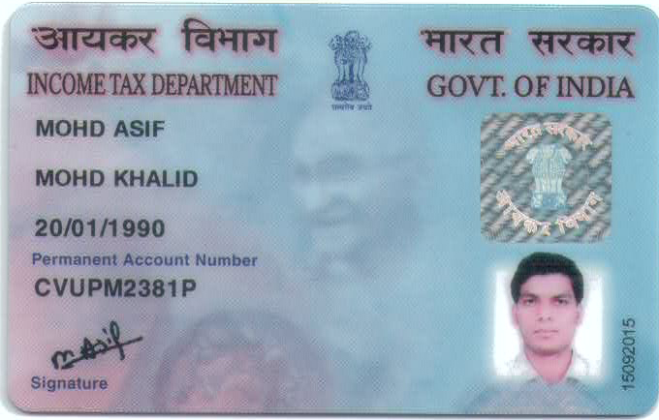

Candidate's Full Legal Name (as it appears on PAN) | Mohd Asif
Supplier Name (Registered Name) | People-Prime Worldwide
Worked for CG previously? (IF yes share CG Employee ID/GGID required) | No
JOB Posting ID | CGEMJP00346459
Contact No (10 Digit No)8149830478 | 7204119194
Email ID | masif_apps@live.com
Job Location (Work Location) | Bangalore
Notice Period (Immediate/ Notice to Serve) | Immediate
Highest Education (Regular or Distance) | B.E 2013
Employment Detail – Last 2 yrs Working period (Payroll Company)People GroupCAGL | Ascendion Engineering
College & University Full Name - | B.E NOIDA INSITUTE ENGG AND TECHNOLOGY
Mandatory Skills & Experience  (quick checklist – verify each skill, years of experience) | Total 9.6years  Frontend Lead 9.6 yrs
“Secondary” Skills & ExperienceTotal 9.6years  Frontend Lead 9.6 yrs | Total 9.6years  Frontend Lead 9.6 yrs
Key Remarks (Supplier Comment) | Candidate Good at Communication Skill.  he is with 9.6years of Total experience and Relevant experience in “Frontend Lead”, is 9.6years.

MOHD ASIF
Frontend Technical Lead
React.js | Angular | TypeScript | Micro-Frontends | System Design
Mobile: 7204119194 | Email: masif_apps@live.com
GitHub: https://github.com/gubali
LinkedIn: https://www.linkedin.com/in/khan-asif/

Professional Summary
Frontend Technical Lead with 9+ years of experience designing and building enterprise-scale web applications using React.js, Angular, TypeScript, and Micro-Frontend architecture. Experienced in leading frontend teams and delivering high-performance solutions for Fortune 500 clients including HP, Ericsson, Cisco, Mercedes-Benz, and UnitedHealthcare.
Passionate about scalable architecture, performance optimization, and AI-assisted software development.
Technical Skills
Frontend Engineering: React.js, Angular (4–22), Progressive Web Apps (PWA), TypeScript, JavaScript (ES6+), HTML5, CSS3
Metaframeworks: Next.js (SSR/SSG), Angular Universal (SSR)
Frontend Architecture & Design: Micro-Frontends (MFE), System Design, Component Architecture, Design Systems, Scalable Frontend Architecture, Server-Side Rendering (SSR), Code Splitting, Lazy Loading, Performance Optimization (Core Web Vitals, Lighthouse)
State Management: Redux Toolkit, RxJS, NgRx, Context API
UI Styling & Frameworks: Tailwind CSS, Sass (SCSS), LESS, Bootstrap, Angular Material, PrimeNG, shadcn/ui
Cloud: AWS (S3, CloudFront), CI/CD Pipelines
Tools & Version Control: Git, GitHub, GitLab, Bitbucket, Visual Studio Code
API Integration & Data Handling: REST APIs, Axios, TanStack Query (React Query), Postman, Swagger, Thunder Client
Engineering Practices: Agile (Scrum), Accessibility (WCAG/ARIA), Confluence
AI-Assisted Development: AI-assisted Code Generation, Debugging, Prompt Engineering

Professional Experience
Technical Lead, Ascendion Engineering Pvt. Ltd (Nov 2025 – Apr 2026)
Senior Project Engineer, Wipro (Aug 2019 – Aug 2025)
Software Engineer 1, Dell International (Client: Jyopa Connexions, Access Automation Pvt Ltd) (Nov 2018 – Aug 2019)
Front-End Developer, TAPZO (Acquired by Amazon, Bangalore) (Oct 2016 – Oct 2018)

Projects & Work History
1. HP AIP Dashboard (All-In Plan / Instant Ink)
Client: HP
Overview:
Enterprise platform for managing printer subscriptions, billing, shipments, and subscription lifecycle.

Key Contributions:
- Led a team of 4 frontend engineers delivering enterprise React Micro-Frontend solutions while driving architecture decisions and code quality.
- Developed reusable TypeScript components adopted across multiple modules, improving consistency and reducing duplicate UI development.
- Leveraged GitHub Copilot and ChatGPT to accelerate feature development, improve code quality, and streamline debugging.
- Integrated REST APIs and implemented subscription flows such as upgrades, downgrades, and cancellations.
- Collaborated closely with cross-functional teams in an Agile (Scrum) setup to deliver features on time.
Tech Stack:
React.js, TypeScript, JavaScript (ES6+), HTML5, CSS3, Micro-Frontends (MFE), REST APIs, AWS, Git, CI/CD, Figma, Agile (Scrum)

2. Portfolio & Commerce (P&C)
Client: Ericsson (Verizon)
Description: Portfolio & Commerce provides a fully enriched portfolio catalog of products, software, and services for Ericsson's customers.
Key Contributions:
- Collaborated with UX/UI designers to implement interactive and responsive user interfaces using Angular's component-based architecture.
- Implemented Angular Universal (SSR) to improve SEO, initial page load performance, and overall user experience.
- Developed Progressive Web App (PWA) features using Angular Service Worker, enabling offline support, asset caching, and faster application loading.
- Integrated frontend applications with backend services through RESTful APIs.
- Optimized application performance through lazy loading, code splitting, and bundle size optimization.
- Set up and managed CI/CD pipelines for frontend application deployment.
- Leveraged Cursor, GitHub Copilot, and ChatGPT to accelerate feature development, improve code quality, and streamline debugging.
Tech Stack:
Angular, Angular Universal (SSR), Progressive Web Apps (PWA), Angular Service Worker, Spartacus, TypeScript, HTML5, CSS3, SAP Commerce Cloud (Hybris), REST APIs, CI/CD

3. Pulse Pilot - Ericsson
Client: Ericsson (Campaign Monitoring)
Description: Developed a campaign monitoring platform to process engagement data from multiple CSPs (Vodafone, AT&T), enabling insights into customer interest and campaign performance.
Key Contributions:
- Built responsive and reusable UI components using a component-based architecture.
- Managed application state and integrated APIs for data-driven features.
- Structured components and data flow to keep the codebase scalable and maintainable.
- Optimized application performance using lazy loading, memoization, and efficient rendering techniques to improve responsiveness.
- Developed responsive UI with a consistent design approach.
- Collaborated with designers, backend teams, and product in an Agile environment.
- Contributed to CI/CD pipelines, code reviews, and resolved production issues.
Tech Stack: React.js, TypeScript, Redux, Tailwind CSS, Axios, Recharts, Vite, Node.js, Express.js, MongoDB, Azure, CI/CD

4. UHC M&R (UnitedHealthcare Medicare & Retirement)
Client: UnitedHealthcare
Description: UHC M&R provides health and well-being solutions to American retirees, managing Medicare Advantage plans, Medicare Supplement plans, Part D prescription drug plans, and employer retiree health services.
Key Contributions:
- Designed, coded, tested, and deployed responsive applications.
- Debugged application issues and ensured adherence to company standards.
- Maintained high Lighthouse performance scores across responsive web applications for mobile and desktop platforms.
Tech Stack: Angular 15, Bootstrap, Spring Boot, Azure DevOps, Lighthouse

5. DIPE (Data Infrastructure Platform Engineering)
Client: Mercedes-Benz Research & Development India (MBRDI)
Description: Developed a platform for data engineering teams to create pipelines without logging into MCI (Mercedes-Benz Cloud Intelligence).
Key Contributions:
- Resolved bug tickets and implemented UI based on UX wireframes.
- Followed Agile methodology and developed unit test cases.
- Created ADO pipelines for deployment.
Tech Stack: Angular 14, Angular Material, Azure DevOps, Ngrx, Rxjs

6. NPA-CIS-PJ-CCBU NEW (Cisco Unified Contact Center Express)
Client: Cisco
Description: UCCX is a secure "Contact center in a box" providing customer interaction management for up to 400 agents.
Key Contributions:
- Fixed bugs and developed UI screens based on UX wireframes.
- Coordinated with internal and external teams for deployment and documentation.
- Troubleshot and resolved technical issues.
Tech Stack: HTML5, CSS3, JavaScript, jQuery, JSP, Tomcat Server, Eclipse, Linux, CI/CD, SonarQube

Education
- Bachelor of Technology (CSE) – AKTU
- Diploma in Computer Science – Board of Technical Education, Lucknow

