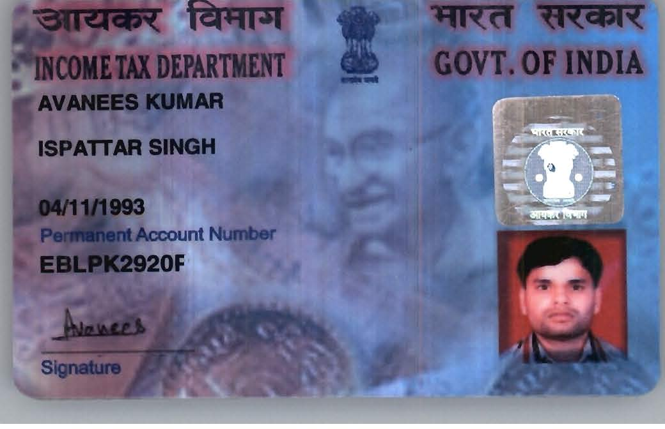

Candidate's Full Legal Name (as it appears on PAN) | Avanees Kumar
Supplier Name (Registered Name) | People-Prime Worldwide
Worked for CG previously? (IF yes share CG Employee ID/GGID required) | No
JOB Posting ID | CGEMJP00347915
Contact No (10 Digit No)8149830478 | 8395860030
Email ID | avanees149@gmail.com
Job Location (Work Location) | Pune
Notice Period (Immediate/ Notice to Serve) | Immediate
Highest Education (Regular or Distance) | MCA 2015
Employment Detail – Last 2 yrs Working period (Payroll Company)People GroupCAGL | Yoeki soft Pvt Ltd
College & University Full Name - | MCA Uttar Pradesh Technical University (UPTU)
Mandatory Skills & Experience  (quick checklist – verify each skill, years of experience) | Total 9years  .Net 6yrs
“Secondary” Skills & Experience | Total 9years  .Net 6yrs
Key Remarks (Supplier Comment) | Candidate Good at Communication Skill.  he is with 9years of Total experience and Relevant experience in “.Net”, is 6 years.

Avanees Kumar  Software Engineer(6 Years) Mobile: +91 8395860030  Email: avanees149@gmail.com | Date of Birth: 04/11/1993  Marital Status: Married Languages: Hindi, English Location: Ghaziabad  LinkedIn: https://www.linkedin.com/in/avanees-kumar-  2bbabb11a/

OBJECTIVE

Experienced senior .NET Full Stack Developer with 6 years of expertise in .NET technologies, Angular, Web APIs, and SQL Server. Passionate about developing scalable, high-performance applications and solving complex business challenges. Looking to contribute my technical expertise, problem-solving abilities, and leadership skills in a dynamic organization focused on innovation and digital transformation.

PROFESSIONAL SUMMARY

- Senior .NET Full Stack Developer with 9.3 years of overall experience and 6+ years of relevant experience in .NET Core, ASP.NET MVC, Web API, Angular, and SQL Server.
- Experienced in developing enterprise applications, REST APIs, workflow-based systems, and database-driven solutions across Government, Banking, and Enterprise domains.
- Strong expertise in C#, SQL Server, API Integration, Authentication & Authorization, Performance Optimization, and IIS Deployment.

TECHNICAL EXPERTISE

Programming Languages | C#, JavaScript
.NET Technologies | .NET, .NET Core, ASP.NET MVC, ASP.NET Web API, Entity Framework, ADO.NET
Front-end Technologies | Angular, JavaScript, jQuery, AJAX, HTML5, CSS3, Bootstrap
RDBMS | SQL Server
Methodology | Agile
Tools/IDE | Visual Studio, Postman, IIS, SSRS Reports
Architecture | N-Layer architecture , MVC Architecture, RESTful Services

QUALIFICATION

Year of completion | Course | Institution | Percentage
June, 2015 | MCA | IMR College, Ghaziabad (AKTU). | 66%
June, 2012 | BCA | UNIT, Ghaziabad (CCSU) | 57%
June, 2009 | Intermediate | SBSB HSS Badkan Shahpur Etawah. | 51%
June, 2007 | Highschool | SSN Intermediate College Dibiyapur Auraiya. | 51%

EXPERIENCE

Yoeki Soft PVT LTD, Noida, India
Software Developer II SEP 2025 to Mar 2026
- Developed middleware APIs for Hero FinCorp banking integrations.
- Implemented e-Mandate and direct debit processing workflows.
- Integrated banking APIs and optimized SQL Server operations.
- Managed deployment and production support on IIS.

Uncial System, Hyderabad, INDIA
Sr. Software Developer July 2023 to Jun 2025
- Developed RMS and NeVA applications using .NET Core, Angular, and SQL Server.
- Integrated government APIs and developed workflow modules.
- Created REST APIs and optimized database performance.
- Managed deployment, testing, and production support.
Path Infotech LTD, NOIDA, INDIA
Software Developer Aug 2021 to May 2023
- Develop of the External Safety Audit (ESA) application for IOCL.
- Developed workflow and reporting modules.
- Implemented SSRS reports and optimized SQL queries.
- Conducted code reviews and mentored developers.

Utility Powertech LTD, Noida, INDIA
Jr. Software Developer Nov 2018 to Apr 2021
- Developed payroll and leave management modules.
- Built Web APIs and SQL Server database solutions.
- Created reports and supported business applications.
Nysa Communications Pvt. LTD, Noida, INDIA
.Net Developer Support Sep 2016 to Oct 2018
- Supported AIIMS Examination Management System.
- Worked on recruitment and examination modules.
- Assisted in maintenance and production support.

PROJECTS

Hero FinCorp (Hero)  Role: Full Stack Developer  Team Size: 4 | Domain: Software Product
Environment: ASP.NET Core Web API, C#, SQL Server, TLS, Payment Gateway Integration, IIS.
Description: Developed middleware APIs for e-Mandate and direct debit processing by integrating banking partners such as BOB and PNB with Hero FinCorp systems. Standardized API communication, transaction tracking, and secure TLS-based processing.

Gold Tracking System (GTS)  Role: Full Stack Developer  Team Size: 5 | Domain: Software Product
Environment: ASP.NET Core, C#, SQL Server, IIS.
Description: Developed a centralized inventory tracking system to monitor gold movement, delivery workflows, alerts, notifications, and role-based access management.

Request Management  System (RMS)  Role: Software Developer Team Size: 2 | Domain: Software Product
Environment: .NET Core 8.0, ASP.NET MVC, Angular, C#, SQL Server, IIS.
Description: Implemented request creation, transfer, approval, and workflow modules for Delhi Police Headquarters with role-based access and audit tracking.

External Safety Audit (ESA)-  Role: IT Professional  Client: Indian Oil Corporation Limited (IOCL)  Team Size: 2 | Domain: Software Product
Environment: ASP.NET MVC, C#, Web API, JavaScript, jQuery, AJAX, SQL Server, SSRS Reports, IIS
Description: Integrated Rajya Sabha employee APIs and developed document management modules for the Digital India paperless legislature initiative.

DECLARATION

I do hereby declare that the details furnished above are true and correct to the best of my knowledge and belief.

AVANEES KUMAR

