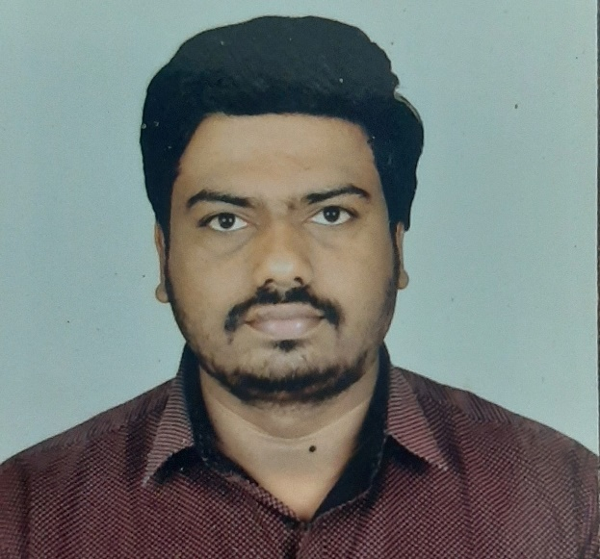 |  | EDUCATION
MCA – Master of Computer Applications
- May 2007 is Year of Passing
- Swarnandhra College of Engineering and Technology affiliated by Jawaharlal Nehru technological university, Hyderabad- India.

CONTACT  ☎+91 7731926884  ✉chandrasekhar.nallam2024@gmail.com  `  Venkata Chandrasekhar Nallam  Senior Database Administrator  Profile  Vekata Chandrasekhar Nallam is an Oracle Database Administrator carrying around 15+ years of experience in Support, implementation, Delivery management, People management and Process management with knowledge of Oracle DBA/EXADATA/EXACC/AWS RDS Administration, Golden Gate, Data guard, Patch management, Performance Tuning Oracle RAC. Have skill set across various key Infrastructures in ExadataX6/X7 and X8, Exadata utilities like CELLCLI, DCLI, DBAASCLI, DBMCLI, ILOM.  Have good experience in managing Oracle database versions of 9i/10g/11gR2/12c/18c and 19C on platforms of EXADATA/EXACC/AWS RDS and On-Prem. Have real time work experience on 13c OEM, DBCA, Data Guard with Physical Standby, Snapshot Standby, RMAN Backups, Logical backups using EXPDP/IMPDP, Database Patching, DB upgradations, migrations, RMAN Duplicate database, RAC, ASM, Oracle database tuning and Golden Gate.  CERTIFICATIONS  - Database 11g)  - ITIL V3 Foundation Certificate in IT |  |  | PROFESSIONAL EXPERIENCE
Currently Working:
LTI Mindtree
Senior Database Administrator (Lead)
Nov 2025 to Till Now

Previously Worked:
HCL Technologies
Associate Consultant
Feb 2022 – Nov 2024

Tata Consultancy Services
Assistant Consultant
July 2010 – Feb 2022
 |  |  | SKILLS
Operating Systems:
RHEL, OEL, SUN Solaris, AIX, Widows and HP-UX
RDBMS:
Oracle 9i/10g/11g, Oracle 11g, 12c and 19C
Storage and Engineered Systems:
ASM, Exadata X2 -X8, AWS RDS, EXACC- Gen1 and Gen2
Oracle Utilities:
Data Pump, RMAN, ASMCMD, DGMGRL, EMCTL, Golden Gate
Exadata, CRS and ODA Utilities:
CELLCLI, DCLI, SRVCTL, CRSCTL and DBAASCLI
Backup Tools:
Cohesity, TSM Tivoli
Monitoring tools:
BMC Remedy, HP Service Center, Service Now and OEM 13c
Job Schedulers:
Cron, Autosys and Control M
Communication tools: Outlook, Lotus Notes, Share point
Professional Summary:
- Leadership and managerial skills with results-driven, cost-effective orientation and ability to manage resources efficiently and mentor and motivate teams to maximize levels of productivity. Well-organized, self-motivated, and dedicated with strong sense of responsibility and loyalty to the organization.
- Contributed technical solutions and share the Knowledge across the team.
- Ensure the team is collaborating closely with our customers and understands their requirements.
- Responsible for Knowledge Transitions and Resourcing left shift activities.
- Designed KT plan for newcomers for Fresher and Laterals, Execution responsibility of KT plan.
- Responsible for Artifacts management to make sure all recurring and new issues are documented.
- Plan, organize and attend the team meetings ensuring the quality of Delivery.
- Represent Oracle team in Root cause analysis meetings related to severity-1 issues like Node Reboot, Instance Crash/recovery, and Critical outages.
- Co-ordinate with application team in resolving issues and prepare deployments plans.
- Prepare weekly status reports and presentation slides for monthly review meetings with client.
- Coordinating with CRQs to Estimate Time Frame and Prepare action plan for Critical activities.
- Coordinating with other teams in unexpected outage and ensure performed Health Check.
- Managing 15 members team who will delivery infrastructure support around 90 Exadata Full RAC machines.
- Administration of Oracle databases on Infrastructures like AWS RDS, On-Prem, EXADATA, EXACC GEN1 and GEN2.
- Manage and Supports AWS RDS Oracle databases including (AWS RDS Oracle Patch management, Database Refreshes, Code Deployments, using rdsadmin package to administer AWS RDS for Oracle databases and troubleshooting issues using Cloud Watch)
- Involve in Oracle database DR drills conducted every year hosted on AWS RDS, EXACC, On-Prem environments.
- Software and firmware maintenance of the Database servers/Exadata storage servers/InfiniBand switches.
- Support the Hard Disk and Flash Disk replacement activities without effecting ASM.
- Shutdown down and starting up Exadata servers gracefully both Storage and Database servers without data lose as battery replacement activity Using ILOM.
- Collect the Sundiag and Exachk Collection data across the Exadata environment.
- Adding Exadata Half RAC Machine X5 to Exiting Exadata Half RAC Machine X4.
- ASR configuration on Exadata Machines and ASR service administration.
- Support and manage Exadata Storage servers using CELLCLI, DBMCLI and DCLI.
- Involved in various activates such as DR configuration and Switch Over testing, SCAN implementation.
- Cloning of Oracle home, Apply Patches, Perform Grid Infrastructure, and database upgrades.
- Configure Staging database DBFS to perform bulk data load on database server.
- Extend /u01 file system on Exadata compute nodes.
- Enable and Disable Write Back feature for Flash Cache Mode at Storage server.
- Manage day-to-day database operations like database administration, planning, design, build/delivery, deployment, monitoring, standards, compliance, etc.
- Experience in Oracle 11g, 12c and 19c Database installation, configuration, and Administration.
- Administering Oracle Database Exadata Cloud Service using dbaascli.
- Converting Non CDB to PDB.
- Troubleshoot the DR issues like long sequence gap and missing data file on DR database.
- Resolved the issues in conflicts between the target and source database in Golden Gate.
- Good experience on Migration and Upgrading various platforms and various versions of databases.
- Expertise on Performance tuning production database. Generate and analyze AWR, ADDM, EXPLAIN PLAN and ASH report Monitoring and optimizing database performance.
- Experience on RAC & ASM and performed various tasks like Administering RAC, adding nodes and instances, Administering Storage Components, Parameter Management and Configuring.
- Database Management - Backup, & Recovery, Configuration of Database, Table space administration, User management.
- Experience in Cloning the databases and Restorations from production to Test using Hot, Cold and RMAN Backups. Cloning (Hot/Cold/RMAN) an oracle database for Testing
- Performed Schema level and table level data refreshes prod to dev environments using Data pump EXPDP/IMPDP.
- Applying PSU Patches and Bug Patches to fix the Bugs using Opatch Utility.
- Responsible for planning, co-ordination and execution of patching on GRID, RDBMS and Databases on EXACC environment.
- Applying patches on to upgrade Image (Image upgrade) on EXACC environment.
- Responsible for planning, co-ordination of Infrastructure patching (Compute nodes, Cell nodes and Infini band switches) and handover servers to Oracle for patching.
- Monitoring of system logs, OS logs, database logs, trace files, database alert logs to detect and troubleshoot runtime problems.
- Monitoring of Oracle databases using OEM13C.
- Administration and patch management of OMS servers and OMA targets and troubleshooting OMS and OEM agent related issues.
- Experience in implementing and maintain Oracle Data guard and providing critical solution with strategic disaster recovery plans with different recovery procedures and methods.
- Work on Database Performance related issues (Plan Change, Statistics issues, index Issues, Partitioning’s, Plan stability, Resource Contentions) using various tools for debugging and provide quick fix.
- AWR/ADDM/ASH reports, analyze, understand the issues and provide fix accordingly.
- Review of Business-critical Database to proactively identify space issues, performance tuning issues.
- Track space usage and forecast storage requirement.
- Enable and Disable Archive log Mode based on application requirement.
- Setting flash back database parameters to perform flashback operations.
- Change the process parameter as it is hitting max process limit without down time.
- Change the database name using NID utility.
- Implemented oracle new features temp files, data files, dynamic SGA, AMM and undo table spaces.
- Implemented Huge Pages feature as it is recommended to Exadata Environment.
- Creating RMAN catalog database and configuring RMAN to perform database backups.
- Scheduling Backups in Autosys backup scheduling tool.
- Troubleshooting RMAN backup failures like block corruption.
- Enable Block Change tracking to improve performance of RMAN Backups.
- Fix the Block Corruption in Index segment and data segment level.
- Resize redo logs to avoid instance crash suggested by Oracle Support team.
- Resize ASM disk groups (reclaim space from one disk group and add to another).
- Administrate Oracle Cluster ware and database instances in a RAC and ASM environment and creating ASM
- Disk Groups and adding disk space to ASM disk group.
- Troubleshooting and RCA for Node eviction and Database Instance Crash.
- Create TAF services as per application requirement.
- Migrate the databases from windows to Linux using RMAN utility.
- Automate jobs using SHELL Scripts for DR sync status monitoring, Capacity Reports, DB restore, RMAN backups and DB upgrade.
- Add node to the existing Cluster Environment and Enable instances on the same.
- Converted RAC database to RAC ONE NODE and single instance database to RAC.
- Convert databases from Non-RAC to RAC with ASM storage environment using RMAN.
- Add and Delete Resource to OCR in Oracle Cluster ware.
- Relocating OCR and Voting disk files from one disk group to another.
- Setup and manage Physical standby databases / Local Standby databases using RMAN active duplication and
- Convert Physical standby database to Snapshot standby database and via-vs.

Soft skills:
- Leadership and managerial skills with results-driven, cost-effective orientation and ability to manage resources efficiently and mentor and motivate teams to maximize levels of productivity.
- Excellent verbal and written communication skills and stakeholder management.
- Well-organized, self-motivated, and dedicated with strong sense of responsibility and loyalty to the organization.
- Experience in working in agile environments, in various security domains and with client organizations of various sizes.
- Worked with clients from various countries like US, UK, Europe, Middle East, Australia and India at various client locations. Experience in handling customers across the globe.

Declaration: I hereby by declare that above furnished details are true to my best of knowledge.

(Venkata Chandrasekhar Nallam)

