
GAJENDRAN VENKATRAJAN
Senior Cloud Architect (DEVOPS & INFRA)

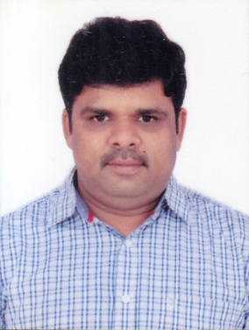

 | +91 9886320057 | +91 9886312158 |  | gajendranv@gmail.com

Results-driven IT leader with 23+ years of progressive experience architecting enterprise-grade cloud infrastructures and driving digital transformation at scale. Seeking a Senior Cloud Architect role to leverage deep expertise in multi-cloud strategy (AWS, Azure, GCP), Kubernetes orchestration, MLOps, and GenAI integration. Proven ability to lead complex cloud migrations, implement Infrastructure as Code, and embed DevOps best practices that accelerate delivery, reduce costs, and elevate operational excellence — all while aligning technology decisions with business outcomes.
 | PROFILE SUMMARY  - Lead Versatile Cloud and DevOps Architect: With over 21 years of diverse IT experience, spearheading cloud infrastructure, DevOps practices, and solution design.  - Proficient in AWS, Azure, and GCP, orchestrated migration projects, design network architectures, and automate deployments for operational excellence and client satisfaction.  - Extensive experience in designing, provisioning, and managing cloud infrastructure on AWS, Azure, and GCP. Proficient in setting up network architectures, handling migrations, and ensuring security in cloud environments.  - Strong expertise in DevOps practices, including automation of system administration tasks, application deployment, and configuration management using tools like Terraform, Ansible, Puppet, and Chef.  - Technocrat with specialization in end-to-end IT Infrastructure & Cloud Operations (Public, Private & Hybrid Cloud); directed the business operations by deploying, automating, managing & maintaining Cloud-based System to ensure availability, performance, scalability and security  - Seasoned professional with a diverse skill set spanning proposal submission, budget management, and network architecture design, recognized for delivering strategic value across multiple domains.  - Extensive experience in managing large teams (100+ members), providing technical leadership, conducting interviews, and nurturing talent for streamlined project delivery. Strong interpersonal and communication skills for effective stakeholder management.  AREAS OF EXPERTISE  - Cloud Infrastructure Management and Migration  - DevOps and Configuration Management  - Solution Architecture  - Continuous Integration and Deployment (CI/CD)  - Automation and Scripting  - Networking & Security  - Infrastructure as Code (IaC) |  | CORE COMPETENCIES  - Cloud Infrastructure  - DevOps & Automation  - Configuration Management  - Release Management  - Architecture  - Database Administration  - Infrastructure Support  - Software Development Lifecycle (SDLC)  - Cloud Based Application Management  - Stakeholder Engagements  - Disaster & Recovery Management  - Monitoring and Performance Tuning  - Data Center Management  - Client Interaction Technical Leadership  - Containerization & Orchestration  - Project Management & Delivery Excellence  DOMAIN EXPOSURE  - Banking  - E-commerce  - Retail  - Immigration  - Telecommunications, and More  SOFT SKILLS  - Leadership  - Change Management  - Attention to Details  - Communication  - Analaytical Thinking  - Time Management
CAREER TIMELINE

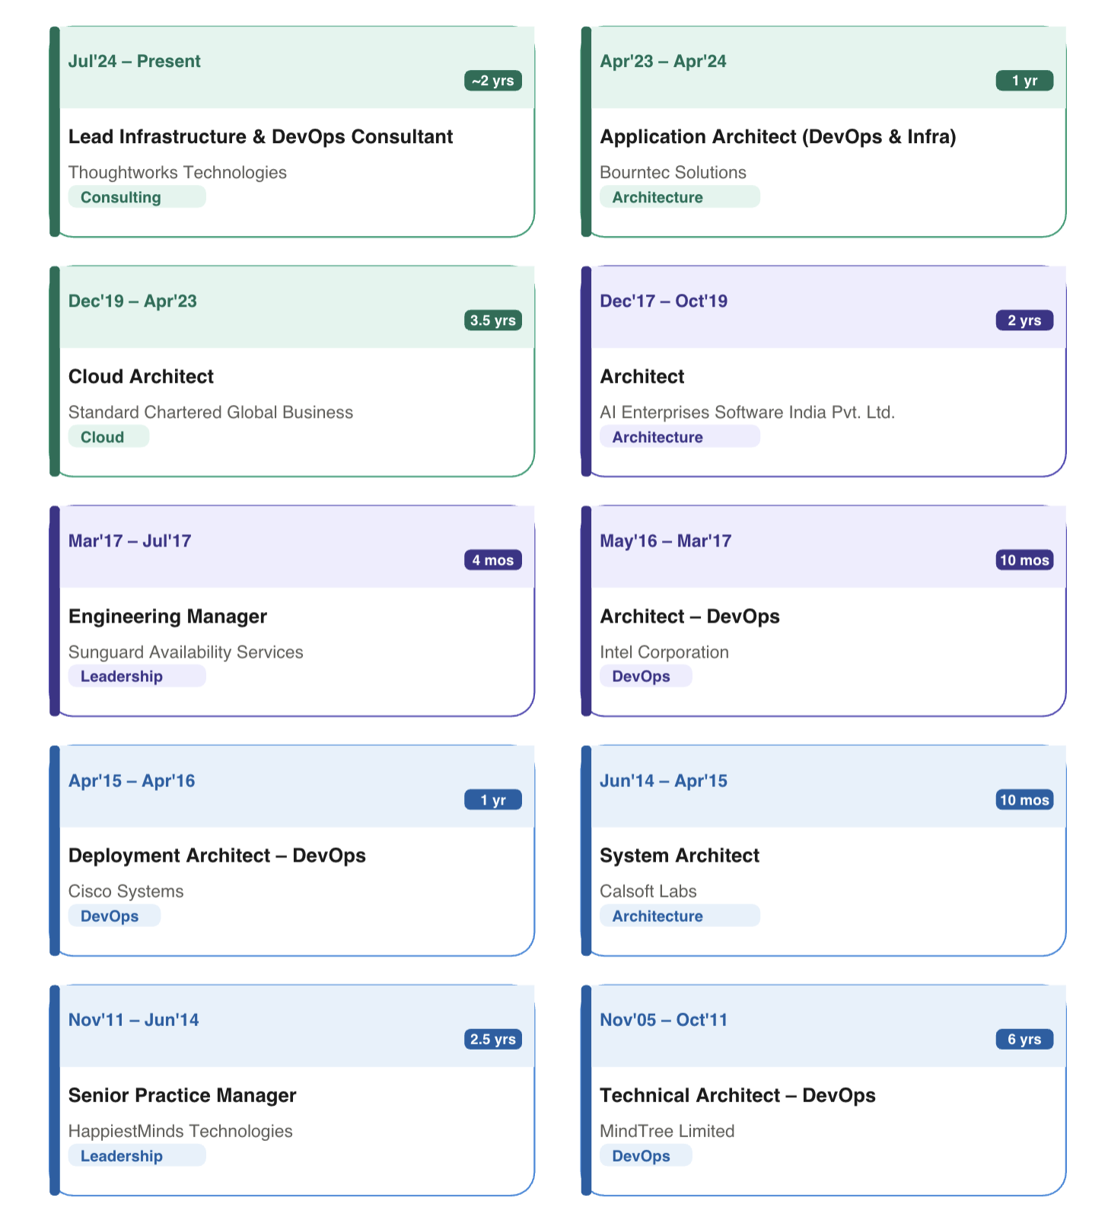
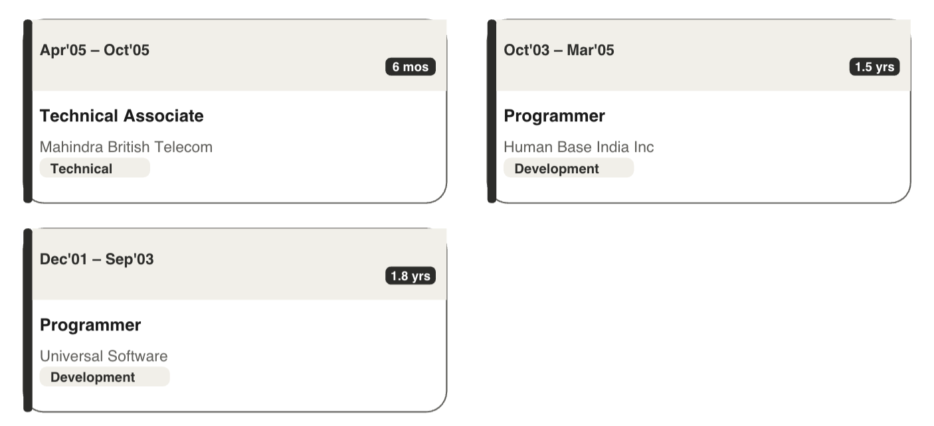

TECHNICAL SKILLS

Platforms: | Windows, Unix, Linux, SunSolaris, Ubuntu, HP-UX
Languages: | C, C++, JAVA, RMI, Servlets, JSP, EJB 2.0, HTML, XML
Web Technologies: | ASP.Net, VB.Net, XML Web Services, ASP, IIS, XSL, Jscript, VBScript , Javascript, Jscript, XML, HTML, DHTML
Middleware: | COM, Knowledge of COM+
Public Cloud: | Azure, AWS, GCP
Private Cloud: | Eucalyptus, OpenStack
Infrastructure As a Code (IaC): | Terraform, Cloud Formation, Azure Resource Management Templates
Video Management: | Kaltura
Ecommerce: | Magento
Version Control: | CVS, SVN, ClearCase, Perforce, GIT
CI Tools: | CruziseControl, Continuum, Hudson, Jenkins, TeamCity
Packaging Tools: | Linux RPM, InstallShield 12, Windows Installer, PKGADD, install, Packer
Build Tools: | ANT, Maven, MAKE and Packer
Application Servers: | Weblogic 11G, Weblogic OSB 11G, SOA Suite, Websphere 5.1.1, JBOSS 4.0.2 and JBOSS 4.0.5, Tomcat-6.0
Web Server: | Apache2, Nginx
Database: | Oracle 10G / 11G, SQLServer 2000/ 7.0, MS Access
DevOps Tools: | Jenkins, Hudson, Puppet, Chef, Salt
Cotainerization: | Docker, Kubernetes
Orchestration: | Spinnaker, Tonomi
Other Tools:  AI | Oracle Virtualbox, Vagrant, Docker  MLOps, GenAI, Agentic AI

WORK EXPERIENCE

Jul’24- Present: Lead Consultant (DevOps & Infra) | Thoughtworks Technologies India Pvt Ltd.,

Cloud: | AWS and Azure
Technical Stack: | Bitbucket, GitHub, Azure Repo, Boards, Pipelines, AWS CodeCommit, CodeBuild, CodeDeploy, Packer, Terraform, Python, Jenkins, K8S, Helm, MLOps etc

Key Result Areas:
- Designing and refining MLOps and CloudOps practices to enhance security and efficiency across project deployments.
- Helping banking team to move to Cloud Infrastructure from Onprem.
- Leading the banking team and their Infrastructure
- Write & Review Terraform code for Infrastructure
- Responsible for end to end deployments
- Innovating the deployment process with AI Powered.
- PoC for Provisioning AI Augmented Infrastructgure
- Leading a team of 8 members, providing technical guidance and direction to drive project success.
- Writing and reviewing Terraform and Packer code to streamline infrastructure provisioning and application deployment processes.
- Collaborating closely with the application team to identify and address cloud-related challenges, ensuring smooth deployment and operation.
- Actively preparing application deployment architectures in Azure and AWS environments to optimize performance and reliability.
- Providing ongoing production deployment support and implementing Site Reliability Engineering (SRE) practices to maintain system stability and resilience.

Apr’23- Apr’24: Application Architect (DevOps & Infra) | Bourntec Solutions

Cloud: | AWS and Azure
Technical Stack: | Azure Repo, Boards, Pipelines, AWS CodeCommit, CodeBuild, CodeDeploy, Packer, Terraform, Python, etc

Key Result Areas:
- Designing and refining DevSecOps and CloudOps practices to enhance security and efficiency across project deployments.
- Crafting network architecture solutions for all ongoing projects to ensure seamless connectivity and scalability.
- Leading a team of 8 members, providing technical guidance and direction to drive project success.
- Writing and reviewing Terraform and Packer code to streamline infrastructure provisioning and application deployment processes.
- Collaborating closely with the application team to identify and address cloud-related challenges, ensuring smooth deployment and operation.
- Actively preparing application deployment architectures in Azure and AWS environments to optimize performance and reliability.
- Providing ongoing production deployment support and implementing Site Reliability Engineering (SRE) practices to maintain system stability and resilience.

Dec’19- Apr’23: Cloud Architect | Standard Chartered Global Business

Cloud: | AWS, Azure and GCP
Technical Stack: | Gerrit, Jenkins, Packer, Terraform, Ansible, Artifactory, Vault, Consul

Key Result Areas:
- Designed network architecture solutions to optimize performance and scalability across multiple projects.
- Successfully migrated existing projects from on-premises infrastructure to public cloud environments, ensuring minimal disruption and maximum efficiency.
- Led a team of 10 members, providing technical guidance and support to drive project execution and achieve objectives.
- Reviewed and optimized Terraform and Packer code to enhance infrastructure provisioning and deployment processes.

Dec’17- Oct’19: Architect | AI Enterprises Software India Pvt. Ltd.

Clients: | BrandsMartUSA, NES Power, Terminix, KOHLS
Products: | Cubes (Microservices) for E-commerce Domain
Technical Stack: | Gerrit, Jenkins, WLST Scripts, Azure DevOps, Azure Experience Cloud, Azure Market Place, Powershell Script, New Relic, Linux Shell Scripting, Ansible, Terraform, Docker, Kubernetes, ELK, Nagios

Key Result Areas:

- Led DevOps design and planning initiatives in the public cloud environment (GCP), ensuring alignment with project goals and objectives.
- Automated application deployment processes and executed rolling upgrades in the public cloud (GCP) to streamline operations and enhance system reliability.
- Prepared comprehensive implementation plans, outlining key steps and timelines for successful project execution.
- Collaborated with cross-functional teams to understand existing system architecture and proposed innovative solutions to address challenges and optimize performance.

PREVIOUS EXPERIENCE

Mar’17- Jul’17: Engineering Manager | Sunguard Availability Services

Technical Stack: | Ansible, Terraform, Jenkins, Docker, Kubernetes, ELK
Team Size: | 6+

May’16- Mar’17: Architect – DevOps | Intel Corporation
|

Project: | ePO Cloud
Technical Stack: | TeamCity, Chef, Docker, Vagrant, JBOSS, Artifactory, Maven

Apr’15- Apr’16: Deployment Architect– DevOps | Cisco Systems

Project: | ePO Cloud
Technical Stack: | Puppet, Docker, Vagrant, Weblogic, Java, Oracle, EM7
Products: | Inmarsat, Quick Silver, SRM, SPP, PNOC, NCCM, RMS

Jun’14- Apr’15: System Architect | Calsoft Labs

Project: | ClearPath
Technical Stack: | OpenStack Grizzly, Tomcat, Jetty, Apache

Nov’11- Jun’14: Senior Practice Manager | HappiestMinds Technologies

Projects: | TimesOfMoney | FWCMS | OneAssist | ScanTryBuy

Nov’05- Oct’11: Configuration & Infra Manager | MindTree Limited

Projects: | Voyager | AutoStart | IATA

Apr’05- Oct’05: Technical Associate | Mahindra British Telecom

Oct’03- Mar’05: Programmer | Human Base India Inc

Dec’01- Sep’03: Programmer | Universal Software

EDUCATION

2001: M.Sc (Computer Sciennce), Madurai Kamaraj University, Madurai
1998: B.Sc. (Mathematics), Saraswathi Narayanan College, Madurai

PERSONAL DETAILS

Languages Known: English, Hindi, Malyalam and Tamil
Address: BRC Sri Hemadurga Siva Hills, Block-F, 105, Puppalaguda Main Raod, Manikonda, Hyderabad-500089.

