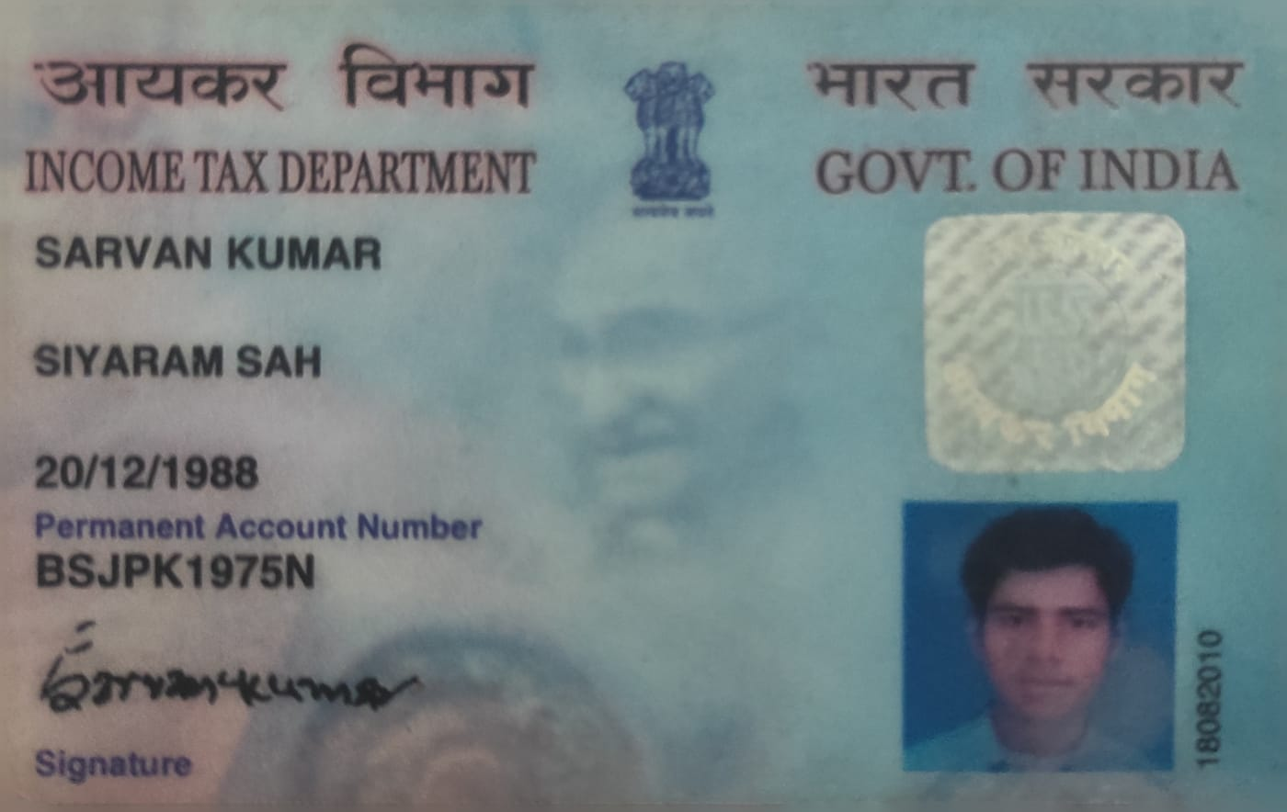
Candidate's Full Legal Name (as it appears on PAN) | Sarvan kumar
Supplier Name (Registered Name) | People-Prime Worldwide
Worked for CG previously? (IF yes share CG Employee ID/GGID required) | No
JOB Posting ID | CGEMJP00344690
Contact No (10 Digit No)8149830478 | 6362864264
Email ID | sarvankumarblr67@gmail.com
Job Location (Work Location) | Pune
Notice Period (Immediate/ Notice to Serve) | Immediate
Highest Education (Regular or Distance) | MCA 2013
Employment Detail – Last 2 yrs Working period (Payroll Company)People GroupCAGL | Amdocs Payroll:Quesscorp
College & University Full Name - | MCA Visveswaraiah Technological University (VTU)
Mandatory Skills & Experience  (quick checklist – verify each skill, years of experience) | Total 7.6years  Mainframe 6yrs
“Secondary” Skills & Experience | Total 7.6years  Mainframe 6yrs
Key Remarks (Supplier Comment) | Candidate Good at Communication Skill.  he is with 7.6years of Total experience and Relevant experience in “Mainframe”, is 6 years.

Sarvan Kumar
E-Mail: sarvankproarch@gmail.com Mobile: 6362864264

CARRIER OBJECTIVE:

To work for progressive organization in a highly motivating and challenging environment that provides me job satisfaction in utilizing my creativity and skills to achieve the organization’s goal while achieving my personal goal.

EXPERIENCE SUMMARY:
- Having 7.6 Years of experience into Mainframe Development, in the development and the implementation of Mainframe based technologies. Possess good analytical and problem solving skills.
- Hands on Experience on Mainframe related skills such as COBOL, JCL, DB2, VSAM, UNIX, Linux.
- Hands on Experience in handling the tools such as XPEDITOR, ENDEVOUR, FILE-AID, Exstream OTX, TWS, IBM MQ, MS POWER BI, Terra Data,

DBeaver, ZGit, SAP BusinessObjects, SERVICE NOW, JIRA, AGILE
- Job Scheduler – Control M And CA7
- Ability to learn new technologies and processes rapidly and implement them in the project.
- Highly motivated with very good problem solving and analytical skills.

PROFESSIONAL EXPERIENCE:

- Amdocs, Pune from Feb 2025 to 4th March 2026.
- Societe Generale, Bangalore from 2nd Jan 2023 to 7th Oct 2024
- US Technologies, Bangalore from 26th Apr 2021 to 24th Aug 2022.
- Proarch IT solutions, Bangalore from 18th Sept 2018 to 31 March 2020.
- Ness Technologies, Bangalore from 3rd May 2017 to 10th Sept 2018.

ACADAMIC QUALIFICATION:
- MCA from VTU University, Karnataka.

TECHNICAL EXPERTISE:

OPERATING SYSTEMS : Z/OS, Windows PROGRAMMING LANGUAGES : COBOL, JCL, DB2, VSAM, CICS

DATABASE : DB2
FILE MANAGEMENT : VSAM
OLTP : CICS
TOOLS : Endeavour, XPEDITOR, File Manager, IBM MQ, Terra Data, DBeaver, ZGit, IDEM, SAP BusinessObjects CMC MS Power BI, Control M, Service Now, JIRA, AGILE

PROJECT # 1:
Company Name : Amdocs Project Name : OWS CBS End Client : AT&T
Period : From Feb 2025 till date. Industry : Tele Communications domain Methodology – AGILE
Project Type : Development and Production support L2.
Environment : COBOL, JCL, DB2, VSAM, IBM MQ, TWS, Extream, Linux, Azure, AWS.

PROJECT DESCRIPTION:

- OWS team is responsible to maintain the business application.
- There is 130+ Business application.
- Cloud Applications.
- Window Applications.
- Backend Validations at Linux server.

ROLES & RESPONSIBILITIES:

- Production support L2
- Patching and Change request activity
- Every need to validate all the application.
- Update all the validated application as green signal.
- Validate backend server at Linux machine.
- Send mail to client if server is up.
- Validate cloud application status is running or not.
- Sent mail to client cloud applications running/stop status.
- AOITs to track the incoming ticket
- Interacting with onsite Coordinator for any clarifications on requirements.
- Preparing unit test cases and UTR (Unit Test Results).
- Updating work related issues and status in the weekly meetings.
- Preparing code and review programs.
- Developing new programs and modifying existing program.
- Involved in preparing the impact Analysis Documents.

ROLES & RESPONSIBILITIES in PRODUCTION SUPPORT
- Worked into 27/7 environment.
- To check the Job status, If any job abend need to fix the job.
- Used to work on ticket, we used ticketing tools to manages the ticket.
- Mail box monitoring.
- Perform Change Request(CR)
- Daily Hanover calls.

PROJECT # 2:

Project Name : Trade Finance (Import/Export)
End Client : Societe Generale
Period : From 2nd Jan 2023 Oct 2024. Industry : Banking Domain Methodology – AGILE
Project Type : Development and Production support.
Environment : COBOL, JCL, Assembler , VSAM,CICS, DB2, ENDEVOUR, Data,
DBeaver, ZGit, SAP , Control M, Service Now, JIRA, AGILE, SAP BO.

PROJECT DESCRIPTION:
- Trade finance used to provide services for their client to Export/Import.
- To maintain the transaction between entity weather they paid.
- Once Entity exported the goods they will get payment from the Bank.
- Once Party Imported the goods they will make payment to Bank.
- To track the goods and maintain the Journals we used this.
- To provide the short terms Loan to the Importer/Exporter.
- Maintain the targeted client for the finance.

ROLES & RESPONSIBILITIES:

- Coding of Online and Batch programs.
- Interacting with onsite Coordinator for any clarifications on requirements.
- Preparing unit test cases and UTR (Unit Test Results).
- Updating work related issues and status in the weekly meetings.
- Preparing code and review programs.
- Developing new programs and modifying existing program.
- Involved in preparing the impact Analysis Documents.

ROLES & RESPONSIBILITIES in PRODUCTION SUPPORT
- To check the Job status
- If any job abend need to fix the job.
- Check the Production job status and send the Morning and evening status mail.
- Create report and share with client based on client requirement by using SAP Business Objects CMC.

PROJECT # 3 :
Project Name : SSCR and EDIT Optimization End Client : Anthem(Legato Health Technologies) Period : From 26 APR 2021 to 24 Aug 2022 Industry : Health Insurance
Methodology – AGILE
Project Type : Enhancement and support.
Environment : COBOL, JCL, VSAM, DB2, ENDEVOUR, MS POWER BI, SERVICE NOW, JIRA, CONTROL-M.

ROLES & RESPONSIBILITIES:
- Coding of Online and Batch programs.
- Interacting with onsite Coordinator for any clarifications on requirements.
- Preparing unit test cases and UTR (Unit Test Results).
- Updating work related issues and status in the weekly meetings.
- Preparing code and review programs.
- Developing new programs and modifying existing program.
- Involved in preparing the impact Analysis Documents.
- Code modification and compilation of the impacted programs.

ROLES & RESPONSIBILITIES in PRODUCTION SUPPORT
- To check the Job status
- If any job abend need to fix the job.
- Check the Production job status and send the Morning and evening status mail.
- Create report and share with client based on client requirement by using Power BI.

PROJECT # 4 :
Project Name : GA Fiber integration
End Client : SEDATA
Period : From Sept 2018 to March 2020 Industry : Public Domain Methodology – AGILE
Project Type : Enhancement, Maintenance and support.
Environment : COBOL, JCL, VSAM, DB2, ENDEVOUR, File-aid, UNIX, CONTROL-M.

ROLES & RESPONSIBILITIES:
- Coding of Online and Batch programs.
- Interacting with onsite Coordinator for any clarifications on requirements.
- Preparing unit test cases and UTR (Unit Test Results).
- Updating work related issues and status in the weekly meetings.
- Preparing code and review programs.
- Developing new programs and modifying existing program.
- Involved in preparing the impact Analysis Documents.
- Code modification and compilation of the impacted programs.

PROJECT #5
Project Name : TFG Policy Auto Administration Organization : Ness Technologies, Bangalore Client : TFG Global Insurance Solutions
Duration : May 2017 to 10th Sept 2018
Environment : COBOL, JCL, DB2, Expeditor, File-aid, CONTROL-M
Methodology – AGILE

PROJECT DESCRIPTION:

- TFG Global Insurance provides insurance services to the Customers across the globe.
- TFG Policy auto administration is designed to send the notification to the customers about their policy expiry date. This is a kind of reminder to the customer to make their payment online.
- The online system supports Inquiry about various Policies, Premium information, various guidelines which TFG Insurance Co. follows, necessary screens to follow/Process the whole cycles of the policy.
- It consists of both Online and Batch processing.
- Online screens developed in CICS were used to enter/view policy details. The policy information was stored on DB2 tables and COBOL and JCL was used to process the policies in Batch environment.

ROLES & RESPONSIBILITIES:
- Coding of Batch programs.
- Interacting with onsite Coordinator for any clarifications on requirements.
- Preparing unit test cases and UTR (Unit Test Results).
- Updating work related issues and status in the weekly meetings.
- Preparing code and review programs.
- Developing new programs and modifying existing program.
- Involved in preparing the impact Analysis Documents.
- Code modification and compilation of the impacted programs.

