Profile
Highly skilled Azure DevOps Engineer with 7+ years of IT experience and strong hands-on expertise in designing, deploying, and managing scalable cloud infrastructure on Microsoft Azure. Experienced in implementing CI/CD pipelines using GitLab, containerizing applications with Docker, and orchestrating workloads using Kubernetes. Proficient in infrastructure automation, monitoring & logging, code quality and image scanning tools, and Python scripting for system automation and troubleshooting. Strong background in system support, networking fundamentals, and cross-team collaboration to ensure reliable and secure application delivery.

Employment History

Azure DevOps Engineer
Xoriant SEPTEMBER2022-PRESENT
- Designed and maintained CI/CD pipelines using GitLab CI/CD for automated build, test, and deployment of applications.
- Worked on Azure cloud services including Virtual Machines, Storage Accounts, Virtual Networks, NSGs, and Azure Resource Groups.
- Managed advanced Jira configuration including workflows and dashboards.
- Containerized applications using Docker and managed container images through Docker Hub.
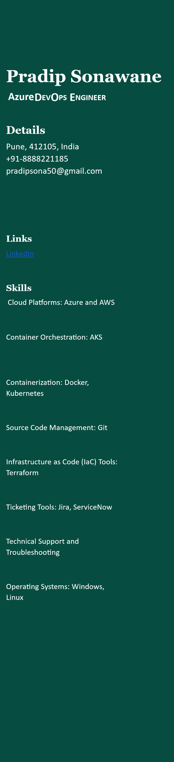
- Deployed and managed containerized applications on Kubernetes clusters, ensuring high availability and scalability
- Implemented code quality checks using SonarQube and integrated image scanning tools into CI/CD pipelines to improve security and code standards.
- Used monitoring and logging tools (Azure Monitor, Log Analytics,
Prometheus/Grafana) to track application health and system performance.
● Automated routine operational tasks using Python scripts and shell scripting, reducing manual intervention.
- Automated application configuration across Dev, UAT and Production environments using Ansible reducing manual effort.
- Raised and managed production change Requests in ServiceNow with deployment steps and rollback plans, ensuring all releases followed ITIL-based CAB approval workflow before touching production.

Technical Support Engineer
Shell Infotech - Client Infosys J_{ANUARY}2022—A_{UGUST}2022
- Set up AWS services like EC2, S3, and RDS.
- Used CloudWatch to monitor AWS resources and performance.
- Managed user access with IAM roles and policies.
- Provided support to ensure services run smoothly.
- Collaborated with teams to deploy and manage applications on AWS.

Technical Support Engineer
Hitachi System Micro clinic - Client Mahle J_{ULY}2021—J_{ANUARY}2022
- Provided technical support to users experiencing problems with Windows operating systems and applications.
- Installed and configured applications and drivers.
- Performed regular maintenance tasks such as updates, backups, and disk cleanups.
- Diagnosed and resolved network connectivity issues on Windows PCs.
- Implemented and maintained security measures like antivirus software and firewalls.
- Provided remote support and troubleshooting for users.
- Resolved tickets within SLA (Service Level Agreement) timelines.

Desktop Support Engineer
Experis IT & Onward eServices Pvt. Ltd
Client - Skoda-Volkswagen India Pvt. Ltd O_{CTOBER} 2018—J_{ULY}2021
- Assisted users with software installations, configurations, and usage.
- Diagnosed and resolved hardware and software issues for end-users.
- Troubleshoot and resolve network connectivity issues on desktops and laptops.
- Managed and executed desktop system upgrades and migrations.

- Provided remote support and troubleshooting for offsite users.
- Responded to and managed incidents, ensuring quick resolution and minimal disruption to users.

Certifications / Achievements
- AWS Certified: AWS Cloud Practitioner
- Google Certified: Associate Cloud Engineer
- AWS Certified DevOps Engineer Professional 2025-DOP-C02
- Diploma in Computer Education (D.Ced): Pragati Foundation, Mumbai in Oct 2012
- CCNA (Cisco Certified Network Associate): Sun Infosystems Certified Institute, Pune in June 2017

Education
M.A. University of Pune, Pune
JULY 2015
B.A. University of Pune, Pune
July 2013

