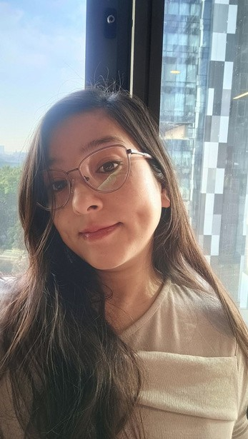

Contact

Raksha Chhetri
Quality Analyst |Customer Support | Trust & Safety | Escalation Specialist

Dedicated and results-driven professional with strong experience in Customer Support, Escalations, Trust & Safety, Quality Analysis, and AI Data Annotation across fast-paced environments.

Phone: +91 75510 09624 | +91 82404 77516
Email: rakshac217@gmail.com Address: Mira Road E, Mumbai – 401107
linkedin.com/in/raksha-chhetri-b0978a205

Experience

Data Annotator | AI Labeler — InnoData Private Limited | Mumbai
22 January 2026 – 15 June 2026 (Contractual)
- Performed AI data annotation and labeling tasks with high accuracy and consistency.
- Reviewed and categorized datasets according to project guidelines and quality standards.
- Supported AI model training by identifying, tagging, and validating data.
- Maintained productivity targets while ensuring compliance with project requirements.

Quality Analyst — ByteDance India Technology Pvt. Ltd. | Mumbai
2022 – 2025
- Monitored and evaluated content moderation quality standards and platform guidelines.
- Audited moderated content and ensured compliance with internal policies.
- Conducted calibration sessions and maintained quality consistency.

Customer Support Representative | Senior Escalation — Tech Mahindra Ltd. | Kolkata
2021 – 2022
- Assisted customers via phone, email, and chat for technical and non-technical concerns.
- Handled escalated customer issues and maintained SLA standards.

Education

Bachelor of Arts (English Hons.)
North Bengal University | 2015 – 2018

ISC (Humanities)
Orange Lake School | 2013 – 2015

Expertise

- Customer Support & Escalation Handling
- Trust & Safety | Content Moderation
- Quality Analysis & Auditing
- AI Data Annotation & Labeling
- MS Office | Excel Reporting
- Policy Compliance & Review

Language

English | Hindi | Nepali

Reference

Praveen Patel - Manager, ByteDance
Phone: +91 72085 28627
Email: pravinpatel718@gmail.com

