RESUME

Santhanaraj Muniraju
B.Tech. (Mechanical Eng.) M.Tech. (Automobile Eng.)

Available for immediate joining


 : rajjob3011@gmail.com
: 9740020133
: Bengaluru

Technical Expertise
- NPD - New Product Design (20 yrs)
- VAVE - Value Engineering (15 yrs)
- Cost Engineering (15 yrs)
- Reverse Engineering (10 yrs)
- CADfiles sustenance(20 yrs)
- Med devices: Product design & documentation (10 yrs)

Leadership Expertise
- Project Management (15 yrs)
- Operations management(5 yrs)
- Team engagement (20 yrs)
- Strategy& Goal setting (10 yrs)
- Operational improvements (5 yrs)
- Client management (20 yrs)
- Lead next gen technology
- Drive diversity & inclusion
Certifications & Trainings
- PMP - Trained by Tech Mahindra
- Six Sigma Green Belt – Certified by GE & HCL
- Value Engineer (VAVE) -AVS – Certified by INVEST India
- Should costing – instrumental in building mathematical model
- Lean practitioner – Trained by Wipro

CURRENT EMPLOYMENT
Senior Manager/ Delivery Manager in an IT engineering service MNC Actalent (EASi Technologies) managing

Consumer & Industrial products team
  - Medical devices team Key Responsibility
+ Account/Project management + Team management
+ Customer/ Vendor management + Business forecast / Plan
+ Business P&Land Pricing + Efficiency improvement
+ Performance metrics + Deliverables quality

Accountable for

Business: | Proposal | Project Pricing | SOW | Change order
Finance: | Revenue | PO, Invoice & Billing | Cost | GP%
Projects: | Risk | Project Delivery | Quality | CSAT
Metrics: | OTD | Project schedule | FTR | Effort Variance
People: | Hiring | Resource utilization | L&D | KRA / Appraisal

PROFILE SUMMARY
- Total 25+ years of experience in IT Company Engineering servicesleadership role and providing solutions & Value toClients across globe
- In my overall career,
  - Designed 24+ different Mechanical & Electromechanical products in different role from Designer to Project Manager (refer page 4)
  - 4+ years in core Automotive R&D (Product design)
  - Expert in Product Design NPD, Design optimization, Reverse engineering& CAD Projects.
  - Expert in Value engineering (VAVE) and Cost engineering
  - Managing multiple Global Client’s projects for 15+ years.
  - Ambassador role / onsite co-ordinator in US with General Electric client

- Expertise in Managing Business in multiple domains
Automotive, Consumer products, Industrial products, Electro mechanical products, Xerox,ATMs and Kiosks, Medical devices etc.

- Reliability Engineer - Certified by University of Arizona –US
- Reliability Practitioner - Certified by GE
- 3D CAD: Creo & AutoCAD
- Worked with topEmployers
- HCL
- Wipro
- Satyam-Tech Mahindra
- Passionate in
- Axis IT&T
- TAFE
- Nash industries
- EASi / Allegis

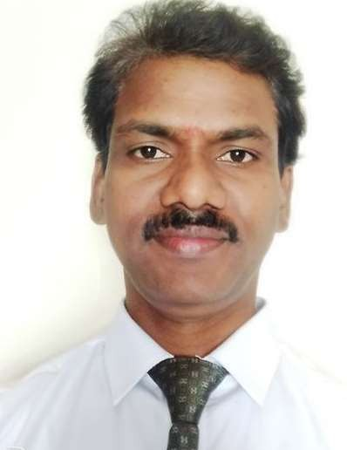
- Situational Leadership
Training by Ken Blanchard

- Talent Management Framework training
- Driving Strategic long-term goal &customer relationship
- Business Sustainability, Scalability and transformation
- Mining opportunities for business growth and result oriented
- Managing P&L and Improving project metrics
- Efficient employee engagement and inspiring / nurturing the team

Role and Responsibilities:
  - Proven track record of independently managing large, complex engagements and global delivery teams (US, Canada, EU and India).
  - Delivery of projects, ensuring alignment with client expectations, timelines, and quality standards.
  - Excellent leadership, communication, and stakeholder management skills.
  - Serve as the primary delivery contact for clients, managing relationships and acting as the first point of escalationand identify growth opportunities.
  - Strong expertise in project management, client engagement and proposal development.
  - Strong understanding of financials, contracts, MSA and service-level agreements (SLAs)
  - Proposal & Growth Enablement: Partner with sales and solution teams to identify new opportunities, lead proposal development and Pricing
  - Review project planning, execution, tracking, and reporting across the PDLC (Product Development Life Cycle).
  - lign resources to projects based on skill and business needs; manage team performance and development.
  - Team motivation, mentoring, and succession planning.

Business Level Project Level
Program Level

  - Business Goal setting
  - Budgeting and Business target achievements
  - Developing strategic Clients / accounts
  - Drive and support Sales team for new business
  - Business capability Presentation to new client
  - Creating MSA, SOW, Estimations, Schedule
  - Client interaction for proposal signoff & PO
  - Stake holder signoff for milestones and deliverables
  - Managing risks, Monitoring & reporting performance metrics
  - Managing OM, Project Margin, Resource costing and Revenue generation
  - Managing multiple Projects (NPI & Value Engineering).
  - Problem solving and conflict management
  - Annual and Quarterly appraisal.
  - Roadmap for recurring revenue model programs
  - Project planning, Execution guidance, Monitoring, Controlling & Reporting Managing Scope, Cost, Schedule and Quality metrics
  - Forming New Project Teams, recruitment and planning competency needs
Setting up KPI, Set judicious expectations for team and carryout performance appraisal to team
  - Problem solving skill, Scope change and escalation management
  - Project closure and signoff with client
  - Training team for project execution needs

Product Engineering

Concept Design
  - Gatheringinput from customer / QFD
  - Brainstorming, Ideation
  - Innovation & creativity
  - Kano Analysis
  - High level Specification consolidation
  - Technical Feasibility study
  - Design of experiments (DOE)
  - Preliminaryconcept3D design
  - Proof of Concept Build

Production release
  - Supply chain & Pilot Production
  - Assembly instructions, Service Manuals
  - PPAP, ROHS, Part Approval
  - ECN
  - Design Release for production

Detailed Design and Testing
  - Detailed design – Part & Subsystem
  - Functional Block Diagram
  - Sheetmetal & plastic parts design
  - FEA analysis & Theoretical analysis
  - DFMEA and Risk analysis
  - Design for Manufacturability, Assembly & Reliability
  - Statistical Tolerance Analysis
  - GD&T and Drawing creation
  - Prototype Build
  - Product Functional Analysis
  - Build issue Root cause analysis
  - Reliability Growth Testing

  - Supplier evaluation & selection
  - Negotiation with Supplier
  - Commercial interaction with Supplier

Design optimization & Testing
  - Design optimization
  - Tool development
  - Tool & Parts approval
  - Standard parts procurement
  - Design Confirmation Build
  - Design verification
  - Design Validation
  - Reliability Testing
  - Field Testing
  - Product Certification

  - VA VE-Value engineering
  - Reverse Engineering
  - Cost Engineering

EMPLOYMENTSNAPSHOT

Employer | Title | Role / Product & Customer |  | Domain | Tenure
Last Employer:Allegis / ActalentEngineering Services (EASI Technologies) | Delivery manager / Engineering Manager | Accountable for Program P&L, Program Delivery, CSAT, Quality, Business growth, Revenue growth, GP%, Project Proposal, Solutioning, Pricing, etc. | Recruitment, Team utilization& engagement, Project Metrics, L&D, cross skill etc. | Consumer & Industrial  Medical Devices | 5+ years, Nov  2020 to Dec  2025
NASH Industries (India) -OEM | Senior Manager – R&D | Point of Sale Printer ATM &KIOSK | Industrial Automation – Production machine data acquisition products | Consumer & Industrial | 3 months (Pandemic)
Wipro Limited (Industries & Engineering Services) | Principal Consultant / Sr. Manager | Projects:>Interactive Vending  - Smart Coolers  - Vending machine innovation  - Baggage scanners  >Scanner Industrial design > ATM design – FL/RL/TTW | - VA/VE cost saving projects  - Induction cooktop  - Water purifier-  - Refrigeration system design | Consumer - Goods, ATM,  Industrial Kiosk | 5+ Years
HCL Technologies  (EngineeringServices) | Project Manager | Projects:>ATM Machine cash Dispenserdesign – NPI -  - Thermal Printer VAVE  - Photocopier machine | - Industrial automation HMI  >Mobile Communication product  - Coin handling system-  Ticket vending machine | Consumer & Industrial | 5 Years
Mahindra Satyam ( Engineering Services) | Technical Specialist | NPI Appliance design - Cooking Range,  - Gas Slide-in Model - NPD  - Electric slide-in Model - NPD  - Drop-in Model- NPD  - Free standing Model- NPD | VA/VE of Cooking Range models  >Structure, Cooktop & Oven subsystem  >Gas system & Controls | Consumer Goods | 6 years
Axis IT&T Ltd  (Engineering Design ) | Asst. Manager  - Design | Off road vehicle - Design  - Excavator system Design - | >Power generators - Frame design | Automotive Industrial | 8 months
TAFE - OEM  Automotive  ( R & D Division) | Sr. DesignEngineer | NPI Tractor system design  >Clutch and Brake Linkages  >Throttle linkages  >Steering linkages | >Hydraulic System  >Hyd. Flow control Valve  >Cabin Floor Design  >Canopy, ROPS, Seat etc. | Automotive (R&D -  Product  Design) | 4.5 years

    - Certificate of “ROLL OF HONOUR” for learning and trainings conducted
Accomplishments
    - Received award as “STAR player of the YEAR” multiple times
    - Outstanding performer of the year in VA / VE
    - Successfully executed numerous new Business contract.
    - Technology related Design template & costing template & Ideation SOP
    - Submitted Two Patents as co-author jointly with PepsiCo – US for Next gen “Zone cooling” vending machine
    - Certificate of Merit for Demonstrated Managerial Proficiency
    - Managing multiple Programs with team at different Geography
    - Exceeded Revenue target multiple years

      - Value Analysis& Engineering
PAPER SUBMISSION
      - Value creation
      - HMI display sealing for IP rating
      - Beverage carbonation

        - Multiple Visit to US (General Electric plant) for NPI product Design,Build and Production
ONSITE
        - Onsite Ambassador Role –in US
        - Onsite client facing role – Singapore

        - Leadership and management skills
KEY EXPERTISE
        - Communication skills &Problem solving
        - Manage large & complex programs
        - Client, People and resource management
        - Risk assessment, RCA &decision making
        - Conflict management
  - Managing globally located team from India
  - Ability to multitask and prioritize tasks
  - Presentation skill to clients
  - Building relationship with Stake holders
  - Team building, mentor & motivate team

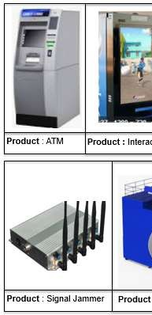
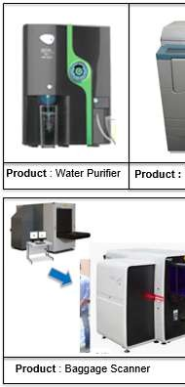
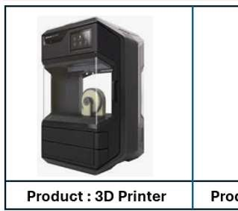
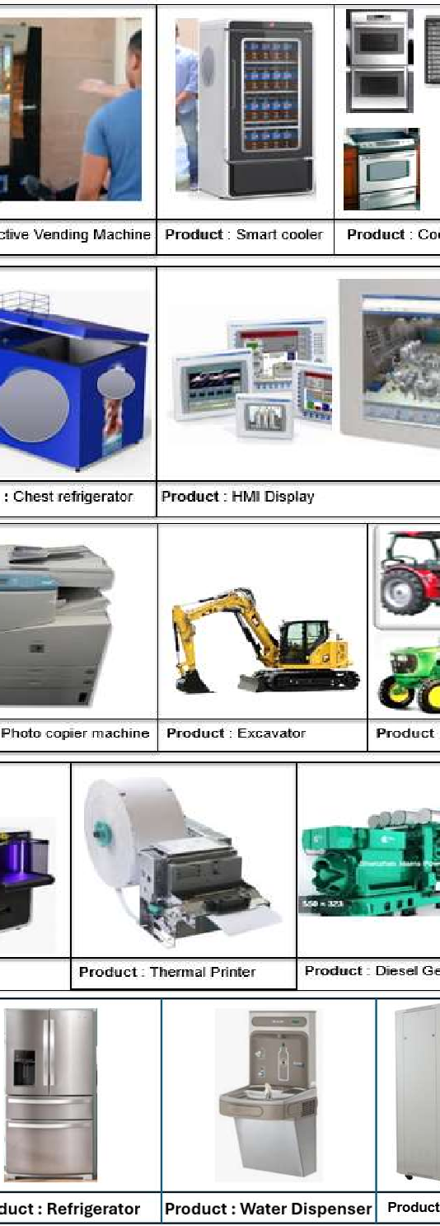
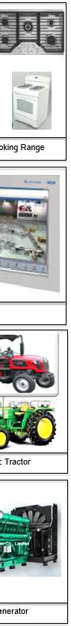
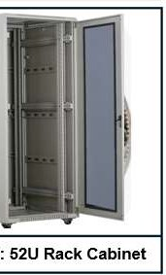
PRODUCT EXPERIENCE…. few snapshots below

Client &Product Experience
In my overall experience, worked with 100+ global OEMs and few listed below

C&IP Customer
- General Electric: Cooling products- Ranges, cooktop and wall oven
- Diebold & Wincor& Nixdorf: ATM machine system design
- Wincor Nixdorf: ATM receipt printer
- Xerox: Photocopier, Ticket vending machine
- PepsiCo: Interactive Vending machine, Hot & Cold Vending machine, Zone cooling vending machine, Smart cooler, Beverage dispenser, Chest refrigerator etc.
- Rapiscan: Airport Baggage scanner
- Breville: Kitchen appliances
- Rockwell Automation: HMI Display
- DLRL (Defence) : Mobile Signal jammer, Rack Cabinet
- Unilever: Water purifier
………many other Clients

Automotive Customer:
- TAFE (R&D): Farm Tractors
- John deer: Farm Tractors
- Caterpillar: Excavator
- Cummins: Power generators

Medical Devices Customer
- Johnson & Johnson
- Arthrex
- Stryker...many other Clients

EXPERIENCE IN SUPPORT FUNCTIONS

  - Business development / Sales
  - Learning and Development
  - Finance – Pricing / Billing / Invoicing / PO
  - HR – Recruitment &Processing Exit
  - Team Annual Performance

Objective
I’m a confident active person willing to take up challenging role and stretch targets by pushing beyond current capabilities. Lead organization Vision & Strategic plans by motivating and inspiring the team and building strong winning culture to achieve business goals.

Will share more details on role and responsibility in each employment during interview.
Truly appreciate your time for going through the profile and eager to connect and discuss the next steps.

Thanks
Santhana

