User Acceptance Test Plan

Radio team

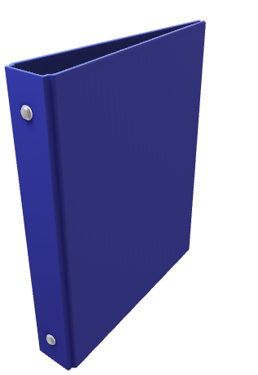

Team members:

* Pepe Loperena Monzon(4518381)
* Marek Stryjeński()
* Aleksei Skorjak(4561139)
* Ian Donker(4629981)

Date:29-3-2021

*Version information*

|  |  |  |  |
| --- | --- | --- | --- |
| Version | Date | Description | Author |
| V 1.0 | 22-3-2021 | Initial version | Radio team |
| V 1.2 | 27-03-2021 | Minor Changes | Radio team |

Contents

1) Introduction 3

1.1 Project objective 3

1.2 Objective of the UAT 3

1.3 Involved in creating the UAT 3

2) Assignment formulation 3

2.1 Assignment 3

2.2 UAT scope 3

2.2.1 Within the scope 3

2.2.2 Out of the scope 3

2.3 Requirements 3

2.3.1 User stories 3

2.3.2 Acceptance criteria 4

2.4 Stakeholders 4

3) Assumptions and Constraints 4

3.1 UAT assumptions 4

3.1.1 Test environment 4

3.1.2 Test documentation 4

3.1.3 Error reporting 4

3.2 UAT constraints 4

3.2.1 Time frames 4

3.2.2 Resources 4

3.2.3 Minimum system requirements 4

3.2.4 Software requirements 4

4) Test strategy 4

5) Approach 4

6) UAT Risks 4

7) Team Roles & Responsabilities 4

8) Entry Criteria 4

9) Test Cases 4

Decision Table 4

10) Requirements-Based Test cases 4

11) Test Results 4

Test results 4

Appendix 1: Risk analysis 4

Appendix 2: Document Changes 4

# Introduction

## 1.1 Project objective

This document contains an overview of how the testing of the Radio application is going to be done. The application has been created for the testing module and requires ‘the radio team’ to design and create an application that works like a radio and a user acceptance test plan for it.

## 1.2 Objective of the UAT

The objective of the UAT is to inform all who are involved in the testing process of the approach, activities, and the product to be delivered.

## 1.3 Involved in creating the UAT

**Version 1.0**

|  |  |
| --- | --- |
| Name | Responsibility |
| Pepe Loperena Monzon | Writing and reviewing the UAT |
| Marek Stryjeński | Writing and reviewing the UAT |
| Aleksei Skorjak | Writing and reviewing the UAT |
| Ian Donker | Writing and reviewing the UAT |

*Table 1. Version 1.0 involvement*

# Assignment formulation

## 2.1 Assignment

The goal of the assignment is to create a radio application for the purpose of testing it.

## 2.2 UAT scope

### 2.2.1 Within the scope

* Being able to listen to desired radio station.
* Being able to adjust the volume to a specific threshold.
* Being able to change the radio station by adjusting the frequency.
* Turning on/off the radio.
* Being able to identify which radio station you are listening to.

### 2.2.2 Out of the scope

* The inner parts of the radio.

## 2.3 Requirements

### 2.3.1 User stories

The table below will describe the user stories, what they want why they want it.

|  |  |  |  |
| --- | --- | --- | --- |
| # | As a | I want | So that |
| 1) | User | to press the power button expecting the radio to turn on or off. | I can use the radio for its purpose. |
| 2) | User | to hear a sound when a threshold of volume has been reached. | I can know when we have reached volume loudness limit. |
| 3) | User | to know what the current frequency I am on. | I can know what frequency I am currently on. |
| 4) | User | to see what radio station, I am on. | I can know that I am listening to the desired radio station. |

*Table 2. User stories*

### 2.3.2 Acceptance criteria

These are the conditions that the software product must meet to be accepted by the user, a customer, or another system. They are unique for each user story and define the feature behavior from the end-user’s view.

## 2.4 Stakeholders

The stakeholders and their involvement with the acceptance testing process can be viewed in the table below.

|  |  |  |  |
| --- | --- | --- | --- |
| # | Stakeholder | Reason | Responsibility |
| 1) | Software team | These are responsible for creating the test plan and product. | Deliver the test plan and the product to the testing team. |
| 2) | Testing team | Responsible for testing the product. | Test the product according to the UAT and deliver a test report. |

*Table 3. Stakeholders*

# Assumptions and Constraints

The assumptionist and constraints include timing and available resources, as well as test documentation processes. The desired operating system to be used and specific browser versions. In addition, clearly stated the defined assumptions, such as what our testing environment is or how a tester should handle error reporting.

### 3.1 UAT assumptions

### 3.1.1 Test environment

The test cases will be conducted individually by 1 or 2 IT students on their personal computers due to the COVID-19 quarantine.

### 3.1.2 Test documentation

All UAT test cases are documented within the Teams environment.

### 3.1.3 Error reporting

Errors, failures, and other flaws are reported in the discord, WhatsApp, or Teams environment.

## 3.2 UAT constraints

### 3.2.1 Time frames

Test results must be provided by April 1st, 2021 by 15:00 PM.

### 3.2.2 Resources

* Human resources: 1-5 testers available for 1 week.
* Provided hardware: None, their PC.
* Operating system: Windows 10 preferred.
* Internet browser: Firefox or Chrome (latest version preferred).

### 3.2.3 Minimum system requirements

Requires a 64-bit processor and operating system.

* RAM: 1GB minimum.
* Storage: 20 GB available space.
* GPU: GTX 670 2GB / AMD R9 280 better minimum;
* CPU: Intel Core i7-3770 / AMD FX-9590 minimum.

### 3.2.4 Software requirements

* IntelliJ IDEA build 202.8194.7.
* JDK version 14.0.2.

# Test strategy

The available time for testing is limited; not everything can be tested with equal thoroughness which means that choices must be made regarding the depth of testing. Also, it is strived to divide test capacity as effectively and efficiently as possible over the total test project. This principle is the basis of the test strategy. The test strategy is based on risks: a system must function in practice to an extend that no unacceptable risks for the organization arise from it. If a delivery of a systems brings along many risks, through testing needs to be put in place; the opposite of the spectrum is also true: ‘no risk, no test’. The first step in determining the test strategy is the execution of our product risk analysis. The result of that product risk analysis (PRA) that care used for our test level (below).

### 4.1 Test Strategy table

The content of the column **<test level>** must be same as the corresponding column from the strategy table in the UAT plan.

|  |  |  |  |  |
| --- | --- | --- | --- | --- |
| Characteristic | Test Goal | Risk Class | Test Level | Test Type |
| Functionality | Making sure the software performs as expected | A | High | Functionality test |
| User-Friendliness | To see whether the application is suitable for the users | B | Medium | Usability test |
| Performance | Check the response time of the application under different conditions (low, normal, high) | A | High | Performance test |
| Security | Revealing flaws in security mechanisms and vulnerable points in the software | C | Medium | Authorization test |
| Sustainability | To make sure the application is efficient and user friendly | B | Low | Process test |

*Table 4. Test strategy table*

# Approach

This chapter describes how the testing is handled in conformity with the test strategy. The test design gives a good overview of this approach.

|  |  |  |  |  |
| --- | --- | --- | --- | --- |
| Characteristic | Risk class | Test Level | Test type | Testing techniques |
| Functionality | A | High | Functionality Test | Data Cycle Test |
| User-Friendliness | B | Medium | Usability Test | Software Usability Measurement Inventory |
| Performance | A | High | Performance test | Error Guessing |
| Security | C | Medium | Authorisation Test | Syntatic Test |
| Sustainability | B | Low | Process test | Process Cycle Test |

*Table 5. Testing approach*

# UAT Risks

This chapter describes the potential UAT risks, which have a chance of occurring during any stage of any UAT test case. For negating the possible risk, each case must be addressed prior testing.

|  |  |  |  |
| --- | --- | --- | --- |
| Description | Probability  High|Med|Low | Impact  High|Med|Low | Mitigation |
| False UAT testing:  bad test case logic | Low | High | Use of trustworthy references and sources |
| Not properly trained Testers | Low | Med | Ongoing online lectures and presentations. |
| Incomplete test environment due to time constraints | Med | Med | Realistic time and resource planning. And team communication |
| Error handling: Testers are not aware on how to report bugs | Med | High | Easy-to-use bug reporting solution for UAT test available |
| UAT test failure | Low | High | Program is ready before UAT start |

*Table 6. User Acceptance Test Plan risks*

# Team Roles & Responsabilities

Our UAT team will ensure:

* That defined test cases are planned and conducted accordingly.
* That test results are documented and shared among the projects team.

|  |  |  |
| --- | --- | --- |
| Name | Roles | Responsabilities |
| Ian Donker | Tester | Testing on windows |
| Marek Stryjenski | Tester | Testing on windows |
| Aleksei Skorjak | Tester | Testing on windows |
| Pepe Loperena | Tester | Testing on windows |

*Table 7. Team Roles*

# Entry Criteria

This chapter describes the criteria that must be followed to complete this project. The main ones are those:

* Development of the project must be archived and available for testers.
* Testers must be first briefed on what and how project operates.
* All errors and bugs that have been reported must be fixed.

|  |  |
| --- | --- |
| ID | Criteria |
| 1 | Completing class diagram, that represents how system should look like |
| 2 | Developing software, based on the class diagram created previously |
| 3 | Testing software |
| 4 | Reporting eventual bugs in the system |
| 5 | Software is ready to move to UAT stage |
| 6 | Testers get brief explanation of how system works, and they start testing |
| 7 | Testers that take part in UAT, report problems/bugs they encounter |
| 8 | UAT test plan is completed |

*Table 8. Entry Criteria*

# Test Cases

## Process Cycle Test

1.1 Purpose of the test case

The goal of the Process cycle test is to focus on covering all the variations of the processing in the application.

1.2 BrieF Description

The process cycle test is a technique that is applied in particular to the testing of the quality characteristic of Suitability (integration between the administrative organisation and the automated information system). The test basis should contain structured information on the required system behaviour in the form of paths and decision points.

Since the volume can be changed at any time, it cannot be connected to the min process cycle.

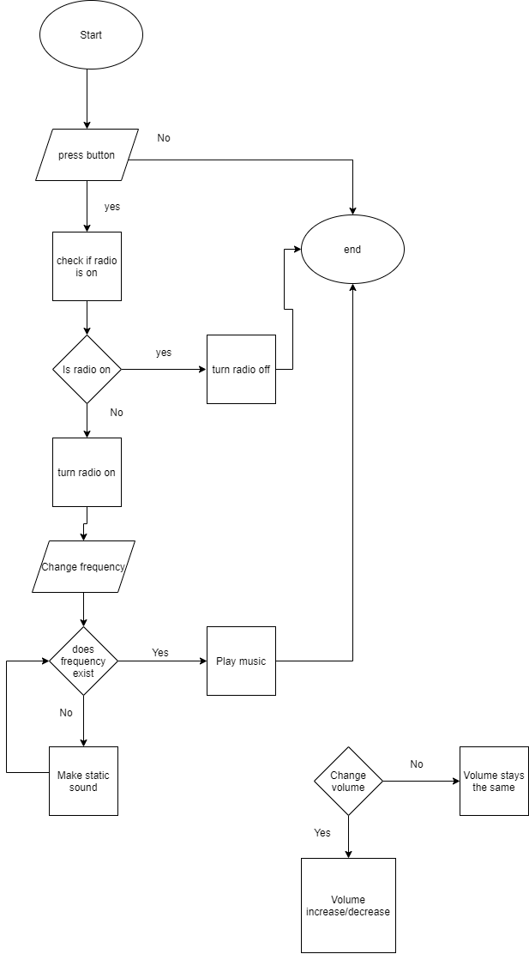

Below we cover all the test situations that can occur based on the graph above.

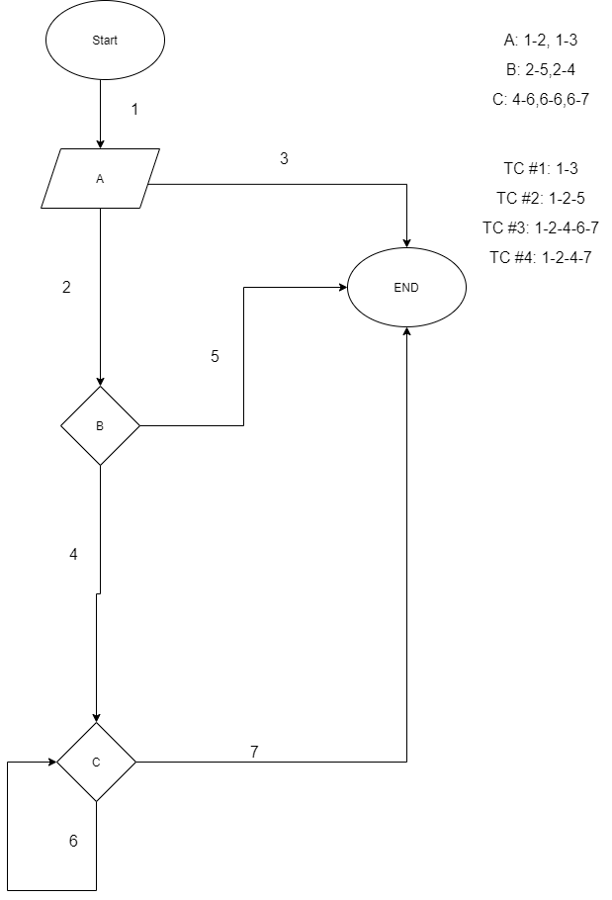

## Decision Table

2.1 Purpose of the test case

The goal of the decision table is to provide testing of functions that will be important for application.

2.2 BrieF Description

One of the tables contains the test cases and each of those test cases can either be 0 or 1. The value "1" means that the condition is true; the value "0" means that the condition is false. The next table contains results for each test case. The symbol, X” represents a result, each test case must have at least one result.

|  |  |  |  |  |  |  |  |
| --- | --- | --- | --- | --- | --- | --- | --- |
| Legend |  |  |  |  |  |  |  |
| 1 means result is true |  |  |  |  |  |  |  |
| 0 means result is false |  |  |  |  |  |  |  |
|  |  |  |  |  |  |  |  |
|  |  |  |  |  |  |  |  |
| Test case Number | 1 | 2 | 3 | 4 | 5 | 6 | 8 |
| Button==True | 0 | 1 | 1 | 1 | 0 | 1 | 0 |
| RadioOn==True | 0 | 0 | 1 | 0 | 1 | 0 | 0 |
| FrequencyExist==True | 0 | 0 | 0 | 1 | 0 | 1 | 1 |
| 0<=Volume<=20 | 0 | 0 | 0 | 0 | 0 | 1 | 0 |
|  |  |  |  |  |  |  |  |
| Results Number | 1 | 2 | 3 | 4 | 5 | 6 | 7 |
| Playing static sound |  | x |  |  |  |  |  |
| Playing music |  |  |  | x |  | x |  |
| Radio turned on |  | x |  | x |  |  |  |
| Radio turned off | x |  | x |  | x |  | x |
| Radio station found |  |  |  | x |  | x |  |
| Volume error message |  | x |  | x |  |  |  |

## ERROR Guessing

3.1 Purpose of the test case

The purpose of the error guessing is to guess possible bugs in the areas where formal testing would not work.

3.2 Brief Description

The value of error guessing is considering unexpected. Tests made up by the guessing might have not been considered otherwise. This technique realies also on the tester experience in guessing the problematic errors in application.

* What will happen if the button is not working?
* What will happen if the radio is already on and we press the radio button?
* What happens if we put frequency over the expected range?
* What happens if there are two radio stations with the same frequency?
* What will happen if user sets the volume over or below the expected range?
* What will happen if no radio station was found on the selected frequency?
* What if radio station exists on the frequency but radio cannot find it?
* What if the song does not actually play?

# Requirements-Based Test cases

For successful testing process, testers must follow the described test cases step by step, whilst still prepared to swiftly implement improvements for testing and documenting the said test cases. Thorough documenting of every program misconduct case like a bug or unexpected behavior is to be followed.

|  |  |
| --- | --- |
| ID | Test Cases |
| 6.1 | Action: Selecting a frequency different from any station  Expected result: The “static” sound plays, radio keeps working |
| 6.2 | Action: Press the power button while radio is playing a station  Expected result: Radio will turn off |
| 6.3 | Action: Volume has been adjusted to minimum  Expected result: Radio sound will be inaudible |
| 6.4 | Action: Adjust the frequency and set a desired station. And checking the display for frequency information  Expected result: See the correct/expected station frequency playing on the radio |
| 6.5 | Action: Set the frequency to outside of the FM band length (hard code set frequency > 108)  Expected result: FrequencyOutOfFMScopeException Radio frequency will play nothing until proper frequency chosen. |

*Table 8. Requirements Based Test Cases*

# 11) Test Results

Each tester after completing UAT phase, must fill out below table to mark down their results.

|  |  |  |  |  |
| --- | --- | --- | --- | --- |
| ID | Test Cases | Pass/Fail | Tested By | Date of testing |
| 1 | Checking if Radio Station Exist |  |  |  |
| 2 | Playing music |  |  |  |
| 3 | Checking volume range |  |  |  |
| 4 | Adding song to radio station |  |  |  |
| 5 | Changing radio station |  |  |  |

*Table 9. Test Results*

# Appendix 1: Risk analysis

|  |  |  |  |  |  |
| --- | --- | --- | --- | --- | --- |
| Risk Number | Description | User impact | Severity | Probability | Risk Factor |
| Risk 1 | Power button is not working | User cannot use radio | 10 | 2 | 20 |
| Risk 2 | Volume button is not working | user cannot change the volume | 5 | 2 | 10 |
| Risk 3 | Frequency button is not working | User cannot change the radio station | 6 | 2 | 12 |
| Risk 4 | Screen is not displaying anything | User has no visual clues about what he is doing | 8 | 5 | 40 |
| Risk 5 | Speakers are not working | User cannot use radio for its purpose | 10 | 7 | 70 |
| Risk 6 | Maximum volume is never reached | The volume does not go up | 3 | 6 | 18 |

*table 10: risk analysis*

# Appendix 2: Document Changes

*This chapter is left empty for subsequent assessment notes and comments.*