Your Name 1 <your-ju-id1@student.ju.se>,  
Your Name 2 <your-ju-id2@student.ju.se>,  
Your Name 3 <your-ju-id3@student.ju.se>

Project Work in Android Development

Jönköping University 2022

Your App title here

*In this template, all italic text should be removed and replaced with your own text (which should not be italic); the italic text is just a placeholder letting you know what to write there.*

*On the cover page, change to your own platform name, your own name and your own JU email address.*

*You have a lot of freedom when it comes to writing this report. You do not have to use any part of this template, but the report you write should in the end somehow (in a good way) provide the same information as indicated in this template. Most students trying to do it in their own way usually fail, so if you try that, be sure to know what you are doing!*

*For more tips on how to write a good report, read:*

[*https://peppel-g.github.io/course-material/lectures/report-writing/*](https://peppel-g.github.io/course-material/lectures/report-writing/)

*This page should of course be removed.*

*(it's amazing how many students delete this text without reading it…)*

Table of Contents

Introduction 3

Overview 4

Application 5

Extra Functionalities 6

Worklog 7

Alice 7

Bob 7

Claire 7

# Introduction

*Describe your application idea here. Write text that indirectly answer questions like:*

* *What is the problem the application solves (why anyone would use it)?*
  + *Describing the problem is usually a good way to start this chapter*
* *Who would be interested in using the application (who are having the problem?)?*
* *How will users use the application to solve the problem?*

*After reading this section, the reader should have been convinced that the application solves the problem in a good way, and that it is a good idea to build the application. You are strongly recommended to use use-case diagrams.*

*Think of this chapter as a text you write to a billionaire, who will give you the money you need to build the application only if you convince him that the application is good. But, of course, do not tell any lies.*

# Overview

*Imagine the billionaire liked your application idea and has given you the money you need to realize it. Now you need to build it, but how? This chapter should provide an overview of all the external components your application makes use of, such as Facebook Login, Google APIs, Firebase, etcetera.*

*If a new programmer starts to work on the application, this chapter should be a really good way for that programmer to get a good understanding of how the solution is structured.*

# Application

*Describe how you have implemented the application, e.g. explain that it has been implemented in Kotlin using the Android SDK, etc. Write which versions of Android your application supports, and motivate why you choose to support these versions, which screen sizes you are supporting, how it works differently depending on the screen size of the device the application runs on, which third party libraries you are using, if you support multiple natural languages, etc. Motivate all your decisions.*

*Especially, provide a link/reference to your mockups, so the reader easily can see what the GUI looks like. Providing real screenshots is probably helpful as well. Providing an overview of the GUI as shown in the figure below might be helpful as well.*

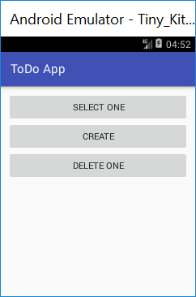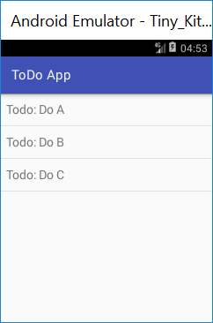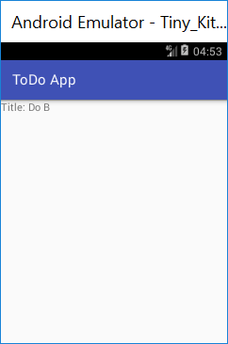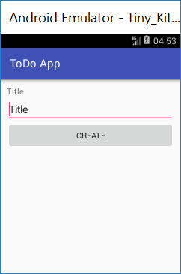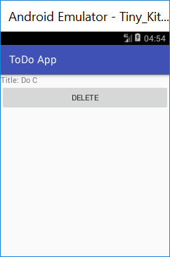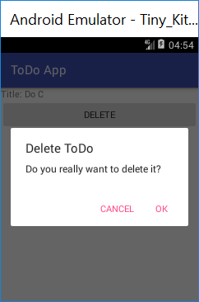

*If not obvious, describe what each screen is used for.*

*Also describe design patterns you are using, and how your code is organized. Do not only explain what fragments and activities you are using, but also services, general classes, etc.*

*Explain how you store data. In a database? Which tables is inside of it? Or in files? How do you organize those files? Etc. Maybe it makes sense to show an ER diagram?*

*What is your strategy when it comes to asking the user for permissions to use different features on the device (e.g. the camera, or accessing contacts, etc.)? When/how do you do that?*

*If a new programmer starts to work on the application, this section should provide a very good introduction to how it works and how it has been implemented.*

# Extra Functionalities

*As explained at:*

[*https://peppel-g.github.io/course-material/courses/android-development/project-grading-guidelines.html#extra-functionalities*](https://peppel-g.github.io/course-material/courses/android-development/project-grading-guidelines.html#extra-functionalities)

*For you to pass the project work, your application must implement some functionalities worth enough points. In the table below, enter which functionalities you have implemented, and describe how you have implemented them. As an example, one functionality has been, but you of course need to remove that one if you have not implemented it.*

|  |  |
| --- | --- |
| Feature name | Implementation |
| Multiple languages | String resources are available in English and Swedish in the different string.xml files in sub-folders to the res folder. In the app, whenever text is shown to the user, it is retrieved from the string.xml file that should be used per the user’s language settings. |
|  |  |
|  |  |
|  |  |
|  |  |

# Worklog

*Although it doesn't make sense to make the worklog part of this report (which should really only describe the implementation of the project), add it here anyway.*

*If you have used Git properly (descriptive commit messages, no huge commit that implements 12.5 features, etc.), showing the list of commits per member is probably enough, for example:*

## Alice

commit 89cc24d3c59d4dc5942d7e4198a9235f85575c72

Author: Alice <al@ice.com>

Date: Thu Nov 25 10:40:18 2021 +0100

Implemented the SignUpActivity.

commit 67f9e90bc3abfbfda57fded1bf30f005406704a3

Author: Alice <al@ice.com>

Date: Tue Nov 23 15:58:05 2021 +0100

Created the Android Studio project and the main activity.

…

## Bob

commit 9f4434e4a538231be1a27cf573ddabb53e1a645f

Author: Bob <bob@by.com>

Date: Thu Nov 25 09:38:20 2021 +0100

Implemented the LoginActivity.

…

## Claire

commit 9f4434e4a538231be1a27cf573ddabb53e1a645f

Author: Bob <bob@by.com>

Date: Thu Nov 26 09:38:20 2021 +0100

Styled the activities.

…

*If you haven't used Git/haven't used Git properly, show similar info in a table, for example:*

|  |  |  |  |
| --- | --- | --- | --- |
| Date | Alice | Bob | Claire |
| 2021-01-17 | Formed group | | |
| 2021-01-18 | Had meeting, decided to build chat application | | |
| 2021-01-19 | Explored different GUI suggestions. | Selected brand colors and created a logo for the application |  |
| 2021-01-20 |  |  | Studied Bluetooth |
| 2021-01-21 | Had meeting, presented work since last meeting | | |
| 2021-01-22 |  |  |  |
| 2021-01-23 | Created the Android Studio project with the main activity. |  |  |
|  |  |  |  |
| 2021-01-24 |  |  |  |
| 2021-01-25 |  |  |  |
| 2021-01-26 |  |  |  |
| 2021-01-27 |  |  |  |
| … |  |  |  |