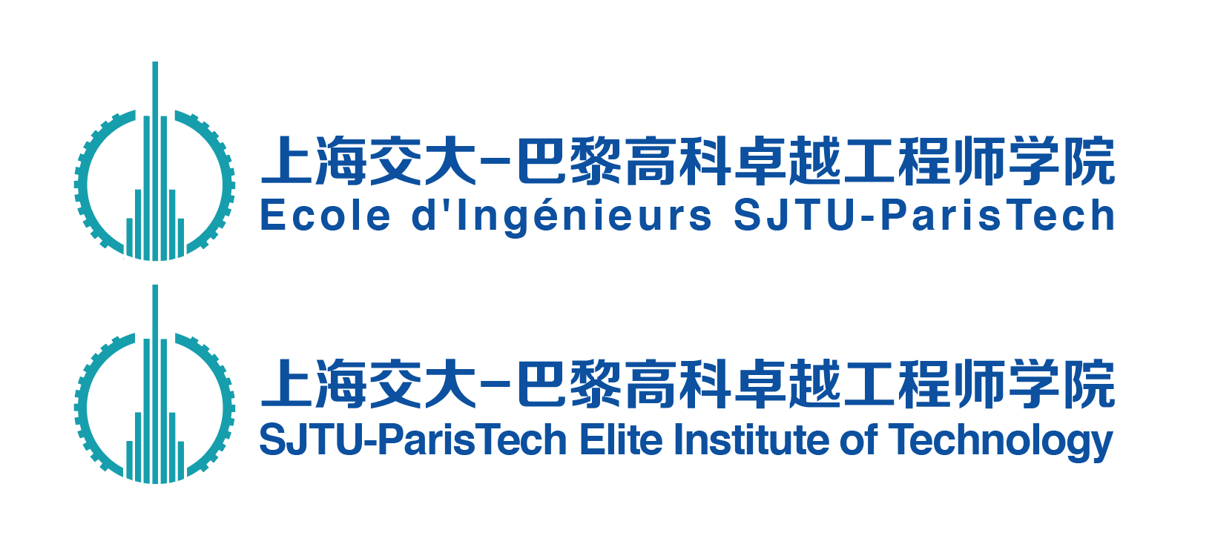

Engineer Internship Report

工程师实习报告

|  |  |
| --- | --- |
| **学号/ Student ID：** |  |
| **姓名/ Name:** |  |
| **专业/ Major:** |  |
| **实习单位/ Company:** |  |
| **实习职位/ Position:** |  |
| **实习时间/ Duration:** |  |
| **校内导师/ SPEIT Tutor:** |  |
| **企业导师/ Enterprise Tutor：** |  |

**撰写要求**

**Instruction**

1. 报告采用英语撰写，须提供2页中文摘要和1页英文摘要。

The report should be written in English with a 2-page Chinese summary and a 1-page English summary.

1. 正文至少25页，封面、摘要、参考文献及附录不计入页数。

The report should be at least 25 pages, whereas, the cover page, summary, reference and appendix are not taken into account.

1. 报告为A4大小，双面打印于左侧装订成册。

This report must be printed in A4 papers (double-sided) and bound together on the left.

1. 英文字体选用Times New Roman, 12号，1.5倍行距。中文字体选用宋体、小四号，1.5倍行距。

12-point font, Times New Roman，1.5 times spacing should be used for English; Tiny IV-point font, Song Ti, 1.5 times spacing should be used for Chinese.

1. 图片（表格、流程图和图表除外）所占比重不可超过正文全部的20%，且必须与正文相关，图片下附简要说明。

The proportion of photos (except the forms, flow chart and chart) shouldn’t exceed 20% of the text. Photos must be closely related to the report contents and concise explanations should be added below.

1. 正文后可以添加附件，不限格式。

Appendix can be attached in the end. No format is required.

1. 报告组成部分应包含：

The report should be consisted of:

1. 封面: Cover page
2. 版权使用授权书: Authorization for Copyright Use
3. 中文+英文大摘要: Chinese & English Abstract
4. 目录: Contents
5. 正文: Text
6. 参考文献: References
7. 附录（如有）: Appendix (if any)

**工程师实习报告版权使用授权书**

Authorization for Copyright Use of Engineer Internship Report

本人确认本实习报告不涉及保密相关内容，允许被公开查阅和借阅，并授权上海交通大学将工程师实习报告的内容采用影印、缩印或扫描等复制手段保存和汇编。

I confirm that this internship report does not involve confidentiality related contents and allow it to be consulted and borrowed publicly.

I also authorize Shanghai Jiao Tong University to keep and compile the contents of this report by means of photocopying, abbreviating or scanning.

作者签名（Author's Signature）： 企业指导教师签名（Tutor's Signature）：

日期（Date）： 年 月 日 日期（Date）： 年 月 日

**中文摘要**

摘要正文Times New Roman, 12号字，左右对齐。1.5倍行距。

**ABSTRACT**

空一行

Times New roman, 14号字加粗居中。

Microsoft Corporation (MS) is an American multinational technology company with headquarters in Redmond, Washington. It develops, manufactures, licenses, supports and sells computer software, consumer electronics, personal computers, and related services. Its best known software products are the Microsoft Windows line of operating systems, the Microsoft Office suite, and the Internet Explorer and Edge web browsers. Its flagship hardware products are the Xbox video game consoles and the Microsoft Surface lineup of touchscreen personal computers. As of 2016, it is the world's largest software maker by revenue, and one of the world's most valuable companies. The word "Microsoft" is a portmanteau of "microcomputer" and "software". Microsoft is ranked No. 30 in the 2018 Fortune 500 rankings of the largest United States corporations by total revenue.

Microsoft was founded by Bill Gates and Paul Allen on April 4, 1975, to develop and sell BASIC interpreters for the Altair 8800. It rose to dominate the personal computer operating system market with MS-DOS in the mid-1980s, followed by Microsoft Windows. The company's 1986 initial public offering (IPO), and subsequent rise in its share price, created three billionaires and an estimated 12,000 millionaires among Microsoft employees. Since the 1990s, it has increasingly diversified from the operating system market and has made a number of corporate acquisitions, their largest being the acquisition of LinkedIn for $26.2 billion in December 2016, followed by their acquisition of Skype Technologies for $8.5 billion in May 2011.

**Key words:** Microsoft, computer software, Windows, Bill Gates, operating system**,** Technologies

“Key words”加粗；关键字逗号分开，最后一个关键字后面无标点符号。

Times New Roma.n, 14号字加粗居中，上下各空一行。

Times New Roma.n, 12号字单倍行距。

**Contents**

**Chapter 1.** Introduction 1

1.1 Microsoft Corporation 3

四级标题不需要写在目录里。

1.1.1 Employment Information 4

**References** ------------------------------------------------------------------------------------------------

**Chapter 1. Introduction**

Microsoft Corporation (MS) is an American multinational technology company with headquarters in Redmond, Washington. It develops, manufactures, licenses, supports and sells computer software, consumer electronics, personal computers, and related services. Its best known software products are the Microsoft Windows line of operating systems, the Microsoft Office suite, and the Internet Explorer and Edge web browsers. Its flagship hardware products are the Xbox video game consoles and the Microsoft Surface lineup of touchscreen personal computers. As of 2016, it is the world's largest software maker by revenue, and one of the world's most valuable companies. The word "Microsoft" is a portmanteau of "microcomputer" and "software". Microsoft is ranked No. 30 in the 2018 Fortune 500 rankings of the largest United States corporations by total revenue.

二、三级标题均为Times New Roma.n, 14号字加粗左对齐，上下各空一行。

**…**

**1.1 Microsoft Corporation**

公式应另起一行，正文中的公式、算式或方程式等应编排序号，公式的编号用圆括号括起，序号标注于该式所在行(当有续行时，应标注于最后一行)的行末。公式可按章节顺序编号或按全文统一编号。公式序号必须连续，不得重复或跳缺。重复引用的公式不得另编新序号。



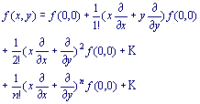 （2-2）

较长的公式，如必须转行时，最好在等号处转行,如做不到这一点,要在+，-，×，÷等数学符号处转行。数学符号应写在转行处的行首。上下式尽可能在等号“＝”处对齐。

表题应写在表格上方正中，不加标点，空一格写表题，表题末尾不加标点，字体为12号Times New Roman加粗。根据章节序号连续标注表格的序号，如Table 1.1，并按序号顺序排列。

表格格式采用简明三线表。表格内英文用12号Times New Roman。

**Table 1.1**

|  |  |  |  |
| --- | --- | --- | --- |
| A | B | C | D |
| A1  A2  A3 |  |  |  |

Table 1.1

表题允许下页接写，接写时表题省略，表头应并右上方重复书写，字体为12号Times New Roman。

页面顶端空一行。

|  |  |  |  |
| --- | --- | --- | --- |
| A | B | C | D |
| A4  A5  A6  A7  A8 |  |  |  |

每幅插图应有图序和图题，图序应写在插图下方正中，不加标点，空一格写图题，图题末尾不加标点，字体为12号Times New Roman加粗。根据章节序号连续标注插图的序号，如ILLUSTRATION 1.2，并按序号顺序排列。

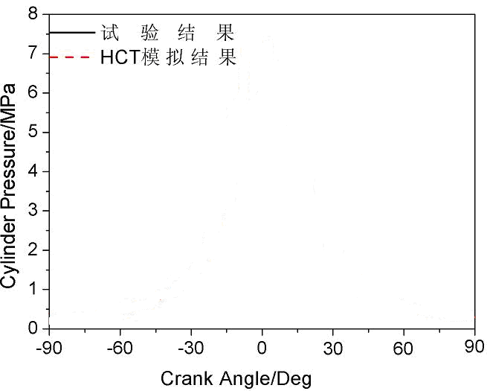

**ILLUSTRATION 1.2**

页面底端空一行。

**…**

中括号的数字连续编号，顶格书写，字体为12号Times New Roman，1.5倍行距。

**REFERENCE**

Times New Roma.n, 14号字加粗居中，上下各空一行。

[1] 蒋有绪,郭泉水,马娟,等. 中国森林群落分类及其群落学特征[M]. 北京:科学出版社,1998:11-12.

[2] <https://stackshare.io/>

[3] World Health Organization. Factors regulating the immune response: report of WHO Scientific Group[R].Geneva: WHO, 1970.

[4] CHRISTINE M. Plant physiology: plant biology in the Genome Era [J/OL].Science,1998,281:331-332[1998-09-23].http://www.sciencemag.org/cgi/collection/anatmorp.

**…**