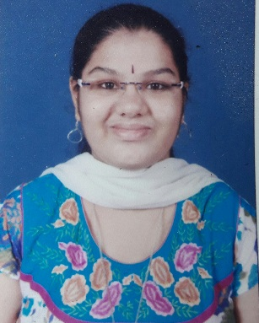**Krittika Ranganathan**

|  |  |
| --- | --- |
| **Title:** | Software Analyst |
| **Location:** | Mumbai, India |
| **Languages:** | Tamil (native),English (fluent),Hindi (fluent), Marathi (conversational), French(translation) |

# Experience Summary

* Exceptional level of versatility and multi-talented.
* Energetic, unique thinker and eager to learn new technology.
* Ability to work in a group and as an individual.
* Successfully completed internship at BARC in Reactor Engineering Department.

**KEY SKILLS:**

* **Functional:** Project Management, Team Building, Team Leader, Excellent Communication and Interpretation skills,
* **Technical:** Java Core, SQL/PLSQL, JSP, Servlet, Spring, HTML, JavaScript, CSS, JPA with Hibernate, jQuery.

# Training, Certifications & Affiliations

* Internship at BARC in Reactor Engineering Department for a month and gained knowledge in Electronic Components and their testing.
* 3 Months Training in Java Platform, Enterprise Edition (Java EE) in Capgemini.

# Published & Presented / Awards

* Published technical BE project paper in The International Journal of Innovative Research in Science, Engineering and Technology (IJIRSET) titled Crack and Obstacle Surveillance Using Wireless Technology dated 4th April,2017 in Volume 6, Issue 4.

# Higher Education

* BE in Electronics Engineering from Vivekanand Education Society Institute of Technology, Mumbai.