1.0 INTRODUCTION
PC Hardware is a full-stack e-commerce web application designed to support customers who wish to purchase individual computer components or build a complete, compatible personal computer. Choosing PC hardware can be difficult because components such as processors, motherboards, memory, graphics cards, power supplies, cooling systems, and cases must work together correctly. The application addresses this problem by combining a conventional online shopping experience with a guided PC Builder that helps users select suitable components from the store catalogue.

The website was developed using Vue.js 3 and follows a component-based architecture. It provides interconnected customer-facing pages including the homepage, product catalogue, product details, PC Builder, wishlist, shopping cart, checkout, order history, and user profile. A separate administration interface allows authorised administrators to manage products, stock quantities, customer orders, users, homepage products, and store performance information. This separation ensures that customers and administrators receive interfaces that are appropriate for their different tasks.

The system uses Supabase as its backend database and storage service. Product information, user details, orders, reviews, shopping cart items, wishlist items, and uploaded images are retrieved and updated through RESTful API requests. The application also integrates external services to provide additional functionality, including live currency conversion, an AI customer assistant, and smart PC component recommendations. These features extend the website beyond a basic e-commerce application and provide users with more useful support when making purchasing decisions.

A major objective of the project was to create an interface that remains usable across desktop, tablet, and mobile devices. Responsive layouts, flexible grids, media queries, dynamic navigation, and adaptive product cards were implemented to ensure that content remains clear and accessible at different screen sizes. The application also includes light and dark colour themes, consistent navigation, visual feedback, form validation, stock availability indicators, and accessible labels to improve the overall user experience.

This report presents the design and implementation of the PC Hardware application. It explains the system structure, interface design decisions, responsive design techniques, usability considerations, accessibility evaluation, and advanced technologies used throughout the project.

2.0 SYSTEM OVERVIEW

2.1 System Purpose
The purpose of PC Hardware Store is to support the complete customer journey for purchasing PC components. The site is not only a product catalogue; it also assists customers who may not fully understand component compatibility. By dividing PC building into clear categories and offering AI-assisted recommendations, the system reduces the difficulty of selecting parts for a working computer.

Role | Main Goals | Key Pages
Customer | Browse components, compare products, build a PC, manage wishlist/cart, checkout, review orders. | Home, Products, Product Details, PC Builder, Wishlist, Cart, Checkout, Orders, Profile
Administrator | Manage inventory, stock, users, orders, homepage listings, profile, and performance information. | Dashboard, Products, Orders, Order Details, Users, Homepage Editor, Admin Profile

2.2 System Architecture
The application follows a client-server architecture. The frontend is a Vue.js single-page application built with Vite. Vue Router manages navigation and route protection, while Pinia stores manage shared state such as cart items, wishlist items, comparison data, and currency selection. Supabase stores persistent data and product/profile images. Vercel serverless functions connect the frontend to external AI and currency services without exposing private API keys to the browser.

Layer | Technology | Purpose
Frontend | Vue.js 3, Vite, Vue Router | Builds the interactive single-page interface and page navigation.
State | Pinia | Shares cart, wishlist, comparison, and currency state across components.
Backend Data | Supabase REST API | Stores and retrieves products, users, orders, reviews, cart items, wishlist items, and homepage product selections.
File Storage | Supabase Storage | Stores product images and profile images.
Serverless APIs | Vercel API routes | Protects API keys and handles Google AI, Groq recommendations, and Twelve Data exchange rates.

2.3 Customer-Facing Features
The customer side of the application is designed to support the complete purchasing process, from discovering a product to reviewing a completed order.

The Home Page introduces the PC Hardware brand and provides direct access to the product catalogue and PC Builder. It displays product categories, store statistics, hot-selling products, latest products, and calls to action that guide users towards important shopping tasks.

The Products Page displays the available hardware components in a responsive product grid. Customers can search for products, filter them by category, sort the results, change product quantities, view product details, add items to the shopping cart, add items to the wishlist, or select products for comparison. Product stock information is displayed clearly so that customers can identify unavailable or low-stock products before attempting to purchase them.

The Product Detail Page provides more information about a selected component. It displays the product image, category, price, stock quantity, description, purchase controls, related products, and customer reviews. Customers can also add the product to their wishlist or comparison list from this page.

The PC Builder Page allows users to create a complete computer build by selecting components from categories such as motherboard, processor, RAM, graphics card, storage, power supply, CPU cooler, PC case, and RGB fans. After the user selects a component, the system can request smart recommendations for the remaining categories based on the store catalogue. This helps reduce the risk of selecting unsuitable or unbalanced components.

The Cart and Checkout Pages allow customers to review their selected items, update quantities, choose delivery and payment options, and place an order. Before an order is submitted, the system checks the latest product stock from the database. After a successful order, the purchased quantities are deducted from the stored product stock.

The Wishlist Page stores products that the customer may want to purchase later. Wishlist and shopping cart data are saved in Supabase so that the items can remain available after a page refresh, sign-out, or login from another device.

The Profile and Order History Pages allow customers to view their account details, total orders, total spending, recent orders, and previous purchases. Customers can also print an order receipt from the order history page.

2.4 Administration Features
The administration interface is separate from the customer storefront. Role-based route protection prevents normal users from accessing administrator pages and prevents administrators from being redirected into customer-only workflows.

The Admin Dashboard provides a summary of the store’s current performance. It displays the number of products, orders, registered users, monthly revenue, total revenue, products by category, orders by status, latest products, and latest orders. This information helps the administrator quickly understand the condition of the store.

The Admin Products Page supports product inventory management. Administrators can add new products, upload product images, edit existing product information, delete products, filter the inventory by category, and monitor low-stock items. Product stock quantities are updated when customers complete purchases.

The Admin Orders Page allows administrators to view customer orders, monitor order values, and update order statuses such as pending, processing, shipping, delivered, or rejected. Administrators can open a detailed order page to review customer information, ordered items, delivery details, and payment information.

The Admin Users Page displays registered customer accounts and summarises the number of total users, administrators, and customers. The interface includes a search function to help administrators locate users efficiently.

The Admin Homepage Editor allows administrators to manage the hot-selling and latest product sections displayed on the customer homepage. The Admin Profile Page allows the administrator to update profile details, change the profile image, and log out.

2.5 Database and RESTful API Integration
Supabase provides persistent data storage for the project. The frontend communicates with Supabase using asynchronous RESTful API requests through a reusable API helper module. The main tables include products, users, orders, reviews, cart_items, wishlist_items, and homepage selections. This makes core user data available across page refreshes, sign-out, and login from another device.

Data Area | Stored Information | CRUD Example
Products | Name, price, category, stock, description, image. | Admin creates/updates/deletes products; checkout updates stock.
Orders | Customer, items, totals, shipping, payment, status. | Checkout creates orders; admin updates order status.
Cart | User email, product ID, product snapshot, quantity. | Customer adds, updates, removes, and clears cart items.
Wishlist | User email, product ID, product snapshot. | Customer saves or removes wishlist products.
Reviews | Product ID, user, rating, comment. | Customer submits product review data.

2.6 External Service Integration
The application integrates several external services to provide functionality beyond a basic e-commerce website.

The Google AI service is used by the customer-facing AI chat assistant. The assistant helps customers understand PC components, compare hardware, and plan a complete build.

The Groq service is used by the PC Builder recommendation feature. The selected components and available store catalogue are sent to a secure serverless endpoint. The recommendation result is then validated so that only real products from the store catalogue can be displayed.

The Twelve Data API provides live foreign exchange rates. Product prices are stored in Malaysian Ringgit by default and can be converted into supported currencies such as Japanese Yen, Korean Won, US Dollars, Singapore Dollars, and Euros. Currency selection is shared across both customer and administrator pages.

2.7 Interface Design Approach
The interface uses a consistent visual language across the website. Product cards, forms, buttons, navigation controls, status indicators, and headings follow repeated styling patterns. Contextually related controls are grouped together, such as quantity controls beside purchase buttons and order status controls beside order actions.

A row-column grid system is used throughout the application to organise products, statistics, charts, forms, and account information. Clear visual hierarchy is achieved through large page headings, smaller section headings, highlighted prices, coloured status indicators, and primary action buttons.

The application also provides light and dark themes. Colours, backgrounds, text, cards, dropdown menus, and interactive controls change dynamically based on the selected theme to maintain readability and visual comfort.

2.8 Vue Framework Techniques
The implementation uses Vue features throughout the project. Reusable components such as Navbar, AdminNavbar, Footer, Toast, AiChatWidget, CompareBar, ProductReviews, and loading skeletons reduce duplicated code. Directives such as v-if and v-for control conditional rendering and repeated product/status lists. v-model is used for form inputs and search fields. Dynamic bindings such as :class and :disabled adjust styling and button availability based on state, stock, selected currency, theme, and user role. The Composition API, computed values, watchers, and asynchronous fetch calls are used to retrieve data and update the interface reactively.

3.0 WIREFRAME DESIGN DIAGRAMS
The wireframes below show the intended structure before final styling. They focus on layout, grouping, navigation, and information hierarchy rather than colour or final visual details.

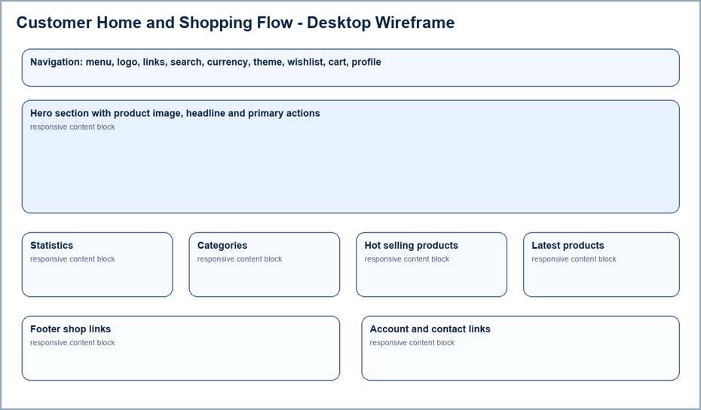
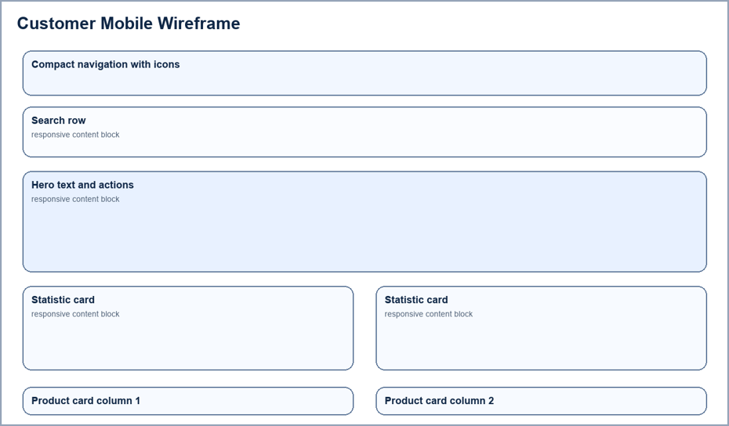

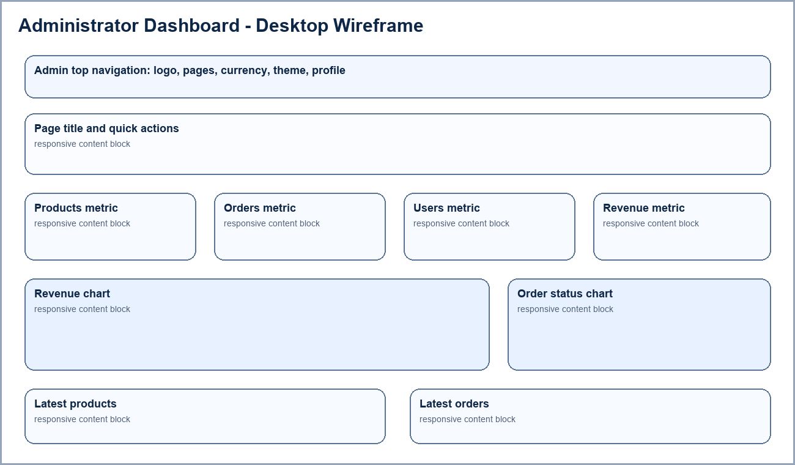

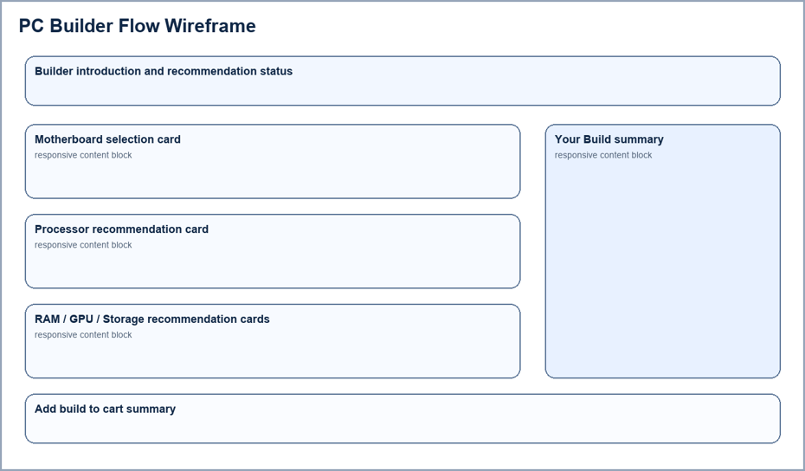

4.0 WEB APPLICATION SCREENSHOTS
This section presents screenshots from the completed application. The screenshots demonstrate the visual design, customer workflow, administrator workflow, and responsive implementation.

5.0 RESPONSIVE UI DESCRIPTION

5.1 Responsive Design Approach
The PC Hardware application was designed to provide a consistent and usable experience across desktop computers, tablets, and mobile phones. Responsive design is especially important for an e-commerce application because customers may browse products, compare components, manage their cart, or place an order using devices with very different screen sizes.

The application uses flexible layouts instead of fixed-width page designs. CSS Grid, Flexbox, relative widths, minmax(), auto-fill, auto-fit, and clamp() are used to allow content to resize and reorganise based on the available screen space. Media queries are used at several breakpoints, including approximately 1200px, 1024px, 900px, 768px, 640px, 560px, and smaller mobile sizes.

The responsive design was tested using three main viewport sizes:
Device Type | Example Viewport | Purpose
Desktop | 1440 × 1000 pixels | Full navigation, multi-column content, sidebars, and dashboard charts
Tablet | 820 × 1180 pixels | Reduced navigation, fewer columns, and reorganised content
Mobile | 390 × 844 pixels | Compact controls, stacked layouts, touch-friendly actions, and simplified navigation

5.2 Flexible Layout System
The application uses a row-column grid system to maintain alignment and consistency. On larger screens, the available horizontal space is used to display more information without requiring unnecessary scrolling. As the screen width becomes smaller, the number of columns is reduced so that the content remains readable.

For example, the customer homepage displays product categories and featured products in a multi-column grid on desktop devices. On tablet devices, the grid changes to two columns. On mobile devices, the content is displayed in a single column so that each card has enough space for its product image, name, price, and action buttons.

The product listing page also uses a responsive grid. Desktop users can view several product cards in each row while the category and sorting controls are displayed in a sidebar. On tablet and mobile devices, the sidebar is hidden to provide more space for the products. Mobile devices display two compact product cards per row where sufficient width is available. On very small screens, the product grid can reduce to a single column to prevent text and buttons from overlapping.

5.3 Responsive Navigation
The customer navigation bar changes its layout based on the available screen width. On desktop devices, the navigation bar displays the brand logo, product link, PC Builder link, search bar, currency selector, theme control, wishlist, cart, and profile controls in one horizontal row.

On mobile devices, less important text links are hidden or moved into the menu. The navigation bar keeps the most important icons visible, including the theme control, wishlist, cart, and profile controls. The search bar is moved to a separate row below the main navigation controls so that users can still search for products without the input field becoming too narrow.

The menu button provides access to additional navigation options when there is not enough space to display all links. This keeps the header compact while ensuring that the user can still access the main sections of the website.

The administrator navigation bar also adapts to smaller screens. Desktop devices display the full navigation labels, currency control, theme control, and administrator profile. On mobile devices, the navigation labels are reduced to recognisable icons. This allows administrators to move between the dashboard, products, orders, users, homepage editor, and profile pages without the navigation bar covering the page content.

5.4 Homepage Responsiveness
The homepage hero section uses a large background image and text overlay on desktop devices. The desktop layout provides enough space for a large heading, supporting description, and primary action buttons.

On tablet devices, the hero content remains visible but the text size and spacing are reduced. The background image is repositioned to keep the important visual content within the viewport.

On mobile devices, the hero section becomes more compact and places the content in the centre of the screen. The heading uses responsive font sizing so that it remains readable without overflowing. The “Shop Now” and “PC Builder” buttons become wider and easier to tap. Store statistics are displayed in a smaller grid below the hero section.

The application uses clamp() for important heading sizes. This allows text to scale smoothly between a minimum and maximum size without depending only on fixed media query values.

5.5 Product Listing Responsiveness
The products page contains several elements that must remain usable at different sizes:
- Product category filters.
- Sorting controls.
- Product search.
- Product images.
- Quantity controls.
- Product details buttons.
- Add to cart buttons.
- Wishlist and comparison actions.
On desktop devices, the category and sorting controls are displayed in a left sidebar while the product grid occupies the remaining space. This arrangement allows users to browse and filter products efficiently.

On mobile and tablet devices, the category sidebar is hidden to avoid reducing the width of the product cards. Product actions are reorganised within each card, and buttons are sized to remain touch friendly. The product grid uses two columns on common mobile widths and one column on very small devices.

5.6 PC Builder Responsiveness
The PC Builder uses a two-column desktop layout. The main component selection area is displayed on the left, while the “Your Build” summary remains visible on the right. This allows desktop users to review their selected components while continuing to browse recommended parts.

On smaller screens, the layout changes to a single column. The build summary moves below the component selection area so that it does not reduce the width of the product recommendation cards. Recommended products change from three columns on desktop to two columns on tablet and one column on mobile.

Selected component cards also adapt to mobile screens. Product images, names, prices, and change buttons are reorganised vertically so that the information remains readable without horizontal scrolling.

5.7 Cart, Checkout, and Profile Responsiveness
The shopping cart and checkout pages use a two-column layout on desktop devices. The main content is shown on the left, while the order summary is displayed on the right. This helps users review their items and total cost at the same time.

When the viewport becomes smaller, the order summary moves below the main content. Form fields and delivery options expand to use the available width. This prevents input fields from becoming too narrow and improves usability for touch-screen users.

The profile page also changes from a sidebar and content layout into a single-column layout on mobile devices. Profile information, order statistics, personal details, and recent orders are stacked vertically. Address forms that use two columns on desktop are reduced to one column on mobile devices.

5.8 Admin Page Responsiveness
The administration pages use responsive grids to ensure that management tasks remain usable on smaller devices.

The Admin Dashboard displays multiple statistic cards, revenue charts, order status charts, latest products, and latest orders. Desktop screens use multiple columns to present this information efficiently. On tablet and mobile devices, the statistic cards and chart sections reduce their number of columns and eventually stack vertically.

The Admin Products page uses a desktop layout with an add-product form beside the product inventory. On smaller screens, the form moves above the product list. Product inventory cards display two cards per row on common mobile sizes and can reduce further when the screen becomes very narrow.

The Admin Orders and Admin Users pages use responsive table containers. When a table contains more information than the mobile screen can display, the table can be scrolled horizontally instead of compressing the text until it becomes unreadable.

5.9 Responsive Images and Media
Product images are placed inside containers with controlled dimensions so that different image sizes do not break the card layout. Images use proportional sizing and object fitting to remain visible without stretching.

The homepage hero image changes its position and scale depending on the viewport size. This ensures that the image continues to support the page content rather than covering important text.

5.10 Touch-Friendly Interaction
Mobile users interact with the website using touch instead of a mouse. Buttons, icons, search fields, quantity controls, and navigation actions are given sufficient spacing to reduce accidental taps. Important actions such as “Add to Cart”, “Shop Now”, and “PC Builder” become more prominent on smaller screens.

Hover effects are treated as visual enhancements rather than required functionality. Users can complete all important tasks by tapping visible controls.

5.11 Responsive Testing and Evaluation
The responsive interface was tested at desktop, tablet, and mobile sizes. The following areas were checked during testing:
- Text remains readable without overlapping other content.
- Navigation controls remain accessible.
- Search fields do not cover nearby icons or labels.
- Product cards resize without breaking their internal alignment.
- Forms remain usable on small screens.
- Tables can be viewed without compressing important data.
- Buttons remain large enough for touch interaction.
- Images remain visible and correctly proportioned.
- Light and dark themes remain readable at all screen sizes.

6.0 USABILITY
The usability of the PC Hardware application was evaluated using a task-based walkthrough and common usability principles, including consistency, visibility of system status, error prevention, user control, recognition rather than recall, and efficiency of use. The evaluation considered both customer and administrator workflows.

6.1 Navigation Efficiency
The customer navigation bar provides direct access to the product catalogue, PC Builder, search function, currency selector, theme control, wishlist, shopping cart, and user profile. These controls remain consistent across the customer-facing pages, allowing users to move between important sections without returning to the homepage.

The administrator interface uses a separate navigation bar with direct links to the dashboard, products, orders, users, homepage editor, and administrator profile. Role-based routing ensures that customers remain on the user side while administrators remain within the management interface. This reduces confusion between customer and administrator functions.

The search bar and product category filters improve navigation efficiency by helping users find products without browsing the entire catalogue. On smaller devices, the navigation layout becomes more compact while maintaining access to important features.

6.2 Consistency and Visual Hierarchy
The application uses consistent design patterns for page headings, product cards, buttons, form fields, status indicators, and navigation controls. Users can recognise similar actions across different pages because repeated features use the same appearance and placement.

Primary actions such as Shop Now, Add to Cart, Place Order, Add Product, and Save are visually highlighted. Secondary actions such as View Details, Edit, and Remove use less prominent styles. This creates a clear visual hierarchy and helps users identify the most important action on each page.

Related information is grouped together. For example, each product card contains the product image, name, category, price, stock level, quantity controls, and purchase actions. Checkout information is separated into customer details, shipping method, payment method, and order summary sections.

6.3 Product Browsing and Selection
The product listing page provides several methods for finding suitable components:
- Searching by product name.
- Filtering products by category.
- Sorting products by price or name.
- Switching between grid and list views.
- Viewing detailed product information.
- Adding products to the wishlist or comparison list.
Stock availability is displayed before users attempt to purchase a product. Out-of-stock products have disabled purchase buttons, while low-stock products display a warning. This helps prevent users from attempting actions that cannot be completed.

Quantity controls use familiar minus and plus buttons with the current quantity displayed between them. This allows users to confirm the selected amount before adding an item to the shopping cart.

6.4 PC Builder Usability
The PC Builder simplifies the complex process of selecting compatible computer components. The build process is divided into clear categories such as motherboard, processor, RAM, graphics card, storage, power supply, CPU cooler, PC case, and RGB fans.

The “Your Build” summary provides continuous visibility of selected components. Users do not need to remember which parts have already been chosen, and they can change or remove a selected component when required.

After the user selects the first component, the smart recommendation feature suggests suitable remaining products from the actual store catalogue. This reduces the technical knowledge required to build a functional PC and supports users who may not understand hardware compatibility requirements.

6.5 Shopping Cart and Checkout Usability
The shopping cart clearly displays selected products, quantities, individual prices, and the total cost. Users can adjust quantities, remove unwanted items, and proceed to checkout.

The checkout page divides the process into logical sections, including delivery information, shipping method, payment method, and order summary. This contextual grouping reduces cognitive load because users can focus on one type of information at a time.

Before an order is placed, the system checks the latest stock quantity from the database. This prevents customers from purchasing unavailable quantities. After a successful order, the product stock is automatically reduced.

6.6 Form Usability
Forms throughout the application use labels, placeholders, consistent input styling, and clearly identified action buttons. Registration, login, checkout, profile editing, product management, and homepage product forms follow similar design patterns.

Required information is grouped logically, and input fields expand on smaller screens to remain easy to use. Password fields include visibility controls so users can check their input before submitting a form.

The application provides feedback when an action fails or succeeds. However, some forms could be improved by displaying validation messages directly beside the affected field instead of relying on a general alert or notification.

6.7 Administrator Usability
The dashboard gives administrators a quick overview of inventory, users, orders, and revenue. Product management cards and order status controls are placed close to the relevant data, supporting efficient repeated management tasks. However, larger catalogues would benefit from pagination, advanced filtering, and bulk actions.

Usability Issue | User Impact | Suggested Improvement
Long product lists | Users may take longer to locate products. | Add pagination, price/spec filters, and visible active filters.
Mobile PC Builder scrolling | Completing a full build takes longer on small screens. | Add progress indicators and collapsible completed sections.
General form errors | Users may not know which field caused the issue. | Display field-level validation and focus the first invalid input.
Technical API messages | Non-technical users may not understand recovery steps. | Translate errors into plain language and provide retry/manual alternatives.
Destructive admin actions | Products or users could be removed accidentally. | Add confirmation dialogs for delete actions.
Usability Issue | User Impact | Suggested Improvement

6.8 System Feedback and Error Prevention
The application provides feedback through toast notifications, loading states, status labels, disabled buttons, stock warnings, and confirmation information. These features help users understand whether the system is processing an action, whether it has succeeded, or whether an error has occurred.

Error prevention is supported by:
- Disabling purchase actions for out-of-stock products.
- Checking stock again before placing an order.
- Restricting administrator pages to administrator accounts.
- Keeping administrators within the administrator interface.
- Limiting PC Builder recommendations to products from the store catalogue.
- Displaying order statuses before administrators make changes.

6.9 Identified Usability Issues
Usability Issue | User Impact
Long product lists may require excessive scrolling | Users may take longer to locate a specific product
Large administrator tables may become difficult to scan | Administrators may miss important order or user information
Mobile users must scroll through multiple PC Builder categories | Completing a full build may take longer on smaller devices
Some errors may display technical service information | Users may not understand the problem or how to recover
Some forms rely on general error notifications | Users may not know which input field caused the error
Destructive actions may be triggered accidentally | Administrators may remove products or users unintentionally
Currency symbols alone may not be clear to all users | Users may not immediately understand the selected currency

7.0 ACCESSIBILITY EVALUATION
The accessibility of the PC Hardware application was evaluated using principles based on the Web Content Accessibility Guidelines (WCAG). The evaluation considered whether the website can be understood and operated by users with different visual, physical, cognitive, and technical needs.

The evaluation focused on keyboard access, screen reader support, colour contrast, readable text, image descriptions, form accessibility, responsive layouts, and system feedback. This evaluation does not claim that the application is fully WCAG compliant, but it identifies the accessibility features currently implemented and the areas that require further improvement.

7.1 Keyboard Accessibility
Users who cannot use a mouse should be able to navigate and operate the application using a keyboard. The website uses standard HTML buttons, links, input fields, and form controls for most interactive features. These elements can normally be reached using the Tab key and activated using the Enter or Space key.

The navigation search bar supports keyboard interaction, allowing users to type a search query and select products without depending only on mouse input. Form fields in login, registration, checkout, profile, and administrator pages also follow a logical order based on their position in the page.

However, some advanced interactions may require additional keyboard testing. Custom dropdown menus, product comparison controls, theme controls, currency selectors, modal dialogs, and mobile navigation menus should be checked to ensure that users can open, close, and navigate them without using a mouse.

7.2 Screen Reader Support
The application includes accessible labels for several important icon-based controls. For example, the customer navigation bar provides labels for the wishlist, shopping cart, profile, and menu buttons. The administrator logo includes a label that explains that it returns the user to the administrator dashboard.

The AI chat widget includes accessible labels for opening, closing, and sending messages. Toast notifications use role="status" and aria-live="polite", allowing screen readers to announce feedback without interrupting the user immediately.

Product images generally use alternative text based on the product name. This allows users who cannot see the image to understand which product is being displayed. Decorative images, such as the homepage background image, use empty alternative text so that screen readers do not announce unnecessary visual content.

A limitation is that some icons and emoji-based category indicators may not provide meaningful information when announced by a screen reader. The application should ensure that important information is not communicated using icons alone.

7.3 Colour Contrast and Theme Support
The website provides both dark and light colour themes. This allows users to select the theme that is more comfortable for their environment or visual preference. Text, backgrounds, cards, dropdown menus, buttons, and navigation elements change dynamically when the theme is changed.

Important status information uses different colours, such as green for available stock or delivered orders, yellow for pending orders, and red for rejected orders or errors. These colours help users recognise the current state quickly.

However, colour should not be the only method used to communicate meaning. The application also includes text labels such as Pending, Delivered, Rejected, In Stock, and Out of Stock, which improves accessibility for users with colour vision deficiencies.

Some secondary text, placeholder text, disabled controls, and light-theme profile information may have lower contrast than the main content. These areas should be tested using a colour contrast checking tool to ensure that text remains readable for users with low vision.

7.4 Text Readability
The application uses a modern technology-style font to support the visual identity of the PC hardware store. Headings are visually distinct from body text, and important information such as prices, totals, and page titles is given greater emphasis.

Responsive font sizing is used so that headings do not overflow on smaller screens. Text is also reorganised when the layout changes from desktop to mobile.

The technology-style font may be more difficult to read for some users when used for long paragraphs or small labels. Body text should remain simple, sufficiently large, and clearly spaced. Decorative fonts are more suitable for headings and short labels than for detailed descriptions or instructions.

7.5 Image Accessibility
Product images include descriptive alternative text using the product name. This helps screen reader users understand the content of product cards, shopping cart items, wishlist items, order history items, and administrator product listings.

The application also prevents product images from stretching or breaking the layout by placing them inside controlled containers. This supports users who zoom the page because images remain associated with the correct product information.

A limitation is that product images may not describe important visual differences between similar products. For example, two graphics cards may have similar names but different physical designs. More detailed alternative text could be useful when the appearance of the product affects a purchasing decision.

7.6 Form Accessibility
Forms are used throughout the website for account registration, login, password reset, checkout, profile editing, product management, and homepage product management.

The forms use visible labels, placeholders, consistent input styling, and clearly identified submission buttons. Related fields are grouped together, such as personal details, delivery information, and payment methods. This makes forms easier to understand for users with cognitive or visual difficulties.

Password fields provide visibility controls so users can confirm what they have entered. Input fields also expand to use the available width on smaller devices, making them easier to operate on touch screens.

Some form errors are displayed using general alerts or toast notifications. Screen reader users may have difficulty identifying which field caused the error. Error messages should be connected directly to the affected input field using accessible descriptions.

7.7 Responsive and Touch Accessibility
The responsive design improves accessibility for users who browse the website on mobile phones, tablets, or devices with browser zoom enabled. Layouts change from multiple columns to fewer columns or a single column when the screen becomes smaller.

Important buttons are given sufficient size and spacing for touch interaction. Mobile navigation controls use familiar icons, and the search bar is moved to a separate row to prevent it from becoming too narrow.

The application should continue to be tested at high zoom levels to ensure that users do not need to scroll horizontally to read ordinary content. Tables and complex administrator pages may require horizontal scrolling because they contain more information than can fit on a small screen.

7.8 Accessibility for Different Users
The application provides support for several different user needs:
User Need | Current Support
Users with low vision | Light and dark themes, responsive text, clear headings, and visible buttons
Users with colour vision deficiencies | Status colours are supported by text labels
Keyboard-only users | Standard links, buttons, inputs, and keyboard-enabled search
Screen reader users | Alternative text, accessible button labels, and live toast notifications
Mobile and touch-screen users | Responsive layouts, larger controls, and compact navigation
Users with cognitive difficulties | Contextual grouping, consistent layouts, and clear primary actions
User Need | Current Support

7.9 Identified Accessibility Issues
Accessibility Issue | Potential Impact
Some secondary text may have low contrast in light mode | Users with low vision may have difficulty reading information
Some controls use icons or emoji without detailed labels | Screen reader users may not understand the control or category
Custom dropdown menus and modal dialogs may not fully support keyboard navigation | Keyboard-only users may be unable to complete some tasks efficiently
General form error messages are not always connected to individual fields | Screen reader users may not know which input requires correction
Decorative technology-style fonts are used for some small text | Users with reading difficulties may find the content harder to understand
Some animations and hover effects do not consider reduced-motion preferences | Users sensitive to motion may experience discomfort
Administrator tables may require horizontal scrolling on small screens | Mobile users and users with zoom enabled may find the information difficult to review

8.0 IMPROVEMENTS
Based on the usability and accessibility evaluation, several improvements can be made to increase the efficiency, clarity, inclusiveness, security, and reliability of the PC Hardware application.

8.1 Improve Form Validation
Forms should provide real-time validation messages beside the affected input field. For example, if a user enters an invalid email address or leaves a required checkout field empty, the error should appear directly below that field.

The application should also:
- Clearly identify required fields.
- Preserve valid user input after an error.
- Move keyboard focus to the first invalid field.
- Use simple error messages that explain how to correct the problem.
- Connect error messages to inputs using aria-describedby.
This would improve form usability for all users, especially screen reader users and users with cognitive difficulties.

8.2 Improve Keyboard Navigation
All interactive elements should be fully operable using only a keyboard. Custom controls such as currency selectors, theme controls, dropdown menus, mobile navigation menus, modal dialogs, and product comparison features should support the Tab, Enter, Space, Escape, and arrow keys where appropriate.

Visible focus indicators should also be added so keyboard users can clearly identify which control is currently selected. When a modal dialog is opened, keyboard focus should move into the dialog and remain inside it until the dialog is closed.

8.3 Improve Colour Contrast
Some secondary text, placeholder text, disabled controls, and light-theme content may not provide sufficient contrast against their backgrounds. A WCAG colour contrast checker should be used to test all important text and interface components.

Normal text should aim for a contrast ratio of at least 4.5:1, while large text should aim for at least 3:1. Status information should continue to use both colour and text labels so that users with colour vision deficiencies can understand the information.

8.4 Add Reduced-Motion Support
The application includes hover effects, card tilting, scrolling animations, and transitions. These interactions improve the visual experience but may cause discomfort for users who are sensitive to motion.

The website should detect the user’s prefers-reduced-motion setting and reduce or disable unnecessary animations when requested. Essential feedback should remain visible without depending on movement.

8.5 Improve Product Filtering and Pagination
As the product catalogue grows, users may need to scroll through many products before finding a suitable component. The product page could be improved by adding:
- Pagination or infinite scrolling.
- Filters for price range, stock availability, brand, and specifications.
- A clear button to reset all filters.
- Active filter indicators.
- A visible count of matching products.
These improvements would make product discovery faster and reduce the effort required to browse a large catalogue.

8.6 Improve Administrator Data Management
Large user, product, and order lists may become difficult for administrators to scan. Administrator pages should include advanced search, sorting, pagination, and bulk actions.

For example, administrators could select multiple products to update stock quantities or remove several inactive items. Sticky table headings would also help administrators understand each column while scrolling through long tables.

8.7 Add Confirmation for Destructive Actions
Deleting a product, user, order, or homepage item can have a significant effect on the system. Destructive actions should display a confirmation dialog that clearly identifies the item being removed.
The confirmation dialog should provide:
- A clear warning message.
- The name or identifier of the affected item.
- Separate cancel and confirm actions.
- A strong visual distinction for the destructive button.
- Keyboard and screen reader accessibility.
- This would reduce accidental data loss.

8.8 Improve Error Messages and Recovery
Errors from external services or the database should be translated into user-friendly messages. Normal users should not see technical information such as API names, JSON parsing errors, status codes, model identifiers, or database schema details.

For example, instead of displaying a technical recommendation error, the interface could display:
- Smart recommendations are temporarily unavailable. You can continue selecting components manually or try again later.
Where possible, error messages should include a retry button or an alternative action.

8.9 Improve PC Builder Guidance
The PC Builder could provide more explanation about why each component is recommended. Compatibility notes could mention factors such as CPU socket, RAM generation, power supply wattage, case size, cooler clearance, and graphics card length.

A progress indicator could show how many required components have been selected. Completed component sections could also be collapsed on mobile devices to reduce scrolling.

Before adding the build to the cart, the system should display a final compatibility summary and clearly identify any missing or uncertain components.

8.10 Improve Screen Reader Support
All icon-only buttons should include descriptive accessible labels. Important icons and category symbols should not be the only method used to communicate information.
The application should also:
- Use semantic headings in a logical order.
- Provide descriptive labels for custom controls.
- Announce loading, success, and error states.
- Ensure product cards have meaningful link descriptions.
- Provide accessible names for tables and modal dialogs.
- Test the interface using a screen reader such as NVDA or VoiceOver.

8.11 Improve Performance
Performance improvements would help users with slower internet connections or lower-powered devices. Product images should be compressed, resized appropriately, and loaded only when required.
Additional performance improvements could include:
- Lazy loading product images.
- Caching frequently requested product data.
- Reducing unnecessary API requests.
- Debouncing search input.
- Splitting large Vue pages into smaller asynchronously loaded components.
- Displaying skeleton loading cards while data is retrieved.

8.12 Improve Authentication and Data Security
The current application uses a custom user table for account management. A future version should migrate authentication to Supabase Auth. This would provide more secure password handling, authenticated sessions, email verification, and password recovery.

Row Level Security policies should then be updated so that users can only access their own cart, wishlist, profile, and order information. Administrator permissions should also be verified using authenticated user roles rather than relying only on browser-stored account information.

8.13 Conduct Formal User Testing
The application should be tested with real users who have different levels of technical knowledge. Participants could be asked to complete tasks such as finding a graphics card, building a PC, placing an order, and updating an order status.
Measurements could include:
- Task completion rate.
- Time required to complete each task.
- Number of errors made.
- User satisfaction ratings.
- Feedback about confusing controls or missing information.
The findings could then be used to make evidence-based improvements to the interface.

8.14 Improvement Priority
Priority | Improvement | Expected Benefit
High | Improve form validation and error messages | Helps users understand and recover from errors
High | Improve keyboard navigation and focus indicators | Supports keyboard-only users
High | Migrate to Supabase Auth and stronger security policies | Protects customer and administrator data
High | Audit colour contrast in light and dark themes | Improves readability for users with low vision
Medium | Add pagination, filters, and administrator sorting | Improves efficiency for large data sets
Medium | Add deletion confirmation dialogs | Reduces accidental data loss
Medium | Improve PC Builder explanations and progress tracking | Helps users understand compatibility decisions
Medium | Add reduced-motion support | Improves comfort for motion-sensitive users
Low | Add further performance optimisation | Improves loading speed and responsiveness
Low | Conduct formal usability testing | Provides evidence for future design decisions

9.0 ADVANCED FEATURES IMPLEMENTED
The PC Hardware application includes several advanced features that extend the system beyond a basic Vue.js e-commerce website. These features demonstrate independent exploration of external services, state management, reusable component design, serverless APIs, database persistence, advanced interactions, and responsive interface techniques.

9.1 Supabase Database and RESTful CRUD Integration
Supabase is used as the main backend database and file storage service. The Vue.js frontend communicates with Supabase through asynchronous RESTful API requests.

A reusable API helper module was created to support common database operations, including:
- Retrieving all records from a table.
- Filtering records using one or more conditions.
- Creating new records.
- Updating existing records.
- Deleting records.
- Upserting cart and wishlist items.
- Uploading product and profile images to Supabase Storage.
The database stores products, users, orders, reviews, cart items, wishlist items, and homepage product selections. This allows data to remain available after the user refreshes the page, signs out, or logs in using another device.

This integration improves the system by providing persistent storage and supporting functional create, read, update, and delete operations for both customers and administrators.

9.2 Google AI Customer Chat Assistant
The customer-facing website includes an AI chat assistant that uses the Google Gemini service. The assistant helps customers understand PC components, compare products, check compatibility considerations, and plan a complete computer build.

The AI chat request is sent through a serverless backend endpoint instead of directly from the browser. This prevents the Google API key from being exposed in the frontend source code.

The assistant is only displayed on customer-facing pages because it is intended to support purchasing decisions rather than administrator tasks. It also includes quick prompt buttons for common questions, such as building a gaming PC or checking component compatibility.

This feature improves the user experience by providing immediate guidance to customers who may not have advanced knowledge of computer hardware.

9.3 Groq Smart PC Component Recommendations
The PC Builder integrates the Groq service to provide smart component recommendations. After a user selects the first component, the application sends the selected parts and the current product catalogue to a secure serverless endpoint.

The recommendation process follows several rules:
- Only products from the real store catalogue can be recommended.
- Selected products are excluded from the remaining recommendations.
- Products must belong to the correct component category.
- In-stock products are prioritised.
- Recommendations consider compatibility and balanced performance.
- Returned product identifiers are validated before being displayed.
The system considers compatibility factors such as processor socket, motherboard platform, RAM generation, graphics card requirements, power supply wattage, case size, storage support, and cooler suitability.

This feature improves the PC Builder by helping users select a complete and functional group of components instead of choosing parts only by appearance or price.

9.4 Live Currency Conversion
The website supports multiple currencies, including:
- Malaysian Ringgit
- Japanese Yen
- Korean Won
- US Dollars
- Singapore Dollars
- Euros
Product prices are stored in Malaysian Ringgit as the base currency. The application retrieves live foreign exchange rates from the Twelve Data service through a serverless API endpoint.

The selected currency is managed using a shared Pinia store, allowing prices to update consistently across customer and administrator pages. This includes product listings, product details, shopping cart totals, checkout summaries, order history, profile statistics, administrator revenue information, and product management pages.

The backend temporarily caches the latest exchange rates and the frontend keeps the last successful rates if the external service becomes unavailable. This improves reliability while still providing real-world currency conversion.

9.5 Pinia State Management
Pinia is used to manage shared application state. Separate stores are used for:
- Shopping cart items.
- Wishlist items.
- Product comparison.
- Currency selection.
Using Pinia prevents unrelated components from maintaining separate copies of the same information. For example, when a user adds a product to the cart, the cart count in the navigation bar and the cart page can update using the same shared state.

The cart and wishlist stores are also connected to Supabase, allowing user selections to remain available across sessions and devices.

9.6 Role-Based Routing and Separate Interfaces
Vue Router is used to manage navigation and protect routes based on the current user role.

Customer pages include the product catalogue, PC Builder, cart, checkout, wishlist, profile, and order history. Administrator pages include the dashboard, products, orders, users, homepage editor, and administrator profile.

The route guard prevents normal users from opening administrator pages. It also keeps administrators within the administration interface instead of redirecting them into customer-only workflows.

This feature improves security, navigation clarity, and task efficiency by providing each user type with an interface that matches their responsibilities.

9.7 Reusable Vue Components and Composables
The application uses reusable Vue components to maintain consistency and reduce duplicated code. Examples include:
- Customer navigation bar.
- Administrator navigation bar.
- Footer.
- AI chat widget.
- Product review section.
- Product comparison bar.
- Toast notifications.
- Loading skeleton cards.
- Product preview components.
Reusable composables are also used for features such as card tilt effects, scroll animations, and recently viewed products.

This component-based approach improves maintainability because changes to shared interface elements can be applied across multiple pages from a single location.

9.8 Automatic Stock Validation and Deduction
The checkout process performs a final stock check before an order is submitted. This ensures that the requested quantity is still available in the database.

After a successful order, the purchased quantity is deducted from the product stock. Updated stock values are then visible on both customer and administrator product pages.

This feature reduces the risk of overselling products and ensures that inventory information remains more accurate.

9.9 Product Comparison, Wishlist, and Reviews
The application includes several advanced shopping features that support customer decision-making.

The product comparison feature allows customers to compare selected components based on information such as category, price, and stock availability. The wishlist allows users to save products for later, while the review system allows customers to submit ratings and comments for products.

These features make the website more useful for customers who need time to compare expensive or technically complex PC components before purchasing.

9.10 Administrator Analytics Dashboard
The administrator dashboard displays store information using statistic cards and charts. The dashboard includes:
- Total products.
- Total orders.
- Total users.
- Monthly revenue.
- Total revenue.
- Revenue from the last six months.
- Orders grouped by status.
- Products grouped by category.
- Latest products.
- Latest orders.
The dashboard retrieves current data from the database instead of relying on hardcoded values. This gives administrators a useful overview of store performance and inventory conditions.

9.11 Dynamic Light and Dark Themes
The application supports both light and dark themes. Theme changes affect backgrounds, text colours, cards, navigation bars, forms, dropdown menus, tables, and interactive controls.

The selected theme is applied across both the customer and administrator interfaces. This allows users to choose a theme that is comfortable for their environment and visual preference.

9.12 Advanced UI Interactions and Feedback
The website includes several interface enhancements that improve user engagement and system feedback:
- Card tilt effects.
- Scroll-based animations.
- Hover transitions.
- Toast notifications.
- Loading states.
- Disabled states for unavailable products.
- Colour-coded order and stock statuses.
- Responsive modal dialogs.
- Printable order receipts.
These interactions help users understand the result of their actions and make the interface feel more responsive.

9.13 Responsive Multi-Device Interface
The application uses responsive CSS Grid, Flexbox, media queries, minmax(), auto-fill, auto-fit, and clamp() to adapt across desktop, tablet, and mobile devices.

Product cards, navigation bars, forms, administrator dashboards, order tables, shopping cart layouts, and PC Builder recommendations reorganise based on the available screen width.

This ensures that the same application can be used effectively across multiple device types without creating separate desktop and mobile websites.

10.0 CONCLUSION
PC Hardware Store demonstrates a full-stack, responsive Vue.js web application that supports both customer shopping workflows and administrator management workflows. The project includes a customer storefront, PC Builder, cart, wishlist, checkout, order history, profile management, reviews, and a separate administrator interface for products, orders, users, homepage products, profile management, and dashboard reporting.
The system applies interface design principles through consistent navigation, contextual grouping, row-column layouts, visual hierarchy, and role-based separation. It also demonstrates modern web development techniques including reusable Vue components, Pinia state management, Supabase database integration, RESTful CRUD operations, external API integration, live currency conversion, AI chat support, PC component recommendations, and responsive multi-device design.
Overall, the project satisfies the main requirements of the assignment while also identifying realistic future improvements such as stronger authentication, better field-level validation, deeper accessibility testing, pagination, and more formal user testing.

REFERENCES
Vue.js. (2026). Introduction. https://vuejs.org/guide/introduction.html
Vue Router. (2026). Vue Router Documentation. https://router.vuejs.org/
Pinia. (2026). Pinia Documentation. https://pinia.vuejs.org/
Vite. (2026). Vite Guide. https://vite.dev/guide/
Supabase. (2026). Supabase Documentation. https://supabase.com/docs
Google AI for Developers. (2026). Gemini API Documentation. https://ai.google.dev/gemini-api/docs
Groq. (2026). Groq API Documentation. https://console.groq.com/docs
Twelve Data. (2026). API Documentation. https://twelvedata.com/docs
W3C Web Accessibility Initiative. (2026). Web Content Accessibility Guidelines. https://www.w3.org/WAI/standards-guidelines/wcag/
MDN Web Docs. (2026). Responsive design. https://developer.mozilla.org/

