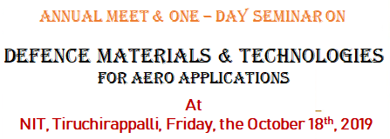

REGISTRATION FORM
Participants are kindly requested to register in advance of the Seminar by completing this form and returning it on or before October 17, 2019.

Personal Details
Title (Prof./Dr/Mr/Mrs/Ms/Miss/other): ……………………………………………………………………………………………..
First Name: ………………………………………………………………………………………………………………………………………….
Surname: ……………………………………………………………………………………………………………………………………………..
Position/Job Title: ………………………………………………………………………………………………………………………………..
Organisation: ……………………………………………………………………………………………………………………………………….
Address: ………………………………………………………………………………………………………………………………………………
City / Country: ……………………………………………………………………………………………………………………………………..
Postcode: …………………………………………………………………………………………………………………………………………….
E-mail: …………………………………………………………………………………………………………………………………………………
Tel.: ……………………………………………………………………………………………………………………………………………………..

Please, submit your registration form attached to the e-mail:
kumara@nitt.edu
Until October 17, 2019

Note:
- No registration fee for participating in the seminar.
- Certificate, Kit and high tea will be provided to all the participants.

