Title, Arial, bold, 16 points, centered
Author A. Surname,ª Author B. Surname,^{b}… (Arial, 12 pt, Presenting Author underlined)
ª Affiliation 1
^{b} Affiliation 2…(Arial, 10 points, italics)
email: presenting.author@domain.edu
Abstract body text (Arial, 11 points, justified; 1,15 line spacing).references, if any, in superscript with Arabic numerals Up to one figure/scheme can be added to the abstract; centered below the text or embedded within it, with a caption below (see the example).
Further instructions: i) use the provided styles; ii) do not add empty paragraphs as spacing; iii) restrict the total content to a single page; iv) do not modify the margins.
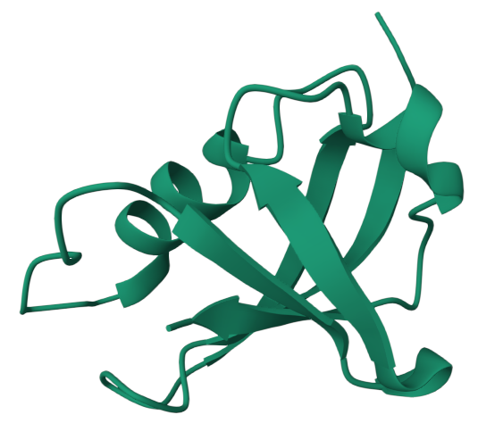
Caption (Arial, 9 pt, justified or centered, italics; use a figure/caption table layout, as here, or delete this entire table if not using a figure).

References
- Arial, 10 pt, sequentially numbered in Arabic, justified, ACS style is suggested, i.e: Author, A.; Author, B. Journal Acronym year, volume, initial page-final page.
- …

Acknowledgements
Arial, 10 pt, justified

