Laboratory 2 WebSocket Server Report
  - ITE183 Web Systems and Technologies
Student name Perlan Jubay
Section __________________ Instructor __________________
Date of verification October 17 2026

Overview
This laboratory implements an event-driven, multi-client WebSocket chat application using Bonezegei Scripting Language 1.3.3. The server serves the chat interface on port 8000 and broadcasts incoming messages to all connected browsers. Verification confirmed two-way delivery, client identification, reconnect behavior, and a custom error page returned with HTTP 404.

Objectives
- Construct and run a Bonezegei HTTP and WebSocket server for full-duplex communication.
- Handle connection handshakes, unique client IDs, incoming data, and disconnections.
- Broadcast messages across concurrent browser clients and verify delivery with screenshots.

Environment
Component | Verified setup
Operating system | Windows
Interpreter | Bonezegei Script Interpreter 1.3.3
Package manager | bzg 1.0.2
Dependency | http package installed with bzg install
Browser and address | Microsoft Edge  http://localhost:8000

Repository
Public repository
https://github.com/PerLanDo/ITE183_Lab2_Websocket
The repository uses the MIT License and includes the required README and .gitattributes configuration. The report describes the current local implementation; the latest local updates must be committed and pushed before submission.

Project Implementation
File | Purpose
package.json | Defines app.bzg as the entry point, the start script, the http dependency, and the MIT license.
app.bzg | Creates the server, selects the chat or error page, assigns session identity, and handles WebSocket events.
public/index.html | Contains the chat UI, WebSocket client, theme toggle, profile editor, and five vector avatars.
public/404.html | Displays the custom page for undefined paths.
.gitattributes | Contains *.bzg linguist-language=JavaScript.
lib/ | Generated HTTP wrapper and native library installed by bzg; excluded from Git.

HTTP routes and connection lifecycle
The root route serves public/index.html. Other paths serve public/404.html. When a WebSocket connects, onConnect logs its client ID and sends that ID to the browser. The browser uses the ID to label its own broadcasts as You and place them on the right. Messages from other clients appear on the left with the sender's display name and avatar.
The onData handler logs the payload and calls server.sendAll, including the sender in the broadcast. The UI renders only the received broadcast, preventing duplicate messages. The onDisconnect handler records closed connections. Reconnect opens a new socket and refreshes the browser's session ID.
server.onData = function (message, clientId) {
print("Received from Client " + clientId + ": " + message);
server.sendAll("User " + clientId + " says: " + message);
};

Profile and interface extensions
The JSON chat payload carries the message text, display name, and selected avatar. The server supplies the client ID independently in its broadcast prefix. Five self-contained SVG avatars are available: Orbit the robot, Ember the fox, Luna the cat, Nova the astronaut, and Sprout the frog. Profile and theme preferences are saved in browser local storage. The interface also supports clearing local messages and responsive mobile layouts.

Execution procedure
cd "<project folder>"
bonezegei -v
bzg install
bzg run
Run these commands from the folder containing package.json. Open http://localhost:8000 in two browser windows, choose different test profiles, and exchange messages. Keep the server terminal running during the test. If reinstalling the native HTTP package fails while the server is active, stop the server, install again, and restart it.

Version Installation and Server Evidence
Figures 1, 2, and 3 demonstrate terminal command execution and server logs for Bonezegei version verification, package installation, and multi-client messaging between Ember and Sprout.
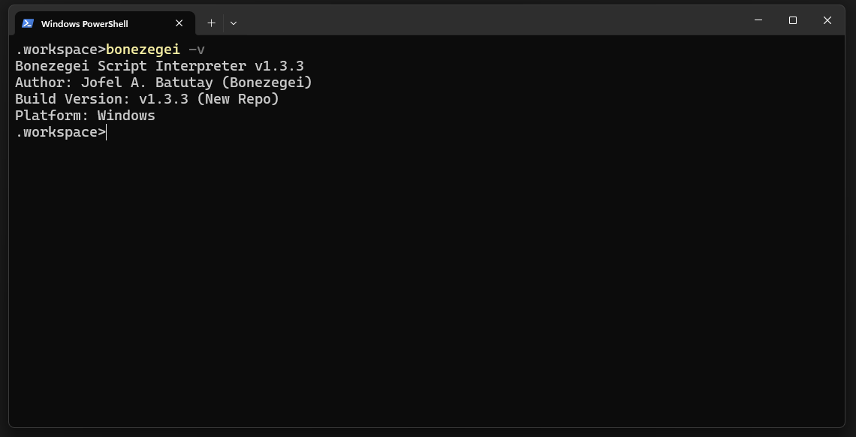
Figure 1 Interpreter output confirms the required Bonezegei version 1.3.3.
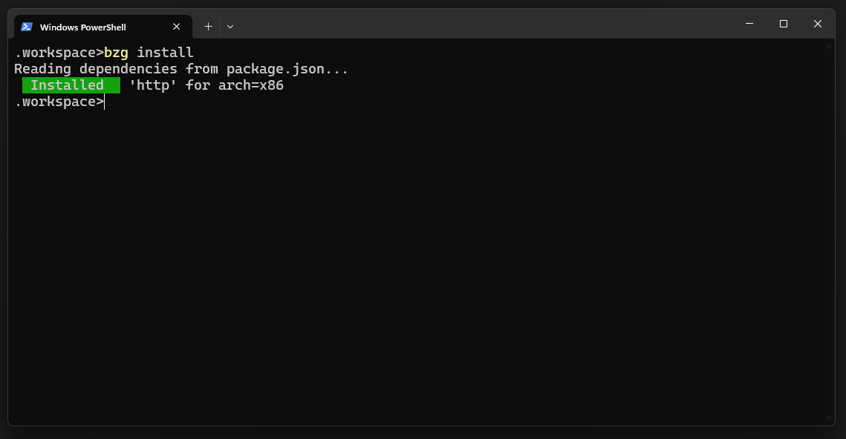
Figure 2 bzg install successfully installs the http dependency for x86.
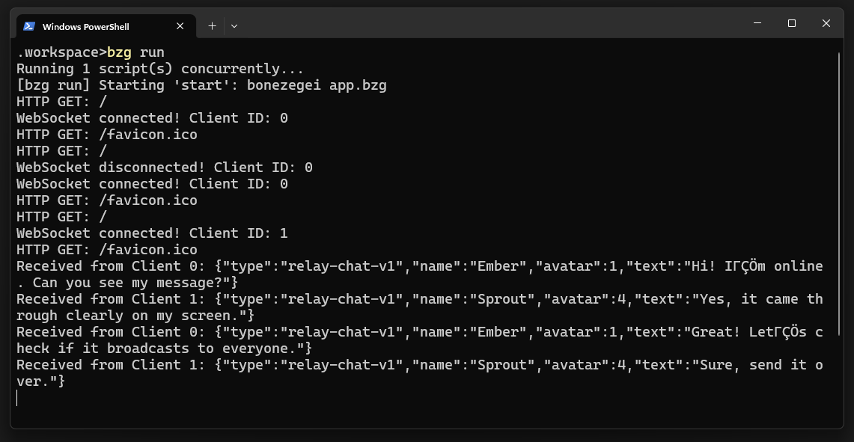
Figure 3 Server output showing WebSocket connections, route handling, and four messages exchanged between Ember (Client 0) and Sprout (Client 1).

Multi Client Broadcast and Error Page
The combined browser capture uses the test profiles Ember and Sprout. Both clients are connected and show the same four-message exchange. Each sender sees their own messages as You on the right; messages from the other client appear on the left with that client's display name and avatar.
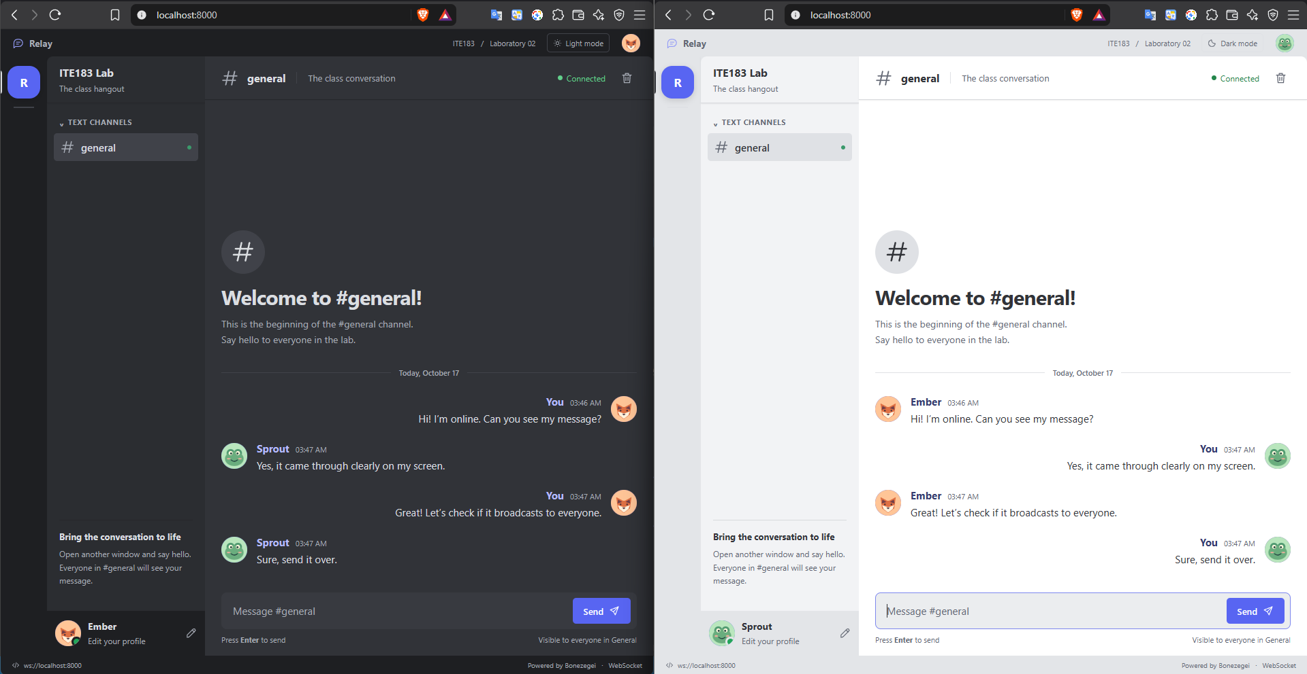
Figure 4 Both clients display the same four messages, demonstrating real-time broadcast in both directions.
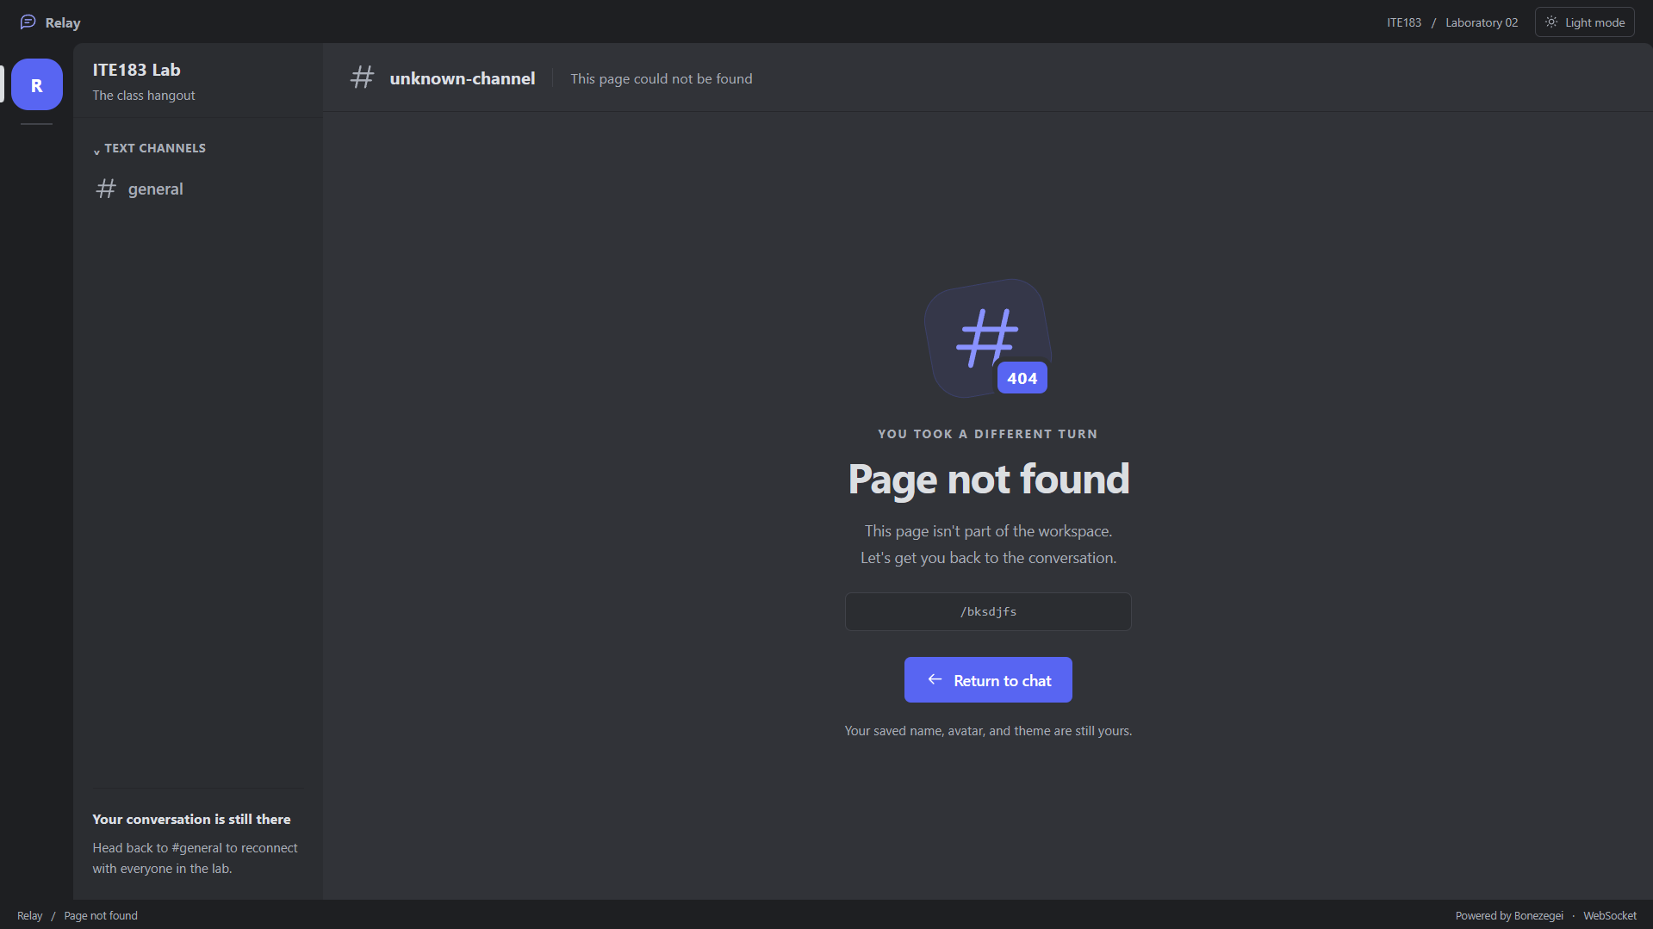
Figure 5 Visiting http://localhost:8000/bksdjfs displays the custom Page not found screen. The server returns HTTP 404 Not Found with this page.

Test Results
Test | Observed result | Status
Runtime version | bonezegei -v reports 1.3.3. | Pass
Package install | http dependency installs successfully. | Pass
Server startup | bzg run starts app.bzg. | Pass
Two client broadcast | All four captured messages appear in both clients. | Pass
Sender and recipient labels | You appears on the right; the remote profile name appears on the left. | Pass
Duplicate prevention | Each session renders one copy of each of four broadcasts. | Pass
Profiles and avatars | Names and selected avatars are shared in messages; profile survives reload. | Pass
Themes and mobile layout | Theme toggle works; mobile layout has no horizontal overflow. | Pass
Disconnect and reconnect | Server logs disconnects; browser reconnects and receives its session ID. | Pass
Custom error page | Unknown route displays public/404.html. | Pass
Unknown route HTTP status | The custom page is returned with HTTP 404. | Pass

Limitations
The server does not persist messages, and display names and avatars are client-supplied rather than authenticated identities. Profile and theme preferences are stored per browser origin.

Conclusion
Testing demonstrated client IDs, two-way broadcasts, single-copy sender-aware display, profile sharing, and reconnect behavior across two browsers. Unknown routes display the custom error page with the correct HTTP 404 status.

Reference and submission items
Reference: ITE183 Laboratory 2 WebSocket Server handout, pages 1 to 11 (Sections III to V; rubric: 70 percent functionality and 30 percent documentation).
Submit the public repository and this report after filling in the section and instructor. Commit and push the current project and documentation before submission.

