**Product Sales Data**

**Objective:**

The project involves using IBM Cognos to analyze sales data and extract insights about top selling products, peak sales periods, and customer preferences. The objective is to help businesses improve inventory management and marketing strategies by understanding sales trends and customer behavior. This project includes defining analysis objectives, collecting sales data, designing relevant visualizations in IBM Cognos, and deriving actionable insights.

**Design Thinking:**

**Analysis Objectives:** Define the specific insights you want to extract from the sale data, such as identifying top-selling products, analyzing sales trends, and understanding customer preferences.

**Data Collection:** Determine the sources and methods for collecting sales data, including transaction records, product information, and customer demographics.

**Visualization Strategy:** Plan how to visualize the insights using IBM Cognos to create interactive dashboards and reports.

**Actionable Insights:** Identify how the derived insights can guide inventory management and marketing strategies.

**1. Project Definition:**

**Objectives:** Clearly define the objectives of your analysis. In this case, you want to analyze sales data to extract insights about top-selling products, peak sales periods, and customer preferences.

**Scope:** Determine the scope of the project, including the specific data sources you'll be using (e.g., sales databases, CRM systems), the timeframe of the analysis, and any constraints or limitations.

**Stakeholders:** Identify key stakeholders who will benefit from the project's insights, such as business managers, inventory managers, and marketing teams.

**2. Design Thinking:**

**User Empathy:** Understand the needs and pain points of your end users (the stakeholders). What are their specific questions or challenges related to sales data? This will help shape the analysis and visualizations.

**Ideation:** Brainstorm potential analysis approaches and visualization techniques. Consider what types of visualizations would best convey the insights you intend to uncover. For example, bar charts, line charts, heatmaps, and pivot tables can be useful in sales analysis.

**Prototyping:** Create initial prototypes or mock-ups of the visualizations you plan to build in IBM Cognos. These prototypes don't need to be detailed but should give you a sense of how the final reports will look.

**Testing and Feedback:** Gather feedback from stakeholders on your prototypes. Make adjustments based on their input to ensure that the visualizations effectively address their needs and questions.

**3. Data Collection:**

Identify and gather the necessary sales data from relevant sources. This may involve database queries, data extraction, and data cleaning to ensure data quality.

**4. Designing Visualizations in IBM Cognos:**

Use IBM Cognos to create the visualizations that you've planned during the design thinking phase. Cognos offers various tools and features for building reports and dashboards.

Utilize appropriate chart types and visualization elements to represent the sales data effectively. Ensure that the visualizations are clear, concise, and aligned with the project objectives.

**5. Deriving Actionable Insights:**

Perform data analysis using IBM Cognos to uncover insights. This may involve exploring data trends, identifying top-selling products, analyzing sales patterns over time, and understanding customer preferences.

Translate these insights into actionable recommendations or strategies. For example, if you discover that a specific product sells best during certain seasons, you might recommend adjusting inventory levels accordingly.

**6. Presentation:**

Prepare a presentation or report that communicates the project's findings and recommendations in a clear and compelling manner. Use the visualizations created in IBM Cognos to support your narrative.

**7. Stakeholder Communication:**

Present your findings to the relevant stakeholders, explaining how the insights can be used to improve inventory management and marketing strategies.

**8. Iteration:**

Be prepared to iterate on your analysis and visualizations based on feedback and evolving business needs.

**Step 1: Import libraries**

In [1]:

*# import the important packages*

import pandas as pd *# library used for data manipulation and analysis*

import numpy as np *# library used for working with arrays*

import matplotlib.pyplot as plt *# library for plots and visualizations*

import seaborn as sns *# library for visualizations*

%matplotlib inline

*# To ignore warnings*

import warnings

warnings.filterwarnings("ignore")

**Step 2: Loading the datasets**

In [2]:

*#if you open in Kaggle editor*

data = pd.read_csv('/kaggle/input/product-sales-data/statsfinal.csv')

*#if you open in juypter notebook*

*# data = pd.read_csv('statsfinal.csv')*

In [3]:

*# Checking the first 5 and last 5 rows of the dataset*

data.head(-1)

Out[3]:

|  | Unnamed: 0 | Date | Q-P1 | Q-P2 | Q-P3 | Q-P4 | S-P1 | S-P2 | S-P3 | S-P4 |
| --- | --- | --- | --- | --- | --- | --- | --- | --- | --- | --- |
| 0 | 0 | 13-06-2010 | 5422 | 3725 | 576 | 907 | 17187.74 | 23616.50 | 3121.92 | 6466.91 |
| 1 | 1 | 14-06-2010 | 7047 | 779 | 3578 | 1574 | 22338.99 | 4938.86 | 19392.76 | 11222.62 |
| 2 | 2 | 15-06-2010 | 1572 | 2082 | 595 | 1145 | 4983.24 | 13199.88 | 3224.90 | 8163.85 |
| 3 | 3 | 16-06-2010 | 5657 | 2399 | 3140 | 1672 | 17932.69 | 15209.66 | 17018.80 | 11921.36 |
| 4 | 4 | 17-06-2010 | 3668 | 3207 | 2184 | 708 | 11627.56 | 20332.38 | 11837.28 | 5048.04 |
| ... | ... | ... | ... | ... | ... | ... | ... | ... | ... | ... |
| 4594 | 4594 | 29-01-2023 | 1227 | 3044 | 5510 | 1896 | 3889.59 | 19298.96 | 29864.20 | 13518.48 |
| 4595 | 4595 | 30-01-2023 | 2476 | 3419 | 525 | 1359 | 7848.92 | 21676.46 | 2845.50 | 9689.67 |
| 4596 | 4596 | 31-01-2023 | 7446 | 841 | 4825 | 1311 | 23603.82 | 5331.94 | 26151.50 | 9347.43 |
| 4597 | 4597 | 01-02-2023 | 6289 | 3143 | 3588 | 474 | 19936.13 | 19926.62 | 19446.96 | 3379.62 |
| 4598 | 4598 | 02-02-2023 | 3122 | 1188 | 5899 | 517 | 9896.74 | 7531.92 | 31972.58 | 3686.21 |

In [4]:

*# drop the first column*

data = data.drop(columns=['Unnamed: 0'])

**Step 3: Checking the info of the training data**

In [5]:

data.info()

<class 'pandas.core.frame.DataFrame'>

RangeIndex: 4600 entries, 0 to 4599

Data columns (total 9 columns):

# Column Non-Null Count Dtype

--- ------ -------------- -----

0 Date 4600 non-null object

1 Q-P1 4600 non-null int64

2 Q-P2 4600 non-null int64

3 Q-P3 4600 non-null int64

4 Q-P4 4600 non-null int64

5 S-P1 4600 non-null float64

6 S-P2 4600 non-null float64

7 S-P3 4600 non-null float64

8 S-P4 4600 non-null float64

dtypes: float64(4), int64(4), object(1)

memory usage: 323.6+ KB

**Step 4: Check for missing values**

In [6]:

data.isnull().sum()

Out[6]:

Date 0

Q-P1 0

Q-P2 0

Q-P3 0

Q-P4 0

S-P1 0

S-P2 0

S-P3 0

S-P4 0

dtype: int64

**Observations:**

* we have no missing data

**Note:**

* No missing values in a dataset is not common.
* while working with fresh data, you will have to do a ton of cleaning, this will result in some missing or lost data.
* Look into "feature engineering" and "missing value handling" for ways to resolve this issues.

**Step 5: EDA**

EDA: Exploratory data analysis [Link](https://www.itl.nist.gov/div898/handbook/eda/section1/eda11.htm)

Lets extract the year, month and Day from the date

In [7]:

*# Extract year from the 'Day' 'Month' 'year' from the 'Date' column using a lambda function*

*# We need to get the year from the data to analyse sales year to year*

data['Day'] = data['Date'].apply(lambda x: x.split('-')[0])

data['Month'] = data['Date'].apply(lambda x: x.split('-')[1])

data['Year'] = data['Date'].apply(lambda x: x.split('-')[2])

data

Out[7]:

|  | Date | Q-P1 | Q-P2 | Q-P3 | Q-P4 | S-P1 | S-P2 | S-P3 | S-P4 | Day | Month | Year |
| --- | --- | --- | --- | --- | --- | --- | --- | --- | --- | --- | --- | --- |
| 0 | 13-06-2010 | 5422 | 3725 | 576 | 907 | 17187.74 | 23616.50 | 3121.92 | 6466.91 | 13 | 06 | 2010 |
| 1 | 14-06-2010 | 7047 | 779 | 3578 | 1574 | 22338.99 | 4938.86 | 19392.76 | 11222.62 | 14 | 06 | 2010 |
| 2 | 15-06-2010 | 1572 | 2082 | 595 | 1145 | 4983.24 | 13199.88 | 3224.90 | 8163.85 | 15 | 06 | 2010 |
| 3 | 16-06-2010 | 5657 | 2399 | 3140 | 1672 | 17932.69 | 15209.66 | 17018.80 | 11921.36 | 16 | 06 | 2010 |
| 4 | 17-06-2010 | 3668 | 3207 | 2184 | 708 | 11627.56 | 20332.38 | 11837.28 | 5048.04 | 17 | 06 | 2010 |
| ... | ... | ... | ... | ... | ... | ... | ... | ... | ... | ... | ... | ... |
| 4595 | 30-01-2023 | 2476 | 3419 | 525 | 1359 | 7848.92 | 21676.46 | 2845.50 | 9689.67 | 30 | 01 | 2023 |
| 4596 | 31-01-2023 | 7446 | 841 | 4825 | 1311 | 23603.82 | 5331.94 | 26151.50 | 9347.43 | 31 | 01 | 2023 |
| 4597 | 01-02-2023 | 6289 | 3143 | 3588 | 474 | 19936.13 | 19926.62 | 19446.96 | 3379.62 | 01 | 02 | 2023 |
| 4598 | 02-02-2023 | 3122 | 1188 | 5899 | 517 | 9896.74 | 7531.92 | 31972.58 | 3686.21 | 02 | 02 | 2023 |
| 4599 | 03-02-2023 | 1234 | 3854 | 2321 | 406 | 3911.78 | 24434.36 | 12579.82 | 2894.78 | 03 | 02 | 2023 |

In [8]:

data_reduced = data.query("Year != '2010' and Year != '2023'")

Graph our TOTAL & MEAN unit sold for each product using a histogram.

In [9]:

*#Create a function that allows us to plot a bar chart for the 4 products*

def plot_bar_chart(df, columns, stri, str1, val):

*# Aggregate sales for each product by year, by sum or mean*

if val == 'sum':

sales_by_year = df.groupby('Year')[columns].sum().reset_index()

elif val == 'mean':

sales_by_year = df.groupby('Year')[columns].mean().reset_index()

*# Melt the data to make it easier to plot*

sales_by_year_melted = pd.melt(sales_by_year, id_vars='Year', value_vars=columns, var_name='Product', value_name='Sales')

*# Create a bar chart*

plt.figure(figsize=(20,4))

sns.barplot(data=sales_by_year_melted, x='Year', y='Sales', hue='Product') *#,palette="cividis")*

plt.xlabel('Year')

plt.ylabel(stri)

plt.title(f'**{**stri**}** by **{**str1**}**')

plt.xticks(rotation=45)

plt.show()

In [10]:

*#use the plot_bar_chart function, enter the Unit Sales Columns and the Unit Sales string*

plot_bar_chart(data_reduced, ['Q-P1', 'Q-P2', 'Q-P3', 'Q-P4'],'Total Unit Sales', 'Year', 'sum')

plot_bar_chart(data_reduced, ['Q-P1', 'Q-P2', 'Q-P3', 'Q-P4'],'Mean Unit Sales', 'Year', 'mean')

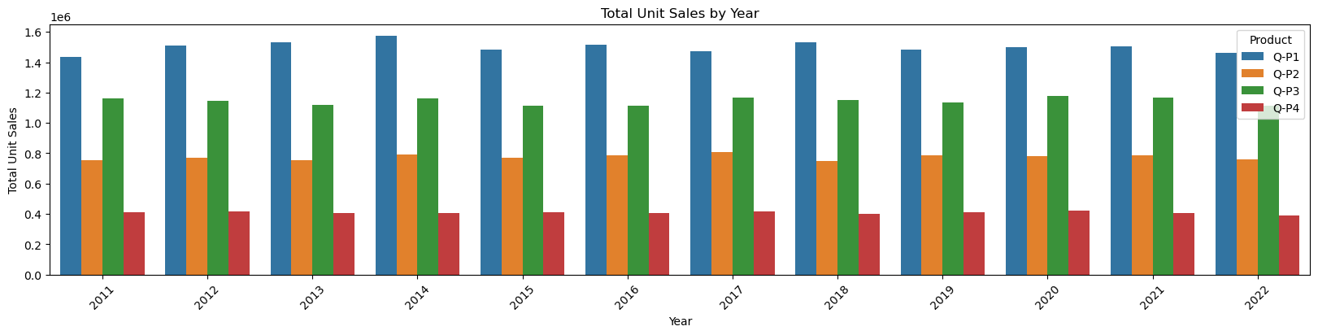

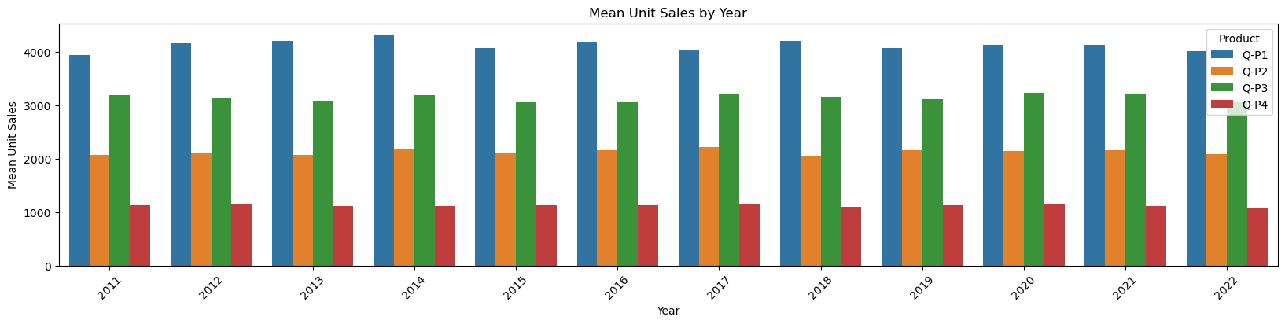

Graph our TOTAL & MEAN revenue of sales for each product using a historgram.

In [11]:

*#use the plot_bar_chart function, enter the Revenue Columns and the Revenue string*

plot_bar_chart(data_reduced, ['S-P1', 'S-P2', 'S-P3', 'S-P4'], 'Total Revenue', 'Year', 'sum')

plot_bar_chart(data_reduced, ['S-P1', 'S-P2', 'S-P3', 'S-P4'], 'Mean Revenue', 'Year', 'mean')

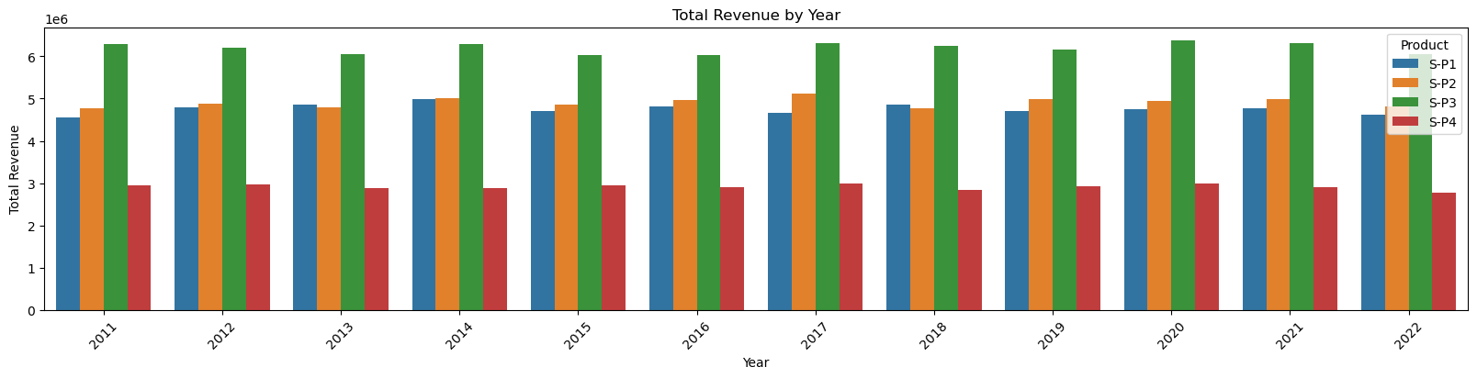

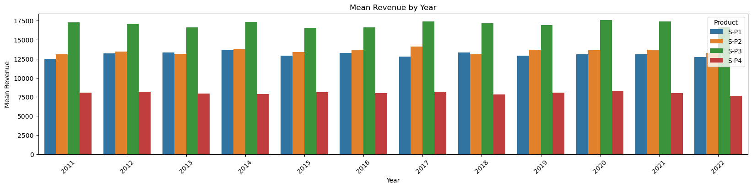

**Observation**

* We can observe that P3 brought in the most revenue. This could be as a result of multiple things:
  + P3 was sold for higher than the rest, as it had the second highest unit sales for each year.
* We can observe than P1 AND P2 brought in similar revenues for each year. With P2 bringing in slightly more.
  + P1 despite having the most unit sold, brought in the second lowest revenue each year.

In [12]:

data

Out[12]:

|  | Date | Q-P1 | Q-P2 | Q-P3 | Q-P4 | S-P1 | S-P2 | S-P3 | S-P4 | Day | Month | Year |
| --- | --- | --- | --- | --- | --- | --- | --- | --- | --- | --- | --- | --- |
| 0 | 13-06-2010 | 5422 | 3725 | 576 | 907 | 17187.74 | 23616.50 | 3121.92 | 6466.91 | 13 | 06 | 2010 |
| 1 | 14-06-2010 | 7047 | 779 | 3578 | 1574 | 22338.99 | 4938.86 | 19392.76 | 11222.62 | 14 | 06 | 2010 |
| 2 | 15-06-2010 | 1572 | 2082 | 595 | 1145 | 4983.24 | 13199.88 | 3224.90 | 8163.85 | 15 | 06 | 2010 |
| 3 | 16-06-2010 | 5657 | 2399 | 3140 | 1672 | 17932.69 | 15209.66 | 17018.80 | 11921.36 | 16 | 06 | 2010 |
| 4 | 17-06-2010 | 3668 | 3207 | 2184 | 708 | 11627.56 | 20332.38 | 11837.28 | 5048.04 | 17 | 06 | 2010 |
| ... | ... | ... | ... | ... | ... | ... | ... | ... | ... | ... | ... | ... |
| 4595 | 30-01-2023 | 2476 | 3419 | 525 | 1359 | 7848.92 | 21676.46 | 2845.50 | 9689.67 | 30 | 01 | 2023 |
| 4596 | 31-01-2023 | 7446 | 841 | 4825 | 1311 | 23603.82 | 5331.94 | 26151.50 | 9347.43 | 31 | 01 | 2023 |
| 4597 | 01-02-2023 | 6289 | 3143 | 3588 | 474 | 19936.13 | 19926.62 | 19446.96 | 3379.62 | 01 | 02 | 2023 |
| 4598 | 02-02-2023 | 3122 | 1188 | 5899 | 517 | 9896.74 | 7531.92 | 31972.58 | 3686.21 | 02 | 02 | 2023 |
| 4599 | 03-02-2023 | 1234 | 3854 | 2321 | 406 | 3911.78 | 24434.36 | 12579.82 | 2894.78 | 03 | 02 | 2023 |

Trend in sales of all four products during certain months

In [13]:

*# Create a figure and axis*

def month_plot():

fig, ax = plt.subplots()

*# Plot the sales data for each product by month*

data_reduced.groupby('Month')[['Q-P1', 'Q-P2', 'Q-P3', 'Q-P4']].sum().plot(ax=ax)

*# Set the x-axis limits to only show up to December*

ax.set_xlim(left=0, right=13)

*# Set the axis labels and title*

ax.set_xlabel('Month')

ax.set_ylabel('Total unit sales')

ax.set_title('Trend in sales of all four products by month')

*# Show the plot*

plt.show()

month_plot()

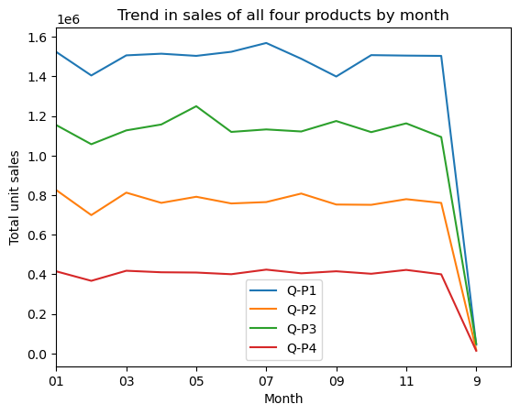

In [14]:

*# Replace all entries of '9' in the Month column with '09'*

data_reduced['Month'] = data['Month'].replace('9', '09')

In [15]:

month_plot()

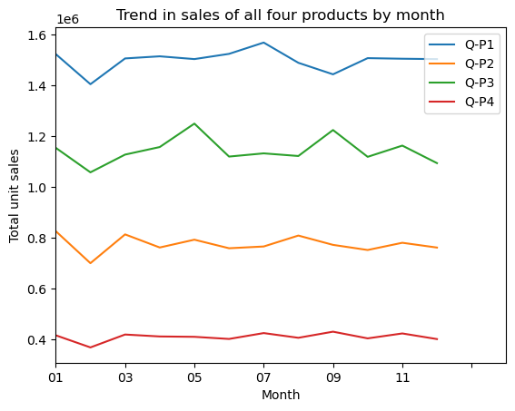

**Estimate for each product the unit of sales that could be sold on 31st of Dec, if all their retail centers were kept open.**

In [16]:

*#get the 31st day for each month in each year. Note: not every month has 31 days*

def month_31_data(df, months):

m31_data = df[df['Month'].isin(months) & (df['Day'] == '31')]

return m31_data

_31_months = month_31_data(data_reduced, ['01', '02', '03', '04', '05', '06', '07', '08', '09', '10', '11', '12'])

_31_months

Out[16]:

|  | Date | Q-P1 | Q-P2 | Q-P3 | Q-P4 | S-P1 | S-P2 | S-P3 | S-P4 | Day | Month | Year |
| --- | --- | --- | --- | --- | --- | --- | --- | --- | --- | --- | --- | --- |
| 231 | 31-01-2011 | 939 | 3325 | 1863 | 1612 | 2976.63 | 21080.50 | 10097.46 | 11493.56 | 31 | 01 | 2011 |
| 290 | 31-03-2011 | 464 | 2220 | 421 | 1663 | 1470.88 | 14074.80 | 2281.82 | 11857.19 | 31 | 03 | 2011 |
| 351 | 31-05-2011 | 1507 | 2980 | 3816 | 1202 | 4777.19 | 18893.20 | 20682.72 | 8570.26 | 31 | 05 | 2011 |
| 412 | 31-07-2011 | 4336 | 744 | 4717 | 667 | 13745.12 | 4716.96 | 25566.14 | 4755.71 | 31 | 07 | 2011 |
| 442 | 31-08-2011 | 4548 | 1484 | 1596 | 1974 | 14417.16 | 9408.56 | 8650.32 | 14074.62 | 31 | 08 | 2011 |
| ... | ... | ... | ... | ... | ... | ... | ... | ... | ... | ... | ... | ... |
| 4352 | 31-05-2022 | 3669 | 2710 | 3067 | 1593 | 11630.73 | 17181.40 | 16623.14 | 11358.09 | 31 | 05 | 2022 |
| 4413 | 31-07-2022 | 1437 | 833 | 1867 | 1270 | 4555.29 | 5281.22 | 10119.14 | 9055.10 | 31 | 07 | 2022 |
| 4443 | 31-08-2022 | 1035 | 1639 | 3658 | 841 | 3280.95 | 10391.26 | 19826.36 | 5996.33 | 31 | 08 | 2022 |
| 4474 | 31-9-2022 | 6964 | 1873 | 5481 | 1336 | 22075.88 | 11874.82 | 29707.02 | 9525.68 | 31 | 09 | 2022 |
| 4535 | 31-11-2022 | 4600 | 2006 | 3796 | 1426 | 14582.00 | 12718.04 | 20574.32 | 10167.38 | 31 | 11 | 2022 |

In [17]:

plot_bar_chart(_31_months, ['Q-P1', 'Q-P2', 'Q-P3', 'Q-P4'], 'Average Units', 'each Month, for 31st', 'mean')

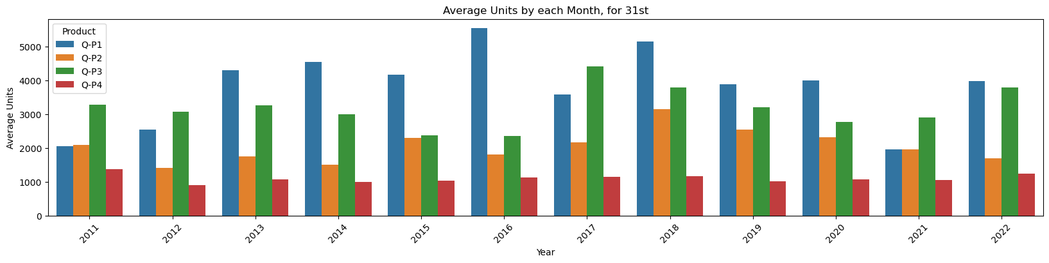

In [18]:

plot_bar_chart(_31_months, ['S-P1', 'S-P2', 'S-P3', 'S-P4'], 'Average Revenue', 'each Month, for 31st', 'mean')

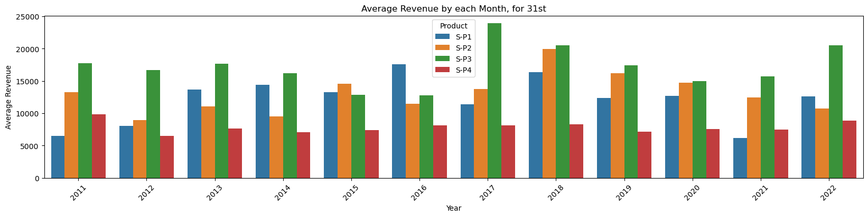

In [19]:

*# gives us the average for all the 31st days across all years for each product*

def avg_on_31st(df, product):

df_31 = df[df['Day'] == '31']

avg_sales = df_31[product].mean()

return avg_sales

In [20]:

*# Average for Unit Sales*

avg_on_31st(data_reduced, ['Q-P1', 'Q-P2', 'Q-P3', 'Q-P4']).round(2)

Out[20]:

Q-P1 3813.74

Q-P2 2058.80

Q-P3 3183.88

Q-P4 1098.61

dtype: float64

In [21]:

*# Average for Revenue*

avg_on_31st(data_reduced, ['S-P1', 'S-P2', 'S-P3', 'S-P4']).round(2)

Out[21]:

S-P1 12089.55

S-P2 13052.78

S-P3 17256.63

S-P4 7833.07

dtype: float64

**How you can use inventory analysis to optimize your operations**

Inventory analysis is the process of examining inventory to determine the optimum amount a business should carry. By obtaining a clear picture of the inventory that keeps your company profitable, you can keep up with customer demand while increasing sales and controlling costs.

You don’t need a complex data infrastructure or [an ERP](https://quickbooks.intuit.com/r/growing-complex-businesses/erp/) to reap the benefits of inventory analysis. It simply requires understanding inventory analysis formulas and a grasp of inventory analysis principles. We’ll cover both of those later on, but first, let’s take a step back and better define this concept.

**What are the benefits of inventory analysis?**

Conducting regular inventory analyses helps to keep your inventory management on track and increases efficiencies over time. Here are the biggest benefits of using inventory analyses in your business workflows.

### 1. Reduce stockouts and project delays

Some companies take on projects that require hundreds, sometimes thousands, of items. Stockouts can mean project delays, which upsets the client and cuts into profits. For retail companies, stockouts mean lost sales and unhappy customers who will go to a competitor to get a similar product.

### 2. Improve cash flow

A [study by U.S. Bank](https://www.entrepreneur.com/article/187366) found 82% of business failures are due to cash flow issues. For manufacturing and retail businesses, the vast majority of their cash is represented by their inventory every month. Without effective inventory analysis methods, operating a business can feel like riding a roller coaster that is about to run off the rails.

Low on cash and run out of an in-demand SKU? Finding short-term financing can be difficult and cuts into your margins. Capital all tied up in inventory that is sitting rotting in storage? It’s incredibly painful to write it off as a loss. Inventory analysis can show you when your business’s lean times are and when the rush is, so you can prepare with safety stock or stop buying inventory you’re not selling.

### 3. Delight customers

In[his 1997 annual letter](https://www.sec.gov/Archives/edgar/data/1018724/000119312518121161/d456916dex991.htm) to Amazon shareholders, Jeff Bezos wrote that his goal was to make Amazon [the earth’s most customer-centric company](https://qz.com/work/1135467/what-i-learned-from-jeff-bezos-after-reading-every-amazon-shareholder-letter/). Well, their inventory analysis (rivaled only by Walmart) allows Amazon to offer Prime members free two-day shipping on millions of products. Inventory analysis enables faster response times and efficiently filled orders, giving you the ability to earn loyal customers.

### 4. Reduce inventory waste

Writing off inventory as a loss is akin to lighting cash on fire. A proper analysis can dramatically improve inventory control, so you never again have to see those boxes that have been sitting in the back of your warehouse for the past year. The same applies to lost inventory, theft, and leakage, which reduces costs and enables you to introduce cost controls.

### 5. Better pricing from suppliers and vendors

When you know what items produce the most profit for your company, you’ll be more likely to confidently negotiate better terms with suppliers, improving your bottom line. Operating a business can drag you in a million directions, often pulling you away from the actions that make money. By analyzing the inventory that keeps your company profitable, you can prioritize it, making the supply chain for that inventory as efficiently as possible.

## How do you analyze inventory?

Depending on the business you run and the types of inventory you carry, you can use several inventory analysis methods. Here are a few examples:

### ABC analysis

[ABC analysis](https://quickbooks.intuit.com/r/growing-complex-businesses/abc-analysis-inventory-management-principles-classifications/) is one of the most popular inventory analysis methods. It is based on the Pareto Principle, which states that, for many events, roughly 80% of the effects come from 20% of the causes. ABC stands for “Always Better Control.”

ABC analysis brings simplicity to inventory analysis by putting all of your inventory into three buckets, enabling you to make more strategic decisions. The buckets are:

* A-Inventory: This inventory has the highest value, most often the highest profit margins or sales revenue. It should be your highest priority and rarely, if ever, stockout.
* B-Inventory: Inventory that sells regularly but doesn’t have as much value as A inventory. Often inventory that costs more to hold than A inventory.
* C-Inventory: This is the rest of your inventory that doesn’t sell much and generates the least revenue, and makes up the bulk of your inventory cost.

ABC Analysis allows you to separate your most important inventory from the rest so you can give it more time and focus, boost your profits, and control your costs. This enables you to reduce obsolete inventory, optimize inventory turnover rate, increase prices, and forecast demand.

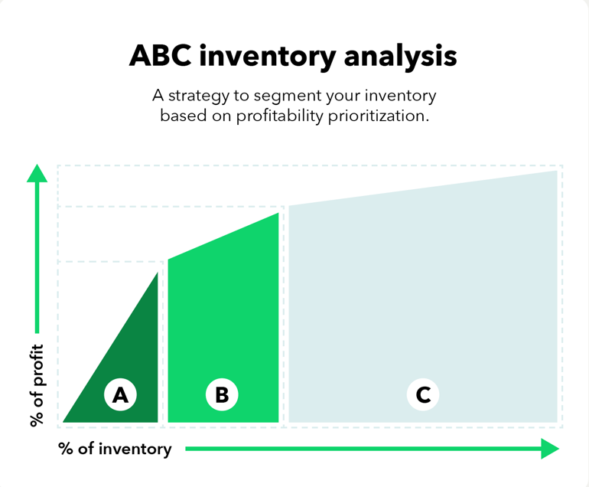

### VED Analysis

VED Analysis is based on inventory value and how critical it is for an item to be in stock. This method is useful for manufacturing companies that stock many components and parts. It’s different from ABC analysis in that it only takes into account how necessary an item is to the continuing operation of the business.

* Vital: Inventory that must be in stock
* Essential: A minimum amount of these items is enough
* Desirable: These are optional items

### HML Analysis

HML analysis is measured according to an item’s unit price. It’s different from ABC analysis because it only considers cost and doesn’t include the sales value of items. HML analysis is useful for controlling costs and staying on budget.

* High Cost: High unit value item
* Medium Cost: Medium unit value item
* Low Cost: Low unit value item

### SDE Analysis

This inventory analysis method is based on the scarcity of items in the market or how soon you can acquire them. It’s usually used in businesses that deal with raw materials or items with long lead times to acquire.

* Scarce: Scarce or imported items that have long lead times
* Difficult: Inventory that has lead times anywhere from weeks to 6 months lead time
* Easily available: Items that are easily acquired

### Safety stock analysis

[Safety stock](https://quickbooks.intuit.com/r/growing-complex-businesses/safety-pipeline-inventory-accounting-for-your-stock/) is inventory that a business holds to mitigate the risk of shortages or stockouts. Think of it as a type of insurance for when demand spikes or there’s a material shortage. Businesses can use a safety stock formula to make data-driven decisions about managing inventory levels to maximize profits.

The formula for safety stock is the difference between your maximum daily usage and lead time and your average daily usage and lead time:

**(Maximum Daily Usage x Maximum Lead Time) – (Average Daily Usage x Average Lead Time)**

As you can tell, there are different ways to analyze your inventory depending on the type of business you’re running, but the underlying principle remains the same. By simplifying your inventory analysis method, you can easily prioritize where to place your time and focus, increasing your operations’ efficiency.

Next, let’s look at some key metrics you can use to drill down and see how healthy your business is.

## What are key metrics you can use to measure inventory efficiency?

Inventory analysis doesn’t just end with the Pareto Principle. You can use key inventory metrics to measure different segments of your business, which uncover ways to optimize your operations and increase profits.

The following inventory formulas can all be used to find ways to increase your bottom line:

### Gross margin return on invested inventory (GMROI)

[GMROI](https://quickbooks.intuit.com/r/growing-complex-businesses/gmroi-formulas-calculations-for-inventory-analysis-methods/) is an inventory formula used by retail businesses to measure a certain element of their profitability. It measures the gross profit that a retailer makes every year for each dollar of inventory they purchased. The formula is:

**Gross profit margin ÷ average on-hand inventory cost**

After doing this calculation, the number should at least be higher than one. If it’s below one, it means you are losing money on your inventory and aren’t a profitable business. A GMROI of 1.50 means you are making a profit on your inventory at 150% of your cost.

There’s no specific benchmark for GMROI. It depends on your industry. Industry-specific retail associations are good resources for benchmarks like this, as is the [Retail Owners Institute](https://retailowner.com/Benchmarks).

### Available to promise

[Available to promise](https://quickbooks.intuit.com/r/growing-complex-businesses/available-to-promise-inventory-calculations-for-supply-chains/) (ATP) is an inventory formula used for analyzing order fulfillment. It helps analyze customer demand and adjust operations to meet it. For example, every time you order takeout from a food delivery app, the app goes through the available to promise formula to calculate how long it will take for your food to arrive.

Here’s the formula:

**ATP = Quantity On Hand + Supply (Planned Orders) – Demand (Sales Orders)**

The ideal promise time depends on customer expectations and varies by industry.

### Inventory turnover rate

Your inventory turnover rate shows you how effectively you’re managing inventory. It measures how many times your average inventory is sold during a certain period.

This inventory formula is calculated by dividing the cost of goods sold by the average inventory for a certain period. So if your average inventory the past year was $1,000 and your cost of goods sold was $10,000, your inventory turnover rate would be 10, meaning you sold your inventory ten times over. Ideally, you want this rate as high as possible because it shows how quickly you can sell your products and proves you’re not overbuying inventory and wasting capital.

### Carrying costs

[Carrying costs](https://quickbooks.intuit.com/r/growing-complex-businesses/carrying-costs/) (also called holding costs) are costs incurred in storing and maintaining inventory. This may include insurances, warehouse space, equipment, security, and labor costs.

An example of a holding cost could be a forklift truck required to move stock in the warehouse. Holding costs are represented by the cumulative dollar value of these various costs. They can be accounted for separately or grouped together.

### Average days to sell inventory

This metric indicates how long it takes a company to buy or create inventory and sell it. Average days to sell inventory is calculated as follows:

**(Inventory cost of sales) x number of days in the year**

The average days to sell inventory ratio alerts the business owner how long, on average, it takes to sell each item of inventory.

### Stockout rate

The stockout rate is the ratio of a company’s total stockout losses to total orders, expressed as a percentage. This metric measures how effective a business is at managing inventory.

Let’s say you are a clothing retailer and want to figure out your stockout rate. One way to calculate your rate would be to divide your total sales back-ordered by your total sales.

So if you did $100,000 in sales, but $10,000 of those sales were for items that were on backorder, your stockout rate would be 10%, which is high. You’d want to look at why and make sure you had enough inventory on hand the next quarter to reduce that rate.

For your most in-demand and profitable inventory, you want your stockout rate to be as close to zero as possible. A high stockout rate can also hurt customer satisfaction, which we’ll talk about next.

### Customer service level (CSL)

CSL is the expected probability of not having a stockout for a given period or the probability of not losing sales. Ideally, your CSL should be as close to 100% as possible, especially if it’s A-inventory based on ABC analysis. There are few ways to calculate customer service level, but an easy inventory calculation is to divide the number of products delivered on time divided by the number of products sold.

## How to start using inventory analysis in your business

If you’re new to inventory analysis, here are some best practices to keep in mind.

### 1. Audit your stock levels

Before conducting an inventory analysis, you should first determine the amount of inventory you have on hand to make sure it aligns with what you think you have. You can audit stock efficiently with a barcoding system.

### 2. Align your inventory analysis with your strategy and business goals

There is no one-size-fits-all approach to analyzing inventory. You can mix and match any of the above methods, but the most important thing is aligning with your team on your [inventory management strategy](https://quickbooks.intuit.com/r/growing-complex-businesses/inventory-management-strategies/) and business goals to use your resources effectively.

### 3. Use inventory management software

When time is at a premium, automation is key when it comes to analyzing inventory. With [QuickBooks Desktop Enterprise](https://quickbooks.intuit.com/desktop/enterprise/advanced-inventory/), you can track inventory in real-time, generate real-time reports, designate reorder points, and ensure the right inventory is in the right place at the right time.

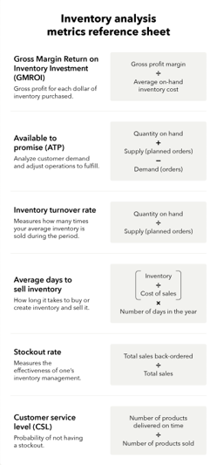

**Conclusion**

**Unit Sales 2011 - 2022**

* P1 has the highest unit sales for each year. And it's highest is in year 2014.
* We can observe that P4 has the lowest unit sales of all the products.

**Revenues 2011 - 2022**

* We can observe that P3 brought in the most revenue. This could be as a result of multiple things:
  + P3 was sold for higher than the rest, as it had the second highest unit sales for each year.
* We can observe than P1 and P2 brought in similar revenues for each year. With P2 bringing in slightly more.
* P1 despite having the most unit sold, brought in the second lowest revenue each year.

**Average Month Sales 2011 - 2022**

* We can observe that all Products unit sales drop in Feb.
* We can observe that Feb and Dec have the lowest sales for each product
* For P1 We can observe Mar - Jul having the highest unit sales
* For P2 We can observe Jan, Mar - Aug having the highest unit sales
* For P3 We can observe May & Sep having the highest unit sales
* For P4 We can observe uniform sales from Jan - Dec

**Estimated Unit Sales for 31st of Dec**

This value can not be properly estimated with out Machine Learning. Currently we used the average for all the 31st days across all years for each product.

* Overall we can see that P1 has the highest unit sales on the 31st for each year, except for 2021 and 2022. (These could be as a result to Covid and other economy issues.)
* P3 has the second highest unit sales for all the 31st in each year.
* We can see that our previous observation correlate as Q-P1 has the higest estimate, followed by Q-P3
* We can approxiamte that the company will make:
  + Q-P1: 3813.74
  + Q-P2: 2058.80
  + Q-P3: 3183.88
  + Q-P4: 1098.61