**SCIENCE EXPERIMENT WEBSITE**



**A Project Documentation Submitted to the**

**College of Information Technology**

**Cagayan de Oro College**

**PHINMA Education**

**Submitted By:**

**Aguirre, Louwie Jie C.**

**Bansing, Paul Markuss S.**

**Bansing, Rastel Cyrus R.**

**Cabual, Keshtian Mark**

**Elison, Cedric E.**

**Galeon, Jay Lourenz C.**

**Perater, Royen July**

**Sismundo, Mark Reniel L.**

**March 2025**

**Introduction**

A selection of science experiments aimed at improving comprehension of basic scientific concepts are offered on this webpage. Every experiment has a thorough description, a list of necessary supplies, a step-by-step guide, and the anticipated outcomes. The goal is to present an interesting and educational method of scientific investigation.  
  
The experiments address a range of scientific topics, such as biology, physics, and chemical reactions. By choosing the "See More" option, users can view more information about each experiment. A deeper understanding of the scientific procedures involved is made possible by this interactive feature.

In order to develop analytical thinking and problem-solving abilities, scientific experimentation is essential. Through practical experiments, students can see how theoretical ideas are applied in the real world, which helps them understand the material better. This method improves retention of scientific knowledge, stimulates critical thinking, and stimulates curiosity (Anderson & Krathwohl, 2001).  
  
Additionally, guided and interactive experiments give students an organized and approachable way to interact with scientific concepts. Science Hub seeks to close the gap between theoretical knowledge and real-world application through meticulously planned processes and understandable explanations. For students, teachers, and science enthusiasts who want to learn more about scientific ideas outside of the classroom, this resource is a great resource (National Research Council, 2012).

**Wireframe**

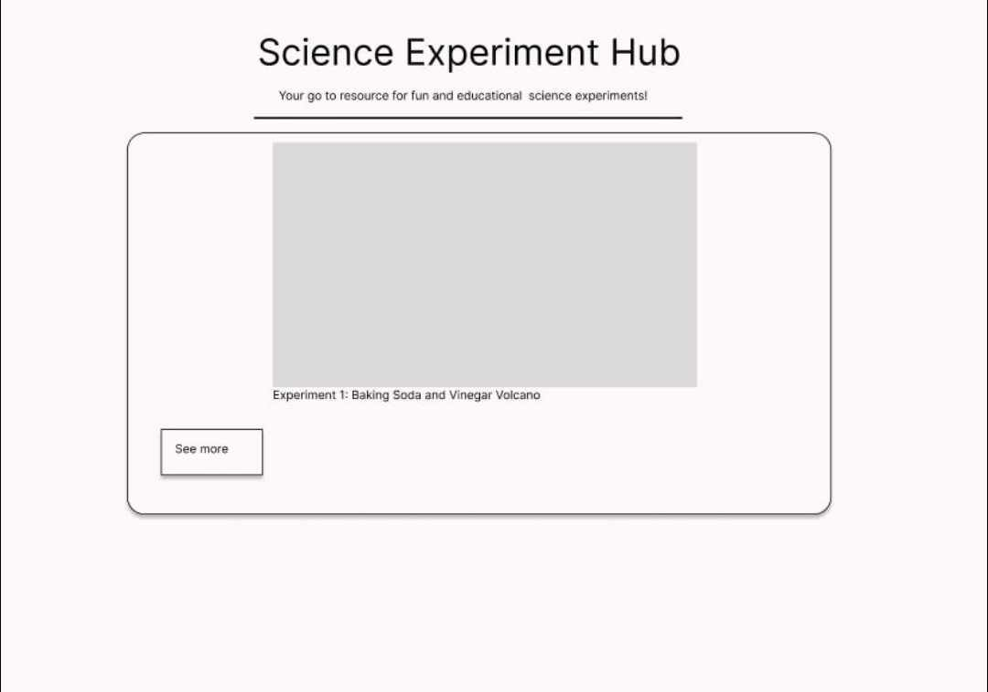

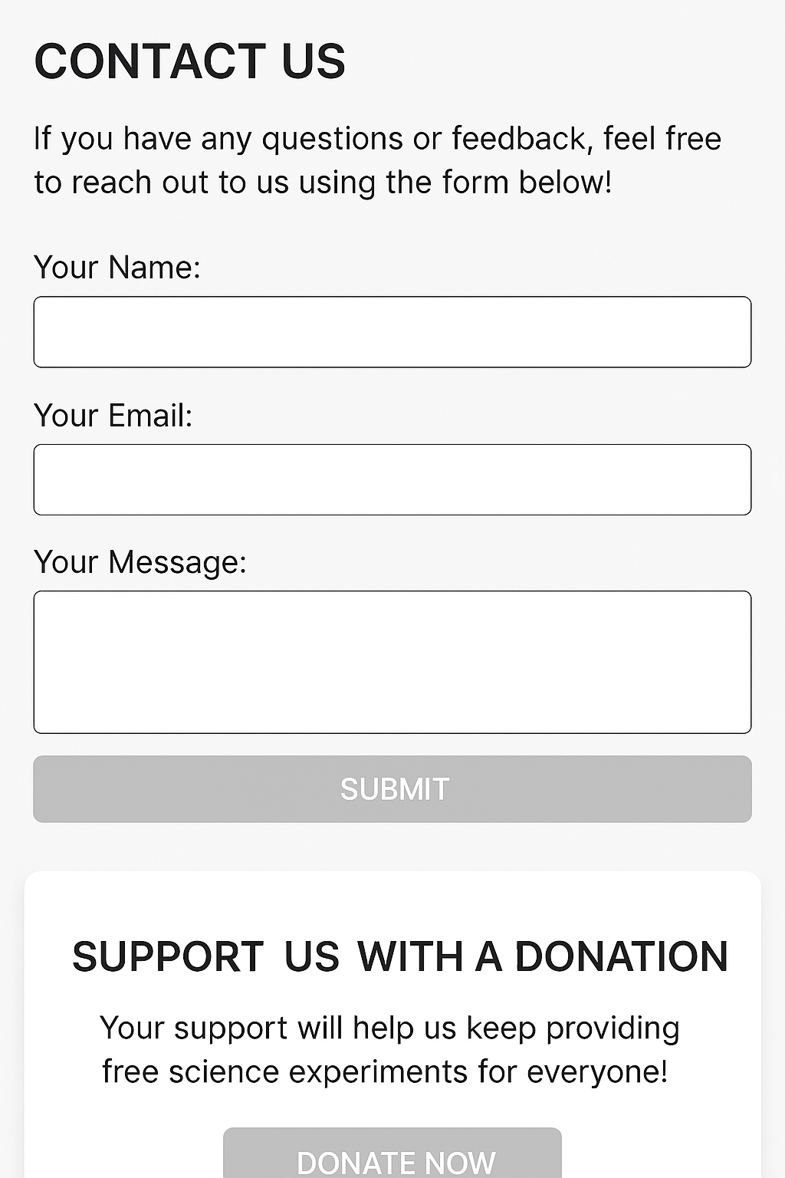

**<!DOCTYPE html>**

**<html lang="en">**

**<head>**

**<meta charset="UTF-8" />**

**<meta name="viewport" content="width=device-width, initial-scale=1.0"/>**

**<title>Science Hub</title>**

**<style>**

**body {**

**font-family: sans-serif;**

**background: #f4f4f4;**

**margin: 0;**

**padding: 0;**

**}**

**header {**

**background: #28a745;**

**color: white;**

**text-align: center;**

**padding: 15px;**

**}**

**nav {**

**background: #218838;**

**display: flex;**

**justify-content: center;**

**padding: 10px;**

**}**

**nav a {**

**color: white;**

**margin: 0 15px;**

**text-decoration: none;**

**font-weight: bold;**

**cursor: pointer;**

**}**

**nav a:hover {**

**text-decoration: underline;**

**}**

**section {**

**padding: 30px 15px;**

**}**

**.container {**

**max-width: 800px;**

**margin: auto;**

**background: white;**

**border-radius: 10px;**

**box-shadow: 0 0 10px rgba(0,0,0,0.1);**

**padding: 20px;**

**margin-bottom: 20px;**

**}**

**.experiment {**

**margin-bottom: 20px;**

**padding: 15px;**

**border: 1px solid #ddd;**

**border-radius: 8px;**

**text-align: center;**

**}**

**.experiment img {**

**max-width: 100%;**

**border-radius: 8px;**

**}**

**.experiment h2 {**

**color: #28a745;**

**}**

**.details {**

**display: none;**

**text-align: left;**

**margin-top: 10px;**

**}**

**button {**

**background: #28a745;**

**color: white;**

**border: none;**

**padding: 10px 15px;**

**border-radius: 5px;**

**cursor: pointer;**

**margin-top: 10px;**

**}**

**button:hover {**

**background: #1e7e34;**

**}**

**form label, form input, form textarea {**

**display: block;**

**margin-bottom: 10px;**

**}**

**form input, form textarea {**

**width: 100%;**

**padding: 10px;**

**}**

**form input[type="submit"] {**

**background: #28a745;**

**color: white;**

**border: none;**

**padding: 10px 15px;**

**border-radius: 5px;**

**cursor: pointer;**

**}**

**form input[type="submit"]:hover {**

**background: #1e7e34;**

**}**

**#termsSection {**

**display: none;**

**background: #ffffff;**

**border-top: 2px solid #28a745;**

**padding: 20px;**

**color: #333;**

**}**

**#termsSection h2 {**

**color: #28a745;**

**}**

**footer {**

**background: #28a745;**

**color: white;**

**text-align: center;**

**padding: 15px;**

**}**

**footer a {**

**color: white;**

**text-decoration: underline;**

**cursor: pointer;**

**}**

**#scrollTopBtn {**

**position: fixed;**

**bottom: 30px;**

**right: 30px;**

**display: none;**

**background-color: #28a745;**

**color: white;**

**border: none;**

**border-radius: 50%;**

**width: 40px;**

**height: 40px;**

**font-size: 20px;**

**cursor: pointer;**

**box-shadow: 0 2px 5px rgba(0,0,0,0.3);**

**transition: background 0.3s;**

**}**

**#scrollTopBtn:hover {**

**background-color: #1e7e34;**

**}**

**</style>**

**</head>**

**<body>**

**<header>**

**<h1>Science Hub</h1>**

**</header>**

**<nav>**

**<a onclick="navigateTo('home')">Home</a>**

**<a onclick="navigateTo('experiments')">Science Experiments</a>**

**<a onclick="navigateTo('about')">About Us</a>**

**<a onclick="navigateTo('contact')">Contact Us</a>**

**<a onclick="navigateTo('donation')">Donation</a>**

**</nav>**

**<section id="home" class="container">**

**<h2>Welcome to Science Hub!</h2>**

**<p>Explore the exciting world of science through fun and educational experiments. Perfect for students, parents, and teachers looking to make learning interactive and engaging!</p>**

**</section>**

**<section id="experiments" class="container">**

**<h2>Science Experiments</h2>**

**<div id="experimentContainer"></div>**

**</section>**

**<section id="about" class="container">**

**<h2>About Us</h2>**

**<p>Science Hub is dedicated to sparking curiosity and encouraging scientific discovery among learners of all ages. We provide simple and safe science experiments that can be done at home or in the classroom.</p>**

**</section>**

**<section id="contact" class="container">**

**<h2>Contact Us</h2>**

**<p>Have a question, suggestion, or just want to say hi? Use the form below to reach out to us!</p>**

**<form>**

**<label for="name">Your Name:</label>**

**<input type="text" id="name" name="name" required>**

**<label for="email">Your Email:</label>**

**<input type="email" id="email" name="email" required>**

**<label for="message">Your Message:</label>**

**<textarea id="message" name="message" rows="4" required></textarea>**

**<input type="submit" value="Submit">**

**</form>**

**</section>**

**<section id="donation" class="container">**

**<h2>Support Science Hub</h2>**

**<p>If you find our content helpful and want to support us, consider making a donation. Your contributions help us create more educational resources and reach more curious minds!</p>**

**<button onclick="alert('Thank you for considering a donation! This feature is coming soon.')">Donate Now</button>**

**</section>**

**<div class="container" id="termsSection">**

**<h2>Terms and Conditions</h2>**

**<ul>**

**<li>This website is for educational purposes only.</li>**

**<li>Experiments should be done with adult supervision when needed.</li>**

**<li>We are not responsible for any harm or damage resulting from trying these experiments.</li>**

**<li>All content (text, images) is owned by Science Hub and may not be copied without permission.</li>**

**<li>Images used are either original or for demonstration only.</li>**

**<li>By continuing to use the website, you accept these terms.</li>**

**</ul>**

**<p>If you have any concerns or questions, feel free to contact us.</p>**

**</div>**

**<footer>**

**&copy; 2025 Science Hub | <a onclick="toggleTerms()">Terms and Conditions</a>**

**</footer>**

**<!-- Scroll to Top Button -->**

**<button id="scrollTopBtn" onclick="scrollToTop()">↑</button>**

**<script>**

**function navigateTo(sectionId) {**

**document.getElementById(sectionId).scrollIntoView({ behavior: 'smooth' });**

**}**

**function toggleTerms() {**

**const terms = document.getElementById('termsSection');**

**terms.style.display = terms.style.display === 'block' ? 'none' : 'block';**

**terms.scrollIntoView({ behavior: 'smooth' });**

**}**

**function toggleDetails(index, btn) {**

**const details = document.getElementById(details-${index});**

**if (details.style.display === "block") {**

**details.style.display = "none";**

**btn.textContent = "See More";**

**} else {**

**details.style.display = "block";**

**btn.textContent = "See Less";**

**}**

**}**

**function scrollToTop() {**

**window.scrollTo({ top: 0, behavior: 'smooth' });**

**}**

**window.onscroll = function () {**

**const btn = document.getElementById('scrollTopBtn');**

**if (document.body.scrollTop > 100 || document.documentElement.scrollTop > 100) {**

**btn.style.display = 'block';**

**} else {**

**btn.style.display = 'none';**

**}**

**};**

**const experiments = [**

**{**

**title: "Baking Soda and Vinegar Volcano",**

**image: "https://masandpas.com/wp-content/uploads/2019/09/explode-main.jpg",**

**materials: ["1 cup of baking soda", "1/2 cup of vinegar", "Plastic container", "Food coloring", "Tray"],**

**procedure: ["Place container on tray.", "Add baking soda.", "Add food coloring.", "Pour vinegar.", "Watch eruption."],**

**result: "The chemical reaction creates carbon dioxide gas, resulting in a fizzy eruption."**

**},**

**{**

**title: "Paper Airplane Flight Test",**

**image: "https://www.foldnfly.com/images/lounge/tape-measure.jpg",**

**materials: ["A4 paper", "Ruler", "Stopwatch", "Notebook"],**

**procedure: ["Fold paper airplanes.", "Throw with same force.", "Measure distance.", "Record time.", "Compare results."],**

**result: "Design affects how far and long the airplane flies."**

**},**

**{**

**title: "Static Electricity Balloon",**

**image: "https://www.snexplores.org/wp-content/uploads/2023/11/1030_SB_static_electricity_exp_feat.jpg",**

**materials: ["Balloon", "Wool cloth", "Paper bits"],**

**procedure: ["Inflate balloon.", "Rub on cloth.", "Bring near paper bits.", "Observe attraction."],**

**result: "Static electricity causes attraction between charged and neutral objects."**

**}**

**// You can add more experiments here...**

**];**

**const container = document.getElementById('experimentContainer');**

**experiments.forEach((exp, i) => {**

**const div = document.createElement('div');**

**div.className = 'experiment';**

**const materialsHTML = exp.materials.map(item => <li>${item}</li>).join('');**

**const procedureHTML = exp.procedure.map(step => <li>${step}</li>).join('');**

**div.innerHTML = `**

**<img src="${exp.image}" alt="${exp.title}">**

**<h2>${exp.title}</h2>**

**<button onclick="toggleDetails(${i}, this)">See More</button>**

**<div class="details" id="details-${i}">**

**<p><strong>Materials:</strong></p>**

**<ul>${materialsHTML}</ul>**

**<p><strong>Procedure:</strong></p>**

**<ol>${procedureHTML}</ol>**

**<p><strong>Result:</strong> ${exp.result}</p>**

**</div>**

**`;**

**container.appendChild(div);**

**});**

**</script>**

**</body>**

**</html>**