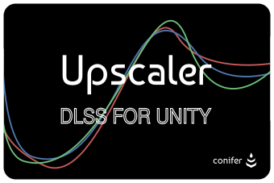
Upscaler Offline Manual (PDF)
v1.0.0
Table of Contents
1 Using the .unitypackage File 3
2 Using the Unity Editor GUI 3
2.1 Upscaler Settings 3
2.2 Basic Upscaler Settings 3
2.3 Advanced Upscaler Settings 3
3 Using the Upscaler API 3
3.1 Changing Settings 3
3.2 Handling Errors 3
3.3 API Reference 4
4 Things to be Aware of 4
5 GUI Integration 4
6 Packaging 4

Using the .unitypackage File
- Describe how to import the Unity Package into an existing project
- Elaborate on what to do with the scripts and other files that come into the project
- End with the user being able to press the run button and have DLSS run

Using the Unity Editor GUI
The Unity Editor GUI consists of 3 sections.
- Include an image of the entire GUI
- Include images and descriptions of the three sections

Upscaler Settings
- Include an image showing the settings in this area
- Elaborate on the names, descriptions, and tool-tips in this area
- Indicate the meaning of different colors

Basic Upscaler Settings
- Include an image showing the settings in this area
- Elaborate on the names, descriptions, and tool-tips in this area
- Include a table describing the effects of the different quality modes

Advanced Upscaler Settings
- Include an image showing the settings in this area
- Include deprecation warnings for the sharpness slider
- Include a suggestion to use a custom sharpness solution
- Include a note that this sharpness solution may be invisible as it likely does nothing

Using the Upscaler API
- Give an overview of the API including its general structure, and syntactic standards
- Include code block examples of anything that may need it

Changing Settings
- A quick list of functions used for changing the settings that are visible in the Unity GUI, and also any that are not
- Include code blocks for examples as well as function signatures

Handling Errors
- A guide on how to handle errors that the Upscaler plugin might throw
  - Registering an error handler
  - Change settings
  - If all else fails, stay calm, the None Upscaler will be used and it will always work

API Reference
- Include documentation for every function, class, enum, etc. that can be used by users
- Include code blocks and images where necessary.

Things to be Aware of
- Disable MSAA
- Disable dynamic resolution
- Change texture bias
- Read DLSS developer guide for more information
- What to use DLSS for and what not to use DLSS for.

GUI Integration
- How to integrate Upscaler into a GUI

Packaging
- How to package Upscaler

This document will be kept up-to-date with the latest releases of Upscaler. The document version number will be the same as the Upscaler version number. If any errors in this documentation are found please report them to <CONTACT INFORMATION>. If you have any further questions, please reach out to <CONTACT INFORMATION>.

