TheInterviewChair.com
Business Plan
Practise interviewing with AI. Get interview coaching. Get that job.
Prepared by Francis Cobbinah
Founder, TheInterviewChair.com
September 2026
theinterviewchair.com

Contents
Executive Summary
The Problem
Our Story
The Loop
What We Have Already Built
Who Benefits
Business Model & Pricing
Unit Economics
How We Reach Them
Risks
The Ask
The Wider Platform
Closing

Executive Summary
TheInterviewChair.com is a working, live platform that lets anyone practise a real job interview with an AI interviewer — speaking, listening, and scoring the answer honestly across five dimensions — and walk away with a genuine, defensible sense of where they stand. It already runs in production today: real candidates, real recruiters, real payments, no prototype or mock-up involved.
The problem it solves is simple to state and hard to argue with: the modern hiring process is built for the people who already have confidence, coaching and contacts, and does almost nothing for everyone else. This plan sets out how that gap becomes a real business — who benefits, how each group is reached, what it costs to run, and what is being asked of the people reading it.
Three things are true at once. First, the product works and is already live — this is proof, not a pitch. Second, no directly comparable product exists today, based on the founder’s own market research — this is a genuinely open field, not a crowded one. Third, the biggest gap between today and real scale is distribution: getting in front of the recruiters, candidates and institutions who would benefit. This plan is honest about that gap and sets out a concrete, assumption-led plan to close it — starting with recruiters, where the numbers are most defensible today.
A note on how this plan uses numbers: where a figure is genuinely measured (product cost, current pricing), it is stated as fact. Where it is a forecast, it is shown as a range built from stated assumptions, not a single confident guess — those assumptions will be tested and revised as real outreach begins.

The Problem
The hiring process was not built for the person it affects most.
A job interview decides, in under an hour, whether someone gets to change their life — and yet almost nobody preparing for one gets real, honest practice against a real question, asked by something that pushes back, follows up, and tells them the truth about how they did. Career coaching is expensive and hard to access. Practice with a friend is well-meaning but rarely rigorous. The result is a system that rewards people who already had confidence, coaching or contacts going in, and offers little to everyone else — exactly the people for whom the outcome matters most.
TheInterviewChair.com exists to put a genuinely rigorous, honest interviewer within reach of anyone, for the cost of a coffee rather than a career coach.

Our Story
TheInterviewChair.com was designed and built from a dialysis chair — three sessions a week, four hours at a time, in the hours a serious kidney condition leaves free. That constraint has shaped the product directly: it forces absolute clarity about what actually matters, and it means every feature in this plan has been built and shipped personally by its founder, not commissioned or outsourced.
The founder has been on both sides of the interview table — as a candidate who has faced homelessness and known exactly what it feels like for a single job offer to be the difference between everything and nothing, and as a hiring manager who has watched genuinely capable people fail to show it under pressure, simply because nobody ever taught them how. Both experiences are the same wound, seen from opposite sides of the table, and both point at the same missing thing: real, honest, repeated practice.
That personal history also produced the product’s central insight, discovered after twenty-five years of searching for how learning actually sticks: knowledge becomes truly owned not by reading or repetition, but by being interrogated on it — questioned, followed up, pushed to go deeper, and told honestly where it falls short. The interview format itself, it turns out, is one of the most powerful learning tools that exists. TheInterviewChair.com is built on that discovery.

The Loop
Practice. Get scored. Close the exact gap. Practice again.
That twenty-five-year discovery is not just the story behind TheInterviewChair.com — it is built directly into the product as a real, working mechanism, not a slogan. It runs automatically, every time:
- Interview — a real, spoken interview for the exact role the candidate names, not a generic question bank.
- Scored, honestly — a dimension-by-dimension result that shows exactly where the gap is, not just a single number to feel good or bad about.
- Learn — the platform routes the candidate straight into a short lesson built around their single weakest topic from that interview, closing the specific gap that was just exposed, not a generic study plan.
- Interview again — armed with what they just learned, they return and prove it under real pressure, the same act of interrogation that the founder’s own research found is what actually makes knowledge stick.
This is the platform’s most distinctive mechanism, and the clearest expression of the effort that has gone into making it genuinely useful rather than merely impressive: most tools either test a candidate or teach a candidate. Very few do both, and fewer still point automatically from one straight into the other. The Loop is that connection, built in from the start.

What We Have Already Built
This is not a concept awaiting funding to begin — it is a live, working product with real infrastructure behind it:
- Live, spoken AI interviewers (Amina and Wayne) conducting real-time interviews across 32 languages, with genuine follow-up questioning, not a scripted question bank.
- Transparent, published scoring across five dimensions — Relevance, Accuracy, Clarity, Depth, Confidence — plus a bonus knowledge round and character questions, with the full method public on the site’s own “How We Score” page.
- A Pass / Keep-on-file / Fail verdict and a shareable, downloadable certificate on a genuine pass.
- A working recruiter portal — candidate search, talent alerts, interview recordings, and a one-click “send an interview-prep link” flow already used by a real client.
- Live, processed payments (Stripe) for candidate subscriptions, one-off interview passes and recruiter seats — real money already moving through the system.
- A free, no-account, three-question live demo (“Try it live”) built specifically to convert cold social-media traffic, including on phones.
- Real-time visitor analytics distinguishing genuine human visitors from automated traffic — the same rigour applied to understanding our own growth as to scoring an interview.
Independent research at the time of writing found no directly comparable product on the market — not a crowded space with a better mousetrap, but a genuinely open field.
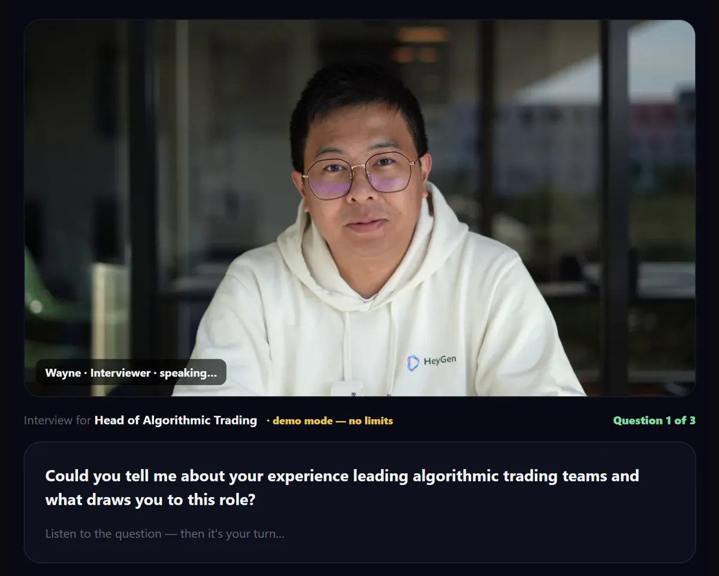
The live interview room — a real, working AI interviewer conducting an actual session.
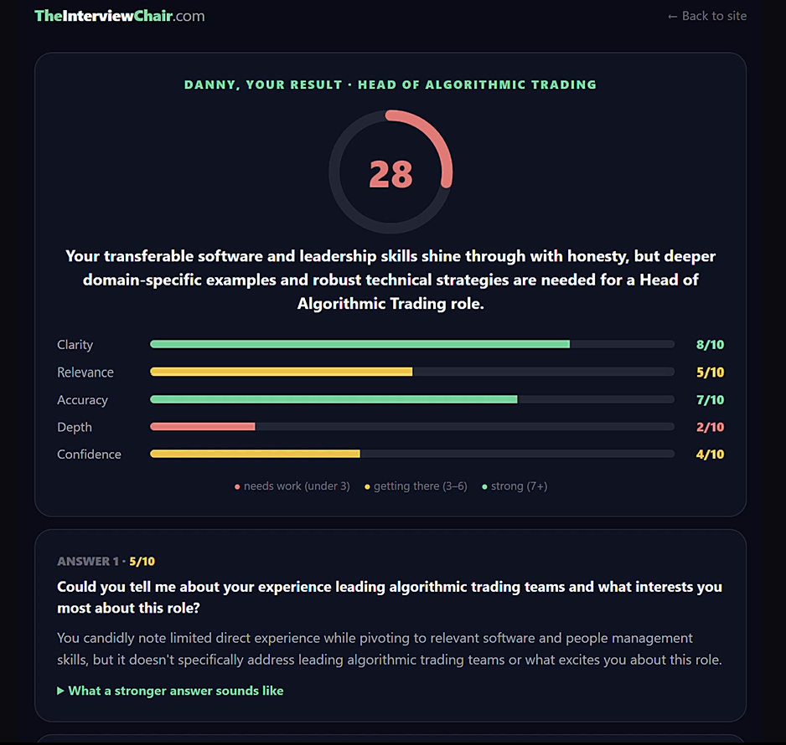
An honest, dimension-by-dimension scored result — nothing hidden, nothing rounded up.

Who Benefits
The product is built candidate-first, and deliberately serves several groups whose needs overlap but whose reasons for being there differ:
- People who lack interview confidence — the single largest, most universal group.
- People returning to work after long-term illness or another life disruption, rebuilding confidence as much as skill.
- College and university leavers, and students still studying, entering the job market for the first time.
- Younger people needing to practise spoken presentations and talks, not just interviews.
- Recruiters and recruitment agencies, who send candidates a prep link before an interview so they arrive genuinely ready — a better outcome for the recruiter’s own placement rate, not just the candidate.

Business Model & Pricing
Who | Price | What it buys
Candidate — free | Free | First full interview free; unlimited 3-question live demo, no account needed.
Candidate — subscription | £4.99 / month | Unlimited interviews, scored report, verdict & shareable certificate, Learn, Career Coach.
Candidate — one-off pass | £5.99 | 7-day interview pass, no subscription — for a single upcoming interview.
Recruiter — seat | £49 / seat / month | Full candidate search, talent alerts, interview recordings — per consultant.
Recruiter — prep link | 99p | Recruiter sends one candidate a tailored interview-prep link before their interview.
Any candidate — Magic Button | £1 / click | Self-serve, on the job-ad page itself — a tailored practice pack for that exact role.
Employer — seat | £399 / seat / month | Candidate marketplace, introductions, talent alerts (unchanged, out of scope for this plan).
Recruiter and Magic Button pricing reflect the founder’s decision (28 September 2026) to price for volume across many individual consultants and job-page visits, rather than a small number of expensive deals.

Unit Economics
The cost to run one full, ten-question live-avatar interview has been measured directly against the AI-avatar provider’s own usage figures, before and after a specific optimisation (disconnecting the avatar’s video/audio session during the candidate’s own thinking and answering time, when nothing needs to be streamed): approximately £0.60 per complete interview, an 85% reduction from the original ~£4.00 estimate. Text-based AI costs (scoring, coaching, question generation) are comparatively small — a fraction of a penny per exchange.
Against a £4.99 monthly candidate subscription or a £49 recruiter seat, this leaves a healthy margin even for a heavy user completing several interviews a month, and the Magic Button’s £1-per-click product carries no live-avatar cost at all — only a single AI text-generation call to build the practice pack.

How We Reach Them
This is the section every credible plan lives or dies on: not that a market is large, but how it is actually reached. Each group below is treated honestly — modelled where a real assumption-led forecast is possible, described as a mechanism where it is not.

Recruiters — the near-term financial engine
The founder already has an established, warm audience on LinkedIn: over 4,500 followers and connections, several hundred of them recruiters or talent-acquisition professionals, with a growing pattern of people asking to connect first and messaging afterwards out of genuine interest. The go-to-market treats this as two distinct waves rather than one blended assumption:
- Wave 1 — existing warm network. Several hundred recruiter connections already in place, reachable directly, with materially better expected response than cold outreach.
- Wave 2 — ongoing new outreach. Approximately 100 targeted messages a week to recruitment agency owners specifically (rather than individual recruiters), since one agency owner’s decision typically covers their whole team — the founder’s own first customer relationship, at roughly 18 seats from a single point of contact, is the model for this.
The offer is a free trial — ten free prep links, or a month of full access — on the reasoning that once a recruiter has sent a genuinely useful prep link, going back to not doing so is a hard habit to break.
The two conversion steps between a message sent and revenue — how many reply, and how many of those become paying customers — cannot yet be known with any precision, since sustained outreach has not yet begun. Rather than presenting a single guessed figure, three scenarios are shown below, each with its assumptions stated plainly:
Scenario | Cold-DM reply rate | Takes free trial | Trial → paying | New agencies / mo | New seats / mo | New MRR / mo
Conservative | 5% | 60% | 15% | ~2 | ~20 | ~£980
Base case | 10% | 75% | 25% | ~8 | ~80 | ~£3,920
Stretch | 15% | 85% | 35% | ~19 | ~190 | ~£9,310
These percentages are general, reasonable ranges for cold B2B outreach, not figures specific to this market — they are working assumptions to be replaced with real data within the first month of sustained outreach, and revised in this plan accordingly.

Candidates — reach through mechanism, not outreach
Candidates are priced far lower than recruiter seats, and the economics of individually messaging people at that price point do not obviously justify the time it would take. Growth here is intended to come from mechanism rather than 1:1 outreach:
- Every recruiter-sent prep link puts a new candidate in front of the product at zero acquisition cost — the recruiter channel directly feeds the candidate channel.
- A free, no-account, three-question demo lets someone experience the product before ever being asked to pay.
- A shareable certificate and interview profile give a candidate who does well a genuine reason to show it to their own network — distribution that is not bounded by the founder’s personal reach.
- An active, growing LinkedIn presence and short-form video content (TikTok) build awareness rather than perform direct sales.

The Magic Button — the Distribution Engine
The founder’s original inspiration for this business was a specific, universal moment: the hesitation every candidate feels the instant before clicking “Apply” on a job advert — could I actually get this, am I good enough, what if I fail. No major job board or professional network currently offers anything to answer that moment directly.
The Magic Button is a working demonstration, built and live today, of a button that could sit on any job advert on the internet: one click, £1, and the candidate receives a tailored interview-practice pack built specifically for that exact role and job description — answering the hesitation at the precise moment it occurs. The underlying generation and payment system is already live in production (it powers the site’s existing printable question-pack product); what remains is the distribution mechanism to place the button on pages the company does not itself own.
The realistic path to that is a browser extension — a small program that recognises a job-advert page on any site the visitor happens to be on and adds the button there directly, without requiring any site’s prior agreement. This is deliberately sequenced before any approach to LinkedIn or Indeed: those companies only engage through slow, formal processes, almost always with someone who can already point to real usage. A working extension, in real use across the open web, is what turns “an idea a founder pitched” into “a button that already runs in the wild” — and that is the leverage a genuine partnership conversation would need. Preliminary patent-candidate material covering aspects of the platform’s interview mechanism has already been prepared and shared with patent counsel for evaluation.

Universities & Government — identified, not yet scoped
Two further groups are named deliberately rather than modelled: university careers services (reaching students and leavers institutionally, at a different price point and through a different buyer than an individual candidate) and government or local-authority back-to-work programmes (typically procurement-driven, with long sales cycles and payment-by-outcome structures). Both are genuine future opportunities. Neither is included in this plan’s financial projections, because doing so honestly would require research this plan has not yet done — inventing a number here would be less credible than naming the gap plainly.

Risks
Risk | Why it matters | How we are addressing it
Competition arrives now the trend is visible | AI-run technical interviews are now a public talking point; a well-funded competitor could enter. | We have an 18-month build lead and no direct competitor found in App Store/Google research to date; speed of go-to-market is now the priority.
Founder-dependent sales capacity | Nearly all outreach today runs through one person. | Plan assumes hiring outreach support once recruiter revenue funds it; this plan’s ask includes support for that step.
AI running cost at scale | Live avatar interviews have a real cost per session. | Measured at ~£0.60 per full 10-question interview after disconnecting the avatar during answer time; margin is healthy at current pricing.
Fairness & bias perception | AI-scored interviews invite scrutiny over how marks are given. | Every scoring dimension and its weighting is published openly on the site (“How We Score”) — deliberately no black box.
Browser-extension distribution risk | Injecting a button onto third-party job pages sits in a legal grey area with some sites’ terms of service. | MVP targets ATS platforms and job boards with the least restrictive practice first; usage data will inform a formal-partnership approach later.

The Ask
This plan is being shared with a small number of people, each able to help in a different way, and this section speaks to all of them directly and honestly:
- Investment or funding to accelerate recruiter outreach (including support beyond one founder’s own capacity) and to build the Magic Button browser extension described above.
- Introductions to recruitment agencies, universities or organisations who would benefit — the single highest-leverage form of help available at this stage.
- Advisory input, including from anyone willing to take a closer role in guiding the business as it scales.
Mike Petrie of Vallum Associates has already offered to become the platform’s first paying recruiter seat, to introduce the product to his own contacts, and has raised the possibility of a closer advisory role — exactly the kind of practical support this plan is asking for, from someone positioned to give it.

The Wider Platform
Everything above is deliberately built around the interview itself, because that is where the business case is clearest. But the interview is one part of a considerably larger platform already live today — worth setting out in full, since it is easy to under-sell a product this complete by only ever talking about its headline feature:
- AI Career Coach — a conversational coach a candidate can talk through their career direction and choices with, on demand, not just interview preparation. Useful for someone who does not yet know what role to aim for, not only someone who already has an interview booked.
- Careers Explorer — browse real careers, what they actually pay, and what they genuinely require, in plain language rather than dense job-spec jargon. Several careers also offer a spoken, personal walkthrough of what the role is really like day to day.
- Talk Practice — practise a spoken presentation or talk out loud, scored with the same rigour as an interview answer, with a browsable library of other users’ public talks to learn from. Aimed particularly at students and younger people who need presentation skills, not only interviews.
- Client Gifts — a recruiter gifts their hiring-manager client a genuinely useful set of free, AI-written interview questions tailored to a specific role. Strengthens the recruiter’s own relationship with that client at zero extra cost, and is a natural companion to the Magic Button described above.
- Exams & Certifications — 172 professional and school exam types, each with its own scored mock paper generated on demand. Mock exams are free, so a candidate can genuinely test their readiness before ever paying for anything.
- CV Analyser & Salary Insights — upload a CV and instantly see which roles genuinely fit, what they typically pay, and personal strengths and gaps, with a spoken walkthrough explaining the result rather than a wall of text. Results are saved and can be shared, the same way an interview result can.
- Interview Gifts — buy a session pass and send it to someone else facing an interview — a small, genuinely useful gift, handled by a proper checkout and email flow, not an afterthought bolted onto the site.
- Question Bank — save any model answer revealed during practice into a personal, searchable library, to study and replay later. Turns a single practice session into an ongoing revision resource rather than a one-off event.
- Company-Specific Interviews — an “Interview Style” picker lets a candidate practise in the actual questioning style of 68 curated, real employers, each with its own AI-built company profile behind it — not a generic interview with a company’s name attached.
- Learn Alerts — spaced-repetition multiple-choice practice questions delivered by email on a schedule, so what was learned in a Learn session is revisited before it fades — the same underlying “interrogation keeps knowledge” principle behind The Loop, applied to ongoing study rather than a single interview.
Coming next: the platform’s own jobs board — a natural extension once distribution (recruiters, candidates, and the Magic Button described above) is established, closing the loop from practising for a role to actually finding one.
Screens illustrating each of the above can be added here once captured — most sit behind a candidate or recruiter login this plan’s preparation did not have access to.

Closing
TheInterviewChair.com already works. The technology is live, the early usage is real, and the cost to run it is proven and low relative to what it charges. What stands between today and meaningful scale is not the product — it is distribution, and this plan sets out, honestly and without inflating a single number, exactly how that gap gets closed.

