f

CAITCHA – Completely Automated **Inference** Turing test to tell Computers and Humans Apart

**Summary of deep learning**

It is evident that humans and computers excel in different tasks. Computers are classically suited to performing complex arithmetic tasks, including finding the cube and quartic root or listing all the factors of a large integer. Conversely, human cognition is more integrative, suited to tasks of object recognition, motion tracking, and tasks of visual or auditory discrimination. Therefore, the challenge of deep learning is extending tasks typically in the arena of humans to machines and making them excel at them at a higher level than human cognition.

**Principles of deep learning**

The goal of deep learning is to learn or converge on a mathematical function between your dependent and independent variables that minimises the total error between the true value for a given set of variables and the machine’s predicted value. As such, deep learning is an optimisation tool that minimises the total loss or error between the predicted value and true value. With sufficient training data, a neural network can theoretically attain this goal – a term called Turing completeness. All deep learning methods ultimately consist of three main features: an input layer, n hidden layers and an output layer. Data – either structured or explicit data in the form of databases, or unstructured, as in images, audio and text data – are passed through each layer.

The input of a given layer n takes the output of the previous layer n-1. As the data are passed through each layer, they are transformed by a series of functions with given weights and spat out in the output layer. The algorithm then compares the predicted value, ŷ, with the real value y and computes the error between these values using a cost function, the sum of all the error in the training dataset.

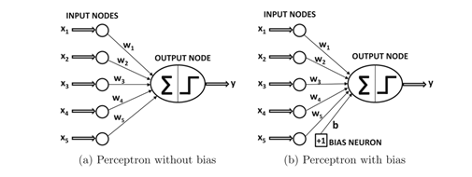

**Figure 1.** Basis of the perceptron single neural layer. Dependent variables are submitted to input nodes that then make a connection of a particular weight, w, that are then summated. The perceptron integrates the weights and fires if the sum exceeds a threshold. In biological systems, one imagines neuromodulation at the integrating region and via spatial and temporal summation. In perceptrons, the weights are only positive, rather than biological systems where hyperpolarising IPSPs are possible.

This is then backpropagated or sent back through the network to update its weights as a direct function of the magnitude of the error. An analogy for what this algorithm does is a blindfolded hiker on the Cairngorm – the hiker is initially unaware of their starting position but knows their destination lies at the bottom of the Cairngorm. Through trial and error, the hiker takes stepwise movements in various directions until they find a slight downward slope; they continually follow this slope downwards until they cannot go further down.

**Study**

Over the honours project, we have developed a cell pose inference and classification model using the ResNet architecture of *cellpose.* We now request your help to perform a CAITCHA to compare the efficiency and accuracy of the machine-automated system compared to manual human labelling.

To achieve this, we have randomly selected five fields of view (FOV) with archetypal primary neurons; the model has never seen these images, but has been trained on similar data.

Your help would involve labelling these five FOVs using the open-source software, ImageJ. We will then use our model to classify the same images and compare the accuracy relative to a ‘fiducial’ standard – namely, an experienced labeller with infinite time for labelling. Your task would involve labelling these images as accurately and rapidly as possible.

**Method**

Maximum intensity projections of five FOVs were collected in .tif format. The intensity on max intensity projections in selected regions of interest (ROIs) will be compared between the fiducial standard and participant/machine labels to compute error (mean absolute percentage error). Researchers will be requested to record additional data on the exercise, including time to completion per FOV.

**Instructions for labelling in ImageJ**

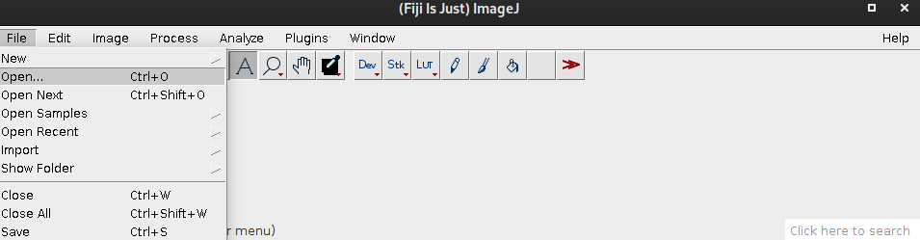1. Open .tif images in numerical order given. Please ensure that ‘Mean gray value’ is the only measurement selected in the ‘Set Measurements’ dialog box, accessed by navigating to Analyze > Set Measurements. Once you have read all the instructions and feel confident on how to label and save the data, start the timer and get your cell-labelling headgear on!

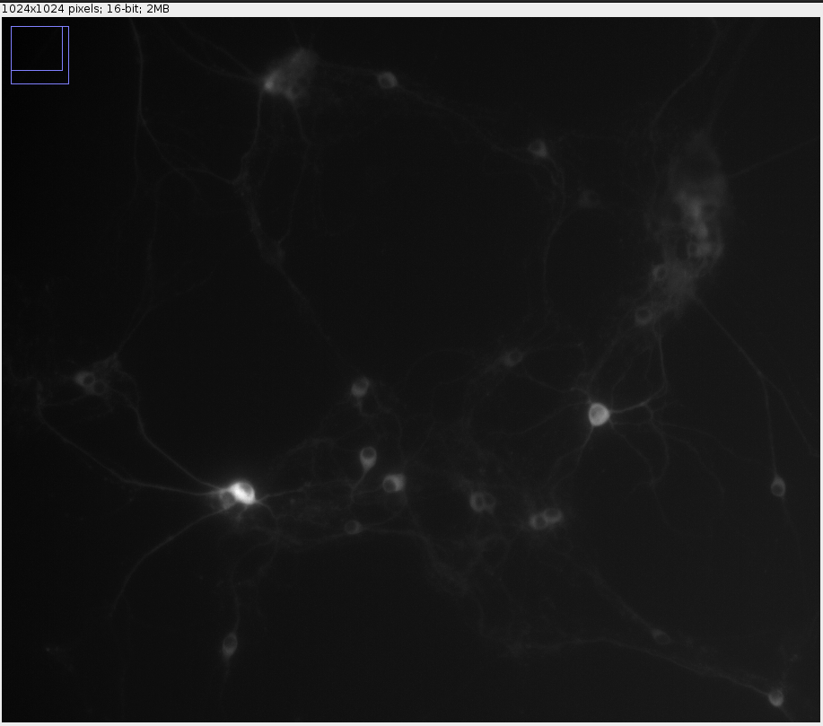

You will see a 1024x1024 greyscale pixel image with a bit-depth of 16.

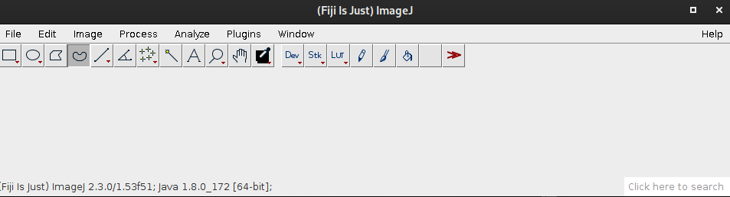2. Select the freehand selections tool in the ImageJ menu

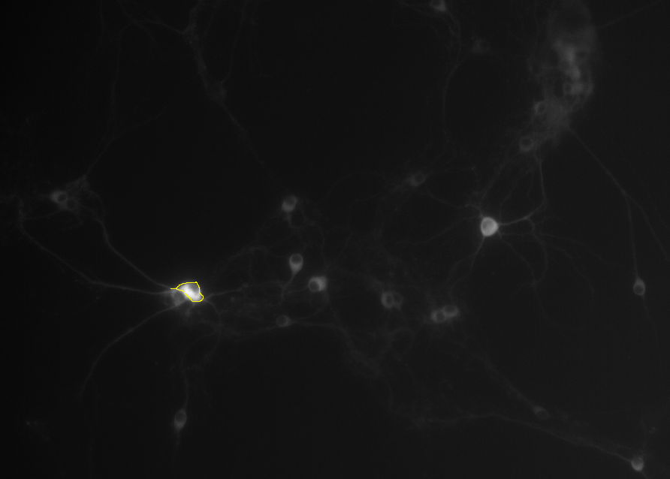3. Hold left-click and circle the perimeter of your chosen ROI and then release to create an enclosed polygon. To zoom into a region of the image, click ‘+’ with your cursor in the desired position. Please try to circle neurons from the top to the bottom of the image.

4. Open the ROI manager; after circling one ROI, press ‘t’ to save it to the ROI manager

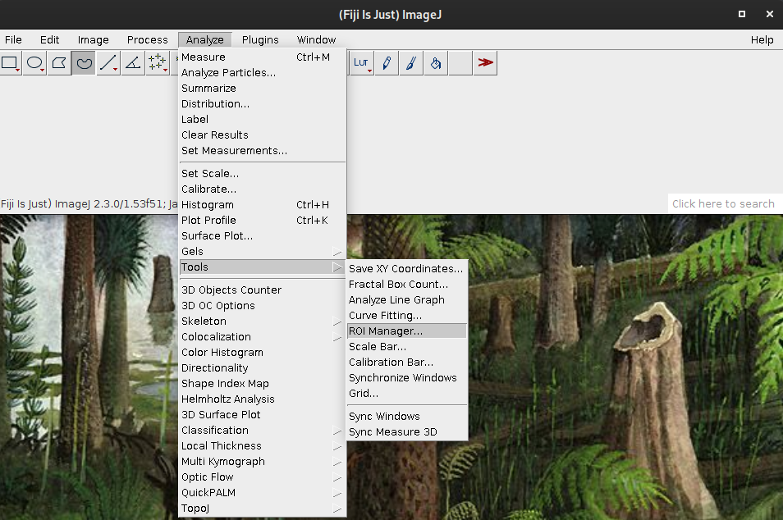

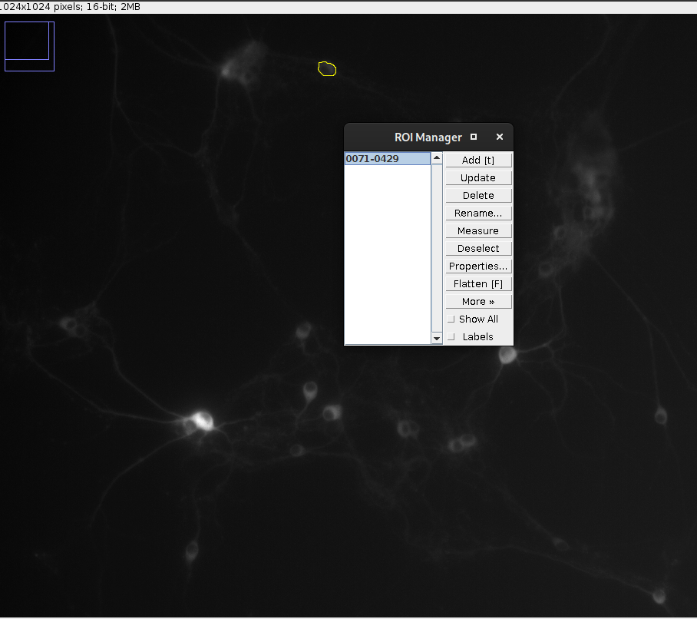

5. Once all ROIs have been selected for a given image, please save the intensity data by selecting save on the ROI manager and ‘Multi Measure’. This will prompt you to the multi measure menu; 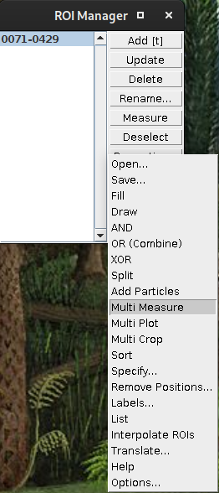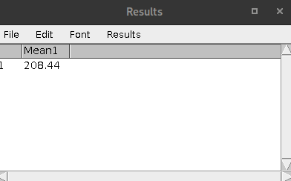the default, ‘one measurement per line’ is fine. Just press ‘okay’ and then save the data to the same directory as the images in csv format. Give the csv file the same name as the labelled image. Please also make a note of the time taken, in seconds, from starting imaging to saving in the .xlsx file provided called ‘completion_data’ in your participant folder, ’P*X’,* where *X* is your participant ID number