**Batch: E2 Roll No.: 16010123325**

**Experiment / assignment / tutorial No.___10____**

|  |
| --- |
| **TITLE:** Study of multiprocessor configuration concepts through Virtual lab |

**AIM:** Understanding Virtual Lab concepts

**_______________________________________________________________**

**Expected OUTCOME of Experiment:**

**__________________________________________________________________**

**Books/ Journals/ Websites referred:**

<http://vlabs.iitb.ac.in/vlab/labscse.html>

[http://vlabs.iitb.ac.in/vlab/#](http://vlabs.iitb.ac.in/vlab/)

<http://www.vlab.co.in/>

**_____________________________________________________________________**

**Pre Lab/ Prior Concepts:**

The main aim of this experiment is to provide remote-access to Labs in various disciplines of Science and Engineering. These Virtual Labs would cater to students at the undergraduate level, post graduate level as well as to research scholars. Also, to enthuse students to conduct experiments by arousing their curiosity. This would help them in learning basic and advanced concepts through remote experimentation. It also provides a complete Learning Management System around the Virtual Labs where the students can avail the various tools for learning, including additional web-resources, video-lectures, animated demonstrations and self-evaluation. We can share costly equipment and resources, which are otherwise available to limited number of users due to constraints on time and geographical distances

**Salient Features:**

. 1. Virtual Labs will provide to the students the result of an experiment by one of the following methods (or possibly a combination)

* Modeling the physical phenomenon by a set of equations and carrying out simulations to yield the result of the particular experiment. This can, at-the-best, provide an approximate version of the ‘real-world’ experiment.
* Providing measured data for virtual lab experiments corresponding to the data previously obtained by measurements on an actual system.
* Remotely triggering an experiment in an actual lab and providing the student the result of the experiment through the computer interface. This would entail carrying out the actual lab experiment remotely.

2. Virtual Labs will be made more effective and realistic by providing additional inputs to the students like accompanying audio and video streaming of an actual lab experiment and equipment.

**Observations**

## Title of Study Experiment: Floating Point Numbers Representation

**Brief description of experiment under study**

FPUs typically represent real numbers in a binary floating-point format. In this format, a real number has three parts: a sign, a significand, and an exponent. The following explaination is in accordance with the standard IEEE format of 32 bit representation .

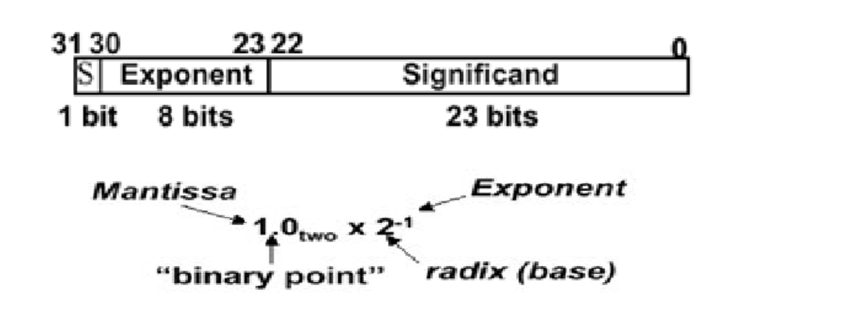

**Learning’s recorded:**

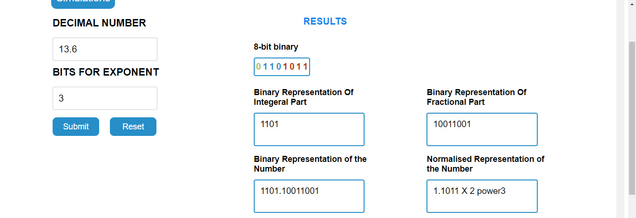

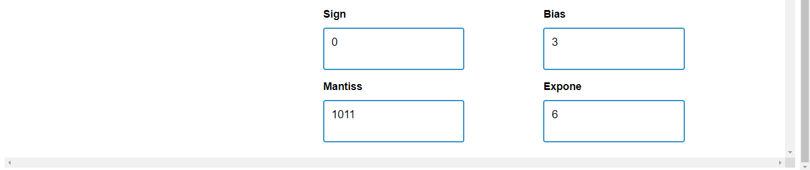

**Knowledge gained / Inference Obtained : we learnt about floating point numbers and learnt how to represent a decimal number in floating point using a simulation.**

**Post Lab Descriptive Questions**

**1. What are the applications of the virtual lab case study / tool reviewed by you?**

Virtual lab case studies enhance remote learning, facilitate interactive simulations, support experimental design, and provide real-time data analysis, making science education more accessible and engaging for students.

**Conclusion :**

We learnt about floating point numbers and learnt how to represent a decimal number in floating point using a simulation.