**Name: Shreyans Tatiya**

**Roll no: 16010123325**

**Batch: E-2**

**Assignment: Circuit Verse**

**Basic Logic Gates [AND, OR, NOT, NAND, NOR, XOR, XNOR]**

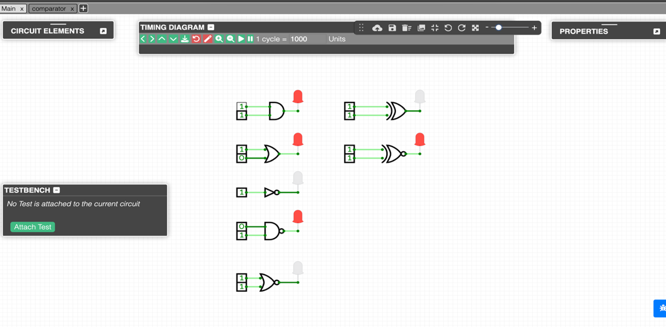

**2 Bit Comparator**

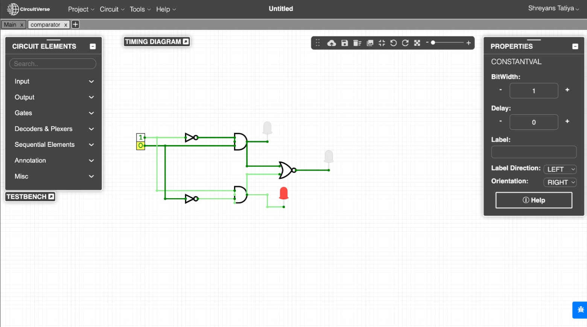

**JK F/F**

**SR**

