Database Benchmark Comparison — TPROC-C Report
HammerDB 5.0 · TPROC-C · 1000 warehouses · 3600 s runs · 600 s ramp-up
Hardware: beast-node2.tp.int.percona.com · 80 logical CPUs · 187.54 GiB RAM · NVMe
OS: Ubuntu 24.04 · kernel 6.8.0-60-generic · governor=performance · THP=off · swappiness=1
Engines: MariaDB 12.2.2, MariaDB 12.3.1-rc, MySQL 8.4.8, MySQL 9.7.0 · Generated: 2026-04-27

Executive Summary
Config | MariaDB 12.2.2 | MariaDB 12.3.1 | MySQL 8.4.8 | MySQL 9.7.0
Peak TPM (BP iterations, 80 VU) | 1,147,448 | 1,102,582 | 1,026,225 | 1,172,021
Peak TPM (VU iterations, BP 110G) | 1,226,157 | 1,212,899 | 1,097,938 | 1,252,012
Scaling 10→320 VU (BP 110G) | 3.9× | 4.0× | 4.0× | 3.8×
Headline: MySQL 9.7.0 posts the highest BP-iterations peak at 80 VU; MySQL 9.7.0 leads the VU-iterations peak at BP 110 GiB. TPM comes from HammerDB's own per-second hdbtcount_*.log; steady-state mean confirmed against the TEST RESULT line in hammerdbcli.out. MySQL columns restricted to runs with innodb_buffer_pool_instances = 2 for apples-to-apples comparison.

Buffer Pool Iterations — 80 VU, 10G–110G
The InnoDB Buffer Pool caches table and index pages in memory. Iterations vary innodb_buffer_pool_size from 10 GiB to 110 GiB while holding everything else constant — 80 virtual users, 1000 warehouses (~100 GB working set), same hardware, same configuration.
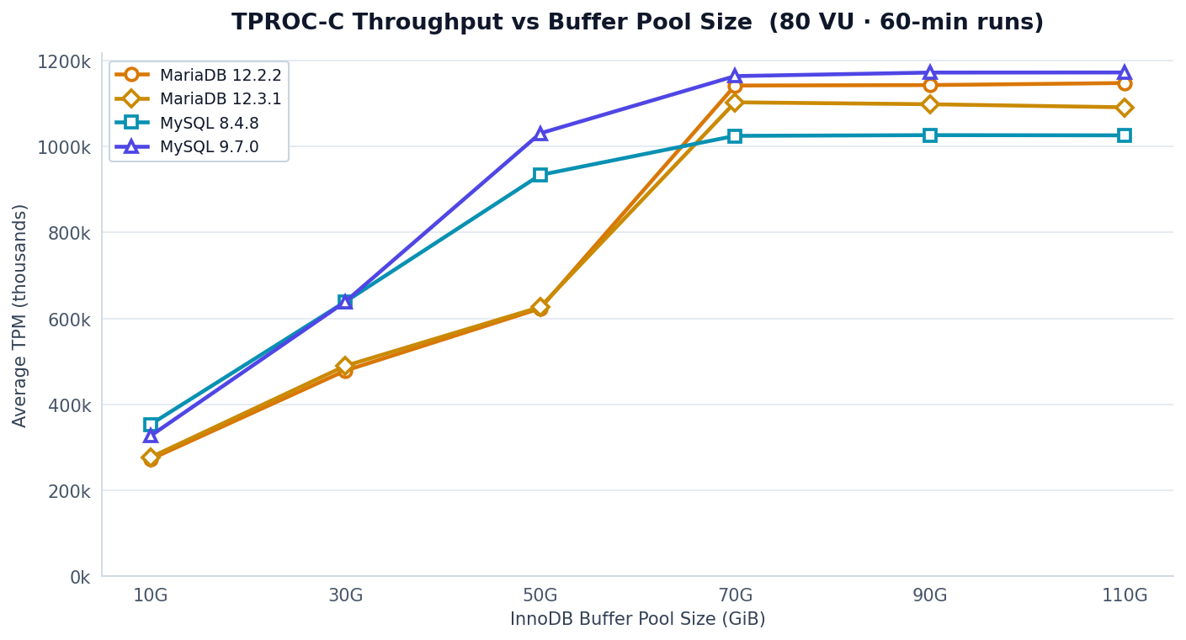
Fig 1 — TPROC-C Throughput vs Buffer Pool Size (80 VU · 60-min runs)
BP Size | MariaDB 12.2.2 | MariaDB 12.3.1 | MySQL 8.4.8 | MySQL 9.7.0
10G | 272,108 | 276,483 | 353,125 | 326,322
30G | 478,234 | 489,355 | 638,556 | 638,562
50G | 622,939 | 626,108 | 933,531 | 1,030,408
70G | 1,141,606 | 1,102,582 | 1,024,559 | 1,163,566
90G | 1,142,685 | 1,098,103 | 1,026,225 | 1,171,792
110G | 1,147,448 | 1,090,956 | 1,025,733 | 1,172,021

Virtual Users Iterations — BP 110G, 10–320 VU
A Virtual User (VU) simulates an independent database client. Concurrency was iterated through {10, 20, 40, 80, 160, 320} virtual users with a fixed 110 GiB buffer pool. MariaDB 12.2.2 was only benchmarked at 80 VU in this dataset.
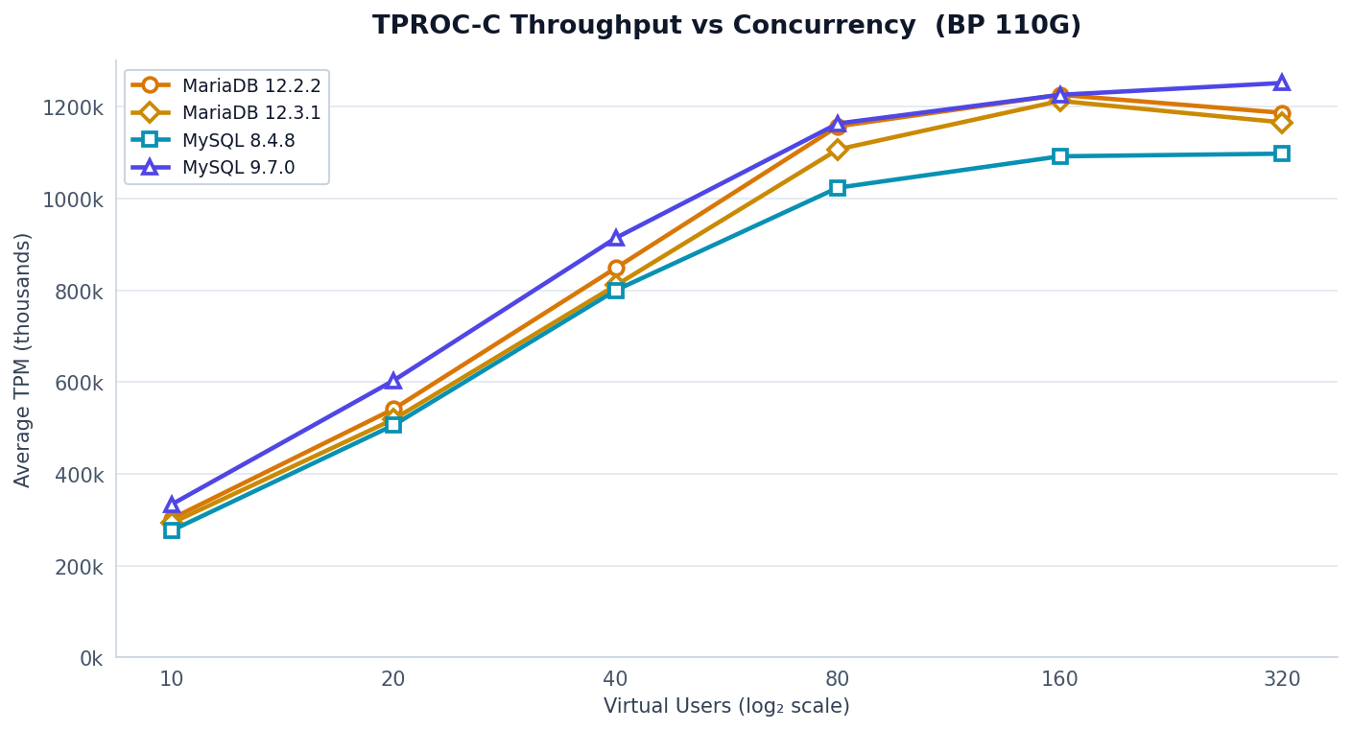
Fig 3 — TPROC-C Throughput vs Concurrency (BP 110G)
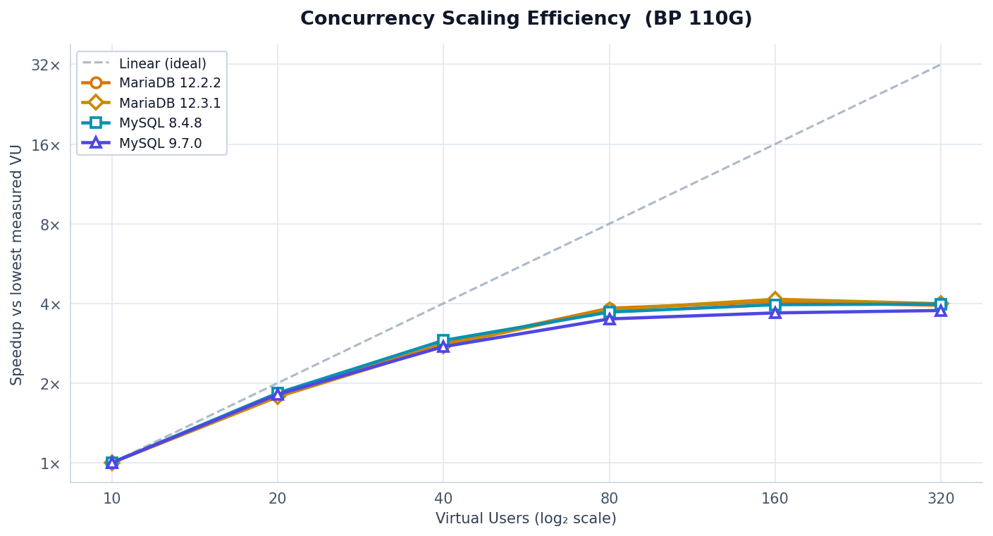
Fig 4 — Concurrency Scaling Efficiency (BP 110G)
VU | MariaDB 12.2.2 | MariaDB 12.3.1 | MySQL 8.4.8 | MySQL 9.7.0
10 | 301,942 | 292,497 | 276,116 | 333,019
20 | 541,276 | 518,776 | 506,079 | 603,331
40 | 848,592 | 810,835 | 800,144 | 914,072
80 | 1,157,551 | 1,107,155 | 1,023,746 | 1,163,664
160 | 1,226,157 | 1,212,899 | 1,092,135 | 1,226,158
320 | 1,186,987 | 1,166,107 | 1,097,938 | 1,252,012

TPM Jitter — steady-state windows
TPM Jitter quantifies the spread of per-second throughput variation during steady-state (ramp-up excluded). CV% = std ÷ mean × 100; lower is more stable. P5 and P95 are the 5th and 95th percentile per-second TPM.
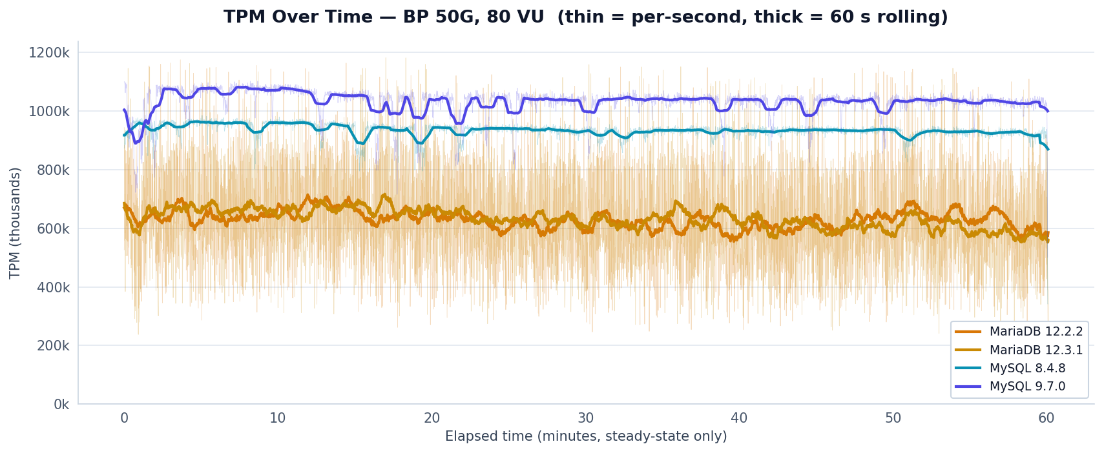
Fig 5 — TPM Over Time at BP 50G / 80 VU (thin = per-second, thick = 60 s rolling)

Buffer Pool Iterations
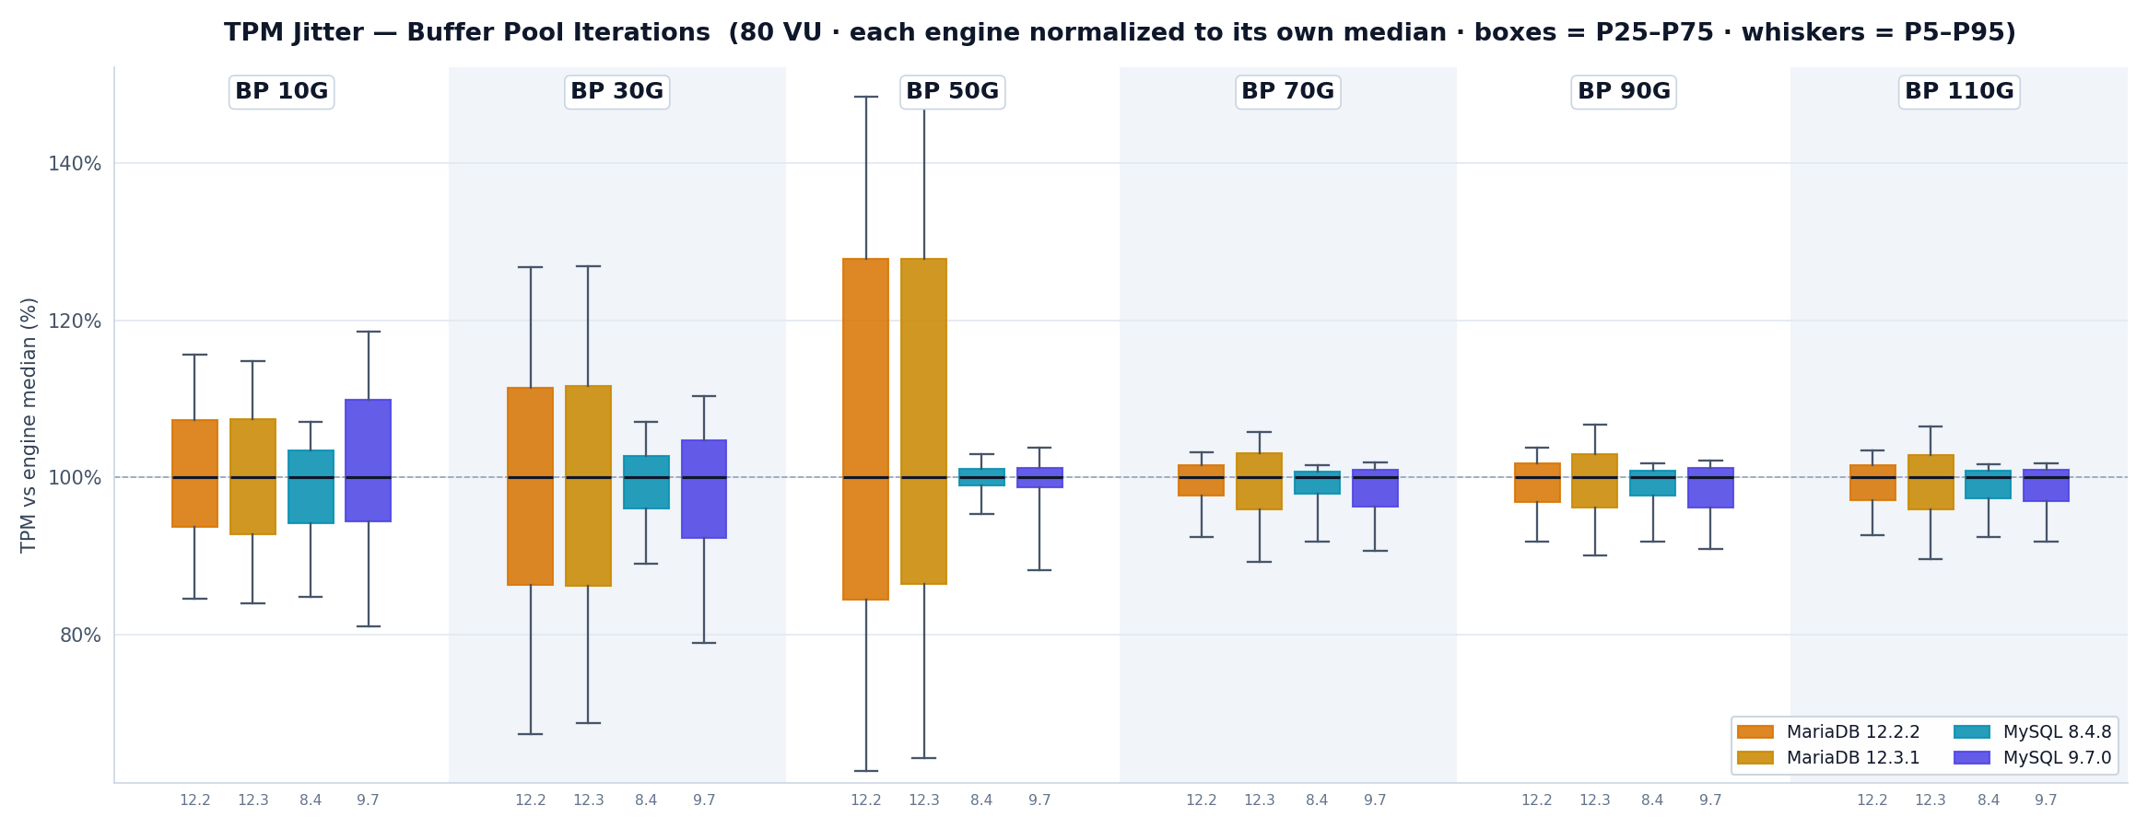
Fig 6 — TPM Jitter — Buffer Pool Iterations (boxes = P25–P75, whiskers = P5–P95)
Config | Engine | Mean TPM | Std Dev | CV% | P5 | P95 | P5–P95
10G | MariaDB 12.2.2 | 272,235 | 27,743 | 10.2% | 230,220 | 314,520 | 84,300
10G | MariaDB 12.3.1 | 276,474 | 28,743 | 10.4% | 232,980 | 318,420 | 85,440
10G | MySQL 8.4.8 | 353,518 | 28,403 | 8.0% | 305,760 | 385,800 | 80,040
10G | MySQL 9.7.0 | 326,649 | 36,258 | 11.1% | 262,380 | 383,820 | 121,440
30G | MariaDB 12.2.2 | 478,762 | 88,404 | 18.5% | 327,600 | 616,020 | 288,420
30G | MariaDB 12.3.1 | 489,985 | 90,599 | 18.5% | 341,220 | 630,000 | 288,780
30G | MySQL 8.4.8 | 639,192 | 38,284 | 6.0% | 574,800 | 691,140 | 116,340
30G | MySQL 9.7.0 | 639,049 | 65,639 | 10.3% | 516,000 | 721,140 | 205,140
50G | MariaDB 12.2.2 | 630,021 | 170,573 | 27.1% | 375,300 | 889,020 | 513,720
50G | MariaDB 12.3.1 | 632,509 | 169,376 | 26.8% | 384,120 | 900,360 | 516,240
50G | MySQL 8.4.8 | 934,618 | 26,676 | 2.9% | 893,460 | 964,800 | 71,340
50G | MySQL 9.7.0 | 1,031,938 | 49,502 | 4.8% | 919,620 | 1,081,620 | 162,000
70G | MariaDB 12.2.2 | 1,143,318 | 39,809 | 3.5% | 1,064,760 | 1,189,560 | 124,800
70G | MariaDB 12.3.1 | 1,103,859 | 61,296 | 5.5% | 994,500 | 1,179,840 | 185,340
70G | MySQL 8.4.8 | 1,025,773 | 37,216 | 3.6% | 954,600 | 1,055,280 | 100,680
70G | MySQL 9.7.0 | 1,165,121 | 47,295 | 4.1% | 1,074,780 | 1,207,800 | 133,020
90G | MariaDB 12.2.2 | 1,144,128 | 45,806 | 4.0% | 1,059,900 | 1,198,320 | 138,420
90G | MariaDB 12.3.1 | 1,099,378 | 59,039 | 5.4% | 996,000 | 1,180,680 | 184,680
90G | MySQL 8.4.8 | 1,027,532 | 35,957 | 3.5% | 956,340 | 1,058,880 | 102,540
90G | MySQL 9.7.0 | 1,173,320 | 48,390 | 4.1% | 1,083,960 | 1,217,820 | 133,860
110G | MariaDB 12.2.2 | 1,148,907 | 42,925 | 3.7% | 1,073,040 | 1,199,520 | 126,480
110G | MariaDB 12.3.1 | 1,092,219 | 59,241 | 5.4% | 986,940 | 1,172,880 | 185,940
110G | MySQL 8.4.8 | 1,027,105 | 35,727 | 3.5% | 961,620 | 1,057,740 | 96,120
110G | MySQL 9.7.0 | 1,173,411 | 44,982 | 3.8% | 1,092,960 | 1,212,060 | 119,100

Virtual Users Iterations
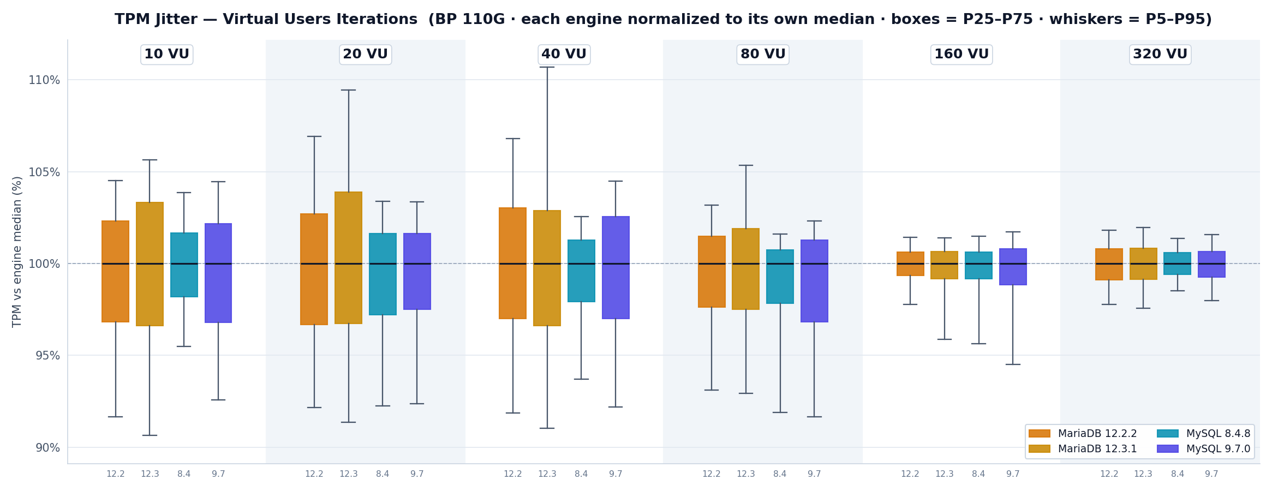
Fig 7 — TPM Jitter — Virtual Users Iterations (boxes = P25–P75, whiskers = P5–P95)
Config | Engine | Mean TPM | Std Dev | CV% | P5 | P95 | P5–P95
10 VU | MariaDB 12.2.2 | 302,186 | 13,847 | 4.6% | 279,120 | 318,300 | 39,180
10 VU | MariaDB 12.3.1 | 292,824 | 16,691 | 5.7% | 267,300 | 311,700 | 44,400
10 VU | MySQL 8.4.8 | 276,348 | 8,857 | 3.2% | 264,360 | 287,520 | 23,160
10 VU | MySQL 9.7.0 | 333,440 | 12,863 | 3.9% | 310,560 | 350,580 | 40,020
20 VU | MariaDB 12.2.2 | 541,811 | 26,263 | 4.8% | 500,880 | 581,160 | 80,280
20 VU | MariaDB 12.3.1 | 519,306 | 29,548 | 5.7% | 473,040 | 566,760 | 93,720
20 VU | MySQL 8.4.8 | 506,616 | 19,442 | 3.8% | 471,540 | 528,660 | 57,120
20 VU | MySQL 9.7.0 | 603,991 | 22,009 | 3.6% | 562,380 | 629,460 | 67,080
40 VU | MariaDB 12.2.2 | 849,380 | 40,668 | 4.8% | 781,980 | 909,600 | 127,620
40 VU | MariaDB 12.3.1 | 811,552 | 48,059 | 5.9% | 737,340 | 896,700 | 159,360
40 VU | MySQL 8.4.8 | 800,838 | 26,530 | 3.3% | 756,000 | 827,580 | 71,580
40 VU | MySQL 9.7.0 | 915,110 | 37,568 | 4.1% | 848,640 | 962,040 | 113,400
80 VU | MariaDB 12.2.2 | 1,158,569 | 45,870 | 4.0% | 1,087,080 | 1,204,680 | 117,600
80 VU | MariaDB 12.3.1 | 1,108,372 | 45,859 | 4.1% | 1,034,400 | 1,172,880 | 138,480
80 VU | MySQL 8.4.8 | 1,024,983 | 37,813 | 3.7% | 953,580 | 1,055,160 | 101,580
80 VU | MySQL 9.7.0 | 1,165,157 | 46,019 | 4.0% | 1,082,400 | 1,208,280 | 125,880
160 VU | MariaDB 12.2.2 | 1,228,908 | 25,099 | 2.0% | 1,203,780 | 1,248,780 | 45,000
160 VU | MariaDB 12.3.1 | 1,215,432 | 29,388 | 2.4% | 1,170,540 | 1,238,100 | 67,560
160 VU | MySQL 8.4.8 | 1,094,419 | 24,871 | 2.3% | 1,051,800 | 1,115,880 | 64,080
160 VU | MySQL 9.7.0 | 1,228,600 | 32,731 | 2.7% | 1,168,680 | 1,258,440 | 89,760
320 VU | MariaDB 12.2.2 | 1,194,182 | 16,935 | 1.4% | 1,168,680 | 1,216,980 | 48,300
320 VU | MariaDB 12.3.1 | 1,172,040 | 22,682 | 1.9% | 1,144,500 | 1,196,400 | 51,900
320 VU | MySQL 8.4.8 | 1,100,789 | 24,254 | 2.2% | 1,085,280 | 1,116,540 | 31,260
320 VU | MySQL 9.7.0 | 1,255,419 | 18,369 | 1.5% | 1,231,380 | 1,276,380 | 45,000

Methodology
- Benchmark: TPROC-C via HammerDB 5.0 (hammerdb_run.tcl)
- Workload: 1000 warehouses (~100 GB), 600 s ramp-up, 3600 s measurement, partitioned InnoDB
- Driver: timed, tc_refresh_seconds=1
- Hardware: beast-node2.tp.int.percona.com — 80 logical CPUs, 187.54 GiB RAM
- OS: Ubuntu 24.04, kernel 6.8.0-60-generic; governor=performance, THP=off, swappiness=1, CPU idle POLL+C1 only
- Metric: TPM — per-second samples from HammerDB's hdbtcount_*.log; end-of-run mean cross-checked against hammerdbcli.out TEST RESULT line
- BP iterations: 80 VU, buffer pool ∈ {10, 30, 50, 70, 90, 110} GiB
- VU iterations: 110 GiB buffer pool, VU ∈ {10, 20, 40, 80, 160, 320}
- MySQL columns restricted to innodb_buffer_pool_instances = 2; MariaDB columns use default instances = 1
- Tail trim: trailing ramp-down samples below 10% of steady-state median are dropped
Data source: github.com/Percona-Lab-results/mysql-tpcc-buffer-pool-sweep

