# Introduction

The Restaurant Management System is an extensive web-based application created to streamline and enhance the management of restaurant operations. This project, undertaken as part of our Java 2 Enterprise Edition (J2EE) coursework, integrates various Java technologies along with XAMPP to deliver a powerful and user-friendly platform. The primary objective of the system is to provide robust CRUD (Create, Read, Update, Delete) functionalities for managing menu items and user accounts efficiently. This report provides an in-depth exploration of the development process, delves into the system architecture, discusses the implementation strategies, and reviews the testing methodologies used to ensure the application's reliability and effectiveness. Additionally, it highlights the collective efforts of the team and details my individual contributions to the project.

# Application Screenshots

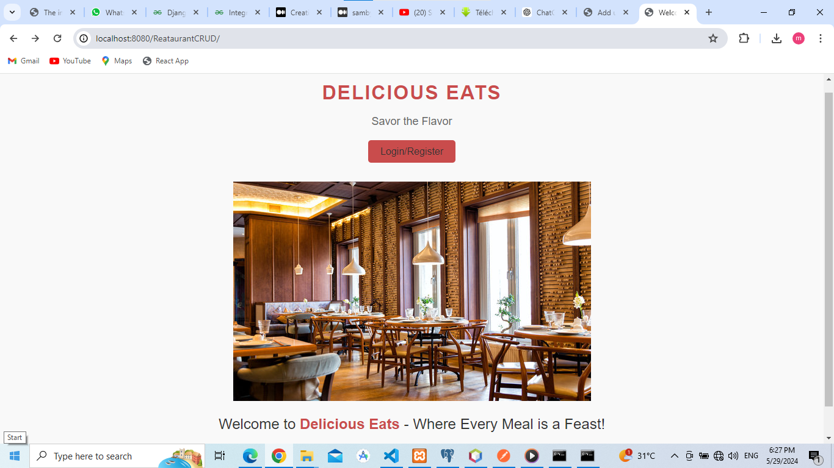

Figure 1: The Welcome Page

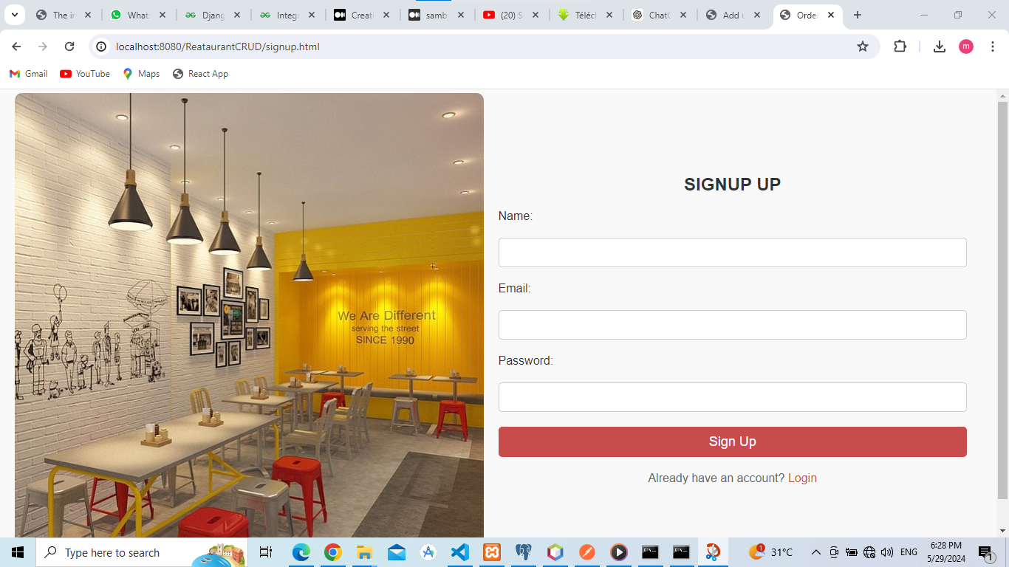

Figure 2: Sign up page

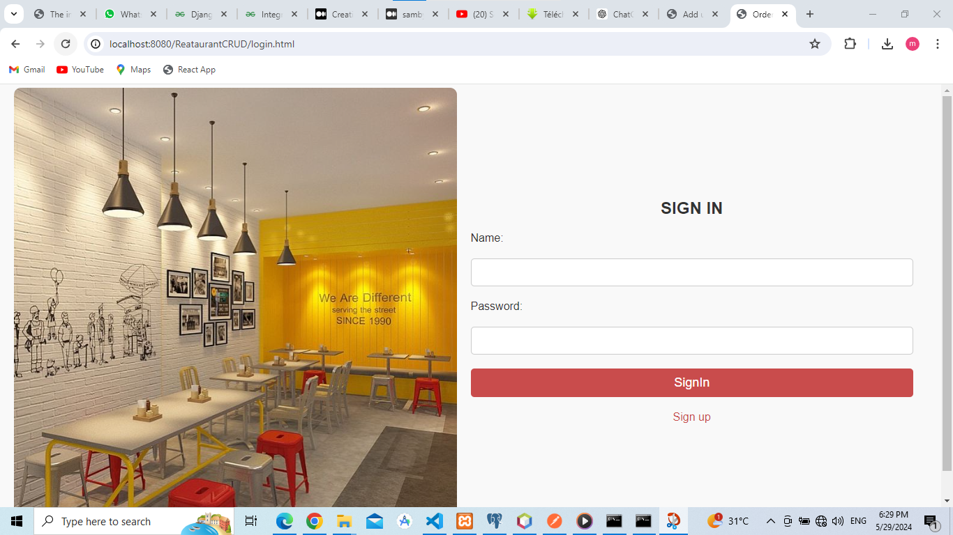

Figure 3: Sign in page

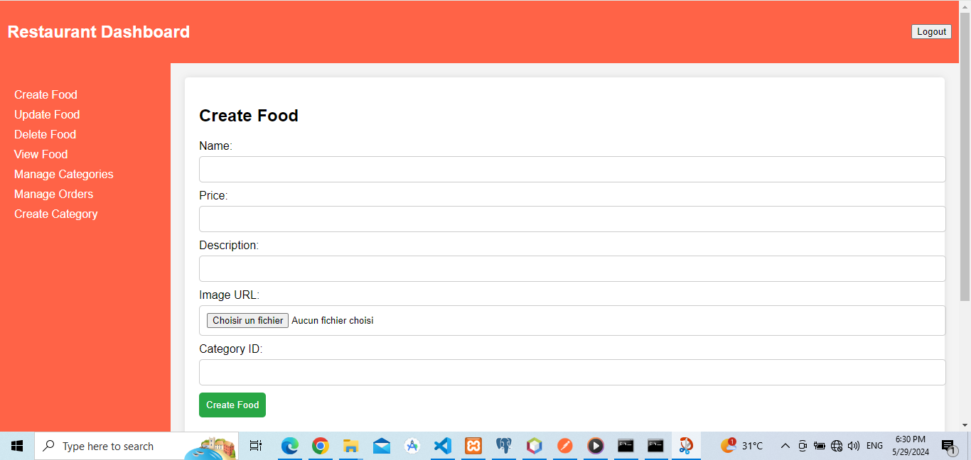

Figure 4: Create Food

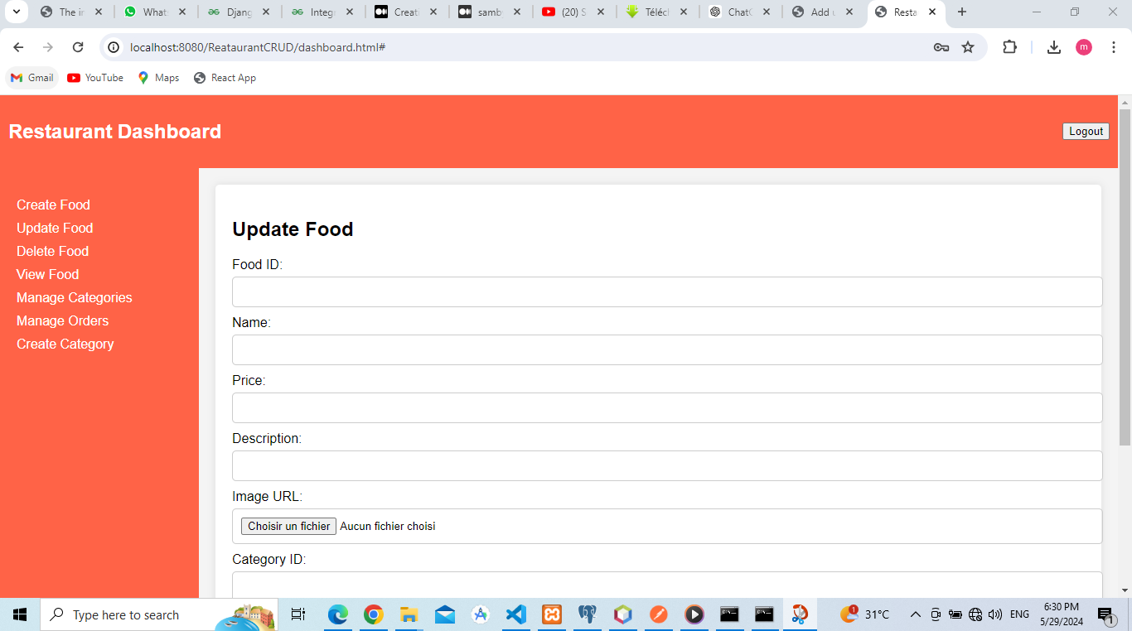

Figure 5: Update Food

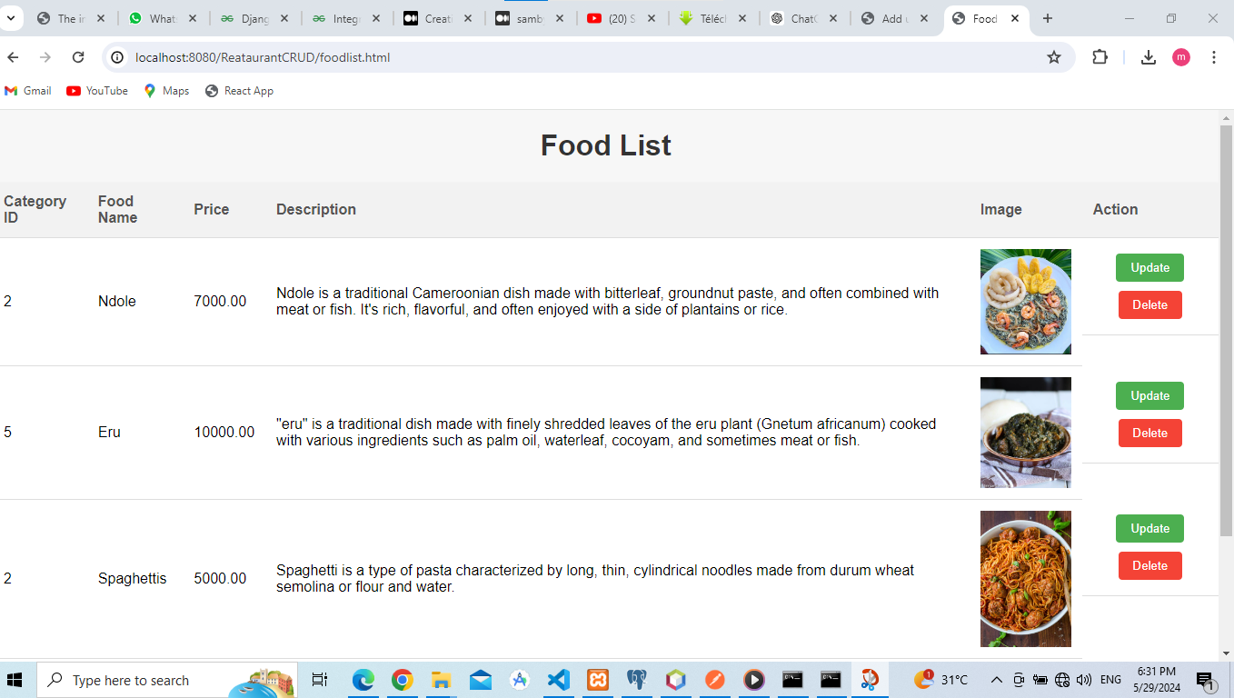

Figure 6: Food List

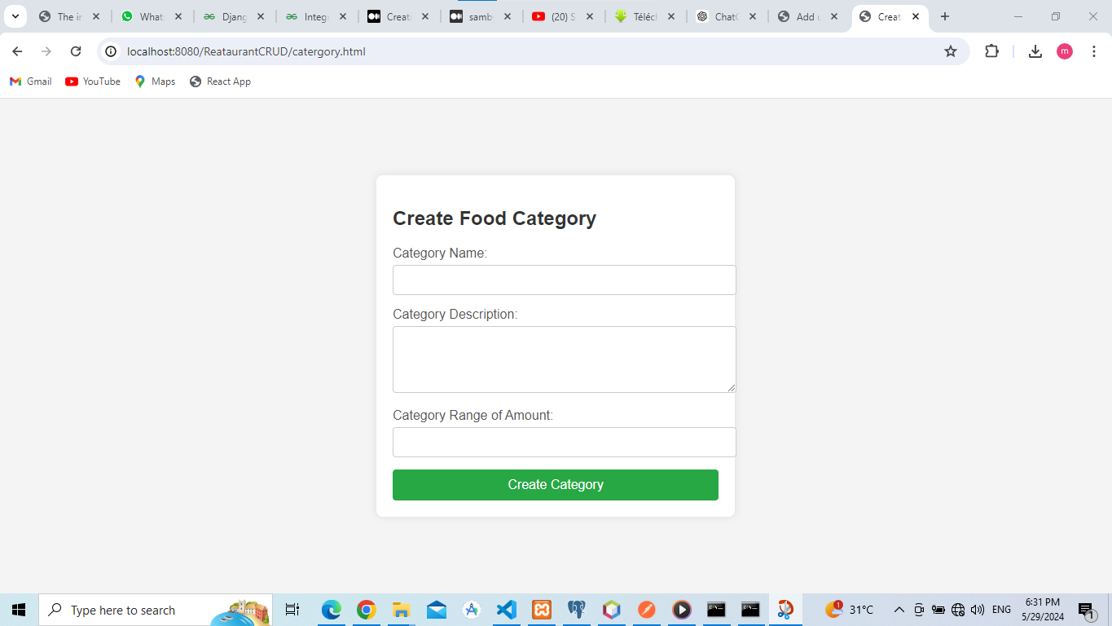

Figure 7: Food Category

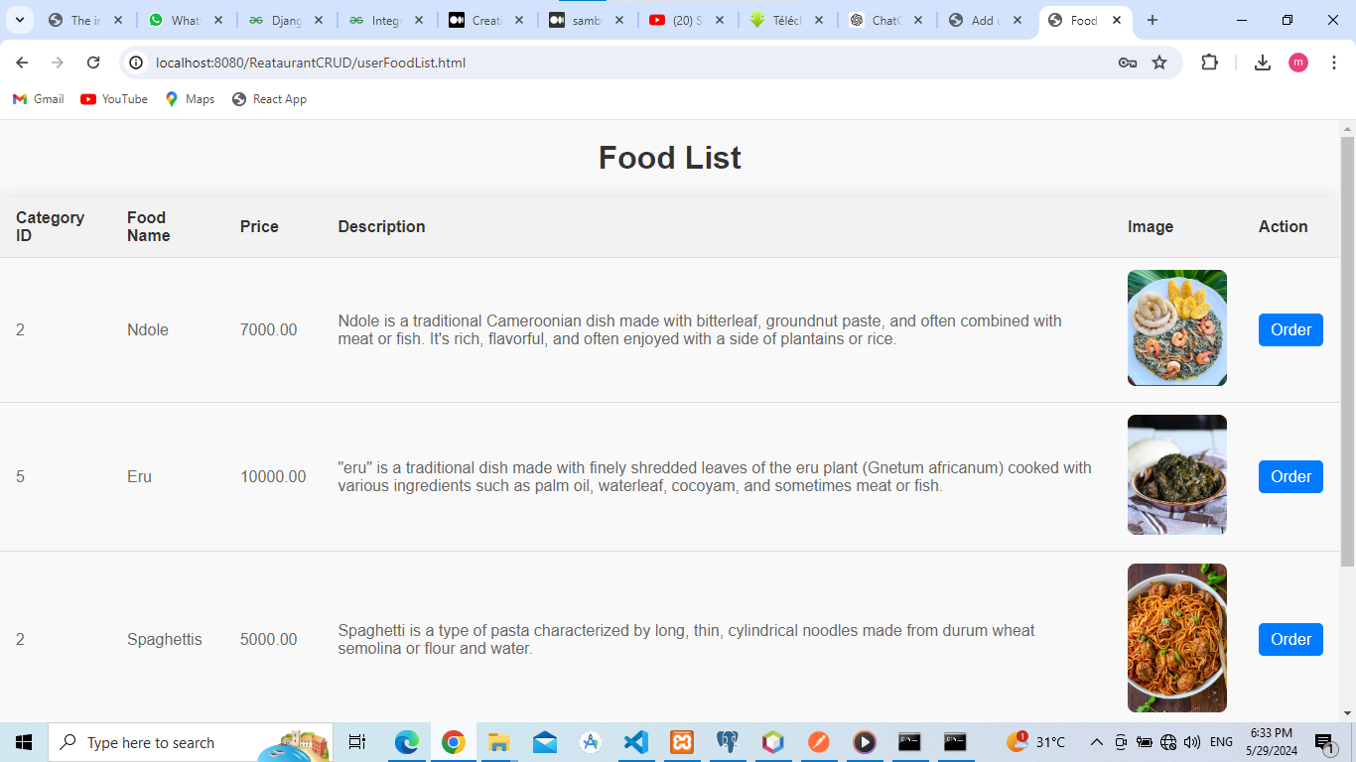

Figure 8: Food list for users

# My Contribution

As part of the team developing the Restaurant Management System, my role was instrumental in several key areas, ensuring the application was, user-friendly, and met all specified requirements. Below are the detailed aspects of my contribution:

1. **Creating a Food:**

* My primary responsibility in the development of the Restaurant Management System was focused on enabling the creation of food items, with special emphasis on implementing the functionality to upload images of the food items. I developed the backend logic and frontend interface for uploading images of food items.
* I developed the backend logic and frontend interface for uploading images of food items.
* I devised a strategy for storing uploaded images efferently. This may have involved configuring server settings, defining storage paths, and managing file permissions.

1. **Styling:**

* I also took charge of styling various pages of the Restaurant Management System like the welcome page, the sign up, sign in, Food Listing page.

1. In the admin dashboard I worked on connecting a category tab in the dashboard.
2. **GitHub Repository Creation:** I initiated the creation of the GitHub repository for the Restaurant Management System, configuring it with appropriate settings and permissions.
3. Debugging Support: Actively participate in identifying and diagnosing issues reported by team members or encountered during development.
4. **Idea Sharing and Brainstorming:** Participate actively in brainstorming sessions to generate new ideas, features, or improvements for the project.

# Conclusion

In conclusion, my contributions to the Restaurant Management System project spanned various aspects, including database design, backend development, user interface styling, version control, debugging, and idea sharing.

Furthermore, my efforts in styling various pages of the application contributed to creating a visually appealing and user-friendly interface, improving the overall user experience. I also actively managed version control using Git and GitHub.