Jiaxuan Pan (jp4131)

Chengyan Gu (cg3114)

Chris Charron (cc4399)

**SmartStox**

**Introduction**

People looking for investments nowadays are constantly bombarded by a barrage of opinions on how certain stocks are likely to behave in the future, or how the market in general is expected to trend. These opinions are often at odds with one another, leaving the casual investor understandably confused about where to place their money. We propose to help such people out with a simple, user-friendly stock recommendation application.

There are a number of metrics that can be used to assess any one stock’s strengths and weaknesses, and by extension its likelihood of faring well or poorly in the future. Before even exploring these metrics, we would like to get a more comprehensive profile of our user, by understanding their:

* Income
* Age
* Favored industries
* Risk profile (Risk averse vs. risk loving, etc)

We solicit this information from the user either through direct prompts when they log into the app. The purpose of asking these questions is two-fold. First, we would like to assess an acceptable risk-return profile for the investor, which will depend on their age and tolerance for risk. Second, as we are assuming our users are not very investment-savvy, we want to ensure that our proposed investments are in companies or industries that they recognize. We expect this will increase the appeal of the app.

The backend has two main jobs: collecting and processing financial data to train our recommendation engine, and then returning recommendations based on the user’s profile. We use Wharton Research Data Services to source data on the US stock market and company financials (earnings, etc) to train our model, and then we use Yahoo Finance info to generate the latest price information on stocks we recommend, and also scrape the web for the latest news sources.

Our output to the user consists of a set of up to 3 stocks for investment, along with information such as the latest price, latest news, and our model’s predicted probability of price increase in the user’s selected timeframe.

**Front end**

The front end asks the users a series of 7 questions to understand more about them, their risk preference, etc. Then, the front end outputs the 3 most recommended stocks for that particular user. Some screenshots of the process are shown below:





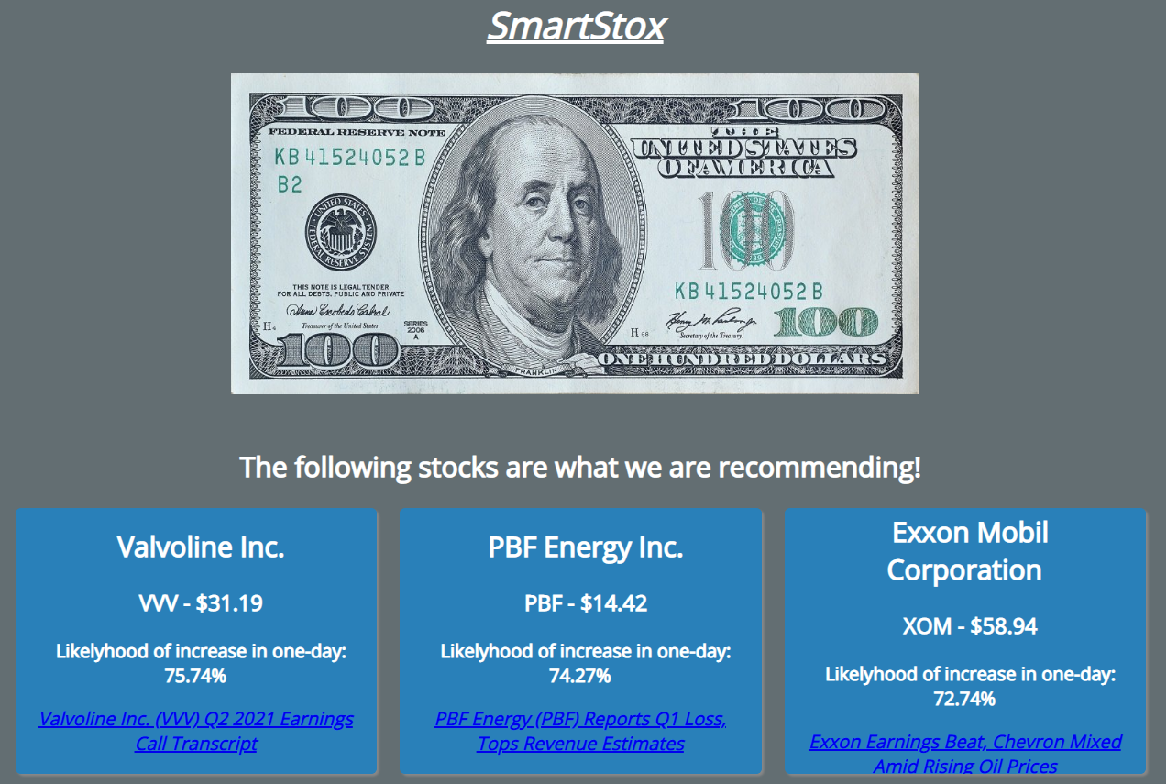

Note that we did create a prototype at the link below, but our final app design ended up being different:

<https://projects.invisionapp.com/prototype/ckkx9erhp00bs1u01rsk97xi3/play>

**Architecture**

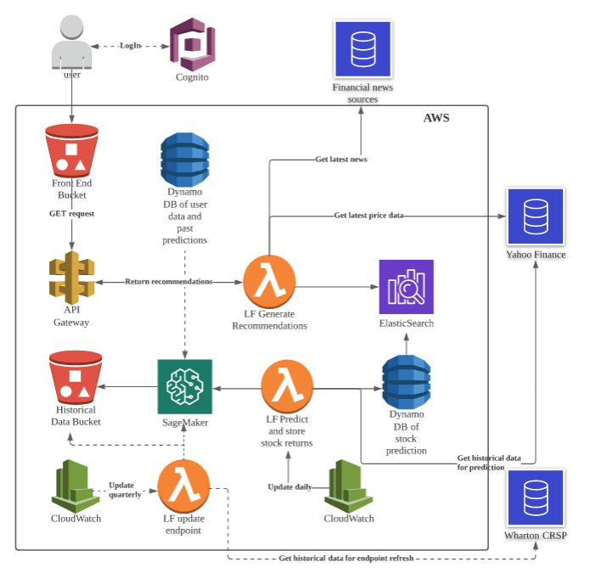

Here’s a quick overview of how the app works:

* Historical stock data is procured from Wharton CRSP and stored in S3. This is used to train our sagemaker endpoints (We have different endpoints for different time horizons. More on how the models work in the next section). We re-train the model every quarter with the latest stock price data
* Every day, we run a lambda function that runs all active stocks through each of our model endpoints to get a prediction on the likelihood of that stock increasing for the particular time horizon (e.g. running MSFT through our 1-day endpoint will give us a prediction for the likelihood that MSFT stock will increase in the next 1 trading day). The prediction results for all stocks are stored in DynamoDB and in Elastic Search for quick retrieval
* End users access the app through the front-end stored in S3. The front end makes an API GET call to the /recommend endpoint which includes the background information provided by the user (age/risk tolerance/etc). A lambda function uses this information to filter the information in ElasticSearch and return the stocks with the highest predicted values. Further information such as latest price data and most recent news is also returned to the end user

**SageMaker Models used to generate recommendations**

In this project, XGBoost model is used to predict the direction of stock price change. The predicted probability of future price increase is used as the signal to make the stock recommendations.

**[Target Variable]** In detail, a binary dummy is created as the target variable to indicate whether there is a price increase over the time horizon X (i.e., it equals to 1 if a price increase is observed and otherwise 0). Here, the time horizon X can be 1-day, 5-day, 10-day, 20-day, etc. In practice, modeling price change direction is one component of the widely used decomposition model (which typically decomposes and models the stock price change into three components: an indicator of price change, the direction of price movement, and the size of price change) (Tsay, 2010; Prado, 2018). The predicted probability of future price increase can be used as the entry signal should the investor want to hold the equity over the time horizon X.

**[Stock Price Data]** This project uses the Center for Research in Security Prices (CRSP) daily stock price data from the Wharton Research Data Services (WRDs) for modeling purposes. Comparing with other data sources, CRSP is free and maintains the most comprehensive collection of security price, return, and volume data for the NYSE, AMEX and NASDAQ stock markets, which can trace back to 1962. It also covers stock events (e.g., merger, dividend, and exit dates), stock characteristics (e.g., SIC Codes/Standard Industrial Classification Codes) and stock indices data. For simplicity, this project uses the daily price data of all stocks in three major US stock exchanges (NYSE, AMEX and NASDAQ) as the modeling population. The data of 2016-2019 are took as the in-time training sample and the 2020 data are treated as the out-of-time sample.

**[User Preference Data]** Ideally, users’ preference data can be combined with stock price data to generate some personalized recommendations. However, unlike many other applications such as Netflix and TikTok in which users have some persistent preferences, in the financial world, there is no publicly available user finance preference data, and users’ preferences are dynamic as the market conditions change rapidly. As a result, this project only takes two input data from the users (i.e., industry and expected holding period) to make the recommendations. Other user information like risk preference, age, income, and review history will be recorded and saved in one DynamoDB and left for future model enhancements (through collaborative filtering or neutral network models).

**[Feature Engineering]** The CRSP data covers five basic daily price features widely used in practice: adjusted high, adjusted low, adjusted open, adjust close and volume. Two types of feature engineering techniques are used to capture market shocks and firm-specific abnormal returns.

*Beta Factors*: To measure how stock returns co-move with the market indices (e.g., a stock’s price might increase or decrease following the S&P 500 index or market-level good or bad news), daily Fama-French five factors (Davis, 2001; Fama and French, 1993, 2015) are pulled directly using the Yahoo Finance API. These factors can help capture excess market return, market-level or industry-level asymmetricities in firm size, value, profitability and investment would affect each stock’s daily return.

*Alpha Factors*: To measure stock-level abnormal returns (e.g., Tesla’s price jumps due to one good news), several alpha factors are created based upon CRSP’s stock daily closing prices (Schwert, 2003). For example, daily return is calculated as the dollar change in a stock's price as a percentage of the previous day's closing price, and its lags (e.g., 1-day lag, 2-day lag, and 3-day lag) are used to capture the price trend. As one momentum (e.g., one good news) can last for several days, momentum factors are created to capture the tendency of winning stocks to continue performing well in the near term. For example, the difference between recent 5-day return and 10-day return can be used in the model to capture how firm’s last week performance affect stock’s current return. Bollinger bands series measure a stock price’s dynamic standard deviation boundaries (i.e., if a stock price is above its 2 standard deviations of its recent moving average, it can be a buy/sell signal combining with other signals). The relative strength index (RSI) is a momentum indicator used in technical analysis that measures the magnitude of recent price changes to evaluate overbought or oversold conditions in the price of a stock or other asset.

**[XGBoost Model]** Given the target binary variable and additional price feature, XGBoost models are built for each expected holding period (e.g., one GBT model for 1-day return > 0 and another one for 20-day return > 0).

Gradient boosting is a technique for regression and classification problems which produce a prediction model in the form of an ensemble of weak predictors (e.g., a decision tree model). Like other boosting methods, it combines weak learners into a single learner but in an iterative fashion: It starts fitting by learning an imperfect model T(x) (i.e., decision tree to minimize the mean squared errors or maximize the Gini index) and calculate the residual y - T(x). Then another weak learner is built to fit such residual and this process keeps running for M stages. In detail, its estimation process is shown as follows:

**GBT Algorithm**

|  |
| --- |
| 1. Initialize a weak learner to optimize the objective function (MSE or Gini) 2. For *m* = 1 to M: 3. Compute the updated residual; 4. Fit a learner (tree) to the residual; 5. Compute the multiplier *rm* by solving the following optimization problem: 6. Update the model: 7. Output |

Here, the multiplier *rm* can be viewed as a relative weight to append an additional weak learner. XGBoost model follows the same principle of gradient boosting. In addition, it uses a regularized model specification to control over-fitting (as well as some memory utilization techniques), which often gives it better performance.

**[Model Performance and Implementation]** The models are trained used the SageMaker’s embedded XGBoost container and hyperparameters are finetuned before deploying into endpoints. Given the limited amount of time and feature engineering work, while building a well performed and profitable model is beyond the scope of this project, our models exhibit some reasonable performances. Their ROCs (Receiver Operating Characteristic) are around 60, which are larger than a random selection (which ROC = 50). Further backtesting and model refinements are needed before throwing any money into it. Careful designs of models and strategies are keys to operate a successful fund, which is also beyond the scope of this project.

The XGBoost models are trained for each expected holding period (e.g., one GBT model for 1-day return > 0 and another one for 20-day return > 0). As described above, two user inputs are utilized during the implementation stage. The user has to specify (1) the interested industry and (2) the expected holding period. From the front end, the lambda function takes user selected industry and extracts all relevant stocks’ (in that industry) latest price information. When a specific holding period is triggered by the user, the relevant model’s endpoint will be invoked accordingly to get the predicted probabilities of price increase for all stocks in that industry. Finally, the lambda function will return/recommend top 3 stocks based upon those predicted probabilities.

**References**

Davis, J.L. 2001. “Explaining Stock Returns: A Literature Survey,” Dimensional Fund Advisors.

Fama, E. and French, K. 1993. “Common Risk Factors in the Returns on Stocks and Bonds,” The *Journal of Financial Economics*, 33, 3-56.

Fama, E. and French, K. 2015. “A Five-Factor Asset Pricing Model,” The *Journal of Financial Economics*, 116, 1-22.

Prado, M.L. 2018. *Advances in Financial Machine Learning*. John Wiley & Sons, Hoboken, NJ.

Rasekhschaffe, K.C. and Jones, R.C. 2019. “Machine Learning for Stock Selection,” *Financial Analysts Journal*, Q3, 70-88.

Schwert, W.G. 2003. “Anomalies and Market Efficiency,” in *Handbook of the Economics of Finance*, ed. By Constantinides, G.M., Harris, M., and Stulz, R. North Holland, New York, NY.

Sezer, O.B., Gudelek, M.G. and Ozbayoglu, M. 2020. “Financial Time Series Forecasting with Deep Learning: A Systematic Literature Review: 2005-2019,” *Applied Soft Computing Journal*, 90, 1-32.

Tsay, R.S. 2010. *Analysis of Financial Time Series*. John Wiley & Sons, Hoboken, NJ.