Peidong Liu
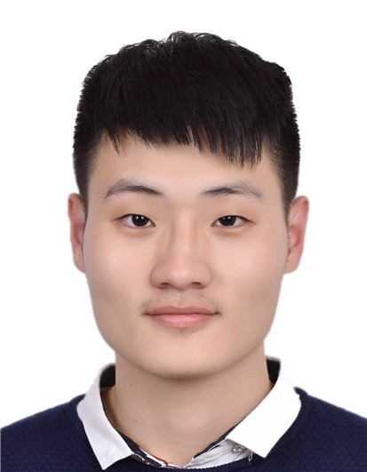
Mobile Phone: +86 137-1917-6449
E-mail: perdon.liu@gmail.com
___·Education·______________________________________________________________________________________
09/2015~present Sun Yat-sen University (SYSU), School of Data and Computer Science, Junior Student
Major: Software Engineering; Overall GPA: 3.9/4.0; Ranking: 3/119 (Top 3%)
01/2018~05/2018 National University of Singapore(NUS), School of Computing, Exchange Student

___·Awards·________________________________________________________________________________________
10/2017 Bronze Award in Intel Cup-Parallel Application Challenge (PAC), China (Top 6%)
10/2017 First Class Scholarship of Sun Yat-Sen University (Top 5%)
04/2017 Third Prize in Accenture Cup-Software Innovation and Development Competition (Top 6%)
01/2017 Honorable Mention in Interdisciplinary Contest in Modeling
10/2016 First Class Scholarship of Sun Yat-Sen University (Top 5%)

___·Research and Teaching Experiences·________________________________________________________________
10/2017~present Smart Mobile Computing Lab, SYSU Research Assistant
Mentor: Xu Chen (Professor, School of Data and Computer Science, SYSU)
- Engaged in modeling the prediction of the information growth, especially in WeChat Moment
- Performed a number of experiments, such as analyzing raw data more than 30GB on WeChat Moment through data mining methods as well as graphing illustrations like Information Diffusion~Time graph
03/2018~05/2018 NUS-Tsinghua Center for Extreme Search(NExT++), NUS Research Assistant
Mentor: Chua Tat-Seng (KITHCT Chair Professor, Founding Dean of the School of Computing, NUS)
- Implemented an algorithm for food classification with complex names using NLP
- Crawled images from google which were used for food image recognition
07/2017~10/2017 NLP Group, Guangdong Province Key Lab of Computational Science, SYSU Research Assistant
Mentor: Yao Lu (Professor, School of Data and Computer Science, SYSU)
- Participated in text mining of medical scientific literature, including preprocessing, word vector representation with word2vec, vector dimensionality reduction with PCA model, keywords obtained via TF-IDF model, topic number analysis via AP model and article topics obtained via LDA model
- Realized parallelization with Spark
- Drew lifecycle diagram of literature and predicted lifecycle
03/2017~06/2017 Research Group of School of Government, SYSU Team Leader
Mentor: Zijie Shao (Associate Researcher, School of Government, SYSU)
- Designed web crawler program with Python for data collection of Weibo users’ reposts and comments
- Analyzed Weibo information spread modes through text analysis and data mining
- Built server with Tomcat to store videos for online surveys
03/2017~07/2017 Programming in High Level Language (C++), SYSU Teaching Assistant
- Gave a short lecture in the lab class, helped students with C++ problems and corrected homework
___·Competition and Extracurricular Experiences·________________________________________________________
10/2017 Bronze Award in Intel Cup-Parallel Application Challenge (PAC), China Team Member
01/2017 Interdisciplinary Contest in Modeling Team Leader
03/2016~09/2016 Organizing Committee, AIESEC in SYSU, Guangzhou Member
11/2015~01/2016 Student’s Software Technology Development Center of SYSU Manager

___·Computer Skills·_________________________________________________________________________________
Programming Languages: C; C++; Python; Java; Scala; R; Html; Css; Javascript; Nodejs; Angularjs
Database: SQL; MongoDB
Others: MapReduce (Spark); Matlab

