Peidong Liu
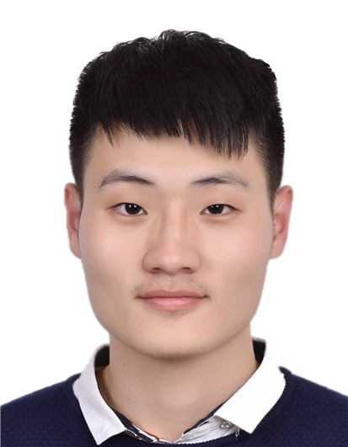
Mobile Phone: +86 137-1917-6449
E-mail: perdon.liu@gmail.com
___·Education·_____________________________________________________________________________________
09/2015~present Sun Yat-sen University (SYSU), School of Data and Computer Science, Junior Student
Major: Software Engineering; Overall GPA: 3.9/4.0; Ranking: 3/119 (Top 3%)
01/2018~05/2018 National University of Singapore(NUS), School of Computing, Exchange Student
__· Publications ·__________________________________________________________________________________
1. C. Li, Y. Lu, J. Wu, Y. Zhang, Z. Xia, T. Wang, D. Yu, X. Chen, P. Liu, and J. Guo. LDA Meets Word2Vec: A Novel Model for Academic Abstract Clustering. In The 2018 Web Conference Companion (WWW 2018) [pdf]
___·Awards·________________________________________________________________________________________
10/2017 Bronze Award in Intel Cup-Parallel Application Challenge (PAC), China (Top 6%)
01/2017 Honorable Mention in Interdisciplinary Contest in Modeling
2016-2017 First Class Scholarship of Sun Yat-Sen University (Top 3%)
___·Research and Teaching Experiences·________________________________________________________________
06/2018~08/2018 Institute of Information System and Engineering, School of Software, THU Research Assistant
Mentor: Chunping Li (Associate Professor, School of Software, THU)
- Implemented the code of several common topic models in NLP area like LDA, GSDMM, HLDA, CTM
- Analyzed Weibo data through topic models above and performed experiments
10/2017~present Smart Mobile Computing Lab, SYSU Research Assistant
Mentor: Xu Chen (Professor, School of Data and Computer Science, SYSU)
- Engaged in modeling the prediction of the information growth, especially in WeChat Moment
- Performed a number of experiments, such as analyzing raw data more than 30GB on WeChat Moment through data mining methods as well as graphing illustrations like Information Diffusion~Time graph
03/2018~05/2018 NUS-Tsinghua Center for Extreme Search(NExT++), NUS Research Assistant
Mentor: Chua Tat-Seng (KITHCT Chair Professor, Founding Dean of the School of Computing, NUS)
- Designed an algorithm for food classification with complex names using NLP
- Crawled images from google which were used for food image recognition
07/2017~10/2017 NLP Group, Guangdong Province Key Lab of Computational Science, SYSU Research Assistant
Mentor: Yao Lu (Professor, School of Data and Computer Science, SYSU)
- Participated in text mining of medical scientific literature, including preprocessing, word vector representation with word2vec, vector dimensionality reduction with PCA model, keywords obtained via TF-IDF model, topic number analysis via AP model and article topics obtained via LDA model
- Realized parallelization with Spark
03/2017~06/2017 Research Group of School of Government, SYSU Team Leader
Mentor: Zijie Shao (Associate Researcher, School of Government, SYSU)
- Designed web crawler program with Python for data collection of Weibo users’ reposts and comments
- Analyzed Weibo information spread modes through text analysis and data mining
03/2017~07/2017 Programming in High Level Language (C++), SYSU Teaching Assistant
- Gave a short lecture in the lab class, helped students with C++ problems and corrected homework
___·Competition and Extracurricular Experiences·________________________________________________________
10/2017 Bronze Award in Intel Cup-Parallel Application Challenge (PAC), China Team Member
01/2017 Interdisciplinary Contest in Modeling Team Leader
03/2016~09/2016 Organizing Committee, AIESEC in SYSU, Guangzhou Member
___·Computer Skills·_________________________________________________________________________________
Programming Languages: C; C++; Python; Java; Scala; R; Html; Css; Javascript; Nodejs; Angularjs
Others: SQL; MongoDB; MapReduce (Spark); Matlab; Tensorflow

