Mobile Phone(SIN): +65 97782725
Mobile Phone(CHN): +86 13719176449
E-mail: perdon.liu@gmail.com
Peidong Liu
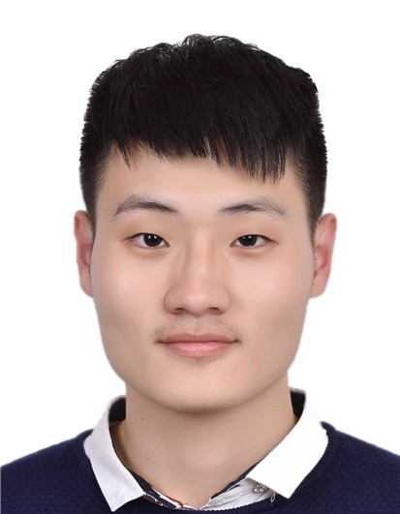

___·Education·__________________________________________________________________________
2015.09-2019.06 Sun Yat-Sen University (SYSU), School of Data and Computer Science, Junior Student
Major: Software Engineering; Overall GPA: 3.91/4.00; Ranking: 2/121
2018.01-present National University of Singapore(NUS), School of Computing, Exchange Student

___·Awards·_____________________________________________________________________________
- 2016.10 First Class Scholarship of Sun Yat-Sen University (Top 5%)
- 2017.10 First Class Scholarship of Sun Yat-Sen University (Top 5%)
- 2017.01 Honorable Mention in Interdisciplinary Contest in Modeling
- 2017.04 Third Prize in Accenture Cup – Software Innovation and Development Competition, SYSU
- 2017.10 Bronze Award in Intel Cup – Parallel Application Challenge (PAC) 2017, China

___·Research Experience·________________________________________________________________
2018.3-present NUS-Tsinghua Center for Extreme Search(NExT++), NUS
Research Assistant
Mentor: Chua Tat-Seng (KITHCT Chair Professor, School of Computing, NUS)
- Implemented an algorithm for Southeast Asia food classification with complex names using NLP
- Crawled images from google which were used for food image recognition training set
2017.10-present Smart Mobile Computing Lab, Advanced Networking and Computing Systems Institute, SYSU
Research Assistant
Mentor: Xu Chen (Professor, School of Data and Computer Science, SYSU)
- Engaged in modeling the prediction of the information growth, especially advertising and political web pages cascade in WeChat Moment
- Performed a number of experiments, such as analyzing raw data more than 30GB on WeChat Moment through data mining methods as well as graphing illustrations like Information Diffusion-Time graph using Python
2017.07-2017.10 Natural Language Processing Group, Guangdong Province Key Laboratory of Computational Science, SYSU
Research Assistant
Mentor: Yao Lu (Professor, School of Data and Computer Science, SYSU)
- Participated in text analysis and text mining of medical scientific literature, including preprocessing, word vector representation with word2vec, vector dimensionality reduction with PCA model, keywords obtained via TF-IDF model, topic number analysis via AP model and article topics obtained via LDA model
- Realized parallelization with Spark
- Drew lifecycle diagram of literature and predicted lifecycle
2017.03-2017.06 Research Group of School of Government, SYSU
Team Leader
Mentor: Zijie Shao (Associate Researcher, School of Government)
- Designed web crawler program with Python for data collection of Weibo users’ reposts and comments
- Analyzed Weibo information spread modes through text analysis and data mining
- Built server with Tomcat to store videos for online surveys
___·Competition Experience·_____________________________________________________________
2017.01 Interdisciplinary Contest in Modeling
Team Leader
- Organized and managed our team, hosted multiple team discussions
- Built mathematical model of intelligent city growth, implemented it with Matlab through quantifying variables including traffic convenience, urban landscaping and pedestrian transportation convenience
2016.09-2017.04 Accenture Cup – Software Innovation and Development Competition, SYSU

Member of Front-End and Back-End Development
- Realized main website functions, participated in UI design
- Mainly used JavaScript, NodeJs and improved the programming abilities and back-end development skills
___·Extracurricular Experience·_ ________________________________________________________
2016.03-2016.09 AIESEC, SYSU, Guangzhou, China
Member of Organizing Committee
- Studied Chinese culture with university students from Russia, Canada, Morocco, Egypt, etc.
- Led more than 50 Chinese students and 9 foreign students to organized inter-city orienteering, culture salons, Guangzhou cultural feasts, etc.
- Improved English proficiency, communication skills and organizing ability
2016.01-2016.03 Youth Volunteers Association of SYSU, Guangzhou, China
Volunteer
- Communicated with senior students from Guangzhou Xiangxian Middle School
- Shared study methods with students and answered questions
2015.11-2016.01 Student’s Software Technology Development Center, SYSU, Guangzhou, China
Manager
- Organized the 17th SYSU Software Innovation and Development Competition
- Arranged competition procedures and coordinated staff
___·Computer Skills·____________________________________________________________________
- Advanced Programming Languages: C; C++ (Familiar); Python (Familiar); Java; Scala; R
- Web Development Languages: Html; Css; Javascript; Nodejs; Angularjs
- Database: SQL; MongoDB
- Programming Software: Matlab
- Distributed System: MapReduce (Spark)

