Dynamic model of Otbot

This live script develops the dynamic model of Otbot and the solution to its forward and inverse dynamics.

Table of Contents

1. Initializations   
2. Computation of the mass matrix   
3. Computation of the Coriolis matrix   
4. Generalized force of actuation   
5. Acceleration constraint   
6. Final model in explicit first-order form   
7. Solution to the forward dynamics problem   
8. Solution to the inverse dynamics problem   
9. Save wokspace and main matrices to file   
10. Print ellapsed time   
Appendix: Function kin_en_trans

Recall that the equation of motion of a robot takes the form



where:

*  is the configuration vector of the robot (of size  in our case)
*  is the vector of motor torques (the right and left wheel torques and the platform torque).
*  is the mass matrix of the unconstrained system (positive-definite of size 
* is the generalized Coriolis and centrifugal force matrix
*  is the generalized gravity force
*  is the constraint Jacobian of the robot
*  is a vector of Lagrange mulitpliers.
*  is the generalized force of actuation, which can be written in the form 
*  is the generalised force modelling all friction forces in the system

Note that, since the Otbot will move on flat terrain, . Friction forces will also be neglected for the moment, so  will be zero initially. The constraint Jacobian  was already obtained in kinematic_model.mlx and we will simply load it from an appropriate mat file.

Our task thus boils down to obtaining , , and  initially. After that, we will assemble the full dynamic model using the acceleration-level constraint (the time derivative of ).

Hereafter, when we say "chassis" we mean the robot chassis **including** the wheels.

# 1. Initializations

% Clear all variables, close all figures, and clear the command window

clearvars

close all

clc

% Start stopwatch

tic;

% Display the matrices with rectangular brackets

sympref('MatrixWithSquareBrackets',true);

% Avoid Matlab's own substitution of long expressions

sympref('AbbreviateOutput',false);

% Symbolic variables to be used (see the figures and explanations below)

syms x y % Absolute coords of the pivot joint

syms x_dot y_dot % Absolute velocity components of the pivot joint

syms alpha % Absolute angle of the platform

syms alpha_dot % Absolute angular velocity of the platform

syms varphi_r % Angle of right wheel relative to chassis

syms varphi_l % Angle of left wheel relative to chassis

syms varphi_p % Pivot joint angle (platform wrt chassis)

syms varphi_dot_l % Angular velocity of left wheel

syms varphi_dot_r % Angular velocity of right wheel

syms varphi_dot_p % Angular velocity of the platform relative to the chassis

syms l_1 % Pivot offset relative to the wheels axis

syms l_2 % One half of the wheels separation

syms m_c % Mass of the chassis (including wheels)

syms m_p % Mass of the platform

syms x_F y_F % Coords of F (c.o.m. of the platform) in platform frame

syms x_B y_B % Coords of B (c.o.m. of the chassis) in chassis frame

syms I_p % Vertical moment of inertia of the platform at its c.o.m.

syms I_a % Axial moment of inertia of one wheel

syms I_c % Vertical moment of inertia of the chassis at its c.o.m.

# 

# 2. Computation of the mass matrix

Recall that the robot configuration is given by



To find the mass matrix  we first write the kinetic energy  of the robot as a function of  and  and then express it as:

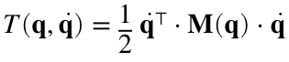

We have to compute the translational and rotational kinetic energies of all bodies in the Otbot, and add them all to obtain .

% Chassis angle theta, and its derivative, in terms of qdot

theta = alpha - varphi_p;

theta_dot = alpha_dot - varphi_dot_p;

% Translational kinetic energies

% Of the chassis

T_tra_c = kin_en_trans(x_B, y_B, m_c, x_dot, y_dot, theta, theta_dot);

% Of the platform

T_tra_p = kin_en_trans(x_F, y_F, m_p, x_dot, y_dot, alpha, alpha_dot);

% Rotational kinetic energies

% Whole chassis including wheels

T_rot_c = 1/2 * I_c * (theta_dot)^2;

% Right wheel when turning about its axis alone

T_rot_r = 1/2 * I_a * (varphi_dot_r)^2;

% Left wheel when turing about its axis alone

T_rot_l = 1/2 * I_a * (varphi_dot_l)^2;

% Platform

T_rot_p = 1/2 * I_p * (alpha_dot)^2;

% Total kinetic energy

T = T_tra_c + T_tra_p + ...

T_rot_c + T_rot_r + T_rot_l + T_rot_p;

% Display the results

display(T_tra_c); display(T_tra_p);

display(T_rot_c); display(T_rot_r); display(T_rot_l); display(T_rot_p);

display(T);

Since  is a quadratic form, the Hessian of  gives the desired mass matrix:

M = hessian(T,[x_dot y_dot alpha_dot varphi_dot_r varphi_dot_l varphi_dot_p])

# 

# 3. Computation of the Coriolis matrix

Recall that the  element of  is given by the following formula (see Murray, Sastry, Lee)

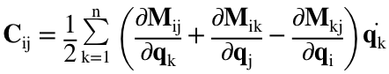,

which in Matlab can be implemented as follows:

qvec = [x y alpha varphi_r varphi_l varphi_p].';

qdotvec = [x_dot y_dot alpha_dot varphi_dot_r varphi_dot_l varphi_dot_p].';

nq = length(qvec);

C = sym(zeros(nq,nq));

for i=1:nq

for j=1:nq

for k=1:nq

C(i,j) = C(i,j) + qdotvec(k) * 0.5 * ( ...

diff(M(i,j),qvec(k)) + ...

diff(M(i,k),qvec(j)) - ...

diff(M(k,j),qvec(i)) );

end

end

end

C = simplify(C);

display(C)

# 

# 4. Generalized force of actuation

Our vector  of motor torques is defined as

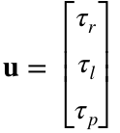

syms tau_r tau_l tau_p

uvec = [tau_r; tau_l; tau_p];

Each of the torques in  acts directly on a  coordinate and, therefore, the generalized force of actuation is given by

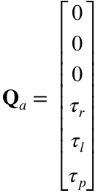

To rewrite this force in the form  we only have to define

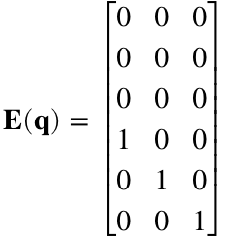

Ematrix = [zeros(3);eye(3)];

This completes our derivation of all matrices involved in the equation of motion.

# 

# 5. Acceleration constraint

We now wish to obtain the robot model in the form  This requires writing  and  as a function of , , and  Recall that the Euler-Lagrange equation is

 (we omit the dependencies on  and  for simplicity)

Since this equation is a system of 6 equations in 9 unknowns (6 coordinates in  and 3 in ) we need 3 additional equations to determine and  for a given . These equations can be obtained by taking the time derivative of the kinematric constraint

,

which gives

,

or, equivalently,



The latter equation is called the acceleration constraint of the robot.

Recall that  was obtained in kinematic_model.mlx. Therefore, we only need to calculate its time derivative now:

% We first import J (obtained by an earlier run of kinematic_model.mlx)

load("J.mat")

% Substitute its variables by functions of t and take the time derivative

syms f1(t) f2(t)

J_of_t = subs(J,[alpha varphi_p],[f1(t) f2(t)]);

dJdt = diff(J_of_t,t);

% Substitute d/dt of f1 and f2 by the original variables using dot notation

Jdot = subs(dJdt,[f1(t) f2(t) diff(f1,t) diff(f2,t)], ...

[alpha varphi_p alpha_dot varphi_dot_p])

# 

# 6. Final model in explicit first-order form

The equations

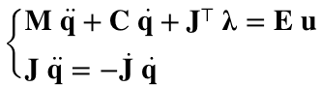

can be written as a linear system with the form

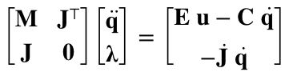

and since  is positive-definite and  is full row rank, the matrix on the left-hand side can be inverted to write

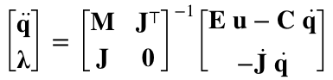.

Therefore

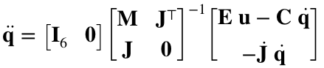.

Finally, by considering the trivial equation  in conjunction with the earlier equation we arrive at

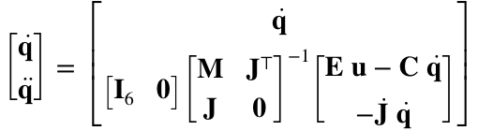,

which is the robot model in the usual control form .

# 7. Solution to the forward dynamics problem

The forward dynamics problem consists in finding the acceleration  that corresponds to a given . Such a  is given by the earlier expression

.

# 8. Solution to the inverse dynamics problem

The inverse dynamics problem consists in finding the torques  that produce a desired . These torques are obtained by solving



for  and  (6 equations and 6 unknowns). For this we define  and rewrite the previous equation as

,

or, equivalently, as

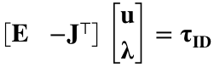.

It is easy to see that  is a  full rank matrix irrespectively of . This follows directly from the expressions of  and  in the Otbot. Thus, we can write

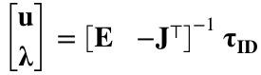,

so that



provides the desired value for .

# 9. Save wokspace and main matrices to file

save('M.mat',"M")

save('C.mat',"C")

# 10. Print ellapsed time

toc

Elapsed time is 8.576265 seconds.

# Appendix: Function kin_en_trans

This function computes the translational kinetic energy of a point mass located at P on the grey body, in terms of the velocity coordinates , , and  of the body.

The following notation is used:

*  = Local coordinates of P in the body-fixed frame {1',2'}
* = Absolute coordinates of the origin of the body-fixed frame
*  = absolute angle of the body
*  = mass of P

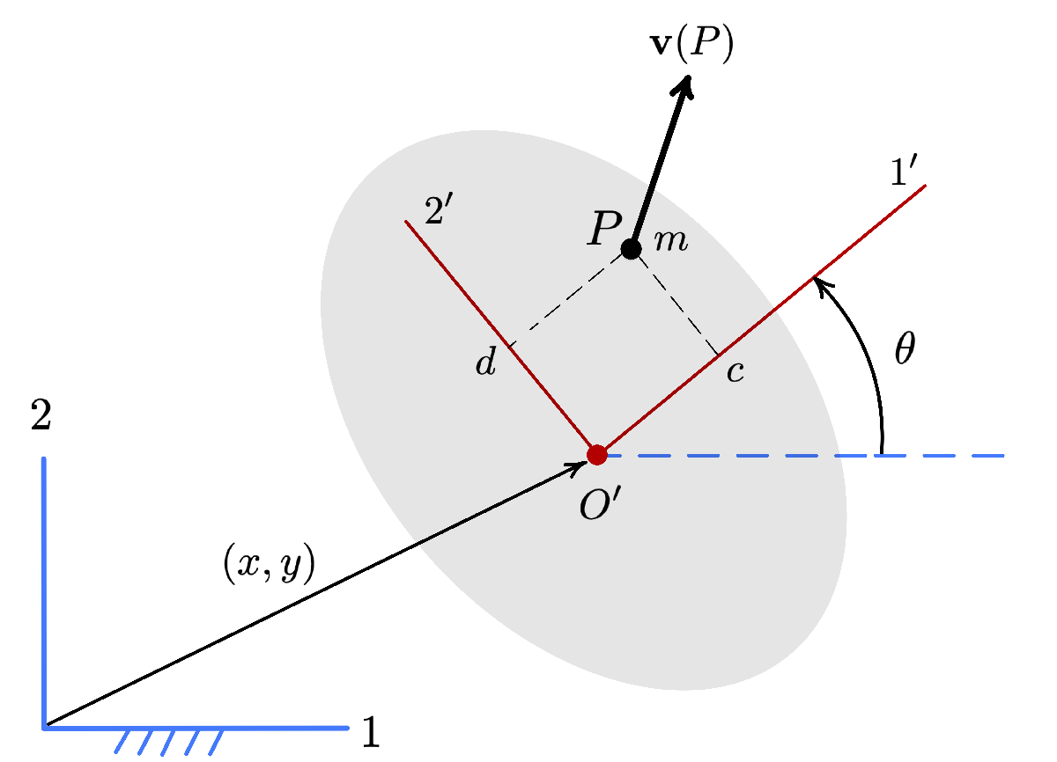

This function can be used to compute the translational kinetic energy of any body in planar motion. Just let P be the c.o.m. of the body, and m be the total mass of the body.

function T = kin_en_trans(c,d,m,xdot,ydot,theta,thetadot)

cth = cos(theta);

sth = sin(theta);

A = [1, 0, -cth * d - sth * c;

0, 1, cth * c - sth * d;

0, 0, 1 ];

Mp = [m, 0, 0; 0, m, 0; 0, 0, 0];

M = simplify(transpose(A) * Mp * A);

w = [xdot;ydot;thetadot];

T = expand(1/2 * transpose(w) * M * w,'ArithmeticOnly',true);

end

# 