APPENDICES

APPENDIX A: SYSTEM SCREENSHOTS
The screenshots below were captured directly from the running application.

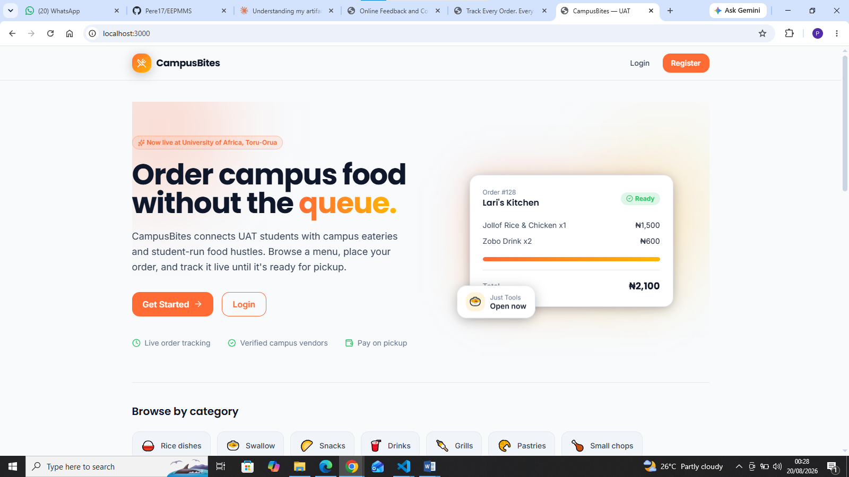
Figure A.1: Landing Page

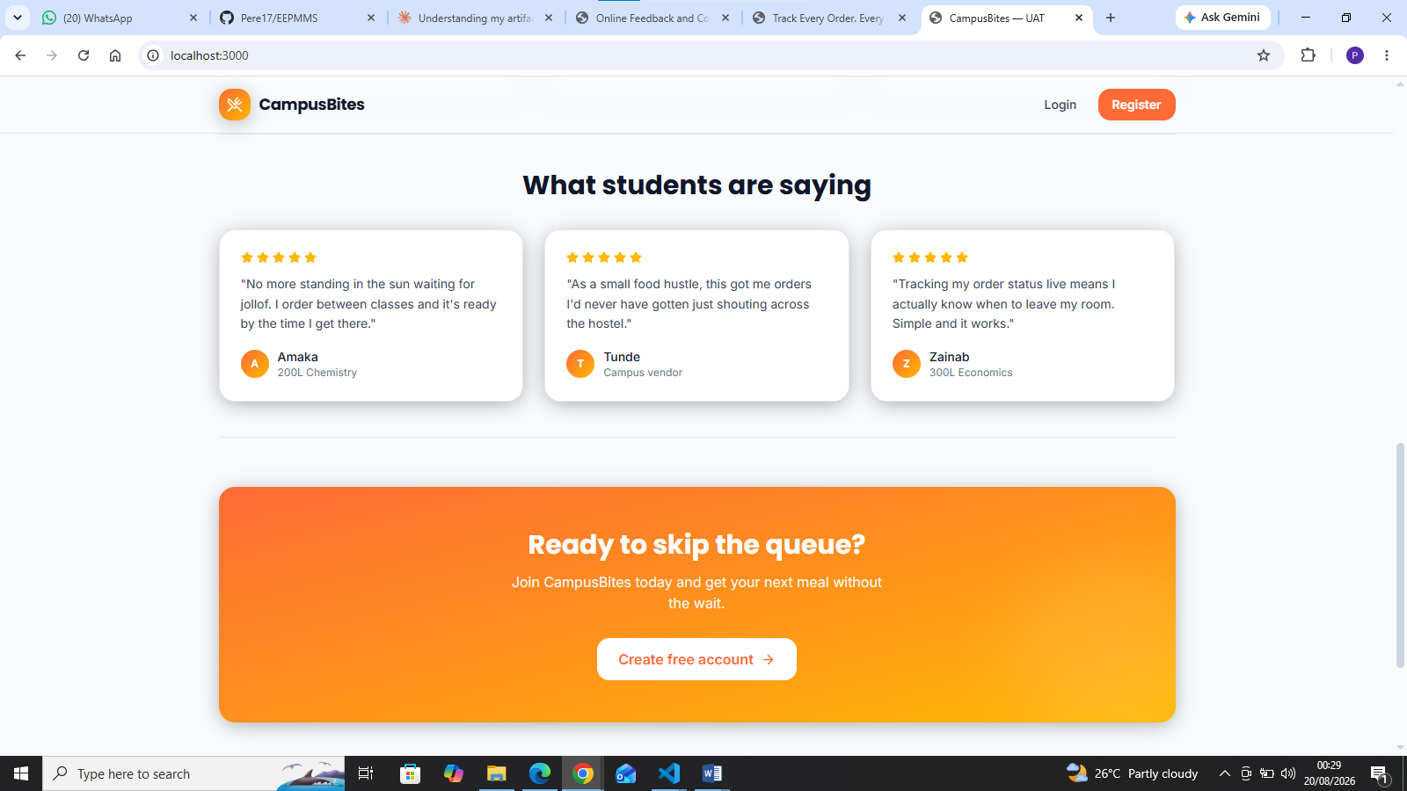
Figure A.2 Student Testimonials

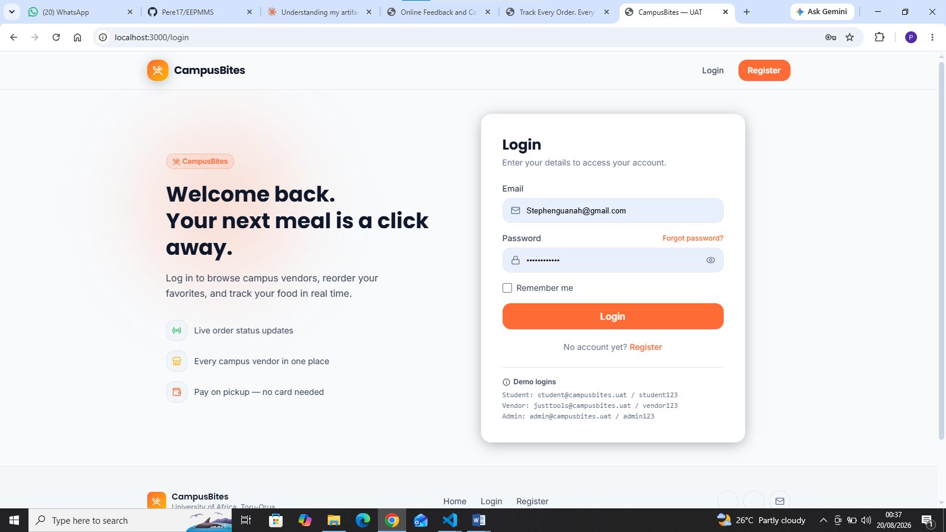
Figure A.3 Login/Sign in page

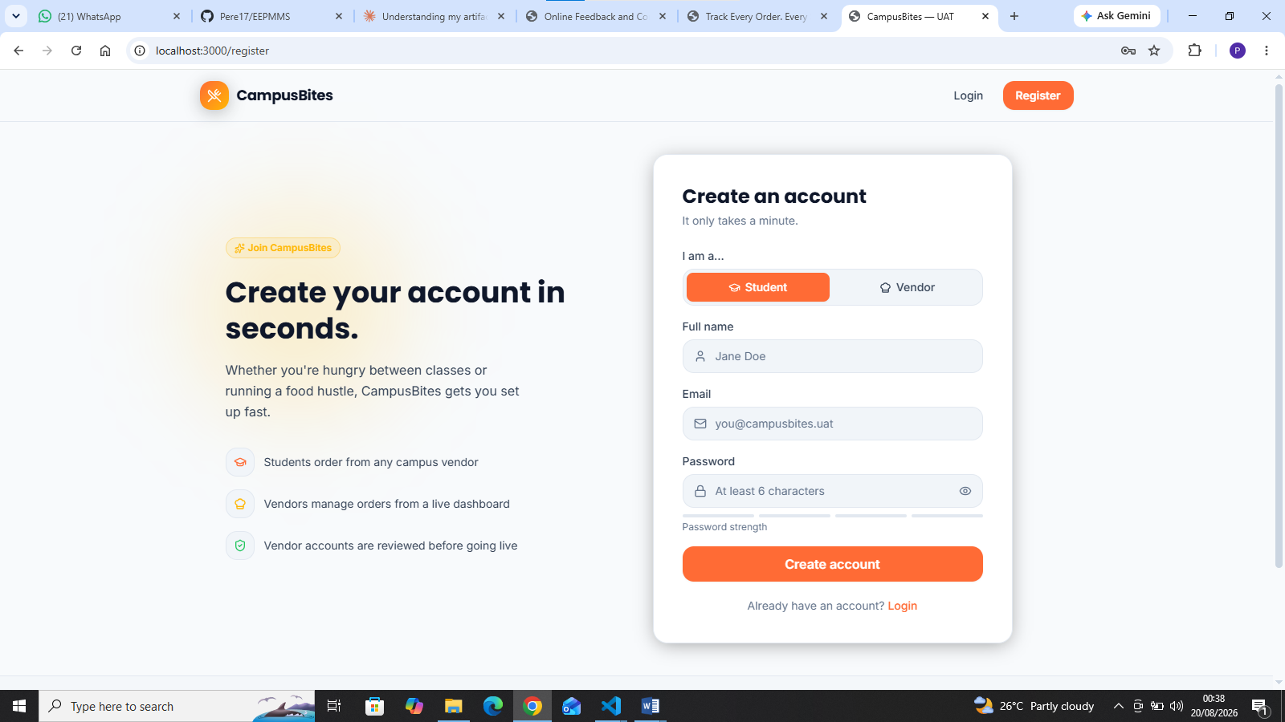
Figure A.4 Sign Up Page

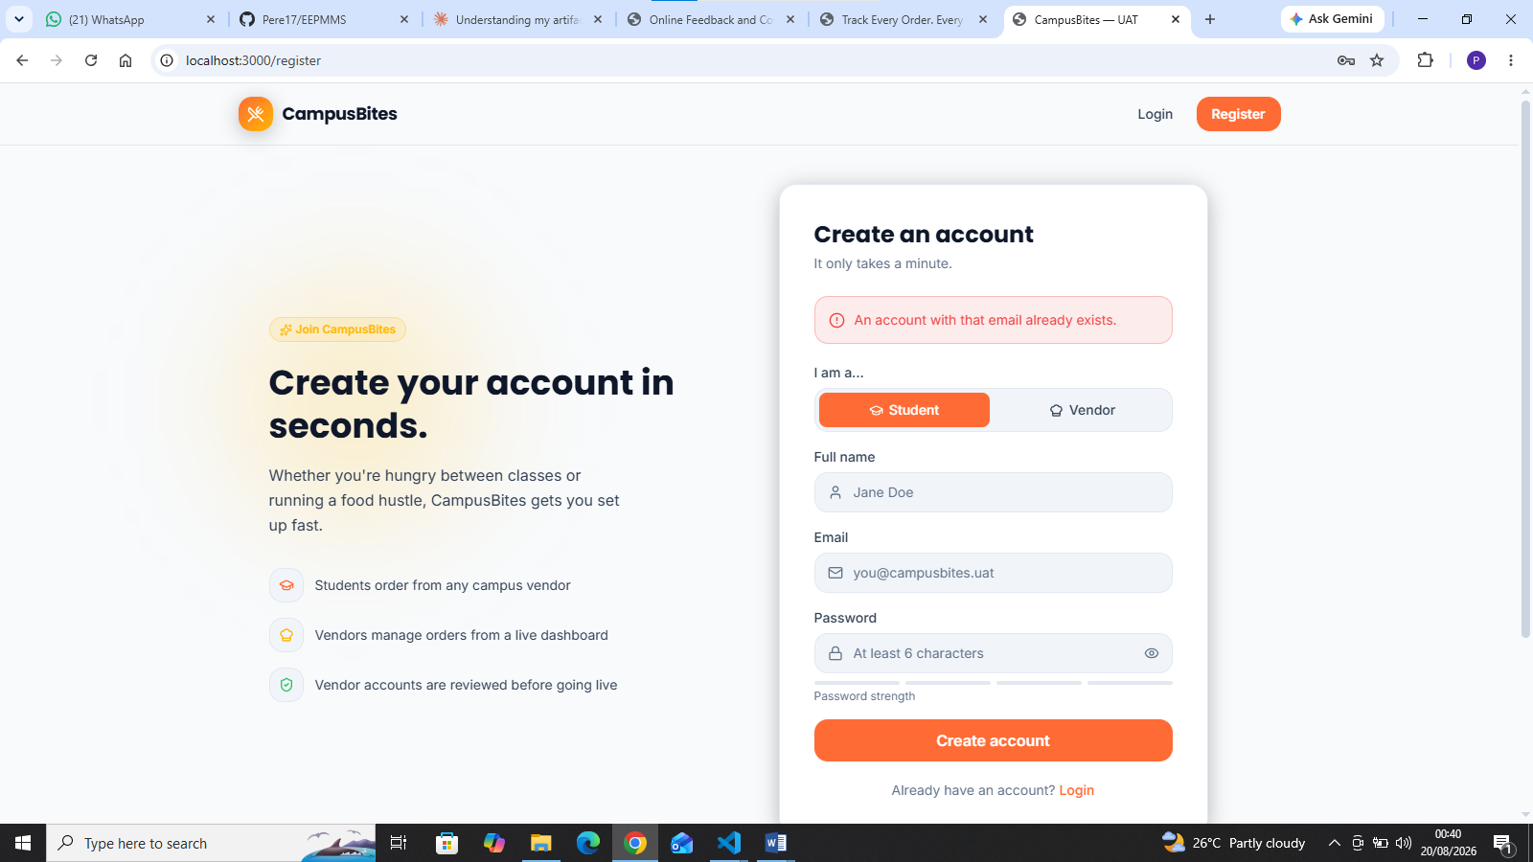
Figure A.5 Eror trying to create another account with the same email

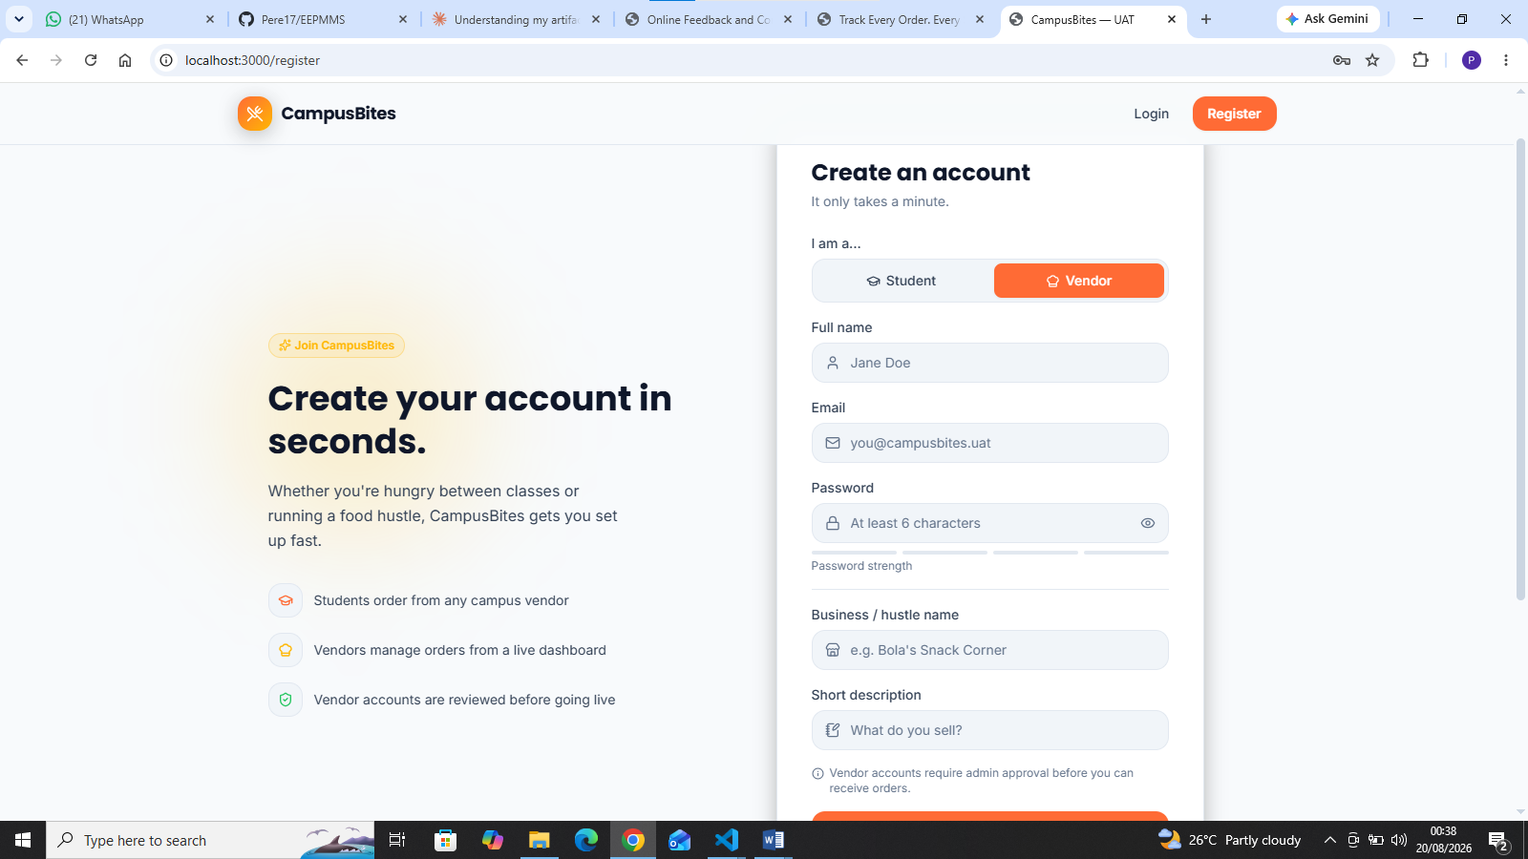
Figure A.6 Create Account as Vendor

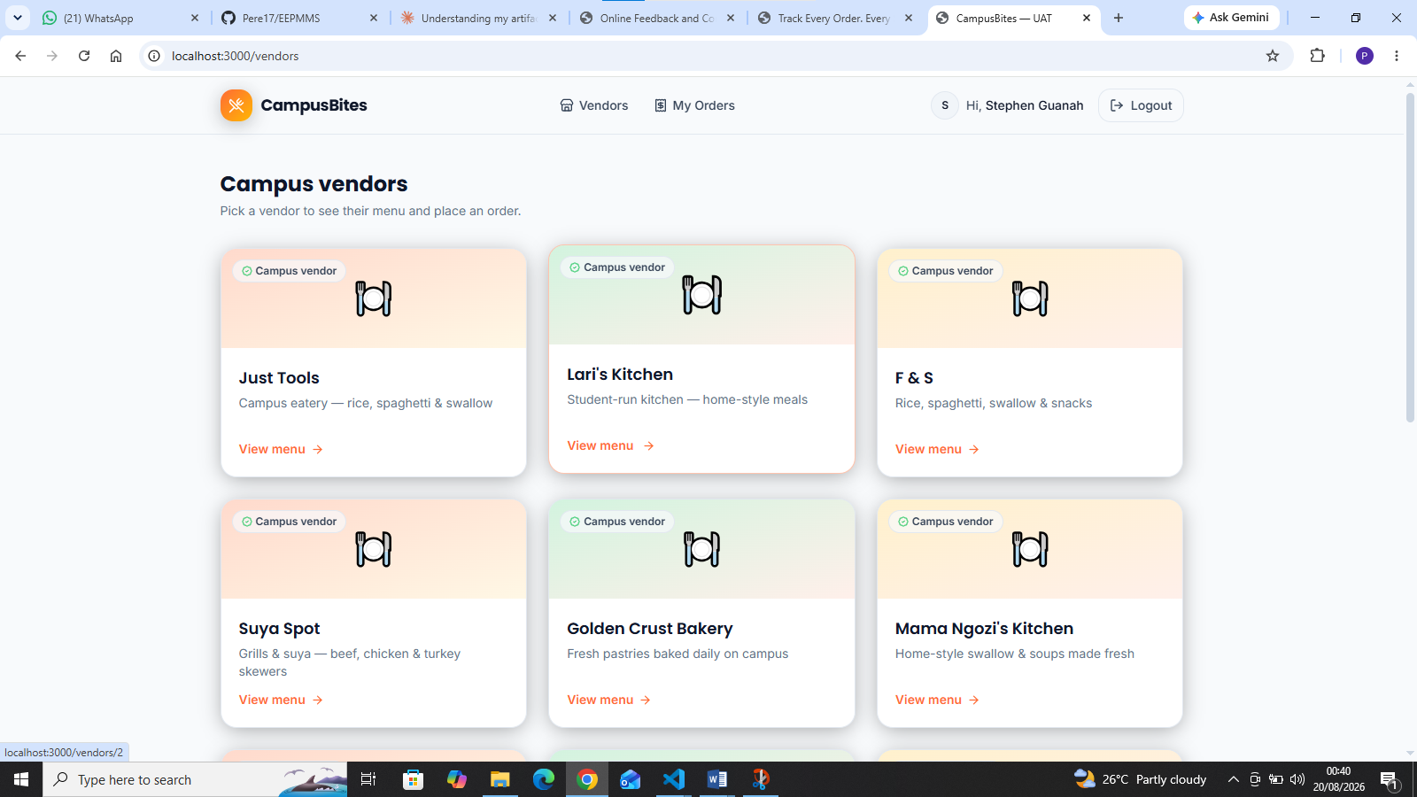
Figure A.7 List of Campus Vendors

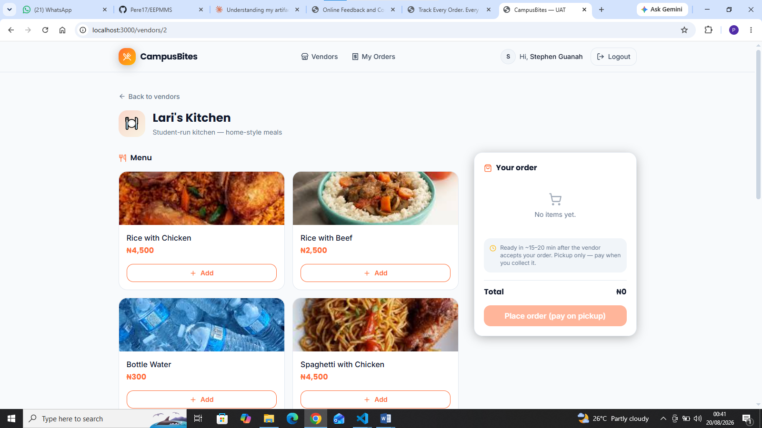
Figure A.8 Vendor menu page with items added to cart and running total

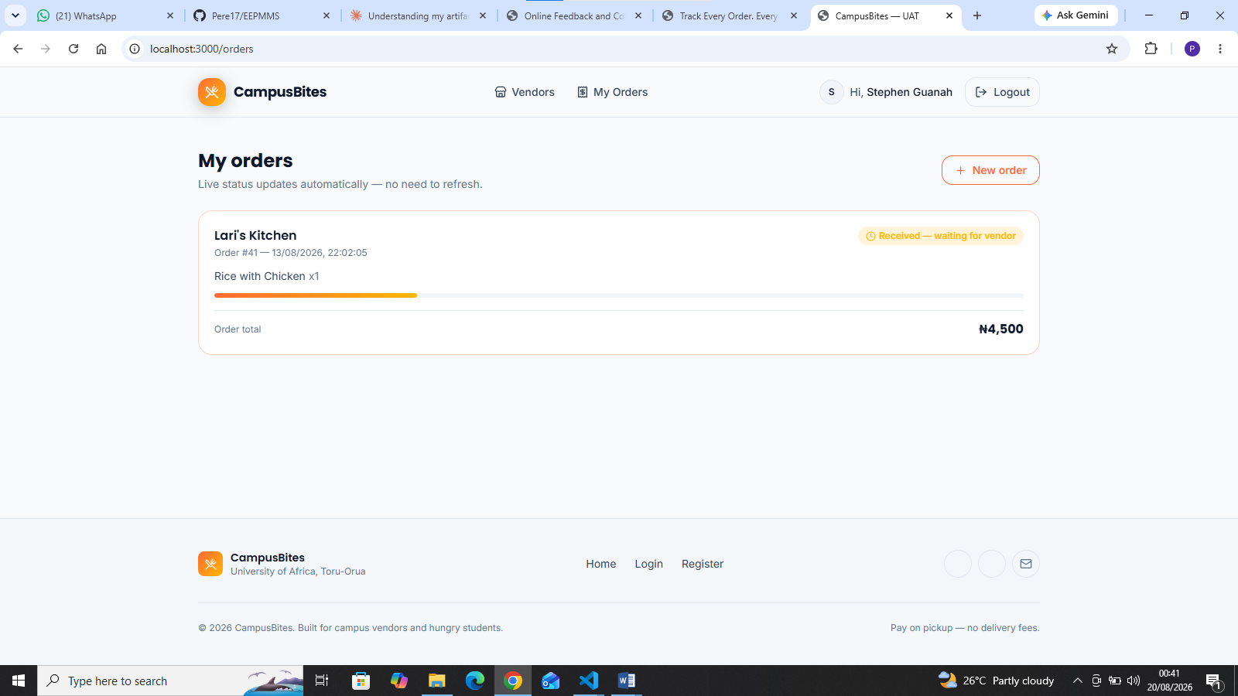
Figure A.9 My Orders Page

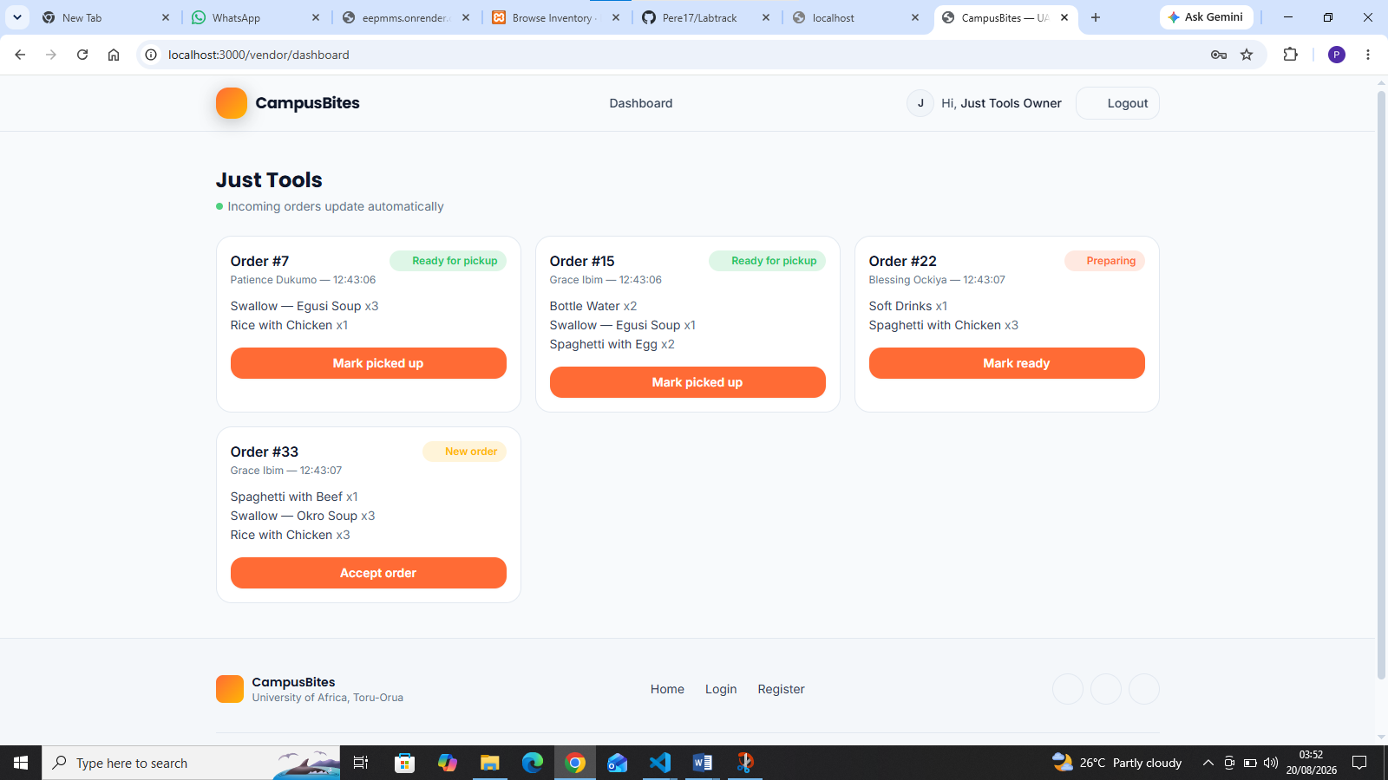

Figure A.10 Vendor Dashboard

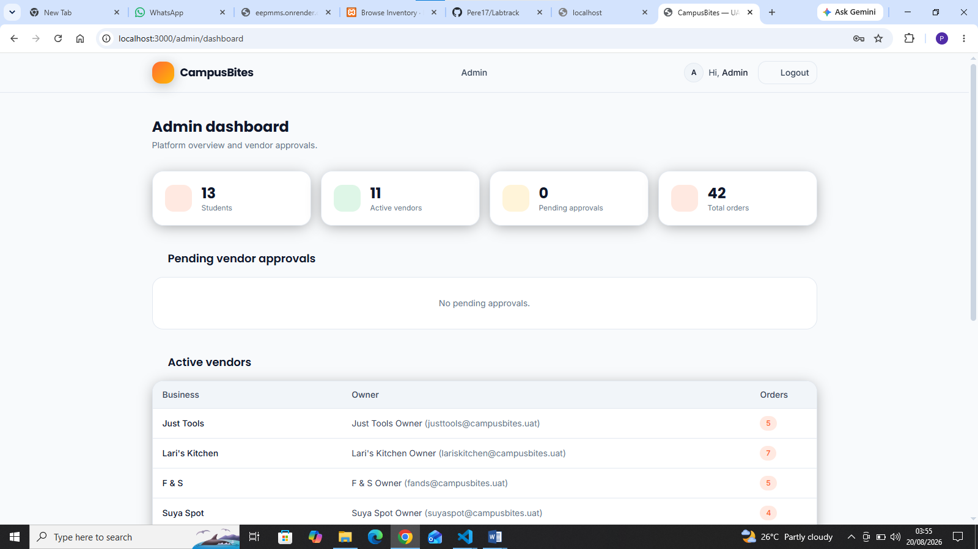
Figure A.11 Admin Dashboard

APPENDIX B: FULL SOURCE CODE LISTING
The complete source code of the CampusBites application is reproduced below, organised by architectural layer as described in Section 3.7: the server entry point, access-control middleware, route handlers, the JSON persistence layer, the EJS view templates, and the Tailwind styling/build configuration. Together with Appendix C (data) and Appendix D (setup), this listing is sufficient to reproduce the system exactly as evaluated in Chapter Four.

B.1 Application entry point Listing B.1: server.js
const express = require('express'); const session = require('express-session'); const path = require('path');
const { attachUser } = require('./middleware/auth'); const authRoutes = require('./routes/auth'); const studentRoutes = require('./routes/student'); const vendorRoutes = require('./routes/vendor'); const adminRoutes = require('./routes/admin');
const app = express();
app.set('view engine', 'ejs'); app.set('views', path.join(__dirname, 'views'));
// Deterministic image filename for a vendor/menu item name, e.g. "Swallow — Egusi Soup" -> "swallow-egusi-soup".
// Used by views to look up /images/vendors/<slug>.jpg and /images/menu/<slug>.jpg — see public/images/README.md.
app.locals.slugify = function slugify( str) { return String( str )
.toLowerCase()
.replace(/&/g, 'and')
.replace(/[^a-z0-9]+/g, '-')
.replace(/(^-|-$)/g, '');
};
app.use(express.static(path.join(__dirname, 'public'))); app.use(express.urlencoded({ extended: true })); app.use(express.json()); app.use( session({ secret: 'campusbites-demo-secret', resave: false, saveUninitialized: false, cookie: { maxAge: 1000 * 60 * 60 * 8 }
}) ); app.use(attachUser);
app.get('/', (req, res) => { res.render('landing');
});
app.use(authRoutes); app.use(studentRoutes); app.use(vendorRoutes); app.use(adminRoutes);
app.use((req, res) => { res.status(404).send('Page not found');
});
const PORT = process.env.PORT || 3000;
app.listen(PORT, () => {
console.log(`CampusBites running at http://localhost:${PORT}`); });
Wires up the Express app: view engine, static assets, session middleware, the four route modules, and the slugify helper (Section 5.4) used by views to resolve vendor/menu photos deterministically from item names. B.2 Access-control middleware

Listing B.2: middleware/auth.js
function requireRole(...roles) { return (req, res, next) => { const user = req.session.user; if (!user) return res.redirect('/login'); if (!roles.includes(user.role)) return res.status(403).send('Forbidden'); next();
}; }
function attachUser(req, res, next) { res.locals.currentUser = req.session.user || null; next();
}
module.exports = { requireRole, attachUser };
Enforces NFR3 (Security, Section 3.6.2) server-side: requireRole gates every protected route, and access is decided here not merely hidden in the interface.
B.3 Route handlers

Listing B.3: routes/auth.js
const express = require('express'); const bcrypt = require('bcryptjs'); const { tx, load } = require('../data/store');
const router = express.Router();
router.get('/register', (req, res) => { res.render('register', { error: null });
});
router.post('/register', (req, res) => { const { name, email, password, role, businessName, description } = req.body;
if (!name || !email || !password || !role) { return res.render('register', { error: 'All fields are required.' });
} if (!['student', 'vendor'].includes( role)) { return res.render('register', { error: 'Invalid role.' });
}
if (role === 'vendor' && !businessName) { return res.render('register', { error: 'Business name is required for vendors.'
}); }
const result = tx((db) => {
const exists = db.users.find((u) => u.email.toLowerCase() ===
email.toLowerCase());
if (exists) return { error: 'An account with that email already exists.' };
const user = { id: db.counters.users + 1, name, email, passwordHash: bcrypt.hashSync(password, 8), role, status: role === 'vendor' ? 'pending' : 'active', createdAt: new Date().toISOString()
}; db.counters.users += 1; db.users.push(user);
if (role === 'vendor') { db.counters.vendors += 1; db.vendors.push({ id: db.counters.vendors, userId: user.id, businessName,
description: description || ''
}); }
return { user };
});
if (result.error) { return res.render('register', { error: result.error });
}
if (result.user.role === 'vendor') { return res.render('login', { error: null,
notice: 'Vendor account created! It is pending admin approval before you can receive orders. You can log in once approved.'
}); }
req.session.user = { id: result.user.id, name: result.user.name, email: result.user.email, role: result.user.role
}; res.redirect('/vendors');
});
router.get('/login', (req, res) => { res.render('login', { error: null, notice: null });
});
router.post('/login', (req, res) => { const { email, password } = req.body; const db = load();
const user = db.users.find((u) => u.email.toLowerCase() === (email || '').toLowerCase());
if (!user || !bcrypt.compareSync(password || '', user.passwordHash)) {
return res.render('login', { error: 'Invalid email or password.', notice: null
}); }
if (user.role === 'vendor' && user.status === 'pending') { return res.render('login', { error: 'Your vendor account is still pending admin approval.', notice: null
}); }
req.session.user = { id: user.id, name: user.name, email: user.email, role: user.role };
if (user.role === 'student') return res.redirect('/vendors'); if (user.role === 'vendor') return res.redirect('/vendor/dashboard'); return res.redirect('/admin/dashboard');
});
router.post('/logout', (req, res) => { req.session.destroy(() => res.redirect('/'));
});
module.exports = router;
Registration and authentication. Passwords are hashed with bcrypt before storage
(bcrypt.hashSync); a vendor account is created with status: 'pending' and only admitted to the platform once an administrator approves it (Section 4.5).

Listing B.4: routes/student.js
const express = require('express'); const { load, tx } = require('../data/store'); const { requireRole } = require('../middleware/auth');
const router = express.Router();
router.get('/vendors', requireRole('student'), (req, res) => { const db = load(); const activeVendorUserIds = new Set( db.users.filter((u) => u.role === 'vendor' && u.status === 'active').map((u) => u.id) ); const vendors = db.vendors.filter((v) => activeVendorUserIds.has(v.userId)); res.render('vendors', { vendors });
});
router.get('/vendors/:id', requireRole('student'), (req, res) => { const db = load(); const vendor = db.vendors.find((v) => v.id === Number(req.params.id)); if (!vendor) return res.status(404).send('Vendor not found'); const items = db.menuItems.filter((m) => m.vendorId === vendor.id); res.render('vendor-menu', { vendor, items });
});
router.post('/orders', requireRole('student'), (req, res) => { const vendorId = Number(req.body.vendorId); let items; try { items = JSON.parse(req.body.items);
} catch (e) {
return res.status(400).send('Invalid cart data');
} if (!Array.isArray(items) || items.length === 0) { return res.status(400).send('Cart is empty');
}
const order = tx((db) => { const vendor = db.vendors.find((v) => v.id === vendorId); if (!vendor) return null;
db.counters.orders += 1; const newOrder = { id: db.counters.orders, studentId: req.session.user.id, vendorId, status: 'pending', createdAt: new Date().toISOString()
};
db.orders.push(newOrder);
items.forEach((it) => { const menuItem = db.menuItems.find((m) => m.id === Number(it.menuItemId)); if (!menuItem) return; db.counters.orderItems += 1;
db.orderItems.push({ id: db.counters.orderItems, orderId: newOrder.id, menuItemId: menuItem.id, quantity: Number(it.quantity) || 1, priceAtOrder: menuItem.price
}); });
return newOrder;
});
if (!order) return res.status(400).send('Vendor not found'); res.redirect('/orders');
});
router.get('/orders', requireRole('student'), (req, res) => { res.render('orders', {}); });
router.get('/api/orders/mine', requireRole('student'), (req, res) => { const db = load(); const myOrders = db.orders
.filter((o) => o.studentId === req.session.user.id)
.sort((a, b) => b.id - a.id)
.map((o) => { const vendor = db.vendors.find((v) => v.id === o.vendorId); const items = db.orderItems
.filter((oi) => oi.orderId === o.id)
.map((oi) => { const mi = db.menuItems.find((m) => m.id === oi.menuItemId); return { name: mi ? mi.name : 'Item removed', quantity: oi.quantity, price: oi.priceAtOrder
}; });
const total = items.reduce((sum, it) => sum + it.price * it.quantity, 0); return { id: o.id, status: o.status, createdAt: o.createdAt, vendorName: vendor ? vendor.businessName : 'Unknown vendor', items, total
}; }); res.json({ orders: myOrders });
});
module.exports = router;
Student-facing routes: vendor browsing, menu display, order placement, and the polled
/api/orders/mine JSON endpoint that drives the live status view in orders.ejs. Implements NFR4 (Data integrity, Section 3.6.2): priceAtOrder snapshots the menu item’s price at the moment of ordering, discussed in Section 4.5. Listing B.5: routes/vendor.js
const express = require('express');
const { load, tx } = require('../data/store'); const { requireRole } = require('../middleware/auth');
const router = express.Router();
const NEXT_STATUS = { pending: 'preparing', preparing: 'ready', ready: 'completed'
};
function myVendor(db, userId) {
return db.vendors.find((v) => v.userId === userId);
}
router.get('/vendor/dashboard', requireRole('vendor'), (req, res) => { const db = load(); const vendor = myVendor(db, req.session.user.id); if (!vendor) return res.status(404).send('Vendor profile not found'); res.render('vendor-dashboard', { vendor });
});
router.get('/api/vendor/orders', requireRole('vendor'), (req, res) => { const db = load(); const vendor = myVendor(db, req.session.user.id); if (!vendor) return res.json({ orders: [] });
const orders = db.orders
.filter((o) => o.vendorId === vendor.id && o.status !== 'completed')
.sort((a, b) => a.id - b.id)
.map((o) => { const student = db.users.find((u) => u.id === o.studentId); const items = db.orderItems
.filter((oi) => oi.orderId === o.id)
.map((oi) => {
const mi = db.menuItems.find((m) => m.id === oi.menuItemId); return { name: mi ? mi.name : 'Item removed', quantity: oi.quantity };
}); return { id: o.id, status: o.status, createdAt: o.createdAt,
studentName: student ? student.name : 'Unknown student', items, nextStatus: NEXT_STATUS[o.status] || null
}; });
res.json({ orders });
});
router.post('/vendor/orders/:id/advance', requireRole('vendor'), (req, res) => { tx((db) => {
const vendor = myVendor(db, req.session.user.id); const order = db.orders.find((o) => o.id === Number(req.params.id)); if (!vendor || !order || order.vendorId !== vendor.id) return; const next = NEXT_STATUS[order.status]; if (next) order.status = next;
}); res.redirect('/vendor/dashboard');
});
module.exports = router;
Vendor-facing routes. NEXT_STATUS implements the server-decided status lifecycle discussed in Section 4.5 — a vendor can only request “advance to the next status,” never set an arbitrary value
— and the ownership check (order.vendorId !== vendor.id) in
/vendor/orders/:id/advance prevents one vendor from altering another’s order.

Listing B.6: routes/admin.js
const express = require('express');
const { load, tx } = require('../data/store'); const { requireRole } = require('../middleware/auth');
const router = express.Router();
router.get('/admin/dashboard', requireRole('admin'), (req, res) => { const db = load();
const vendorUsers = db.users.filter((u) => u.role === 'vendor'); const pendingVendors = vendorUsers .filter((u) => u.status === 'pending')
.map((u) => ({ user: u, vendor: db.vendors.find((v) => v.userId === u.id) }));
const activeVendors = vendorUsers .filter((u) => u.status === 'active')
.map((u) => { const vendor = db.vendors.find((v) => v.userId === u.id);
const orderCount = vendor ? db.orders.filter((o) => o.vendorId === vendor.id).length : 0;
return { user: u, vendor, orderCount };
});
const stats = {
totalStudents: db.users.filter((u) => u.role === 'student').length, totalVendors: activeVendors.length, pendingVendors: pendingVendors.length, totalOrders: db.orders.length
};
res.render('admin-dashboard', { pendingVendors, activeVendors, stats });
});
router.post('/admin/vendors/:userId/approve', requireRole('admin'), (req, res) => { tx((db) => { const user = db.users.find((u) => u.id === Number(req.params.userId)); if (user && user.role === 'vendor') user.status = 'active';
});
res.redirect('/admin/dashboard');
});
router.post('/admin/vendors/:userId/reject', requireRole('admin'), (req, res) => { tx((db) => { const userId = Number(req.params.userId); const user = db.users.find((u) => u.id === userId); if (user && user.role === 'vendor') { user.status = 'rejected'; const vendor = db.vendors.find((v) => v.userId === userId); if (vendor) { db.menuItems = db.menuItems.filter((m) => m.vendorId !== vendor.id); db.vendors = db.vendors.filter((v) => v.id !== vendor.id); }
}
});
res.redirect('/admin/dashboard');
});
module.exports = router;
Admin-facing routes: platform statistics and the vendor approve/reject workflow. Rejecting a vendor also cascades the removal of its menu items, keeping db.json consistent (Section 4.4).
B.4 Data persistence layer

Listing B.7: data/store.js
const fs = require('fs'); const path = require('path');
const DB_FILE = path.join(__dirname, 'db.json');
function emptyDb() { return { users: [], vendors: [], menuItems: [], orders: [], orderItems: [],
counters: { users: 0, vendors: 0, menuItems: 0, orders: 0, orderItems: 0 }
}; }
function load() { if (!fs.existsSync( DB_FILE)) { const fresh = emptyDb(); fs.writeFileSync(DB_FILE, JSON.stringify(fresh, null, 2)); return fresh;
} return JSON.parse(fs.readFileSync(DB_FILE, 'utf-8'));
}
function save( db) {
fs.writeFileSync(DB_FILE, JSON.stringify(db, null, 2));
}
function nextId(db, table) { db.counters[table] += 1; return db.counters[table];
}
// Simple synchronous "transaction": load, mutate via fn, save, return result function tx( fn) { const db = load(); const result = fn(db); save(db); return result;
}
module.exports = { load, save, nextId, tx };
The single synchronous read-mutate-write helper (tx) through which every route handler that changes state accesses the JSON document store described in Section 3.8 and Section 4.4.

Listing B.8: data/seed.js
const bcrypt = require('bcryptjs'); const { load, save, nextId } = require('./store'); const vendorCatalog = require('./vendor-catalog');
const db = load();
// Reset to a clean slate for the demo db.users = []; db.vendors = []; db.menuItems = []; db.orders = []; db.orderItems = []; db.counters = { users: 0, vendors: 0, menuItems: 0, orders: 0, orderItems: 0 };
function addUser({ name, email, password, role, status }) { const user = { id: nextId(db, 'users'), name, email, passwordHash: bcrypt.hashSync(password, 8), role, status, createdAt: new Date().toISOString()
}; db.users.push(user); return user;
}
function addVendor(userId, businessName, description, items) { const vendor = { id: nextId(db, 'vendors'), userId, businessName, description
};
db.vendors.push(vendor); items.forEach(([name, price]) => { db.menuItems.push({ id: nextId(db, 'menuItems'), vendorId: vendor.id, name, price
}); });
return vendor;
}
// Admin addUser({ name: 'Admin', email: 'admin@campusbites.uat', password: 'admin123', role: 'admin', status: 'active'
});
// All vendors (active + the one pending demo) come from the shared catalog // so fresh installs and data/add-new-vendors.js never drift out of sync. vendorCatalog.forEach((v) => { const owner = addUser({ name: v.ownerName, email: v.ownerEmail, password: v.password, role: 'vendor', status: v.status
});
addVendor(owner.id, v.businessName, v.description, v.items); });
// One demo student addUser({ name: 'Demo Student', email: 'student@campusbites.uat', password: 'student123', role: 'student', status: 'active'
});
save(db);
const activeCount = vendorCatalog.filter((v) => v.status === 'active').length; console.log('Seed complete.'); console.log(`Admin login: admin@campusbites.uat / admin123`); console.log(`${activeCount} active vendors + 1 pending vendor seeded (password for all: vendor123)`);
console.log('Student login: student@campusbites.uat / student123');
Full-reset seed script invoked by npm run seed (Table D.1). Builds the admin account, every vendor in the shared catalog (Listing B.9), and one demo student from a clean db.json.

Listing B.9: data/vendor-catalog.js
// Shared vendor + menu definitions, used by both data/seed.js (fresh installs)
// and data/add-new-vendors.js (appending to an already-running db.json without // wiping existing users/orders). Keep both files' vendor data in sync by only // editing it here.
//
// Each item's image is resolved at render time from its *name* via slugify()
// (see server.js + public/images/README.md), so items with the same name // across vendors (e.g. "Rice with Chicken") automatically share one photo.
module.exports = [
{ ownerName: 'Just Tools Owner', ownerEmail: 'justtools@campusbites.uat', password: 'vendor123', status: 'active', businessName: 'Just Tools', description: 'Campus eatery — rice, spaghetti & swallow', items: [
['Rice with Chicken', 4500],
['Rice with Beef', 3000],
['Soft Drinks', 600],
['Bottle Water', 400],
['Spaghetti with Chicken', 4500],
['Spaghetti with Egg', 3500],
['Spaghetti with Beef', 3000],
['Swallow — Egusi Soup', 4500],
['Swallow — Okro Soup', 4500],
['Swallow — Vegetable', 4500],
['Swallow — Banga', 4500]
]
}, {
ownerName: "Lari's Kitchen Owner", ownerEmail: 'lariskitchen@campusbites.uat', password: 'vendor123', status: 'active',
businessName: "Lari's Kitchen",
description: 'Student-run kitchen — home-style meals', items: [
['Rice with Chicken', 4500],
['Rice with Beef', 2500],
['Bottle Water', 300],
['Spaghetti with Chicken', 4500],
['Spaghetti with Egg', 2500],
['Spaghetti with Beef', 2000],
['Swallow — Egusi Soup', 3500],
['Swallow — Okro Soup', 3500],
['Swallow — Vegetable', 3500],
['Swallow — Banga', 3500]
]
}, { ownerName: 'F & S Owner', ownerEmail: 'fands@campusbites.uat',
password: 'vendor123', status: 'active', businessName: 'F & S', description: 'Rice, spaghetti, swallow & snacks', items: [
['Rice with Chicken', 4500],
['Rice with Big Chicken', 8000],
['Rice with Beef', 3500],
['Soft Drinks', 600],
['Bottle Water', 400],
['Spaghetti with Chicken', 4500],
['Spaghetti with Egg', 3500],
['Spaghetti with Beef', 3000],
['Swallow — Egusi Soup', 4500],
['Swallow — Vegetable', 4500],
['Snack — Meatpie', 1000],
['Snack — Chicken Bread', 1000],
['Snack — Milky Doughnuts', 1000],
['Snack — Sausage Roll', 1000]
]
}, { ownerName: 'Suya Spot Owner', ownerEmail: 'suyaspot@campusbites.uat', password: 'vendor123', status: 'active', businessName: 'Suya Spot',
description: 'Grills & suya — beef, chicken & turkey skewers', items: [
['Beef Suya', 1500],
['Chicken Suya', 1500],
['Turkey Suya', 2000],
['Suya Wrap', 2000],
['Soft Drinks', 600],
['Bottle Water', 400]
]
}, { ownerName: 'Golden Crust Bakery Owner', ownerEmail: 'goldencrust@campusbites.uat', password: 'vendor123', status: 'active',
businessName: 'Golden Crust Bakery',
description: 'Fresh pastries baked daily on campus', items: [
['Snack — Meatpie', 1000],
['Snack — Chicken Bread', 1000],
['Snack — Sausage Roll', 1000],
['Snack — Milky Doughnuts', 1000],
['Cupcake', 800],
['Bread Loaf', 1200]
]
}, { ownerName: "Mama Ngozi's Kitchen Owner",
ownerEmail: 'mamangozi@campusbites.uat', password: 'vendor123', status: 'active', businessName: "Mama Ngozi's Kitchen", description: 'Home-style swallow & soups made fresh', items: [
['Swallow — Egusi Soup', 4500],
['Swallow — Okro Soup', 4500],
['Swallow — Vegetable', 4500], ['Amala & Ewedu', 3500],
['Pounded Yam & Egusi', 4000],
['Bottle Water', 400]
]
}, { ownerName: 'Campus Brew & Smoothies Owner', ownerEmail: 'campusbrew@campusbites.uat', password: 'vendor123', status: 'active', businessName: 'Campus Brew & Smoothies', description: 'Drinks, smoothies & zobo to cool you down', items: [
['Zobo (bottle)', 500],
['Chapman', 700],
['Fresh Smoothie', 1200],
['Iced Coffee', 1000],
['Soft Drinks', 600], ['Bottle Water', 400]
]
}, { ownerName: 'Iya Basira Rice Spot Owner', ownerEmail: 'iyabasira@campusbites.uat', password: 'vendor123', status: 'active', businessName: 'Iya Basira Rice Spot', description: 'Rice specialist — jollof, fried & coconut rice', items: [
['Jollof Rice', 3000],
['Fried Rice', 3000],
['Coconut Rice', 3500],
['Rice with Chicken', 4500],
['Rice with Beef', 3000],
['Soft Drinks', 600]
]
}, { ownerName: 'Bola (Snack Hustle)', ownerEmail: 'bolasnacks@campusbites.uat', password: 'vendor123', status: 'pending', businessName: "Bola's Snack Corner", description: 'Student hustle — awaiting admin approval', items: [
['Puff Puff (5pcs)', 500],
['Chin Chin (cup)', 500],
['Zobo (bottle)', 500]
]
}
];
The full vendor and menu catalogue, tabulated for readability in Table C.1. Both data/seed.js and data/add-new-vendors.js read from this single source of truth to avoid data drift.

Listing B.10: data/add-new-vendors.js
// Appends any vendor-catalog.js entries that don't exist yet to the live db.json,
// WITHOUT touching existing users, vendors, orders, etc. Safe to re-run — entries // whose ownerEmail is already registered are skipped.
//
// Use this instead of `npm run seed` when the app already has real data (accounts, // orders) you don't want wiped. `npm run seed` remains the full-reset path for // brand-new installs.
const bcrypt = require('bcryptjs'); const { tx, load } = require('./store'); const vendorCatalog = require('./vendor-catalog');
const db = load(); const existingEmails = new Set(db.users.map((u) => u.email.toLowerCase()));
const toAdd = vendorCatalog.filter((v) =>
!existingEmails.has(v.ownerEmail.toLowerCase()));
if (toAdd.length === 0) {
console.log('Nothing to add — every vendor in the catalog is already seeded.'); process.exit(0);
}
tx((db) => { toAdd.forEach((v) => { db.counters.users += 1; const user = { id: db.counters.users, name: v.ownerName, email: v.ownerEmail,
passwordHash: bcrypt.hashSync(v.password, 8), role: 'vendor', status: v.status, createdAt: new Date().toISOString()
}; db.users.push(user);
db.counters.vendors += 1; const vendor = { id: db.counters.vendors, userId: user.id,
businessName: v.businessName, description: v.description
};
db.vendors.push(vendor);
v.items.forEach(([name, price]) => { db.counters.menuItems += 1; db.menuItems.push({ id: db.counters.menuItems, vendorId: vendor.id, name, price
});
});
console.log(`Added vendor: ${v.businessName} (${v.status}) — login
${v.ownerEmail} / ${v.password}`);
});
});
console.log(`Done. Added ${toAdd.length} vendor(s).`);
Non-destructive catalogue sync (npm run add-vendors, Table D.1), invoked when the platform already holds real accounts and orders that must not be wiped.

Listing B.11: data/list-images-needed.js
// Prints the exact image filenames the app is looking for, based on whatever
// vendors/menu items currently exist in db.json. Re-run this any time you add // a vendor or dish to see what new photos are needed.
// // node data/list-images-needed.js
const { load } = require('./store'); const db = load();
function slugify( str) { return String( str )
.toLowerCase()
.replace(/&/g, 'and')
.replace(/[^a-z0-9]+/g, '-')
.replace(/(^-|-$)/g, '');
}
console.log(`\nVendor photos -> public/images/vendors/<name>.jpg (or
.jpeg/.png/.webp)\n`);
db.vendors.forEach((v) => console.log(` ${slugify(v.businessName).padEnd(28)} (${v.businessName})`));
const uniqueItems = [...new Set(db.menuItems.map((m) => m.name))].sort(); console.log(`\nMenu item photos -> public/images/menu/<name>.jpg (or
.jpeg/.png/.webp)\n`); uniqueItems.forEach((name) => console.log(` ${slugify(name).padEnd(28)} (${name})`));
console.log(`\n${db.vendors.length} vendor photos + ${uniqueItems.length} menu photos
= ${db.vendors.length + uniqueItems.length} total.`);
console.log('Any missing file just falls back to the emoji placeholder — nothing
breaks.\n');
Development utility that reports every deterministic image filename the running catalogue expects, so missing photos (Section 5.4) can be sourced without guesswork.
B.5 View templates (EJS)

Listing B.12: views/partials/header.ejs
<%- include('partials/header') %>
<!doctype html>
<html lang="en">
<head>
<meta charset="UTF-8" />
<meta name="viewport" content="width=device-width, initial-scale=1.0" />
<title>CampusBites — UAT</title>
<meta name="theme-color" content="#0F172A" />
<link rel="preconnect" href="https://fonts.googleapis.com" />
<link rel="preconnect" href="https://fonts.gstatic.com" crossorigin />
<link href="https://fonts.googleapis.com/css2?
family=Inter:wght@400;500;600;700&family=Poppins:wght@500;600;700&display=swap" rel="stylesheet" />
<!-- Compiled locally from src/input.css via `npm run build:css` (see tailwind.config.js) -->
<!-- so the design system renders even when this machine can't reach an external CDN. -->
<link rel="stylesheet" href="/css/app.css" />
<script src="https://unpkg.com/lucide@latest"></script>
<script>
// Tries jpg -> jpeg -> png -> webp for a given /images/<basePath> before giving up
// and removing the <img>, revealing the emoji/icon placeholder behind it.
// Defined here (in <head>) so it exists before any <img onerror> in the page can fire.
function imgFallback(img, basePath) { const exts = ['jpg', 'jpeg', 'png', 'webp']; const next = (Number(img.dataset.extIndex) || 0) + 1; if (next < exts.length) {
img.dataset.extIndex = String(next);
img.src = '/images/' + basePath + '.' + exts[next];
} else { img.remove();
}
}
</script>
<style>
body { font-feature-settings: "cv11"; }
</style>
</head>
<body class="bg-bg text-ink font-sans min-h-screen flex flex-col antialiased">
<header class="sticky top-0 z-50 bg-bg/85 backdrop-blur-md border-b border-line">
<div class="max-w-6xl mx-auto px-4 sm:px-6 lg:px-8 h-16 flex items-center justify-between gap-4">
<a href="/" class="flex items-center gap-2.5 shrink-0 group">
<span class="w-9 h-9 rounded-xl bg-gradient-to-br from-primary to-accent flex items-center justify-center shadow-soft group-hover:scale-105 transitiontransform duration-200">
<i data-lucide="utensils-crossed" class="w-4.5 h-4.5 text-white" style="width:18px;height:18px"></i>
</span>
<span class="font-display font-bold text-lg tracking-tight textink">CampusBites</span>
</a>
<nav class="hidden md:flex items-center gap-1">
<% if (typeof currentUser !== 'undefined' && currentUser) { %>
<% if (currentUser.role === 'student') { %>
<a href="/vendors" class="nav-link"><i data-lucide="store" style="width:16px;height:16px"></i> Vendors</a>
<a href="/orders" class="nav-link"><i data-lucide="receipt" style="width:16px;height:16px"></i> My Orders</a>
<% } else if (currentUser.role === 'vendor') { %>
<a href="/vendor/dashboard" class="nav-link"><i data-lucide="layoutdashboard" style="width:16px;height:16px"></i> Dashboard</a>
<% } else if (currentUser.role === 'admin') { %>
<a href="/admin/dashboard" class="nav-link"><i data-lucide="shield" style="width:16px;height:16px"></i> Admin</a>
<% } %>
<% } %>
</nav>
<div class="hidden md:flex items-center gap-3">
<% if (typeof currentUser !== 'undefined' && currentUser) { %>
<div class="flex items-center gap-2 pl-1 pr-1">
<span class="w-8 h-8 rounded-full bg-surface border border-line flex
items-center justify-center text-xs font-semibold text-ink"><%= currentUser.name.charAt(0).toUpperCase() %></span>
<span class="text-sm text-ink2">Hi, <span class="text-ink font-medium">
<%= currentUser.name %></span></span>
</div>
<form action="/logout" method="POST">
<button class="btn-ghost !px-3 !py-2 border border-line" arialabel="Logout">
<i data-lucide="log-out" style="width:16px;height:16px"></i>
<span class="text-sm">Logout</span>
</button>
</form>
<% } else { %>
<a href="/login" class="nav-link">Login</a>
<a href="/register" class="btn-primary !px-4 !py-2 text-sm">Register</a>
<% } %>
</div>
<button id="mobileMenuBtn" class="md:hidden w-10 h-10 flex items-center justify-center rounded-xl text-ink2 hover:text-ink hover:bg-surface transition-colors" aria-label="Toggle menu" aria-expanded="false" ariacontrols="mobileMenu">
<i data-lucide="menu" id="mobileMenuIcon"></i>
</button>
</div>
<div id="mobileMenu" class="hidden md:hidden border-t border-line bg-bg/95 backdrop-blur-md px-4 sm:px-6 py-3 space-y-1">
<% if (typeof currentUser !== 'undefined' && currentUser) { %>
<% if (currentUser.role === 'student') { %>
<a href="/vendors" class="nav-link !flex">Vendors</a>
<a href="/orders" class="nav-link !flex">My Orders</a>
<% } else if (currentUser.role === 'vendor') { %>
<a href="/vendor/dashboard" class="nav-link !flex">Dashboard</a>
<% } else if (currentUser.role === 'admin') { %>
<a href="/admin/dashboard" class="nav-link !flex">Admin</a>
<% } %>
<div class="flex items-center justify-between pt-2 mt-2 border-t borderline">
<span class="text-sm text-ink2">Hi, <span class="text-ink font-medium"><%= currentUser.name %></span></span>
<form action="/logout" method="POST">
<button class="btn-ghost !px-3 !py-1.5 border border-line textsm">Logout</button>
</form>
</div>
<% } else { %>
<a href="/login" class="nav-link !flex">Login</a>
<a href="/register" class="nav-link !flex text-primary">Register</a>
<% } %>
</div>
</header>
<main class="flex-1 max-w-6xl w-full mx-auto px-4 sm:px-6 lg:px-8 py-8 sm:py-10">
Shared page shell included at the top of every view: document head, font/icon loading, the imgFallback client-side helper that walks jpg → jpeg → png → webp before falling back to an emoji placeholder, and the responsive header/nav with role-aware links.

Listing B.13: views/partials/footer.ejs
</main>
<footer class="border-t border-line bg-bg2/60 mt-auto">
<div class="max-w-6xl mx-auto px-4 sm:px-6 lg:px-8 py-10">
<div class="flex flex-col sm:flex-row items-start sm:items-center justifybetween gap-6">
<div class="flex items-center gap-2.5">
<span class="w-8 h-8 rounded-lg bg-gradient-to-br from-primary to-accent flex items-center justify-center">
<i data-lucide="utensils-crossed" style="width:15px;height:15px" class="text-white"></i>
</span>
<div>
<p class="font-display font-semibold text-ink text-sm">CampusBites</p>
<p class="text-xs text-ink3">University of Africa, Toru-Orua</p>
</div>
</div>
<nav class="flex flex-wrap items-center gap-x-6 gap-y-2 text-sm text-ink2">
<a href="/" class="hover:text-primary transition-colors">Home</a>
<a href="/login" class="hover:text-primary transition-colors">Login</a>
<a href="/register" class="hover:text-primary transitioncolors">Register</a>
</nav>
<div class="flex items-center gap-2">
<span class="w-9 h-9 rounded-full border border-line flex items-center justify-center text-ink3 hover:text-primary hover:border-primary transitioncolors">
<i data-lucide="instagram" style="width:16px;height:16px"></i>
</span>
<span class="w-9 h-9 rounded-full border border-line flex items-center justify-center text-ink3 hover:text-primary hover:border-primary transitioncolors">
<i data-lucide="twitter" style="width:16px;height:16px"></i>
</span>
<span class="w-9 h-9 rounded-full border border-line flex items-center justify-center text-ink3 hover:text-primary hover:border-primary transitioncolors">
<i data-lucide="mail" style="width:16px;height:16px"></i>
</span>
</div>
</div>
<div class="border-t border-line mt-8 pt-6 flex flex-col sm:flex-row itemscenter justify-between gap-2">
<p class="text-xs text-ink3">&copy; <span id="year"></span> CampusBites. Built for campus vendors and hungry students.</p>
<p class="text-xs text-ink3">Pay on pickup — no delivery fees.</p>
</div>
</div>
</footer>
<script> document.getElementById('year').textContent = new Date().getFullYear();
const mobileMenuBtn = document.getElementById('mobileMenuBtn');
const mobileMenu = document.getElementById('mobileMenu'); const mobileMenuIcon = document.getElementById('mobileMenuIcon'); if (mobileMenuBtn) { mobileMenuBtn.addEventListener('click', () => { const isOpen = !mobileMenu.classList.contains('hidden'); mobileMenu.classList.toggle('hidden'); mobileMenuBtn.setAttribute('aria-expanded', String(!isOpen)); mobileMenuIcon.setAttribute('data-lucide', isOpen ? 'menu' : 'x'); if (window.lucide) lucide.createIcons();
}); }
if (window.lucide) lucide.createIcons();
</script>
</body>
</html>
Closes the page shell begun in the header partial: footer content, the copyright-year script, and the mobile-menu toggle handler.

Listing B.14: views/landing.ejs
<%- include('partials/header') %>
<!-- Hero -->
<section class="relative overflow-hidden">
<div class="pointer-events-none absolute -top-24 -left-24 w-72 h-72 bg-primary/20 rounded-full blur-3xl"></div>
<div class="pointer-events-none absolute top-10 -right-16 w-72 h-72 bg-accent/10 rounded-full blur-3xl"></div>
<div class="relative grid lg:grid-cols-2 gap-12 items-center py-8 lg:py-16">
<div class="animate-fade-up">
<span class="badge bg-primary/10 text-primary border border-primary/30 mb-5">
<i data-lucide="sparkles" style="width:13px;height:13px"></i>
Now live at University of Africa, Toru-Orua
</span>
<h1 class="font-display text-4xl sm:text-5xl lg:text-[3.4rem] font-bold leading-[1.08] tracking-tight text-ink mb-5">
Order campus food<br class="hidden sm:block" /> without the <span class="bg-gradient-to-r from-primary to-accent bg-clip-text text-transparent">queue.</span>
</h1>
<p class="text-lg text-ink2 max-w-lg mb-8 leading-relaxed">
CampusBites connects UAT students with campus eateries and student-run food hustles.
Browse a menu, place your order, and track it live until it's ready for pickup.
</p>
<div class="flex flex-wrap gap-4 mb-10">
<% if (typeof currentUser !== 'undefined' && currentUser) { %>
<% const dest = currentUser.role === 'student' ? '/vendors' : currentUser.role === 'vendor' ? '/vendor/dashboard' : '/admin/dashboard'; %>
<a href="<%= dest %>" class="btn-primary text-base">
Go to <%= currentUser.role === 'student' ? 'Vendors' : 'Dashboard' %>
<i data-lucide="arrow-right" style="width:17px;height:17px"></i>
</a>
<% } else { %>
<a href="/register" class="btn-primary text-base">
Get Started
<i data-lucide="arrow-right" style="width:17px;height:17px"></i>
</a>
<a href="/login" class="btn-secondary text-base">Login</a>
<% } %>
</div>
<div class="flex flex-wrap items-center gap-x-8 gap-y-3 text-sm text-ink3">
<span class="inline-flex items-center gap-2"><i data-lucide="clock" style="width:16px;height:16px" class="text-success"></i> Live order tracking</span>
<span class="inline-flex items-center gap-2"><i data-lucide="badge-check" style="width:16px;height:16px" class="text-success"></i> Verified campus vendors</span>
<span class="inline-flex items-center gap-2"><i data-lucide="wallet" style="width:16px;height:16px" class="text-success"></i> Pay on pickup</span>
</div>
</div>
<div class="relative animate-fade-up" style="animation-delay:.1s">
<div class="relative mx-auto max-w-sm">
<div class="absolute inset-0 bg-gradient-to-br from-primary/30 to-accent/20 blur-2xl rounded-[2rem]"></div>
<div class="relative card shadow-soft p-6 animate-float">
<div class="flex items-center justify-between mb-5">
<div>
<p class="text-xs text-ink3">Order #128</p>
<p class="font-display font-semibold text-ink">Lari's Kitchen</p>
</div>
<span class="badge bg-success/15 text-success"><i data-lucide="checkcircle-2" style="width:13px;height:13px"></i> Ready</span>
</div>
<ul class="space-y-2.5 mb-5 text-sm">
<li class="flex justify-between text-ink2"><span>Jollof Rice &amp;
Chicken x1</span><span class="text-ink">₦1,500</span></li>
<li class="flex justify-between text-ink2"><span>Zobo Drink x2</span>
<span class="text-ink">₦600</span></li>
</ul>
<div class="w-full bg-surface rounded-full h-2 mb-4 overflow-hidden">
<div class="bg-gradient-to-r from-primary to-accent h-2 rounded-full" style="width:100%"></div>
</div>
<div class="flex justify-between items-center border-t border-line pt-4">
<span class="text-sm text-ink3">Total</span>
<span class="font-display font-bold text-lg text-ink">₦2,100</span>
</div>
</div>
<div class="absolute -bottom-5 -left-6 card shadow-soft px-4 py-3 flex itemscenter gap-2.5 animate-float" style="animation-delay:.4s">
<span class="w-9 h-9 rounded-xl bg-accent/15 flex items-center justifycenter text-lg">🍲</span>
<div class="text-left">
<p class="text-xs text-ink3 leading-tight">Just Tools</p>
<p class="text-sm font-semibold text-ink leading-tight">Open now</p>
</div>
</div>
</div>
</div>
</div>
</section>
<!-- Categories -->
<section class="py-10 border-t border-line">
<div class="flex items-center justify-between mb-6">
<h2 class="font-display text-xl font-semibold text-ink">Browse by category</h2> </div>
<div class="flex gap-3 overflow-x-auto scrollbar-thin pb-2 -mx-1 px-1">
<% const categories = [
{ label: 'Rice dishes', icon: '🍚' },
{ label: 'Swallow', icon: '🍲' },
{ label: 'Snacks', icon: '🥟' },
{ label: 'Drinks', icon: '🥤' },
{ label: 'Grills', icon: '🍢' },
{ label: 'Pastries', icon: '🥐' },
{ label: 'Small chops', icon: '🍗' }
] ; % >
<% categories.forEach(c => { %>
<a href="/vendors" class="shrink-0 flex items-center gap-2.5 bg-surface hover:bg-card border border-line hover:border-primary/50 rounded-xl px-4 py-3 transition-all duration-200 hover:-translate-y-0.5">
<span class="text-xl"><%= c.icon %></span>
<span class="text-sm font-medium text-ink2 whitespace-nowrap"><%= c.label %>
</span>
</a>
<% }) %>
</div>
</section>
<!-- Roles / how it works -->
<section class="py-10 border-t border-line">
<div class="text-center max-w-2xl mx-auto mb-10">
<h2 class="font-display text-2xl sm:text-3xl font-bold text-ink mb-3">Built for everyone on campus</h2>
<p class="text-ink2">One platform for students ordering food, vendors fulfilling it, and admins keeping things running smoothly.</p>
</div>
<div class="grid md:grid-cols-3 gap-6">
<div class="card p-7 hover:border-primary/40 hover:-translate-y-1 transition-all duration-300 shadow-soft">
<div class="w-12 h-12 rounded-xl bg-primary/15 flex items-center justify-center mb-4">
<i data-lucide="graduation-cap" class="text-primary"
style="width:22px;height:22px"></i>
</div>
<h3 class="font-display font-semibold text-lg text-ink mb-2">Students</h3>
<p class="text-sm text-ink2 leading-relaxed">Browse vendor menus, place an order, and track it from "received" to "ready" without leaving your seat.</p>
</div>
<div class="card p-7 hover:border-primary/40 hover:-translate-y-1 transition-all duration-300 shadow-soft">
<div class="w-12 h-12 rounded-xl bg-accent/15 flex items-center justify-center mb-4">
<i data-lucide="chef-hat" class="text-accent" style="width:22px;height:22px">
</i>
</div>
<h3 class="font-display font-semibold text-lg text-ink mb-2">Vendors</h3>
<p class="text-sm text-ink2 leading-relaxed">From established campus eateries to student-run food hustles — get notified instantly and manage orders as you cook.</p>
</div>
<div class="card p-7 hover:border-primary/40 hover:-translate-y-1 transition-all duration-300 shadow-soft">
<div class="w-12 h-12 rounded-xl bg-success/15 flex items-center justify-center mb-4">
<i data-lucide="shield-check" class="text-success"
style="width:22px;height:22px"></i>
</div>
<h3 class="font-display font-semibold text-lg text-ink mb-2">Admin</h3>
<p class="text-sm text-ink2 leading-relaxed">Approve new vendors, keep the platform clean, and see basic stats on activity.</p>
</div>
</div>
</section>
<!-- Testimonials -->
<section class="py-10 border-t border-line">
<h2 class="font-display text-2xl sm:text-3xl font-bold text-ink mb-8 textcenter">What students are saying</h2>
<div class="grid md:grid-cols-3 gap-6">
<% const testimonials = [
{ quote: "No more standing in the sun waiting for jollof. I order between classes and it's ready by the time I get there.", name: "Amaka", role: "200L Chemistry" },
{ quote: "As a small food hustle, this got me orders I'd never have gotten just shouting across the hostel.", name: "Tunde", role: "Campus vendor" },
{ quote: "Tracking my order status live means I actually know when to leave my room. Simple and it works.", name: "Zainab", role: "300L Economics" }
] ; % >
<% testimonials.forEach(t => { %>
<div class="card p-6 shadow-soft">
<div class="flex gap-1 text-accent mb-3">
<% for (let i=0;i<5;i++) { %><i data-lucide="star"
style="width:14px;height:14px" fill="currentColor"></i><% } %>
</div>
<p class="text-sm text-ink2 leading-relaxed mb-4">"<%= t.quote %>"</p>
<div class="flex items-center gap-2.5">
<span class="w-8 h-8 rounded-full bg-gradient-to-br from-primary to-accent flex items-center justify-center text-xs font-semibold text-white"><%= t.name.charAt(0) %></span>
<div>
<p class="text-sm font-medium text-ink"><%= t.name %></p>
<p class="text-xs text-ink3"><%= t.role %></p>
</div>
</div>
</div> <% }) %>
</div>
</section>
<!-- CTA -->
<section class="py-14 border-t border-line">
<div class="relative overflow-hidden rounded-2xl bg-gradient-to-br from-primary toaccent px-8 py-12 text-center shadow-soft">
<div class="absolute -bottom-10 -right-10 w-56 h-56 bg-white/10 rounded-full blur-2xl"></div>
<h2 class="font-display text-2xl sm:text-3xl font-bold text-white mb-3 relative">Ready to skip the queue?</h2>
<p class="text-white/90 max-w-md mx-auto mb-7 relative">Join CampusBites today and get your next meal without the wait.</p>
<% if (typeof currentUser !== 'undefined' && currentUser) { %>
<a href="/vendors" class="relative inline-flex items-center gap-2 bg-white text-primary font-semibold px-6 py-3 rounded-xl hover:-translate-y-0.5 hover:shadow-lg transition-all duration-200">Browse vendors <i datalucide="arrow-right" style="width:17px;height:17px"></i></a>
<% } else { %>
<a href="/register" class="relative inline-flex items-center gap-2 bg-white
text-primary font-semibold px-6 py-3 rounded-xl hover:-translate-y-0.5 hover:shadow-lg transition-all duration-200">Create free account <i datalucide="arrow-right" style="width:17px;height:17px"></i></a>
<% } %>
</div>
</section>
<%- include('partials/footer') %>
The public landing page (Plate A.1): hero, category shortcuts, role explainer, testimonials, and a closing call-to-action, adapting its links based on whether currentUser is signed in.

Listing B.15: views/login.ejs
<%- include('partials/header') %>
<div class="grid lg:grid-cols-2 gap-10 items-center max-w-5xl mx-auto">
<div class="hidden lg:block animate-fade-up">
<div class="relative">
<div class="absolute -top-10 -left-10 w-64 h-64 bg-primary/20 rounded-full blur-3xl"></div>
<div class="relative">
<span class="badge bg-primary/10 text-primary border border-primary/30 mb-5">
<i data-lucide="utensils-crossed" style="width:13px;height:13px"></i> CampusBites
</span>
<h1 class="font-display text-4xl font-bold text-ink leading-tight mb-
4">Welcome back.<br />Your next meal is a click away.</h1>
<p class="text-ink2 mb-8 max-w-sm leading-relaxed">Log in to browse campus vendors, reorder your favorites, and track your food in real time.</p>
<ul class="space-y-4">
<li class="flex items-center gap-3 text-sm text-ink2">
<span class="w-9 h-9 rounded-xl bg-surface border border-line flex items-
center justify-center text-success"><i data-lucide="radio" style="width:16px;height:16px"></i></span>
Live order status updates
</li>
<li class="flex items-center gap-3 text-sm text-ink2">
<span class="w-9 h-9 rounded-xl bg-surface border border-line flex items-
center justify-center text-accent"><i data-lucide="store" style="width:16px;height:16px"></i></span>
Every campus vendor in one place
</li>
<li class="flex items-center gap-3 text-sm text-ink2">
<span class="w-9 h-9 rounded-xl bg-surface border border-line flex items-
center justify-center text-primary"><i data-lucide="wallet" style="width:16px;height:16px"></i></span>
Pay on pickup — no card needed
</li>
</ul>
</div>
</div>
</div>
<div class="card shadow-soft p-7 sm:p-9 animate-fade-up w-full max-w-md mx-auto lg:mx-0">
<h1 class="font-display text-2xl font-bold text-ink mb-1">Login</h1>
<p class="text-sm text-ink3 mb-6">Enter your details to access your account.</p>
<% if (typeof notice !== 'undefined' && notice) { %>
<div class="flex items-start gap-2.5 bg-success/10 border border-success/30 text-success text-sm rounded-xl p-3.5 mb-5">
<i data-lucide="check-circle-2" style="width:17px;height:17px" class="mt-0.5 shrink-0"></i>
<span><%= notice %></span>
</div>
<% } %>
<% if (error) { %>
<div class="flex items-start gap-2.5 bg-danger/10 border border-danger/30 textdanger text-sm rounded-xl p-3.5 mb-5">
<i data-lucide="alert-circle" style="width:17px;height:17px" class="mt-0.5 shrink-0"></i>
<span><%= error %></span>
</div>
<% } %>
<form action="/login" method="POST" class="space-y-4" id="loginForm"> <div>
<label class="field-label" for="email">Email</label>
<div class="relative">
<i data-lucide="mail" class="absolute left-3.5 top-1/2 -translate-y-1/2 text-ink3" style="width:16px;height:16px"></i>
<input id="email" type="email" name="email" required autocomplete="email" placeholder="you@campusbites.uat" class="input-field" />
</div>
</div>
<div>
<div class="flex items-center justify-between mb-1.5">
<label class="field-label !mb-0" for="password">Password</label>
<a href="#" class="text-xs text-primary hover:text-primary-hover fontmedium">Forgot password?</a>
</div>
<div class="relative">
<i data-lucide="lock" class="absolute left-3.5 top-1/2 -translate-y-1/2 text-ink3" style="width:16px;height:16px"></i>
<input id="password" type="password" name="password" required autocomplete="current-password" placeholder="••••••••" class="input-field !pr-11" />
<button type="button" onclick="togglePassword('password', this)" class="absolute right-3.5 top-1/2 -translate-y-1/2 text-ink3 hover:text-ink2" aria-label="Show password">
<i data-lucide="eye" style="width:16px;height:16px"></i>
</button>
</div>
</div>
<label class="flex items-center gap-2 text-sm text-ink2 cursor-pointer selectnone">
<input type="checkbox" name="remember" class="w-4 h-4 rounded border-line bgsurface text-primary focus:ring-primary/40 focus:ring-2" />
Remember me
</label>
<button type="submit" id="loginBtn" class="btn-primary w-full">
<span id="loginBtnText">Login</span>
</button>
</form>
<p class="text-sm text-ink3 mt-5 text-center">No account yet? <a href="/register" class="text-primary hover:text-primary-hover font-medium">Register</a></p>
<div class="mt-6 border-t border-line pt-4">
<p class="text-xs font-semibold text-ink2 mb-1.5 flex items-center gap-1.5"><i data-lucide="info" style="width:13px;height:13px"></i> Demo logins</p>
<div class="text-xs text-ink3 space-y-0.5 font-mono">
<p>Student: student@campusbites.uat / student123</p>
<p>Vendor: justtools@campusbites.uat / vendor123</p>
<p>Admin: admin@campusbites.uat / admin123</p>
</div>
</div>
</div> </div>
<script> function togglePassword(id, btn) { const input = document.getElementById(id); const isHidden = input.type === 'password'; input.type = isHidden ? 'text' : 'password'; btn.innerHTML = `<i data-lucide="${isHidden ? 'eye-off' : 'eye'}" style="width:16px;height:16px"></i>`;
if (window.lucide) lucide.createIcons();
}
document.getElementById('loginForm').addEventListener('submit', function () { const btn = document.getElementById('loginBtn'); btn.disabled = true;
document.getElementById('loginBtnText').innerHTML = '<span class="spinner">
</span> Logging in…';
});
</script>
<%- include('partials/footer') %>
Login page (Plate A.2), including the visible demo-account credentials panel used throughout testing in Chapter Four.

Listing B.16: views/register.ejs
<%- include('partials/header') %>
<div class="grid lg:grid-cols-2 gap-10 items-center max-w-5xl mx-auto">
<div class="hidden lg:block animate-fade-up">
<div class="relative">
<div class="absolute -top-10 -left-10 w-64 h-64 bg-accent/20 rounded-full blur-
3xl"></div>
<div class="relative">
<span class="badge bg-accent/10 text-accent border border-accent/30 mb-5">
<i data-lucide="sparkles" style="width:13px;height:13px"></i> Join CampusBites
</span>
<h1 class="font-display text-4xl font-bold text-ink leading-tight mb4">Create your account in seconds.</h1>
<p class="text-ink2 mb-8 max-w-sm leading-relaxed">Whether you're hungry between classes or running a food hustle, CampusBites gets you set up fast.
</p>
<ul class="space-y-4">
<li class="flex items-center gap-3 text-sm text-ink2">
<span class="w-9 h-9 rounded-xl bg-surface border border-line flex items-
center justify-center text-primary"><i data-lucide="graduation-cap" style="width:16px;height:16px"></i></span>
Students order from any campus vendor
</li>
<li class="flex items-center gap-3 text-sm text-ink2">
<span class="w-9 h-9 rounded-xl bg-surface border border-line flex items-
center justify-center text-accent"><i data-lucide="chef-hat" style="width:16px;height:16px"></i></span>
Vendors manage orders from a live dashboard
</li>
<li class="flex items-center gap-3 text-sm text-ink2">
<span class="w-9 h-9 rounded-xl bg-surface border border-line flex items-
center justify-center text-success"><i data-lucide="shield-check" style="width:16px;height:16px"></i></span>
Vendor accounts are reviewed before going live
</li>
</ul>
</div>
</div>
</div>
<div class="card shadow-soft p-7 sm:p-9 animate-fade-up w-full max-w-md mx-auto lg:mx-0">
<h1 class="font-display text-2xl font-bold text-ink mb-1">Create an account</h1>
<p class="text-sm text-ink3 mb-6">It only takes a minute.</p>
<% if (error) { %>
<div class="flex items-start gap-2.5 bg-danger/10 border border-danger/30 textdanger text-sm rounded-xl p-3.5 mb-5">
<i data-lucide="alert-circle" style="width:17px;height:17px" class="mt-0.5 shrink-0"></i>
<span><%= error %></span>
</div>
<% } %>
<form action="/register" method="POST" class="space-y-4" id="registerForm">
<div>
<label class="field-label">I am a...</label>
<div class="grid grid-cols-2 gap-2 p-1 bg-surface rounded-xl border borderline">
<label class="cursor-pointer">
<input type="radio" name="role" value="student" checked class="peer sronly" onchange="toggleVendorFields()" />
<div class="text-center text-sm font-medium py-2 rounded-lg text-ink2
peer-checked:bg-primary peer-checked:text-white peer-checked:shadow-sm transition-all duration-200 flex items-center justify-center gap-1.5">
<i data-lucide="graduation-cap" style="width:15px;height:15px"></i> Student
</div>
</label>
<label class="cursor-pointer">
<input type="radio" name="role" value="vendor" class="peer sr-only" onchange="toggleVendorFields()" />
<div class="text-center text-sm font-medium py-2 rounded-lg text-ink2
peer-checked:bg-primary peer-checked:text-white peer-checked:shadow-sm transition-all duration-200 flex items-center justify-center gap-1.5">
<i data-lucide="chef-hat" style="width:15px;height:15px"></i> Vendor
</div>
</label>
</div>
</div>
<div>
<label class="field-label" for="name">Full name</label>
<div class="relative">
<i data-lucide="user" class="absolute left-3.5 top-1/2 -translate-y-1/2 text-ink3" style="width:16px;height:16px"></i>
<input id="name" name="name" required autocomplete="name" placeholder="Jane Doe" class="input-field" />
</div>
</div>
<div>
<label class="field-label" for="regEmail">Email</label>
<div class="relative">
<i data-lucide="mail" class="absolute left-3.5 top-1/2 -translate-y-1/2 text-ink3" style="width:16px;height:16px"></i>
<input id="regEmail" type="email" name="email" required autocomplete="email" placeholder="you@campusbites.uat" class="input-field !pr-11" oninput="validateEmail(this)" />
<i id="emailCheck" data-lucide="check-circle-2" class="hidden absolute right-3.5 top-1/2 -translate-y-1/2 text-success" style="width:16px;height:16px"></i>
</div>
</div>
<div>
<label class="field-label" for="regPassword">Password</label>
<div class="relative">
<i data-lucide="lock" class="absolute left-3.5 top-1/2 -translate-y-1/2 text-ink3" style="width:16px;height:16px"></i>
<input id="regPassword" type="password" name="password" required
autocomplete="new-password" placeholder="At least 6 characters" class="inputfield !pr-11" oninput="updateStrength(this.value)" />
<button type="button" onclick="togglePassword('regPassword', this)" class="absolute right-3.5 top-1/2 -translate-y-1/2 text-ink3 hover:text-ink2" aria-label="Show password">
<i data-lucide="eye" style="width:16px;height:16px"></i>
</button>
</div>
<div class="flex gap-1.5 mt-2" id="strengthBar">
<span class="h-1 flex-1 rounded-full bg-line transition-colors duration200"></span>
<span class="h-1 flex-1 rounded-full bg-line transition-colors duration200"></span>
<span class="h-1 flex-1 rounded-full bg-line transition-colors duration200"></span>
<span class="h-1 flex-1 rounded-full bg-line transition-colors duration-
200"></span>
</div>
<p class="text-xs text-ink3 mt-1" id="strengthLabel">Password strength</p> </div>
<div id="vendorFields" class="hidden space-y-4 border-t border-line pt-4">
<div>
<label class="field-label" for="businessName">Business / hustle name</label>
<div class="relative">
<i data-lucide="store" class="absolute left-3.5 top-1/2 -translate-y-1/2 text-ink3" style="width:16px;height:16px"></i>
<input id="businessName" name="businessName" class="input-field" placeholder="e.g. Bola's Snack Corner" />
</div>
</div>
<div>
<label class="field-label" for="description">Short description</label>
<div class="relative">
<i data-lucide="notebook-pen" class="absolute left-3.5 top-1/2 translate-y-1/2 text-ink3" style="width:16px;height:16px"></i>
<input id="description" name="description" class="input-field" placeholder="What do you sell?" />
</div>
</div>
<p class="text-xs text-ink3 flex items-start gap-1.5"><i data-lucide="info"
style="width:13px;height:13px" class="mt-0.5 shrink-0"></i> Vendor accounts require admin approval before you can receive orders.</p>
</div>
<button type="submit" id="registerBtn" class="btn-primary w-full">
<span id="registerBtnText">Create account</span>
</button>
</form>
<p class="text-sm text-ink3 mt-5 text-center">Already have an account? <a href="/login" class="text-primary hover:text-primary-hover fontmedium">Login</a></p>
</div> </div>
<script>
function toggleVendorFields() { const isVendor = document.querySelector('input[name="role"]:checked').value === 'vendor';
document.getElementById('vendorFields').classList.toggle('hidden', !isVendor);
}
function togglePassword(id, btn) { const input = document.getElementById(id); const isHidden = input.type === 'password'; input.type = isHidden ? 'text' : 'password'; btn.innerHTML = `<i data-lucide="${isHidden ? 'eye-off' : 'eye'}" style="width:16px;height:16px"></i>`;
if (window.lucide) lucide.createIcons();
}
function validateEmail( input) {
const ok = /^[^\s@]+@[^\s@]+\.[^\s@]+$/.test(input.value);
document.getElementById('emailCheck').classList.toggle('hidden', !ok);
}
function updateStrength( value) { const bars = document.querySelectorAll('#strengthBar span'); const label = document.getElementById('strengthLabel'); let score = 0; if (value.length >= 6) score++ ; if (value.length >= 10) score++ ;
if (/[A-Z]/.test(value) && /[a-z]/.test(value)) score++ ; if (/[0-9]/.test(value) && /[^A-Za-z0-9]/.test(value)) score++ ;
const colors = ['bg-line', 'bg-danger', 'bg-accent', 'bg-accent', 'bg-success']; const labels = ['Password strength', 'Weak', 'Fair', 'Good', 'Strong']; bars.forEach((bar, i) => { bar.className = `h-1 flex-1 rounded-full transition-colors duration-200 ${i < score ? colors[score] : 'bg-line'}`;
}); label.textContent = value.length === 0 ? 'Password strength' : labels[score];
}
document.getElementById('registerForm').addEventListener('submit', function () { const btn = document.getElementById('registerBtn'); btn.disabled = true;
document.getElementById('registerBtnText').innerHTML = '<span class="spinner">
</span> Creating account…';
});
</script>
<%- include('partials/footer') %>
Registration page (Plates A.3–A.4), with client-side email format and password-strength feedback, and a conditionally revealed vendor fieldset.

Listing B.17: views/vendors.ejs
<%- include('partials/header') %>
<div class="mb-8">
<h1 class="font-display text-2xl font-bold text-ink">Campus vendors</h1>
<p class="text-sm text-ink3 mt-1">Pick a vendor to see their menu and place an order.</p>
</div>
<% if (vendors.length === 0) { %>
<div class="card p-12 text-center">
<div class="w-14 h-14 rounded-full bg-surface flex items-center justify-center mx-auto mb-4">
<i data-lucide="store" class="text-ink3" style="width:24px;height:24px"></i> </div>
<p class="text-ink2 font-medium mb-1">No vendors available yet</p>
<p class="text-sm text-ink3">Check back soon — new campus vendors are added regularly.</p>
</div>
<% } %>
<div class="grid sm:grid-cols-2 lg:grid-cols-3 gap-6">
<% const palettes = [
[ 'from-primary/25', 'to-accent/10'],
[ 'from-success/20', 'to-primary/10'],
[ 'from-accent/20', 'to-primary/10' ]
] ; % >
<% vendors.forEach((v, i) => { const p = palettes[i % palettes.length]; %>
<a href="/vendors/<%= v.id %>" class="card group overflow-hidden shadow-soft hover:border-primary/40 hover:-translate-y-1 transition-all duration-300">
<div class="h-28 bg-gradient-to-br <%= p[0] %> <%= p[1] %> flex items-center justify-center relative overflow-hidden">
<span class="text-4xl group-hover:scale-110 transition-transform duration300">🍽</span>
<img
src="/images/vendors/<%= slugify(v.businessName) %>.jpg" data-ext-index="0" onerror="imgFallback(this, 'vendors/<%= slugify(v.businessName) %>')" alt="<%= v.businessName %>" class="absolute inset-0 w-full h-full object-cover group-hover:scale-110 transition-transform duration-300"
/>
<span class="badge bg-bg/70 text-ink2 backdrop-blur-sm absolute top-3 left-3 border border-line z-10">
<i data-lucide="badge-check" style="width:12px;height:12px" class="textsuccess"></i> Campus vendor
</span>
</div>
<div class="p-5">
<h2 class="font-display font-semibold text-lg text-ink mb-1"><%= v.businessName %></h2>
<p class="text-sm text-ink3 line-clamp-2 min-h-[2.5rem]"><%= v.description %> </p>
<span class="inline-flex items-center gap-1.5 mt-3 text-primary text-sm fontsemibold group-hover:gap-2.5 transition-all duration-200">
View menu <i data-lucide="arrow-right" style="width:15px;height:15px"></i>
</span>
</div>
</a>
<% }) %>
</div>
<%- include('partials/footer') %>
Vendor listing page (Plate A.5), showing only vendors whose owner account is active (filtered server-side in routes/student.js).

Listing B.18: views/vendor-menu.ejs
<%- include('partials/header') %>
<a href="/vendors" class="inline-flex items-center gap-1.5 text-ink3 hover:textprimary text-sm font-medium transition-colors">
<i data-lucide="arrow-left" style="width:15px;height:15px"></i> Back to vendors </a>
<div class="flex items-start gap-4 mt-4 mb-8">
<span class="w-14 h-14 rounded-2xl bg-gradient-to-br from-primary/25 to-accent/10 flex items-center justify-center text-2xl shrink-0 relative overflow-hidden"> 🍽
<img src="/images/vendors/<%= slugify(vendor.businessName) %>.jpg" data-ext-index="0" onerror="imgFallback(this, 'vendors/<%= slugify(vendor.businessName) %>')" alt="<%= vendor.businessName %>" class="absolute inset-0 w-full h-full object-cover"
/>
</span>
<div>
<h1 class="font-display text-2xl font-bold text-ink"><%= vendor.businessName %> </h1>
<p class="text-ink3 text-sm mt-1"><%= vendor.description %></p>
</div>
</div>
<div class="grid lg:grid-cols-3 gap-8">
<div class="lg:col-span-2">
<h2 class="font-display font-semibold text-ink mb-4 flex items-center gap-2">
<i data-lucide="utensils" style="width:17px;height:17px" class="text-primary">
</i> Menu
</h2>
<div class="grid sm:grid-cols-2 gap-4">
<% items.forEach(item => { %>
<div class="card overflow-hidden group flex flex-col justify-between hover:border-primary/30 transition-colors duration-200" id="item-<%= item.id %>">
<div class="h-28 bg-surface relative overflow-hidden flex items-center justify-center shrink-0">
<span class="text-3xl">🍛</span>
<img src="/images/menu/<%= slugify(item.name) %>.jpg" data-ext-index="0" onerror="imgFallback(this, 'menu/<%= slugify(item.name) %>')" alt="<%= item.name %>"
class="absolute inset-0 w-full h-full object-cover group-hover:scale-
110 transition-transform duration-300"
/>
</div>
<div class="p-4 flex flex-col flex-1 justify-between">
<div class="mb-4">
<h3 class="font-medium text-ink leading-snug"><%= item.name %></h3>
<p class="text-primary font-display font-bold mt-1">₦<%= item.price.toLocaleString() %></p>
</div>
<div id="item-btn-<%= item.id %>">
<button type="button" class="btn-secondary w-full !py-2 text-sm" onclick="addToCart(<%= item.id %>, '<%= item.name.replace(/'/g,
"\\'") %>', <%= item.price %>)"
>
<i data-lucide="plus" style="width:15px;height:15px"></i> Add
</button>
</div>
</div>
</div> <% }) %>
<% if (items.length === 0) { %>
<p class="text-ink3 text-sm col-span-2">This vendor hasn't added any menu items yet.</p>
<% } %>
</div>
</div>
<div class="card shadow-soft p-5 h-fit lg:sticky lg:top-20">
<h2 class="font-display font-bold text-ink mb-4 flex items-center gap-2">
<i data-lucide="shopping-bag" style="width:17px;height:17px" class="textprimary"></i> Your order
</h2>
<ul id="cartList" class="text-sm space-y-3 mb-4 max-h-64 overflow-y-auto scrollbar-thin">
<li class="flex flex-col items-center text-center py-6 text-ink3" id="emptyCartMsg">
<i data-lucide="shopping-cart" style="width:28px;height:28px" class="mb-2 opacity-60"></i> No items yet.
</li>
</ul>
<div class="flex items-start gap-2 bg-surface rounded-xl p-3 mb-4 text-xs textink3">
<i data-lucide="clock" style="width:14px;height:14px" class="mt-0.5 shrink-0 text-accent"></i>
Ready in ~15–20 min after the vendor accepts your order. Pickup only — pay when you collect it.
</div>
<div class="flex justify-between font-display font-bold text-ink border-t borderline pt-3 mb-4">
<span>Total</span>
<span id="cartTotal">₦0</span>
</div>
<form action="/orders" method="POST" onsubmit="return submitOrder(event)">
<input type="hidden" name="vendorId" value="<%= vendor.id %>" />
<input type="hidden" name="items" id="itemsInput" />
<button type="submit" class="btn-primary w-full" id="placeOrderBtn" disabled>
<span id="placeOrderBtnText">Place order (pay on pickup)</span>
</button>
</form>
</div>
</div>
<script> const MENU_ITEMS = {
<% items.forEach(item => { %>
<%= item.id %>: { name: '<%= item.name.replace(/'/g, "\\'") %>', price: <%= item.price %> },
<% }) %>
};
const cart = {}; // menuItemId -> { name, price, qty }
function addToCart(id, name, price) {
if (!cart[id]) cart[id] = { name: name || (MENU_ITEMS[id] && MENU_ITEMS[id].name), price: price != null ? price : (MENU_ITEMS[id] &&
MENU_ITEMS[id].price), qty: 0 };
cart[id].qty += 1; renderCart(); renderItemButton(id);
}
function removeFromCart( id) { if (!cart[id]) return; cart[id].qty -= 1; if (cart[id].qty <= 0) delete cart[id]; renderCart(); renderItemButton(id);
}
function renderItemButton( id) { const el = document.getElementById('item-btn-' + id); if (!el) return; const entry = cart[id]; if (!entry || entry.qty <= 0) { const item = MENU_ITEMS[id]; el.innerHTML = `
<button type="button" class="btn-secondary w-full !py-2 text-sm" onclick="addToCart(${id}, '${item.name.replace(/'/g, "\\'")}',
${item.price}) " >
< i data-lucide="plus" style="width:15px;height:15px"></i> Add
</button>`; } else { el.innerHTML = `
<div class="flex items-center justify-between bg-surface border borderprimary/40 rounded-xl px-2 py-1.5">
<button type="button" onclick="removeFromCart(${id})" class="w-7 h-7 flex items-center justify-center rounded-lg hover:bg-card text-ink2 transitioncolors" aria-label="Decrease quantity">
< i data-lucide="minus" style="width:14px;height:14px"></i >
< /button >
<span class="text-sm font-semibold text-ink">${entry.qty}< /span >
<button type="button" onclick="addToCart(${id})" class="w-7 h-7 flex itemscenter justify-center rounded-lg hover:bg-card text-primary transitioncolors" aria-label="Increase quantity">
< i data-lucide="plus" style="width:14px;height:14px"></i >
< /button >
</div>`;
} if (window.lucide) lucide.createIcons();
}
function renderCart() { const list = document.getElementById('cartList'); const ids = Object.keys(cart); list.innerHTML = ''; if (ids.length === 0) { list.innerHTML = `
<li class="flex flex-col items-center text-center py-6 text-ink3" id="emptyCartMsg">
<i data-lucide="shopping-cart" style="width:28px;height:28px" class="mb-2 opacity-60"></i> No items yet.
</li>`; if (window.lucide) lucide.createIcons();
} let total = 0; ids.forEach((id) => { const it = cart[id]; total += it.price * it.qty; const li = document.createElement('li');
li.className = 'flex justify-between items-center gap-2 animate-fade-up'; li.innerHTML = `
<span class="text-ink2 truncate">${it.name} <span class="textink3">x${it.qty}< /span></span >
< span class="flex items-center gap-2 shrink-0" >
<span class="text-ink font-medium">₦${(it.price * it.qty).toLocaleString()} < /span >
<button type="button" class="text-ink3 hover:text-danger transition-colors" onclick="removeFromCart(${id}) " aria-label="Remove item" >
< i data-lucide="x" style="width:14px;height:14px"></i >
< /button > </span>`; list.appendChild(li);
}); document.getElementById('cartTotal').textContent = '₦' + total.toLocaleString(); document.getElementById('placeOrderBtn').disabled = ids.length === 0; if (window.lucide) lucide.createIcons();
}
function submitOrder( e) { const ids = Object.keys(cart); if (ids.length === 0) {
e.preventDefault(); return false;
}
const items = ids.map((id) => ({ menuItemId: Number(id), quantity: cart[id].qty
}));
document.getElementById('itemsInput').value = JSON.stringify(items); document.getElementById('placeOrderBtn').disabled = true;
document.getElementById('placeOrderBtnText').innerHTML = '<span class="spinner">
</span> Placing order…';
return true;
}
</script>
<%- include('partials/footer') %>
Vendor menu and client-side cart (Plate A.6). The cart is built entirely in memory in the browser (cart object) and only serialised to items on submit — the server independently re-validates every item and re-prices it from db.menuItems (Listing B.4), so the client cart is never trusted for pricing.

Listing B.19: views/orders.ejs
<%- include('partials/header') %>
<div class="flex items-center justify-between mb-6">
<div>
<h1 class="font-display text-2xl font-bold text-ink">My orders</h1>
<p class="text-sm text-ink3 mt-1">Live status updates automatically — no need to refresh.</p>
</div>
<a href="/vendors" class="btn-secondary !px-4 !py-2 text-sm hidden sm:inline-flex">
<i data-lucide="plus" style="width:15px;height:15px"></i> New order
</a>
</div>
<div id="ordersList" class="space-y-4">
<% for (let i=0;i<3 ;i++) { % >
<div class="card p-5">
<div class="flex justify-between mb-4">
<div class="space-y-2">
<div class="skeleton h-4 w-32 rounded"></div>
<div class="skeleton h-3 w-44 rounded"></div>
</div>
<div class="skeleton h-6 w-24 rounded-full"></div> </div>
<div class="skeleton h-3 w-full rounded mb-2"></div>
<div class="skeleton h-3 w-2/3 rounded"></div>
</div>
<% } %>
</div>
<script> const STATUS_LABEL = { pending: 'Received — waiting for vendor', preparing: 'Preparing', ready: 'Ready for pickup', completed: 'Picked up'
}; const STATUS_ICON = { pending: 'clock', preparing: 'flame', ready: 'check-circle-2', completed: 'package-check'
}; const STATUS_STYLE = { pending: 'bg-accent/15 text-accent', preparing: 'bg-primary/15 text-primary', ready: 'bg-success/15 text-success', completed: 'bg-surface text-ink3'
};
const STATUS_ORDER = ['pending', 'preparing', 'ready', 'completed'];
async function loadOrders() { const res = await fetch('/api/orders/mine'); const data = await res.json(); render(data.orders);
}
function render( orders) { const container = document.getElementById('ordersList'); if (orders.length === 0) { container.innerHTML = `
< div class="card p-12 text-center" >
<div class="w-14 h-14 rounded-full bg-surface flex items-center justifycenter mx-auto mb-4">
<i data-lucide="receipt" class="text-ink3"
style="width:24px;height:24px"></i>
< /div >
< p class="text-ink2 font-medium mb-1">No orders yet</p >
< p class="text-sm text-ink3 mb-5">You have not placed any orders yet.</p >
<a href="/vendors" class="btn-primary !px-5 !py-2.5 text-sm inlineflex">Browse vendors</a>
</div>`; if (window.lucide) lucide.createIcons(); return;
} container.innerHTML = orders.map(o => `
<div class="card p-5 hover:border-primary/30 transition-colors duration-200 animate-fade-up">
< div class="flex justify-between items-start mb-3 gap-3" >
< div >
<h3 class="font-display font-semibold text-ink">${o.vendorName}< /h 3>
<p class="text-xs text-ink3 mt-0.5">Order #${o.id} — ${new Date(o.createdAt).toLocaleString()}< /p >
< /div >
<span class="badge ${STATUS_STYLE[o.status]} shrink-0">
<i data-lucide="${STATUS_ICON[o.status]}" style="width:13px;height:13px"> < /i >
${STATUS_LABEL[o.status]}
< /span >
< /div >
< ul class="text-sm text-ink2 mb-3 space-y-0.5" >
${o.items.map(it => `<li>${it.name} <span class="text-ink3">x${it.quantity}
</span></li>`).join('')}
< /ul >
< div class="w-full bg-surface rounded-full h-1.5 mb-4 overflow-hidden" >
<div class="bg-gradient-to-r from-primary to-accent h-1.5 rounded-full transition-all duration-500"
style="width:${(STATUS_ORDER.indexOf(o.status)+1)/STATUS_ORDER.length*100}%">
< /div >
< /div >
< div class="flex justify-between items-center border-t border-line pt-3" >
< span class="text-xs text-ink3">Order total</span >
<span class="font-display font-bold text-ink">₦${o.total.toLocaleString()}
< /span >
< /div >
< /div > `).join(''); if (window.lucide) lucide.createIcons();
}
loadOrders(); setInterval(loadOrders, 4000);
</script>
<%- include('partials/footer') %>
Student order-tracking page (Plate A.7). loadOrders() polls /api/orders/mine every four seconds — the “live tracking” experience described in Section 3.6.1 (FR7) is client-side polling rather than a persistent WebSocket connection, a scope trade-off discussed in Section 5.3.

Listing B.20: views/vendor-dashboard.ejs
<%- include('partials/header') %>
<div class="flex items-center justify-between mb-6 gap-4 flex-wrap">
<div>
<h1 class="font-display text-2xl font-bold text-ink"><%= vendor.businessName %> </h1>
<p class="text-sm text-ink3 mt-1 flex items-center gap-1.5">
<span class="w-2 h-2 rounded-full bg-success animate-pulse"></span>
Incoming orders update automatically
</p>
</div>
</div>
<div id="ordersList" class="grid sm:grid-cols-2 lg:grid-cols-3 gap-4">
<% for (let i=0;i<3 ;i++) { % >
<div class="card p-4">
<div class="flex justify-between mb-3">
<div class="space-y-2">
<div class="skeleton h-4 w-24 rounded"></div> <div class="skeleton h-3 w-32 rounded"></div>
</div>
<div class="skeleton h-6 w-20 rounded-full"></div> </div>
<div class="skeleton h-3 w-full rounded mb-2"></div>
<div class="skeleton h-8 w-full rounded-xl mt-3"></div>
</div>
<% } %>
</div>
<script> const STATUS_LABEL = { pending: 'New order', preparing: 'Preparing', ready: 'Ready for pickup'
}; const STATUS_ICON = { pending: 'bell', preparing: 'flame', ready: 'check-circle-2'
}; const STATUS_STYLE = { pending: 'bg-accent/15 text-accent', preparing: 'bg-primary/15 text-primary', ready: 'bg-success/15 text-success'
}; const ACTION_LABEL = { preparing: 'Accept order', ready: 'Mark ready', completed: 'Mark picked up'
}; const ACTION_ICON = { preparing: 'check', ready: 'bell-ring', completed: 'package-check'
};
async function loadOrders() { const res = await fetch('/api/vendor/orders'); const data = await res.json(); render(data.orders);
}
function render( orders) { const container = document.getElementById('ordersList'); if (orders.length === 0) { container.innerHTML = `
< div class="card p-12 text-center sm:col-span-2 lg:col-span-3" >
<div class="w-14 h-14 rounded-full bg-surface flex items-center justifycenter mx-auto mb-4">
<i data-lucide="inbox" class="text-ink3" style="width:24px;height:24px">
< /i >
< /div >
< p class="text-ink2 font-medium mb-1">No active orders right now</p >
< p class="text-sm text-ink3">New orders will appear here automatically.</p >
</div>`;
if (window.lucide) lucide.createIcons(); return;
} container.innerHTML = orders.map(o => `
<div class="card p-4 hover:border-primary/30 transition-colors duration-200 animate-fade-up">
< div class="flex justify-between items-start mb-3 gap-2" >
< div >
<h3 class="font-semibold text-ink">Order #${o.id}< /h 3>
<p class="text-xs text-ink3 mt-0.5">${o.studentName} — ${new Date(o.createdAt).toLocaleTimeString()}< /p >
< /div >
<span class="badge ${STATUS_STYLE[o.status]} shrink-0">
<i data-lucide="${STATUS_ICON[o.status]}" style="width:12px;height:12px"> < /i >
${STATUS_LABEL[o.status]}
< /span >
< /div >
< ul class="text-sm text-ink2 mb-4 space-y-0.5" >
${o.items.map(it => `<li>${it.name} <span class="text-ink3">x${it.quantity}
</span></li>`).join('')}
< /ul >
${o.nextStatus ? `
<form method="POST" action="/vendor/orders/${o.id}/advance">
< button class="btn-primary w-full !py-2 text-sm" >
<i data-lucide="${ACTION_ICON[o.nextStatus]}"
style="width:15px;height:15px"></i>
${ACTION_LABEL[o.nextStatus]}
< /button >
</form>` : ''}
< /div > `).join(''); if (window.lucide) lucide.createIcons();
}
loadOrders();
setInterval(loadOrders, 4000); </script>
<%- include('partials/footer') %>
Vendor dashboard (Plate A.8), showing only orders not yet marked completed (Listing B.5) and offering a single “advance to next status” action per order.

Listing B.21: views/admin-dashboard.ejs
<%- include('partials/header') %>
<div class="mb-8">
<h1 class="font-display text-2xl font-bold text-ink">Admin dashboard</h1>
<p class="text-sm text-ink3 mt-1">Platform overview and vendor approvals.</p> </div>
<div class="grid sm:grid-cols-2 lg:grid-cols-4 gap-4 mb-10">
<div class="card p-5 flex items-center gap-4 shadow-soft">
<span class="w-11 h-11 rounded-xl bg-primary/15 flex items-center justify-center text-primary shrink-0"><i data-lucide="graduation-cap" style="width:20px;height:20px"></i></span>
<div>
<p class="text-2xl font-display font-bold text-ink"><%= stats.totalStudents %> </p>
<p class="text-xs text-ink3">Students</p>
</div>
</div>
<div class="card p-5 flex items-center gap-4 shadow-soft">
<span class="w-11 h-11 rounded-xl bg-success/15 flex items-center justify-center text-success shrink-0"><i data-lucide="store" style="width:20px;height:20px">
</i></span>
<div>
<p class="text-2xl font-display font-bold text-ink"><%= stats.totalVendors %> </p>
<p class="text-xs text-ink3">Active vendors</p>
</div>
</div>
<div class="card p-5 flex items-center gap-4 shadow-soft">
<span class="w-11 h-11 rounded-xl bg-accent/15 flex items-center justify-center text-accent shrink-0"><i data-lucide="hourglass" style="width:20px;height:20px"></i></span>
<div>
<p class="text-2xl font-display font-bold text-ink"><%= stats.pendingVendors %> </p>
<p class="text-xs text-ink3">Pending approvals</p>
</div>
</div>
<div class="card p-5 flex items-center gap-4 shadow-soft">
<span class="w-11 h-11 rounded-xl bg-primary/15 flex items-center justify-center text-primary shrink-0"><i data-lucide="receipt" style="width:20px;height:20px"></i></span>
<div>
<p class="text-2xl font-display font-bold text-ink"><%= stats.totalOrders %> </p>
<p class="text-xs text-ink3">Total orders</p>
</div>
</div>
</div>
<h2 class="font-display text-lg font-semibold text-ink mb-4 flex items-center gap-2">
<i data-lucide="user-check" style="width:18px;height:18px" class="text-primary">
</i> Pending vendor approvals
</h2>
<% if (pendingVendors.length === 0) { %>
<div class="card p-8 text-center mb-10">
<p class="text-ink3 text-sm">No pending approvals.</p>
</div>
<% } else { %>
<div class="space-y-3 mb-10">
<% pendingVendors.forEach(({ user, vendor }) => { %>
<div class="card p-4 flex items-center justify-between gap-4 flex-wrap shadowsoft">
<div class="flex items-center gap-3 min-w-0">
<span class="w-10 h-10 rounded-xl bg-accent/15 flex items-center justify-
center text-accent shrink-0"><i data-lucide="chef-hat" style="width:18px;height:18px"></i></span>
<div class="min-w-0">
<p class="font-semibold text-ink truncate"><%= vendor ? vendor.businessName : user.name %></p>
<p class="text-xs text-ink3 truncate"><%= user.name %> — <%= user.email %></p>
<% if (vendor && vendor.description) { %><p class="text-sm text-ink2 mt-
1"><%= vendor.description %></p><% } %>
</div>
</div>
<div class="flex gap-2 shrink-0">
<form method="POST" action="/admin/vendors/<%= user.id %>/approve">
<button class="btn-primary !bg-success hover:!bg-success !px-4 !py-2 text-sm hover:!brightness-110">
<i data-lucide="check" style="width:15px;height:15px"></i> Approve
</button>
</form> <form method="POST" action="/admin/vendors/<%= user.id %>/reject">
<button class="btn-danger !px-4 !py-2 text-sm">
<i data-lucide="x" style="width:15px;height:15px"></i> Reject
</button>
</form>
</div>
</div> <% }) %>
</div>
<% } %>
<h2 class="font-display text-lg font-semibold text-ink mb-4 flex items-center gap-2">
<i data-lucide="store" style="width:18px;height:18px" class="text-primary"></i> Active vendors
</h2>
<div class="card overflow-hidden shadow-soft">
<div class="overflow-x-auto scrollbar-thin">
<table class="w-full text-sm">
<thead class="bg-surface text-ink2">
<tr>
<th class="text-left px-4 py-3 font-medium">Business</th>
<th class="text-left px-4 py-3 font-medium">Owner</th> <th class="text-left px-4 py-3 font-medium">Orders</th>
</tr>
</thead>
<tbody>
<% if (activeVendors.length === 0) { %>
<tr><td colspan="3" class="px-4 py-6 text-center text-ink3">No active vendors yet.</td></tr>
<% } %>
<% activeVendors.forEach(({ user, vendor, orderCount }) => { %>
<tr class="border-t border-line hover:bg-surface/60 transition-colors">
<td class="px-4 py-3 font-medium text-ink"><%= vendor ?
vendor.businessName : '—' %></td>
<td class="px-4 py-3 text-ink2"><%= user.name %> <span class="text-ink3"> (<%= user.email %>)</span></td>
<td class="px-4 py-3"><span class="badge bg-primary/15 text-primary"><%= orderCount %></span></td>
</tr>
<% }) %>
</tbody>
</table>
</div>
</div>
<%- include('partials/footer') %>
Admin dashboard (Plate A.9): platform statistics, the pending-vendor approve/reject queue, and a table of active vendors with running order counts.
B.6 Styling and build configuration

Listing B.22: tailwind.config.js
/** @type {import('tailwindcss').Config} */ module.exports = { content: ['./views/**/*.ejs'], theme: { extend: { colors: { primary: { DEFAULT: '#FF6B35', hover: '#FF8C42' }, accent: '#FFB703', success: '#22C55E', danger: '#EF4444', bg: '#F8FAFC', bg2: '#F1F5F9', card: '#FFFFFF', surface: '#F1F5F9', line: '#E2E8F0', ink: '#0F172A', ink2: '#334155', ink3: '#64748B'
}, fontFamily: { sans: ['Inter', 'ui-sans-serif', 'system-ui', 'sans-serif'], display: ['Poppins', 'ui-sans-serif', 'system-ui', 'sans-serif']
}, borderRadius: { xl: '14px', '2xl': '18px' }, boxShadow: { soft: '0 4px 24px -4px rgba(0,0,0,0.4)', glow: '0 0 0 3px rgba(255,107,53,0.25)'
}
} }, plugins: []
};
Design-token source for the whole UI: brand colours, the semantic bg/ink/surface/line scale that drives the light theme, and the display/body type stack.

Listing B.23: src/input.css
@tailwind base;
@tailwind components;
@tailwind utilities;
@layer components {
.btn-primary {
@apply inline-flex items-center justify-center gap-2 bg-primary hover:bg-primaryhover text-white font-semibold px-5 py-2.5 rounded-xl shadow-sm hover:shadowlg hover:-translate-y-0.5 active:translate-y-0 transition-all duration-200 disabled:opacity-50 disabled:pointer-events-none disabled:hover:translate-y-0 disabled:shadow-none;
}
.btn-secondary {
@apply inline-flex items-center justify-center gap-2 bg-transparent border
border-primary text-primary hover:bg-primary/10 font-semibold px-5 py-2.5 rounded-xl transition-all duration-200 disabled:opacity-50 disabled:pointerevents-none;
}
.btn-ghost {
@apply inline-flex items-center justify-center gap-2 text-ink2 hover:text-ink hover:bg-surface font-medium px-4 py-2 rounded-xl transition-colors duration-
200;
}
.btn-danger {
@apply inline-flex items-center justify-center gap-2 bg-danger/90 hover:bg-danger text-white font-semibold px-4 py-2 rounded-xl transition-all duration-200 disabled:opacity-50;
}
.input-field {
@apply w-full bg-surface border border-line rounded-xl pl-10 pr-4 py-2.5 text-sm
text-ink placeholder-ink3 focus:outline-none focus:ring-2 focus:ringprimary/40 focus:border-primary transition-all duration-200;
}
.field-label {
@apply block text-sm font-medium text-ink2 mb-1.5;
}
.card {
@apply bg-card border border-line rounded-2xl;
}
.badge {
@apply inline-flex items-center gap-1 text-xs font-semibold px-2.5 py-1 roundedfull;
}
.nav-link {
@apply px-3 py-2 rounded-xl text-sm font-medium text-ink2 hover:text-ink hover:bg-surface transition-colors duration-200 inline-flex items-center gap-
1.5;
}
}
@layer base {
* { scrollbar-color: #CBD5E1 transparent; } html { scroll-behavior: smooth; }
::selection { background: #FF6B35; color: #fff; } }
@keyframes fadeInUp { from { opacity: 0; transform: translateY(14px); } to { opacity:
1; transform: translateY(0); } }
.animate-fade-up { animation: fadeInUp .6s cubic-bezier(.16,1,.3,1) both; }
@keyframes shimmer { 0% { background-position: -400px 0; } 100% { backgroundposition: 400px 0; } }
.skeleton { background: linear-gradient(90deg,#E2E8F0 25%,#F1F5F9 37%,#E2E8F0 63%); background-size: 400px 100%; animation: shimmer 1.4s ease infinite; }
@keyframes floaty { 0%,100% { transform: translateY(0); } 50% { transform:
translateY(-10px); } }
.animate-float { animation: floaty 5s ease-in-out infinite; }
.spinner { border: 2px solid rgba(255,255,255,0.35); border-top-color: #fff; borderradius: 9999px; width: 1rem; height: 1rem; animation: spin .7s linear infinite; }
@keyframes spin { to { transform: rotate(360deg); } }
Tailwind entry point compiled to public/css/app.css via npm run build:css (Table D.1): the reusable component classes (.btn-primary, .card, etc.) referenced throughout the views in Section B.5, plus the loading-skeleton, floating-card, and spinner animations used on the landing page and the two live dashboards.

Listing B.24: package.json
{
"name": "campusbites",
"version": "1.0.0",
"private": true,
"description": "CampusBites - campus food ordering demo for University of Africa, Toru-Orua",
"main": "server.js",
"scripts": {
"start": "node server.js",
"seed": "node data/seed.js",
"add-vendors": "node data/add-new-vendors.js",
"build:css": "tailwindcss -i ./src/input.css -o ./public/css/app.css --minify",
"prestart": "npm run build:css"
} ,
"dependencies": {
"bcryptjs": "^2.4.3", "ejs": "^3.1.10",
"express": "^4.19.2",
"express-session": "^1.18.0"
} ,
"devDependencies": {
"playwright-core": "^1.62.0",
"tailwindcss": "^3.4.19"
}
}
Project manifest and npm scripts, reproduced in full in Table D.1.

APPENDIX C: SUPPORTING TABLES AND DATA

Table C.1: Full vendor and menu catalogue (source: data/vendor-catalog.js)
Vendor | Status | Menu items (price, ₦)
Just Tools | active | Rice with Chicken (4,500); Rice with Beef (3,000); Soft Drinks (600); Bottle Water (400);  Spaghetti with Chicken (4,500);  Spaghetti with Egg (3,500);  Spaghetti with Beef (3,000);  Swallow — Egusi Soup (4,500);  Swallow — Okro Soup (4,500);  Swallow — Vegetable (4,500);  Swallow — Banga (4,500)
Lari’s Kitchen | active | Rice with Chicken (4,500); Rice with Beef (2,500); Bottle Water (300); Spaghetti with Chicken  (4,500); Spaghetti with Egg  (2,500); Spaghetti with Beef  (2,000); Swallow — Egusi Soup  (3,500); Swallow — Okro Soup  (3,500); Swallow — Vegetable  (3,500); Swallow — Banga  (3,500)
F & S | active | Rice with Chicken (4,500); Rice with Big Chicken (8,000); Rice with Beef (3,500); Soft Drinks (600); Bottle Water (400);  Spaghetti with Chicken (4,500);  Spaghetti with Egg (3,500);  Spaghetti with Beef (3,000);  Swallow — Egusi Soup (4,500);  Swallow — Vegetable (4,500);  Snack — Meatpie (1,000);  Snack — Chicken Bread  (1,000); Snack — Milky  Doughnuts (1,000); Snack —  Sausage Roll (1,000)
Suya Spot | active | Beef Suya (1,500); Chicken  Suya (1,500); Turkey Suya  (2,000); Suya Wrap (2,000);  Soft Drinks (600); Bottle Water  (400)
Vendor | Status | Menu items (price, ₦)
Golden Crust Bakery | active | Snack — Meatpie (1,000);  Snack — Chicken Bread  (1,000); Snack — Sausage Roll  (1,000); Snack — Milky  Doughnuts (1,000); Cupcake  (800); Bread Loaf (1,200)
Mama Ngozi’s Kitchen | active | Swallow — Egusi Soup (4,500);  Swallow — Okro Soup (4,500);  Swallow — Vegetable (4,500);  Amala & Ewedu (3,500);  Pounded Yam & Egusi (4,000);  Bottle Water (400)
Campus Brew & Smoothies | active | Zobo, bottle (500); Chapman  (700); Fresh Smoothie (1,200);  Iced Coffee (1,000); Soft Drinks  (600); Bottle Water (400)
Iya Basira Rice Spot | active | Jollof Rice (3,000); Fried Rice  (3,000); Coconut Rice (3,500); Rice with Chicken (4,500); Rice with Beef (3,000); Soft Drinks  (600)
Bola’s Snack Corner | pending | Puff Puff, 5pcs (500); Chin  Chin, cup (500); Zobo, bottle  (500)
9 vendors, 68 menu items in total, consistent with Table 4.2.

Table C.2: Demo/test account credentials (source: data/seed.js)
Role | Email | Password
Administrator | admin@campusbites.uat | admin123
Vendor (any of the 9 businesses in Table C.1) | <vendor-specific, e.g.  justtools@campusbites.uat > | vendor123
Demo student | student@campusbites.uat | student123
Table C.3: Sample API input/output — GET /api/orders/mine Illustrative example only, built from real menu data in Table C.1, showing the JSON contract produced by the response-construction logic in routes/student.js.
Request:
GET /api/orders/mine
Cookie: connect.sid=<session cookie issued at login>
Response body:
{
"orders": [
{
"id": 2,
"status": "pending",
"createdAt": "2026-08-08T11:43:06.305Z",
"vendorName": "Just Tools",
"items": [
{ "name": "Rice with Chicken", "quantity": 1, "price": 4500 },
{ "name": "Rice with Beef", "quantity": 1, "price": 3000 } ],
"total": 7500
}
]
}

APPENDIX D: SYSTEM SETUP AND REPRODUCTION INSTRUCTIONS

Table D.1: npm scripts (source: package.json)
Command | Effect
npm install | Installs dependencies
npm run seed | Resets the database and loads the vendor catalogue in Table C.1, the admin account, and the demo student
npm run add-vendors | Non-destructively adds any catalogue vendors missing from an already-running database, without altering existing users/orders (Section 4.4)
npm run build:css | Compiles src/input.css with Tailwind CLI to public/css/app.css (runs automatically before npm start via prestart)
npm start | Starts the Express server on port 3000

Steps to run the system locally:
- npm install
- npm run seed
- npm start
- Visit http://localhost:3000 and sign in using an account from Table C.2.

