## 332.01.01 - Summarise what types of information are needed for the document and how they should be linked or integrated

The document I have produced is an introductory handbook for the people joining my team this year. The guide was to contain a description of the work my team does, the software we use, and our Agile development process. I decided to split each of these areas into sections with headings. I tried to phrase each heading as a question a new joiner might ask.

## 332.01.02 – Use appropriate techniques to enter text and other types of information accurately and efficiently

I typed the text for this document, and used the Microsoft Word GUI (Graphical User Interface) to add bullet points and indentation. I used copy and paste, and the ‘Insert > Pictures’ menu command to add the pictures that I had found on the internet.

## 332.01.03 – Create, use and modify appropriate template for different types of documents

This document is based on the Single spaced (blank) template, and modified the style of this template as the style of the document evolved over time. For example, I changed the line spacing at the end of paragraphs from 1 to 1.5, to improve the separation of paragraphs and make the document less intimidating and easier to read.

## 332.01.04 – Explain how to combine and merge information from other software or multiple documents

I found the images contained in the document from the internet: either Google Images, or the BT Brand site. This meant I needed to take the information from my browser software and add it to my Microsoft Word document. To do this I used my web browser to save the image to my Desktop. From Word I selected the Insert tab on the top ribbon, and the clicked Picture:

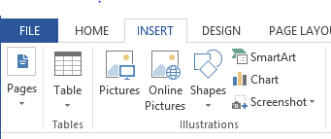

This brings up the Windows Open file dialog, and from there I select the picture to import.

## 332.01.05 – Combine and merge information within a document from a range of sources.

I needed a diagram of how the Git version control system works. Instead of manually drawing the diagram, I used one from the internet using the method described in section 332.01.04. The result is on page 3. I embedded hyperlinks into the document, pointing the new joiners to webpages that expanded topics in the document. For example on page 2 I have included a link to the Getting Started with Rails tutorial, which includes a good introduction to the Model-View-Controller pattern.

## 332.01.06 – Store and retrieve document and associated files effectively, in line with local guidelines and conventions where available

I used the git version control system to keep a backup of my document and associated images. This is kept in a private repository on Github. The repository was made private since the document is only intended for internal use. The version control system allowed me to save successive drafts of my work, and to wind back to previous versions if I felt the changes I had made were not useful. This also meant I could access the document and continue work at home as well as at BT.

## 332.01.07 – Select and use tools and techniques to work with multiple documents or users

The Git repository I used allows access to be granted to collaborators. To do this, I went to the settings for the repository, and selected collaborators. From here you can type the username of another Github user, and select ‘Add Collaborator’. This allows access for that collaborator to my document versions and images.

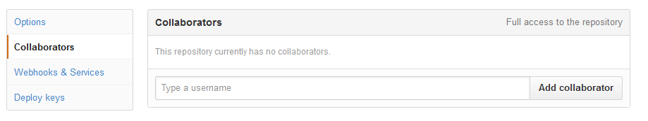

## 332.01.08 – Customise interface to meet needs

I find the default text size hard to read on most monitors, so I use the zoom slider at the bottom of the page. This increases the size of the text on the screen, without actually increasing the size of the text within the document. In Microsoft Word, the zoom slider is located at the bottom of the GUI.

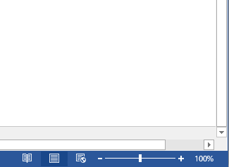

## 332.02.01 – Analyse and explain the requirements for structure and style

This is a document that is intended to be sent out to new joiners before they actually arrive in the team, as an introduction in case they want to start their own preparation and to demystify the job role. It is aimed at software graduates who have programmed before, but may not be familiar with Agile ways of working. I was trying to cover several specific topics, so the structure reflects that by splitting the text up into sections. For these reasons I phrased each heading as a question I thought a new joiner might ask, and kept the prose informal and welcoming.

## 332.03.01 – Explain how the information should be formatted to aid meaning

The Vim cheatsheet on page 5 presents information that links a hotkey with a command. I decided to reflect this structure using a table to format the information into two clear headings: hotkey and command.

## 332.03.03 – Select and use appropriate page and section layouts to present and print multi-page and multi-section documents

Word automatically splits your document into pages, but sometimes a section does not completely fit onto a page. On page 5 I use the ‘Page break’ tool to manually force the layout to use a new page for the section.

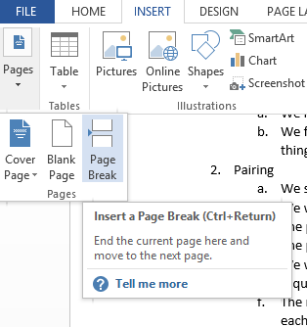

## 332.03.04 – Check documents meet needs, using IT tools and making corrections as necessary

I posted a copy of this document on the team wiki site (an editable set of web pages for team information), and sent everyone in my team a link to the document. They were then able to comment and suggest improvements. I then edited the wiki to reflect these changes, and produced my final version.

Below is an example of some of the feedback I got from one of the members of my team:

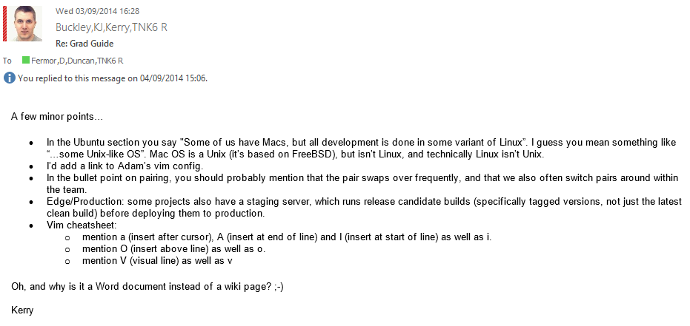

## 332.03.05 – Evaluate the quality of the documents produced to ensure they are fit for purpose

I gathered feedback from our new joiners about the usefulness of the guide, and while some of them were happier finding the information out themselves, many of them commented the handbook helped to welcome them to the team. From this feedback I conclude that the document is fit for purpose for this year, although it may need updating for the next intake since our processes to change over time.